ST Electronics (Info-Software Systems) Pte Ltd
(Regn No: 198601030N)

NUS
OOO Setup Process and Design Document

The information contained herein is the property of ST Electronics (Info-Software Systems) Pte Ltd and may not be copied, used or disclosed in whole or in part to any third party except with written approval of ST Electronics (Info-Software Systems) Pte Ltd or, if it has been authorized under a contract.

 | Name | Designation/Dept | Signature
Prepared By: | James Wong | Technical Manager / LIS
Reviewed By: | Woo Weng Kong | Project Manager / LIS
Approved By: | Malcom Tay | Director / NUS

Revision : 1.0 | Copy Number : _ of N
Document ID : | Date of Issue :
File name : OOOProcessModelDesign.doc | Total Number of Pages :

 | 

DISTRIBUTION LIST

Copy Number | Name
01 | Project Library
02 | NUS

AMENDMENTS RECORD

Revision No. | Affected Page(s) | Details of Change  (if necessary) | CP/DCR No.  (where applicable) | Date of Implementation
1.0 | All | New Creation | - | 05-05-2015
TABLE OF CONTENTS

DISTRIBUTION LIST 2
AMENDMENTS RECORD 3
TABLE OF CONTENTS 4
LIST OF TABLES 4
Out-of-Office-Setup Expanded Process Model 6
Details of activities in the Process Model 7
1. Set-up Out of Office Message & Delegate Tasks 7
1.1. Enable Out of Office Set-up 7
2. Actual Delegation of tasks to back-up 8
2.1. Delegate Tasks to Back-up in a BPD 9
2.2. Wait for end date of OOO 10
3. Delegate back to the Original User 10
3.1. Restore delegation to original user 10
3.2. Email Summary to Original User 10
3.3. User edits end date to current date 10
Glossary 11
Participants, Business Owners, Experts 11
Inputs, Outputs 11

LIST OF TABLES

Out-of-Office-Setup Collapsed Process Model
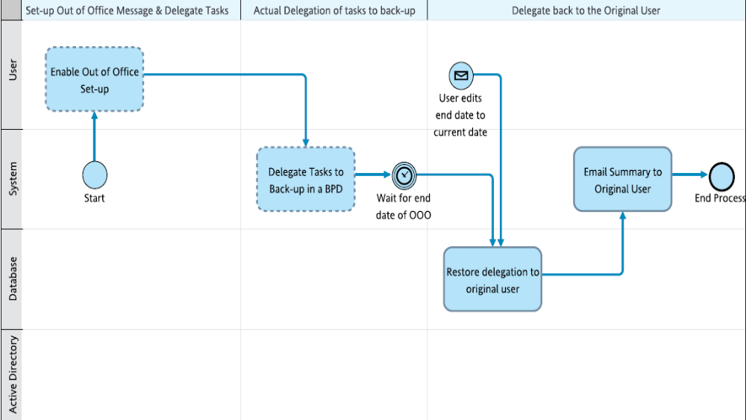

Out-of-Office-Setup Expanded Process Model

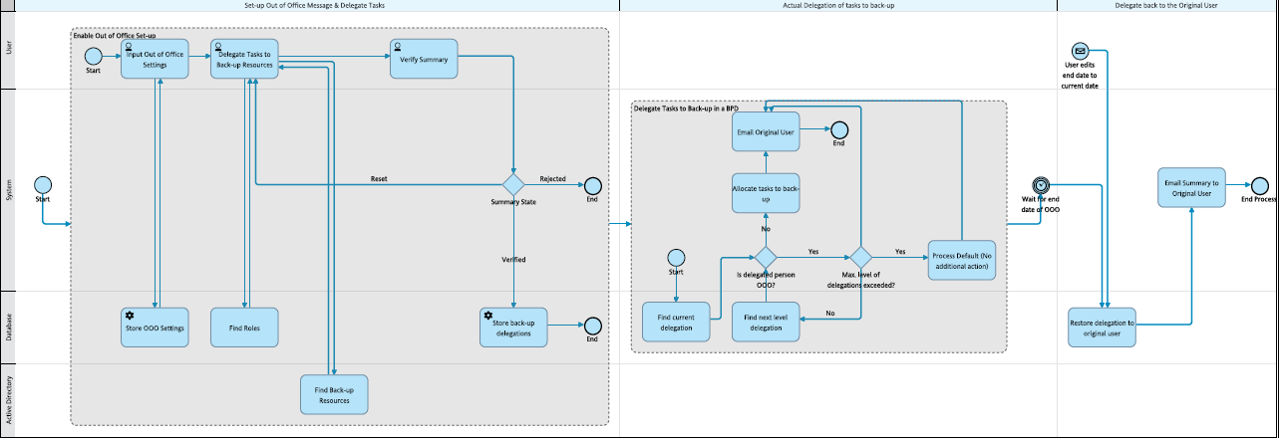

Details of activities in the Process Model

1. Set-up Out of Office Message & Delegate Tasks

1.1. Enable Out of Office Set-up
This activity enables a user to set-up the out-of-office configurations.

1.1.1. Input Out of Office Settings
In this activity, a user inputs into a screen the start and end date and time of the duration he/she will be out of office. The user can also key in a message.
  Participants
  User
  Inputs
  User Id
  Outputs
  Start date & time
  End date & time
  Out of Office Message
.

1.1.2. Store OOO Settings
In this activity, the out-of-office settings from the step 'Input Out of Office Settings' are stored in the database.
  Participants
  Database
  Inputs
  User Id
.

1.1.3. Delegate Tasks to Back-up Resources
If back-up resources are available, then the list of those resources are displayed for each role so that the user can delegate the tasks for a particular role to a particular back-up resource.
  Participants
  User
  Inputs
  User Id
  Current Roles
  Back-up Resource List for each Role
  Outputs
  Back-up Resource for each Role
.

1.1.4. Find Roles
This activity returns the current roles assigned to the user from the database.
  Participants
  Database
  Inputs
  User Id
  Outputs
  Current Roles
.

1.1.5. Verify Summary

  Participants
  User
  Inputs
  User Id
  Current Roles
  List of Back-up Resources
  Outputs
  List of Selected Back-up Resources
  Submission Button Response
.

1.1.6. Summary State
This gateway decides which path to take next based on the value of the field 'Submission Button Response'. If reset, the control goes back to the previous screens to select the back-up resources again; if verified the delegation details are stored in a database. If rejected, no action is needed i.e. no re-delegation details are saved.

1.1.7. Store back-up delegations
Store the delegated resource as current delegation for each role as per the inputs from the step 'Verify Summary'.
  Participants
  Database
  Inputs
  Current Roles
  Back-up Resources for each Role
.

1.1.8. Find Back-up Resources
This activity returns the list of users who can be back-ups for the user from an AD.
  Participants
  Active Directory
  Outputs
  List of Back-up Resources
.

2. Actual Delegation of tasks to back-up

2.1. Delegate Tasks to Back-up in a BPD

2.1.1. Find current delegation
In a BPD, activity assignment needs to be checked from the current delegation stored in the database.
  Participants
  Database
  Inputs
  Role
  Outputs
  Current Delegation
  Back-up Resource Availability
.

2.1.2. Is delegated person OOO?
This gateway decides if the delegated person is also OOO based on the field 'Back-up Resource Availability'.

2.1.3. Allocate tasks to back-up
Using the outputs from the step 'Find current delegation', current tasks are allocated to the correct user.
  Participants
  System
  Inputs
  Current Delegation
.

2.1.4. Email Original User
This activity sends an email notification to the original task owner regarding the re-assignment of tasks.
Participants
System

.

2.1.5. Max. level of delegations exceeded?
This gateway decides which path to take based on the pre-configured maximum no. of allowed forward delegations. If this is exceeded, no action is needed as the process defaults apply. Else the next level back-up resource is to be found from the database.

2.1.6. Process Default (No additional action)

Participants
System

.

2.1.7. Find next level delegation
If the person to whom the task has been re-delegated is also out of office the task has to be assigned to his or her back-up. This activity gets the next level back-up resource from the database.
  Participants
  Database
  Inputs
  Role
  Outputs
  Current Delegation
  Back-up Resource Availability
.

2.2. Wait for end date of OOO
The process waits here for the end date and time of the Out of Office configurations to approach.

3. Delegate back to the Original User

3.1. Restore delegation to original user
At the end date and time of the Out of Office duration, this step restores the delegations to the original user.
  Participants
  Database
  Inputs
  Current Roles
  User Id
.

3.2. Email Summary to Original User
This activity sends an email notification to the original task owner with the summary of the re-assignment of tasks.
Participants
System

.

3.3. User edits end date to current date
In case the user decides to edit the end date and time of the out of office configurations, an alternate start to the process is triggered which directly goes to the step to restore the original delegations to the user.

Glossary

Participants, Business Owners, Experts
Value | Description
Database | Database server to store the configurations and other process related data
Active Directory | Directory which stores list of users
System | BPM System
User | User who needs to set-up Out of Office configurations

Inputs, Outputs
Value | Description
Back-up Resource Availability | This field tells if a back-up resource is available or out-of-office
List of Selected Back-up Resources | The back-up resources who are selected to delegate the tasks assigned to the role
Back-up Resource List for each Role | List of back-up resources who can perform the tasks assigned to the role
Current Delegation | The user to whom the tasks for a particular role is currently assigned (could be the original user or the selected back-up user)
Current Roles | Current roles assigned to the original user
End date & time | End date and time of the duration when the user is going to be Out of Office
Out of Office Message | Message left by the user to be displayed during the period when the user is going to be Out of Office
Role | A particular role used to implement a particular activity
Start date & time | Start date and time of the duration when the user is going to be Out of Office
User Id | User Identification for the original user who intends to set up out of office configurations.

