1. Download Android studio (<https://developer.android.com/studio/>)
2. When started install in-between will be options a). Custom b). Setup in that we need to choose **Custom** then will be install all SDK
3. Once setup Done setup, **“Environment Variables”** this will be in system settings here we need to change the path **“SOME_NAME”** **“C:\Users\krishna_renabothu\AppData\Local\Android\Sdk”**

<https://facebook.github.io/react-native/docs/getting-started.html>

1. In the **Android App** File > Settings > Android SDK >

a). **SDK Platform** in that need to choose **Android 9.0** and **Android 8.1** check boxes  
b). **SDK Tools** need to choose SDK Build Tool, Android Emulator, Android SDK Platform, Android

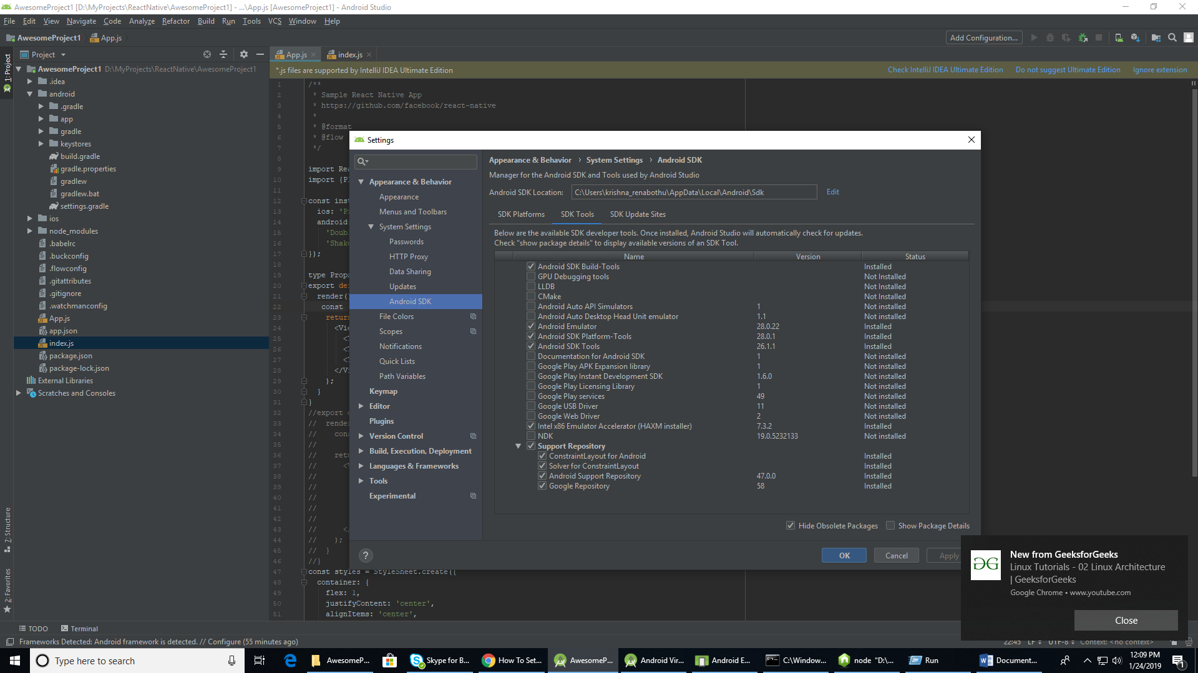

1. For installing emulator must choose “**AVD Manager”** on the right corner in App
2. Choose a Device in the window
3. Once open the emulator need to run the “npm server” Command “**react-native run-android**”
4. From android Studio need do Build the code.
5. For installation need to follow this : <https://facebook.github.io/react-native/docs/getting-started>