Carbon Dioxide Emission Analysis

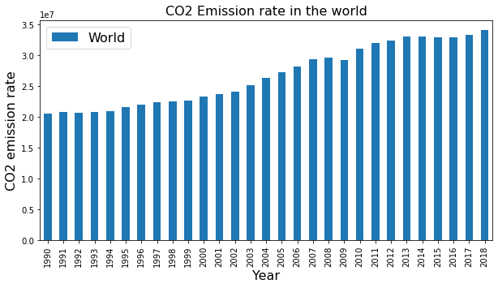Carbon dioxide is one of the greenhouse gases which helps in keeping the earth warm and make it an adequate place for living beings to thrive. However, in the last 50 years, there has been a tremendous increase in carbon dioxide emissions. This document analyses various trends in CO2 emission and finds possible correlations to various factors considering few countries and the world altogether.

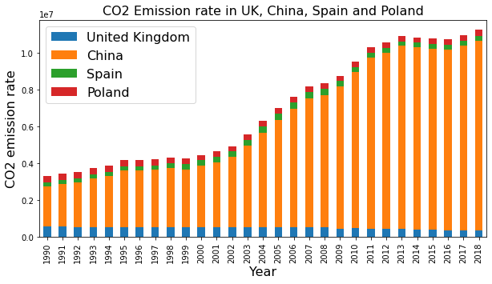There is no doubt that the CO2 emission is increasing consistently worldwide, and the last dataset considered in this document is having an any time peak in 2018. China is at the top of the countries contributing to the much greater CO2 emission above the other countries such as the United Kingdom, Spain and Poland considered for analysis.

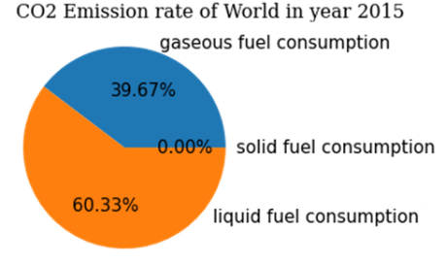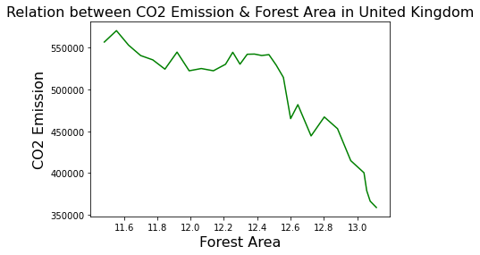 Liquid fuel contributes to the majority of the CO2 emission than the gaseous and solid fuels. This is in line with the modern lifestyle where everything is connected to transportation systems and mobility. The buses, trains, cars, and airplanes definitely pump out a lot of CO2 into the atmosphere.

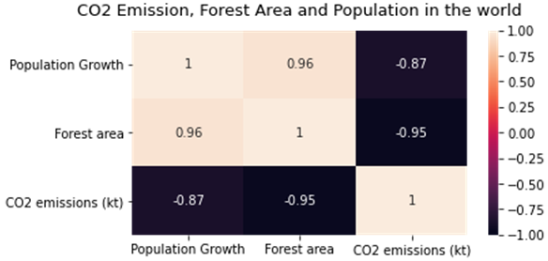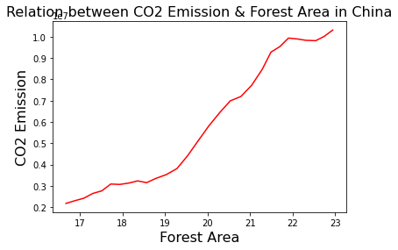 One of the major observations from the dataset is that most of the countries which are considered in this document are investing heavily in increasing the forest area and there is a substantial reduction in the CO2 emission in these countries. This diagram clearly depicts that in the United Kingdom there has been a huge reduction in CO2 emission owing to the increase in the forest area. However, in China, the CO2 emission is keeping up high despite the increase in the forest area. This might be attributed to industrialization and globalization.

Another noticeable observation is that the population is reducting in all the considered countries and also throughout the world. However, despite the reduction in the population, the CO2 levels are rising. The diagram clearly depicts a negative correlation between population CO2 and forest area.

In conclusion, CO2 emission is a worrying problem and a lot of countries throughout the world are investing a lot to reduce it. Countries’ focus on forest conservation and improving the forest area is a positive trend and the indicators have clearly shown that in most of the countries under consideration have witnessed a reduction in the CO2 levels. A major contributor to CO2 emission throughout the world is liquid fuel and this might remain the same until an alternative fuel with minimal emission is identified.

Github: <https://github.com/Krishnasasi21/CarbonDioxideEmissionAnalysis.git>