Used Car Market Analysis

Cars are an inevitable part of modern society, as it provides quick, easy, convenient, and flexible transportation. Due to the modern lifestyle, where time is money and as the affordability of people increases, a major portion of the society are now using cars for their day-to-day life and daily commutation. The used car market provides a vital role in making transportation economical and also increases affordability. This document analyses the various trends in the used car markets from 1997 till 2020 and derives some noticeable trends and facts.

One of the major observations from the dataset is that there is a direct relationship between the total miles and the prize. The cars with maximum miles are the least expensive, regardless of the brand or transmission type.

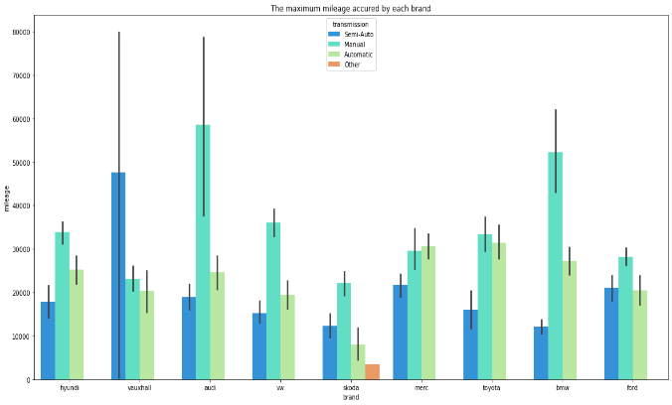 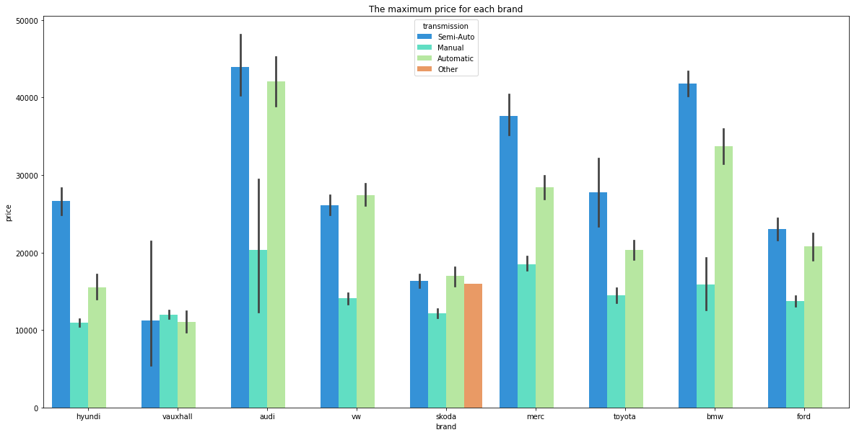

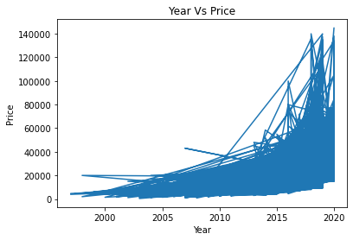

A second noticeable observation is that the older cars are comparatively less expensive than newer ones. This is in line with the above- mentioned point where most of the older cars have more miles.

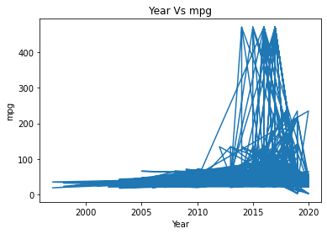

Another noticeable observation is that the miles per gallon which the vehicles provide is improving with the year. This could be since newer vehicles are more technically advanced than the older ones.

In conclusion, the used car market is very big and provides a user with a choice to purchase a car for his taste and budget. For instance, if a person has sufficient budget to afford a comparatively newer car, then he will be benefited with less price for the fuel charges. On the other hand, if someone is looking to buy a cheaper car or less expensive car then he can purchase an older car, but might have to spend more on fuel expenses as older car provides fewer miles per gallon. However, if he does not drive too much then it will still be a viable and economical solution.