**INITIAL SETUP**

**Step 1** :- Open the Pycharm application.

At top go to file>>Open(then open the directory from its location) and click on ok.

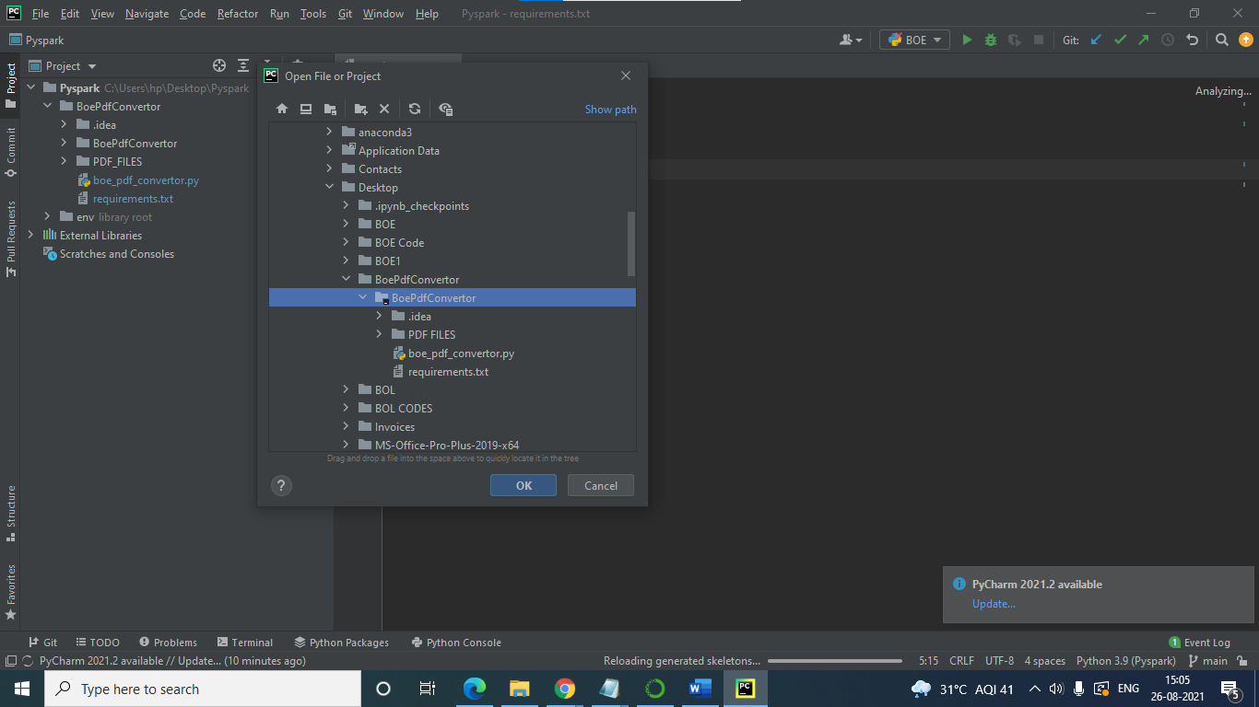

**Step2:-**

In pycharm at bottom line open terminal.

In terminal go to the project location (up to BoePdfConvertor).

Example:-((base) C:\Users\hp\Desktop\Pyspark\BoePdfConvertor>).

Now create the virtual environment using command- 'py -m venv env'

Next activate the virtual environment in terminal using command- '.\env\Scripts\activate'.

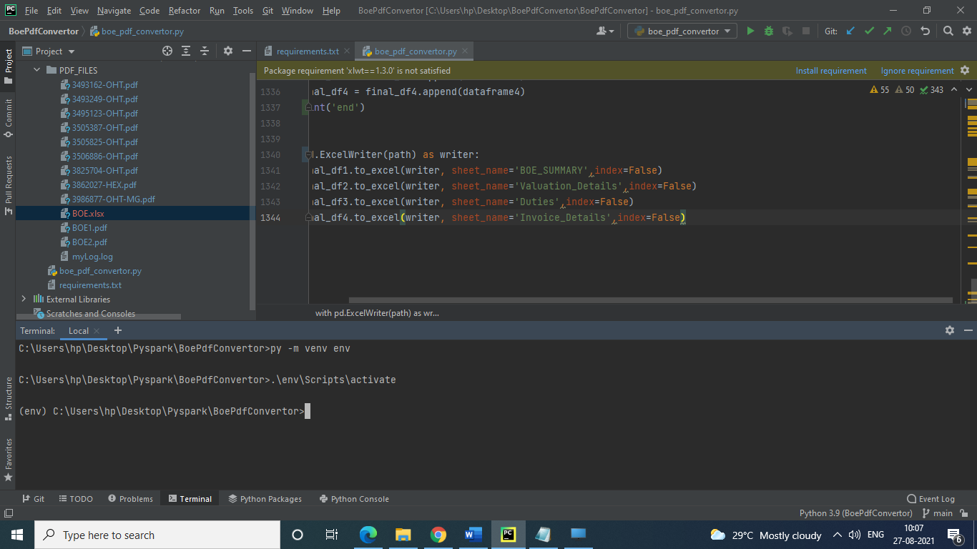

**Step 3:-**

Now on the top click on add configuration and under Environments Python 3.9 (Pyspark) C:\Users\hp\Desktop\Pyspark\env\Scripts\python.exe

For running the code you need to install some requirements.

For installing requirements use this command-- 'pip3 install -r requirements.txt'.

It will install all the necessary libraries for the project

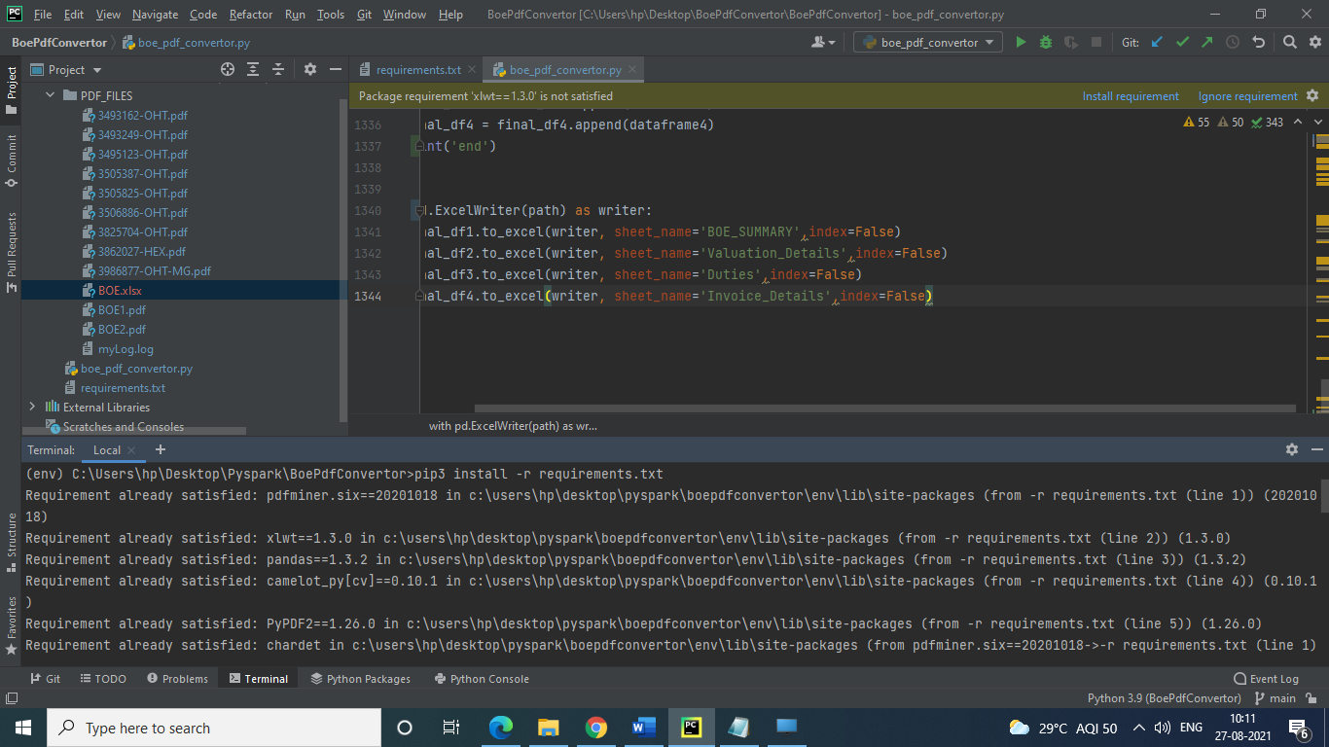

**Step 4:-**

Now run the code using the command ‘python boe_pdf_convertor.py’



Note:-

Whenever you want to from second time Open the project, go to terminal and set the project path and enter below two commands.

To activate virtual enviromnment-- '.\env\Scripts\activate'

To run the code--'python boe_pdf_convertor.py'

Type 'deactivate' to exit virtual environment in terminal