1. Download the application from <https://github.com/KrishnatMohite/ContactManagementProject.git>
2. Project key points : -
   1. I have used n-tier architecture to develop this application.
   2. Used Simple injector for Dependency injection.
   3. I have handled exception in application error event in global.asax.cs file. Logged exceptions in text file.
3. Create database in sql server using given script ‘ContactManagement_DBScript.sql’. Run that script in sql server.
4. Project Developed under below version of visual studio

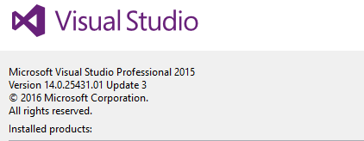

1. At the time of Opening Project in visual studio if you get below Message then **uncheck** the “Ask me for every Project in this solution” and click on **OK** button.

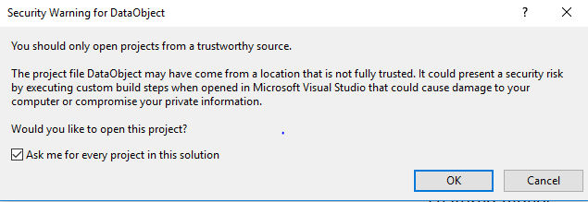

1. Once you open the Solution Automatically create the virtual directory for Contact Api and Contact Management Project in IIS.

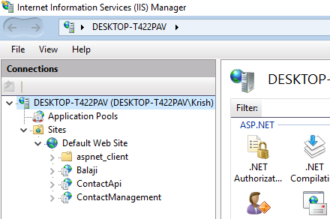

1. Change below connection string in api Project i.e. change the data source, userid and password accordingly.

<connectionStrings>

<add name="ContactDbConnection" connectionString="data source=DESKTOP-T422PAV\SQLEXPRESS;initial catalog=ContactManagement;user id=sa;password=sa123" providerName="System.Data.SqlClient" /> </connectionStrings>

1. Solution has 5 Folders (Projects) :
   1. Data Access Layer - It has reference of Contact model
   2. Business Layer – It has reference of Data access Layer, Contact model
   3. ContactManagement – It has logic to connect to web api
   4. Api –It has reference of Business Layer, Contact model, Used simple injector to achieve dependency injection.
   5. DataObject - It has Model.
2. Run the Application from Visual studio
3. Web Application Screen

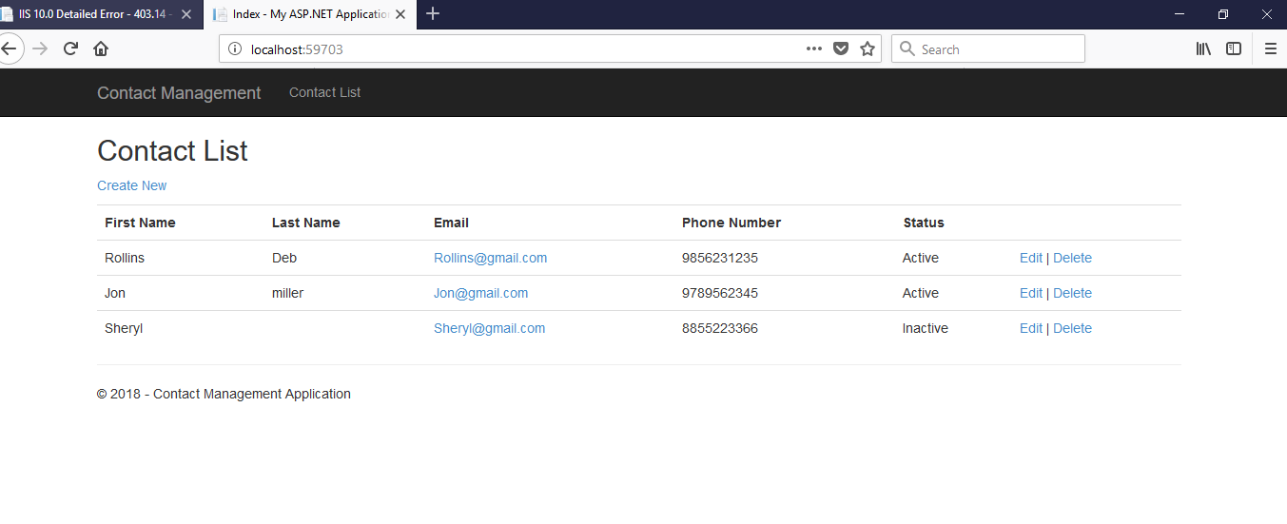

1. Click on Create New Link to create New Contact
2. Click on Edit Link of List to Update the Contact Detail.
3. Click on Delete Link of list to delete the Contact Detail.