1. Download the application from <https://github.com/KrishnatMohite/ContactProject.git>
2. Project key points : -
   1. I have used n-tier architecture to develop this application.
   2. Used Simple injector for Dependency injection.
   3. I have handled exception in application error event in global.asax.cs file. Logged exceptions in text file.
3. Copy Project on “C:” Drive.
4. Project Developed under below version of visual studio

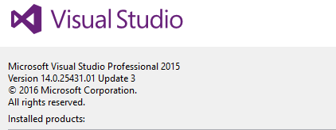

1. If project copied other than “C:” drive then need to change below connection string in api Project

<connectionStrings>

<add name="ContactDbConnection" connectionString="Data Source=(LocalDb)\MSSQLLocalDB;AttachDbFilename=C:\ContactManagement\Api\App_Data\ContactsPrjDB.mdf;Integrated Security=True" providerName="System.Data.SqlClient" />

</connectionStrings>

1. Solution has 5 Folders (Projects) :
   1. Data Access Layer - It has reference of Contact model
   2. Business Layer – It has reference of Data access Layer, Contact model
   3. ContactManagement – It has logic to connect to web api
   4. Api –It has reference of Business Layer, Contact model , Used simple injector to achieve dependency injection .
   5. DataObject - It has Model.
2. Run the Application from Visual studio
3. Once run the application, you can find two tab’s 1. Web api 2. Web Application.
4. Web Api Run on <http://localhost:61126/>

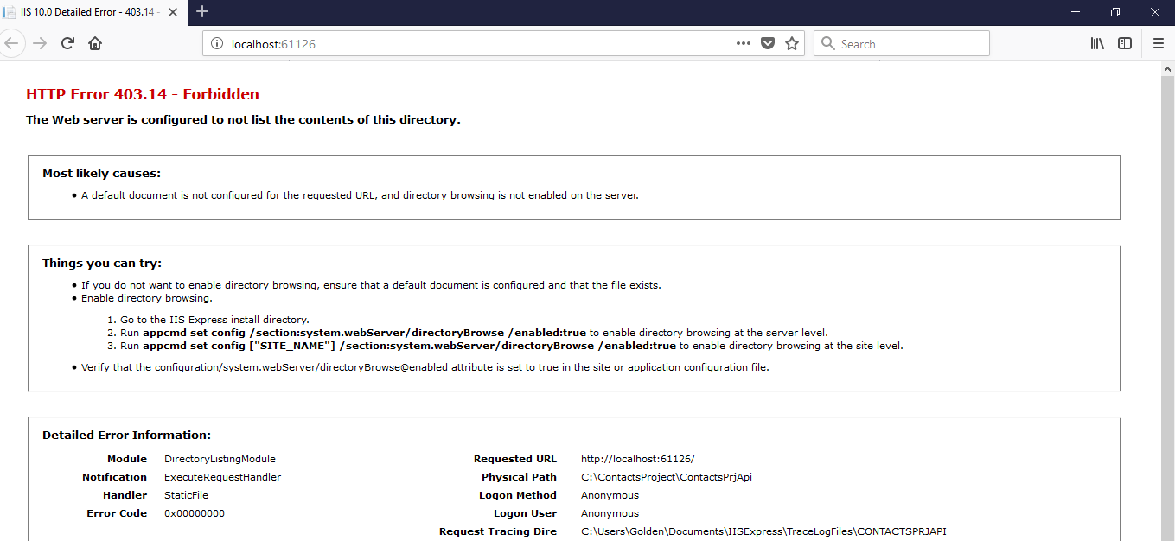

1. Web Application Screen

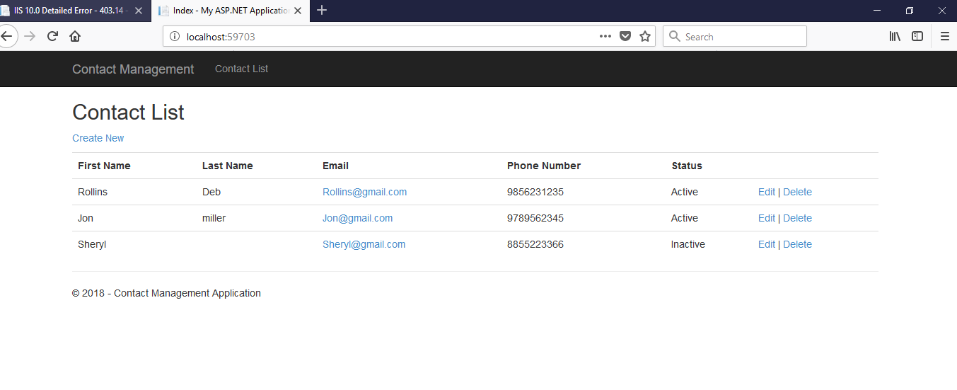

1. Click on Create New Link to create New Contact
2. Click on Edit Link of List to Update the Contact Detail.
3. Click on Delete Link of list to delete the Contact Detail.