23CSE471 – Natural Language Processing · Case Study Report

Case study
MedNarrate: Explaining Medical Lab and Pathology Reports to Patients Using RAG-Based LLMs
G. Manaswini Yoshitha, G. Harsha Chowdary, R. Krishna Teja, D. Joy Sandeep
Department of Computer Science and Engineering, Amrita School of Computing, Amrita Vishwa Vidyapeetham, Coimbatore, India
A R T I C L E I N F O  Course:  23CSE471 – Natural Language Processing  Product: MedNarrate  “Medical Reports, Made Simple.”  Keywords:  Medical report simplification  Retrieval-augmented generation  Large language models  Small language models  Clinical NLP  Ablation study  Multilingual explanation  Health literacy |  | A B S T R A C T  Patients often get their lab and pathology reports before they can see a doctor, and the reports are written for clinicians. MedNarrate is a mobile application that reads an uploaded report and explains it in plain English, Hindi or Telugu. The design rests on one rule: the language model writes the explanation, but it does not decide the facts. OCR and a rule-based parser pull out each test, value, unit and printed reference range, fixed rules mark every value high, low or normal, and a biomedical NER model tags clinical terms. Only then does a language model, given the de-identified report and retrieved context, write a summary for the clinician and one for the patient, and a verifier checks both for numbers that are not in the report. For this review we ran an ablation study that removes or replaces one safeguard at a time, and a controlled comparison between our hosted LLM chain (Gemini 3.1 Flash-Lite) and a 1.5-billion-parameter small language model (Qwen2.5-1.5B) running on a laptop CPU. On the same test sets the SLM matched the LLM on grounded answers (10 of 10), but it kept every number in only 81% of the translations that contained numbers, against 100%, reached a Hindi chrF of 26.9 against 67.1, and, asked to judge values against a printed range, got 16 of 30 right without once calling a value normal. Our rule-based flagger made no wrong call on the same lines. Without the report context, the SLM fell back on textbook ranges that disagreed with the laboratory's own and declined only 2 of 5 questions it could not answer. The ablations also exposed two faults in our own output verifier, which we describe along with fixes.

1. Introduction
Many patients get their lab or pathology report before they can meet their doctor. The report is written for doctors, so it is full of short forms, units and reference ranges that most people cannot read. People then search online or ask friends, and often end up confused or worried for no reason.
Pasting the report into a chatbot is not a safe fix. A general language model can change a number, invent a normal range or suggest a disease that the report does not mention. Studies that used ChatGPT to simplify radiology reports found the results easy to read but sometimes wrong or incomplete [1], [2].
MedNarrate takes a different approach. The values, units, reference ranges and the high or low flags are taken from the report by fixed rules. The language model is used only to explain what those rules have already found. On top of this, the app explains reports in Hindi and Telugu, compares a patient's reports over time, and has a chat that answers questions without giving a diagnosis. The project supports SDG 3 (Good Health and Well-being) by making health information easier to understand.
Our first version of this case study described the system and tested the parts that do not use a language model. It left two questions open. Does each safeguard in the pipeline earn its place, and would a small model that runs without internet be good enough to replace the hosted one? This version answers both. Its contributions are:
(1) a review of published work on report simplification, grounded generation, clinical entity extraction, de-identification and small language models, with the gap MedNarrate addresses (Section 2);
(2) a stage-by-stage description of the pipeline, naming the model or rule used at each stage and how that stage is tested (Section 3);
(3) a controlled comparison of the hosted LLM chain and Qwen2.5-1.5B on the same prompts, test sets and scoring code (Section 4);
(4) an ablation study of fifteen configurations, which also found two faults in our output verifier (Section 5).
Every number in Sections 4 and 5 can be regenerated from the scripts, test sets and raw model replies kept in the project repository under mednarrate-backend/experiments/review2.
2. Related work
2.1. Explaining medical text to patients
Most of the research on this problem has looked at radiology. Jeblick et al. asked ChatGPT to simplify radiology reports and had 15 radiologists rate the output [1]. Most simplified reports were judged correct and complete, yet the raters still found wrong statements, missed findings and passages that could harm a patient. Lyu et al. reached a similar conclusion for ChatGPT and GPT-4 and showed that better prompts reduce, but do not remove, lost or oversimplified content [2]. Zaretsky et al. rewrote 50 discharge summaries with GPT-4 [3]: the reading grade fell from 11.0 to 6.2 and understandability rose from 13% to 81%, but only 54 of 100 physician reviews gave full marks for accuracy and 18 reviews raised safety concerns, mostly omissions.
Two other results set the bar. Van Veen et al. found that adapted LLMs wrote clinical summaries that physicians rated as good as or better than those written by medical experts [4], and Ayers et al. found that chatbot answers to patient questions on a public forum were rated higher for quality and empathy than physicians' answers [5]. Med-PaLM showed that large models encode a good deal of clinical knowledge, while also showing gaps that clinicians picked up in long-form answers [6]. The picture is consistent: language models write well for patients, and the errors that remain are the kind a patient cannot spot.
2.2. Grounding and retrieval
Hallucination, text that reads fluently but is not supported by the source, is a known property of neural text generation [7]. Retrieval-augmented generation (RAG) reduces it by putting the relevant source passages in the prompt [8]. In medicine, Almanac retrieved from curated clinical sources and was rated more factual than an unaugmented chatbot [9], and the MIRAGE benchmark showed that retrieval raised the accuracy of six LLMs on medical questions by up to 18% over chain-of-thought prompting [10]. These systems retrieve knowledge to answer a question. Our case is narrower: the source is the patient's own report, and the facts that matter most are the numbers on it, so we extract and check them outside the model as well as retrieving them.
2.3. Clinical entity extraction and de-identification
Domain pre-training made transformer models the standard tool for biomedical entity recognition, first with BioBERT [11] and then PubMedBERT [12]. The tagger we use, d4data/biomedical-ner-all, is a DistilBERT model [13] trained on the MACCROBAT case reports to recognise 107 entity types, released with the work of Raza et al. [14]. For privacy, Meystre et al. reviewed rule-based and learned approaches to removing identifiers from clinical text [15], and the 2014 i2b2/UTHealth shared task gave the field a common benchmark [16]. Learned de-identifiers do best on that benchmark; MedNarrate currently uses line-level rules, and Section 5 measures what they miss on Indian report headers.
2.4. Small language models
Small language models, roughly 100 million to 5 billion parameters, are attractive for health apps because they can run on the device and keep data off third-party servers. Lu et al. surveyed open SLMs and measured their latency and memory on phones and edge hardware [17]. Phi-3-mini showed that a 3.8-billion-parameter model can run locally on a phone [18], and the Qwen2.5 family goes down to 0.5 billion parameters [19]. For Indian languages, dedicated translation models such as IndicTrans2 cover all 22 scheduled languages [20]. We found no study that tests whether an SLM can stand in for a hosted LLM inside a guarded patient-facing pipeline, which is the comparison we run in Section 4.
2.5. Healthcare platforms and commercial tools
Work on healthcare information systems has mostly modelled the provider side. Gayen et al., whose IEEE Access paper we used as the structural model for this report, built a trust-based multilayer network of doctors, departments and hospitals to support referrals and patient support services, and kept the patient outside the model as an external entity [21]. MedNarrate looks at the other end of that relationship: what the patient understands from the report in their hand. Commercial AI tools follow the provider-side pattern too (Table 1).
Table 1. Existing products and what they miss for patients.
Product | Main use | Gap for patients
Microsoft Dragon Copilot [22] | Clinical notes and summaries | Made for clinicians; few Indian languages
Oracle Health Clinical AI Agent [23] | Clinical summaries | Needs Oracle's hospital system
Google MedLM / MedGemma [24] | Medical AI models | For developers, not an app
Philips clinical informatics [25] | Imaging and hospital workflow | No plain-language explanations

Table 2 places MedNarrate next to the research systems above. The gap is the combination. Earlier work either hands the whole document to the model and asks clinicians to check the result afterwards, or answers general questions for clinicians. None of it fixes the values and flags before generation, explains lab reports in Indian languages, or measures whether a small offline model can do the job.
Table 2. Research systems compared with MedNarrate.
Work | Text and reader | Facts fixed before generation | Indian languages
Jeblick et al. [1] | Radiology reports, patients | No | No
Lyu et al. [2] | Radiology reports, patients | No | No
Zaretsky et al. [3] | Discharge summaries, patients | No | No
Van Veen et al. [4] | Clinical text, clinicians | No | No
Almanac [9] | Clinical questions, clinicians | No (retrieves sources) | No
MedNarrate (ours) | Lab and pathology reports, patients | Yes (rules) | Hindi, Telugu

3. Proposed method
3.1. Dataset description
We could not find a single public dataset that covered all the report types we needed, so we built our own, which we call MRAD (Medical Report Analysis Dataset). It combines three public sources: a general health records dataset, a blood test dataset, and pathology reports from The Cancer Genome Atlas (TCGA) in the machine-readable form released as TCGA-Reports [26]. Each source had its own format and column names, so we mapped every record to one common schema with 15 attributes. These include the report and patient IDs, report type, source, age, gender, report date, visit details, the report text itself, a quality score and quality category, diagnosis, label, and a structured field for the lab values extracted from the text. Patient identifiers were removed or replaced with generated keys, and medical terms were made consistent across the three sources. After removing duplicates we were left with 123,367 usable reports (out of 123,371) belonging to 110,677 different patients, all stored in one CSV file. We split the data by patient rather than by report, giving 98,492 reports for training, 12,421 for validation and 12,454 for testing. Splitting this way means no patient's reports appear in more than one set, so the test scores are not inflated by the model having already seen the same person.
About 81% of the training reports are blood tests, 11% are health records and 8% are pathology reports. Our separate IEEE paper analyses the corpus in detail [27]. Its main finding matters here: the two structured sources are table rows rendered as text, mostly without reference ranges, so MRAD is useful for building the pipeline but cannot test the flagging step. The test sets in Sections 4 and 5 were therefore written separately.
3.2. System overview
MedNarrate has a Flutter mobile app, a FastAPI backend in Python and a PostgreSQL database with the pgvector extension; a Next.js portal lets staff manage the service. Figure 1 shows what happens to a report after it is uploaded, and Table 3 lists the method used at each stage and how we test it.
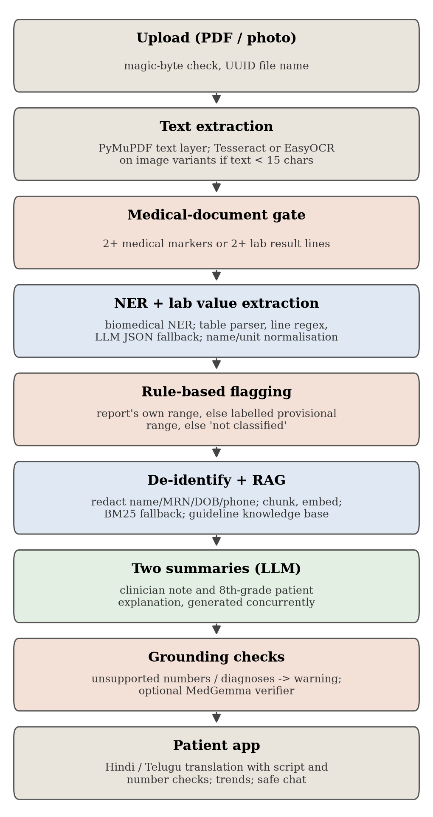
Fig. 1. The MedNarrate pipeline. The language model is used only in the summary step, for translation, and as a fallback when the rule parsers find nothing.
Table 3. Pipeline stages, the method at each stage, and how it is tested.
Stage | Method or model | Test used here
Text extraction | PyMuPDF; Tesseract OCR, EasyOCR fallback | OCR on 4 rendered reports, 6 image conditions (A15)
Medical-document gate | Count of independent medical signals (2 needed) | 13 medical, 8 non-medical documents (A14)
Entity tagging | d4data/biomedical-ner-all (DistilBERT, 107 types) | 25 sentences, 84 entities
Lab-value extraction | Column, table and line parsers in cascade; LLM JSON fallback | 5 reports, 42 gold values (A1-A3)
Name normalisation | Alias table and comparison names | 36 same-test and 12 different-test pairs (A9)
Flagging | Range comparison; lab flag wins; else not classified | 20 labelled values, 30 printed lines (A4, A5)
De-identification | Line-level regular expressions | 12 synthetic headers, 26 identifiers (A10)
Retrieval | Report chunks: Gemini embeddings, BM25 fallback; knowledge base: all-MiniLM-L6-v2 | 23 queries, 21 passages (A8)
Generation | Gemini 3.1 Flash-Lite chain; Qwen2.5-1.5B offline | 15 questions, 56 translations, 12 summaries
Grounding check | Number and diagnosis matching against the source | 203 edited summaries (A11)
Translation check | Digit-normalised number multiset; script ratio | 36 Hindi variants (A12, A13)
Chat router | Keyword patterns for emergencies and diagnosis requests | 60 messages (Table 6)

3.3. Pipeline stages
Reading the report. PDFs are read with PyMuPDF. Scanned PDFs and phone photos go through OCR (Tesseract [28], with EasyOCR as a backup). A gate then counts independent signs of medical content, such as named lab tests or section words like "impression" or "specimen", and rejects anything with fewer than two, so a bill or receipt never reaches a model.
Finding the values. The NER model tags diseases, medicines, doses and lab terms in the first 4,000 characters. Lab values are pulled out by three rule parsers tried in a fixed order: one for column layouts where value, test name, range and unit sit on separate lines, one for printed tables, and one for single-line rows such as "Hemoglobin 12.5 g/dL 13.0 - 17.0". The first parser that returns results wins. Only when all three return nothing is a language model asked for the values as JSON, and its output is cleaned by the same record sanitiser. Test names are then normalised, so that "SGPT" and "ALT" are treated as the same test when two reports are compared.
High or low. Each value is compared with the reference range printed next to it. Below the lower bound is low, above the upper bound is high, inside is normal, and a flag printed by the laboratory wins. If there is no range, the value is marked "not classified" instead of guessing. The language model never makes this decision.
Writing the explanation. Names, phone numbers, dates of birth, hospital IDs and similar fields are redacted line by line. The cleaned report is split into chunks of about 512 tokens with a 64-token overlap and indexed. Chunks are ranked by Gemini embeddings with cosine similarity, falling back to BM25 [29] when no embedding is available, and general health questions in chat draw on a small knowledge base indexed with all-MiniLM-L6-v2 sentence embeddings [30]. The language model then writes two summaries in parallel: a technical one for clinicians and a five-section one for patients at about an eighth-grade reading level.
Checking the output. Every number in both summaries is matched against the report and the extracted values, and a short list of serious diagnoses is matched against the report text. If anything cannot be found, the summary is shown with a warning that a doctor should review it. Translations into Hindi and Telugu are rejected if the multiset of numbers changes (native digits are converted first) or if too little of the text is in the target script. In chat, a keyword router sends emergency messages to a fixed "call emergency services" reply and refuses requests for a diagnosis, a medicine or a dose.
3.4. Language models compared
The hosted chain uses Gemini 3.1 Flash-Lite as its primary model; when a call fails, the chain falls back to other configured hosted models, so a small share of replies in the hosted runs may come from a fallback. The small model is Qwen2.5-1.5B-Instruct [19] in 4-bit Q4_K_M quantisation (a 1.12 GB file), run through the llama.cpp runtime [31] with four CPU threads, a 4,096-token context, temperature 0.2 and seed 42. The app already ships this model as its offline translation fallback, so the comparison tests a configuration we could actually deploy. Both models receive the prompts used by the app itself.
3.5. Evaluation protocol
We report precision and recall for extraction (a predicted value counts when it is within 0.1% of the gold value and the test names agree), Recall@k and mean reciprocal rank for retrieval, chrF [32] and the share of numbers kept for translation, and the Flesch-Kincaid grade [33] for readability. For model answers we also count invented numbers, meaning numbers in a reply that do not appear in the report. The ablation follows the usual rule [34]: change one component, keep everything else fixed, and rerun the same test set.
The hosted-chain results come from the project's evaluation script, run on 17 October 2026 on a MacBook Air with the app's own provider settings. The SLM and all ablations were run on 19 October 2026 in an Ubuntu 22.04 virtual machine on the same laptop (arm64, 4 virtual CPUs, 3 GB of memory). Hosted latencies include the network round trip; SLM latencies do not have one. Apart from the 42-value extraction set, the de-identification headers, safety messages, gate documents and name pairs were written by us for this review, and all patient details in them are invented.
4. Results and discussions
4.1. Component results
Table 4 gives the measured performance of each component in the full system.
Table 4. Measured performance of each component in the full system.
Component | Test set | Result
Biomedical NER | 25 sentences, 84 entities | P 66.3%, R 72.6%, F1 69.3%
Report retrieval (Gemini embeddings) | 23 queries | Recall@1 100%, MRR 1.000
Knowledge retrieval (MiniLM) | 23 queries | Recall@1 95.7%, MRR 0.964
Lab extraction (rules only) | 5 reports, 42 values | P 100%, R 81.0%, F1 89.5%
Rule-based flags | Extracted labelled values | 12 of 12 correct
Grounded answers (hosted LLM) | 10 answerable, 5 not | 10/10 correct, 5/5 abstained
Translation (hosted LLM) | 56 translations | 100% numbers kept, chrF (Hindi) 67.1
Speech to text (Whisper large-v3) | 15 synthetic clips | WER 6.7% English, 24.6% Hindi
Report-type classifier | 12,454 MRAD test reports | Macro F1 1.00 (format shortcut [35])
De-identification | 26 identifiers | 22 removed (84.6%)
Chat router | 20 / 20 / 20 messages | 9 emergencies, 9 diagnosis requests, 17 general correct
Document gate | 13 medical, 8 non-medical | 8 accepted, 8 rejected

The rule parsers are precise but incomplete. Every value they returned was correct, and every value they returned with a range carried the right flag. They missed eight of 42 values: all five rows of a pipe-separated export, two thyroid rows written as "T3, Total", and one blood urea row. In the app, the pipe-separated case goes to the language-model fallback, which this test switches off.
Two components did worse than the first version of this report suggested. On our earlier set of 12 emergency messages the keyword router caught 8. The new set adds paraphrases, and the router caught 9 of 20: it missed "my lips are turning blue", "I took 30 sleeping pills an hour ago" and "I swallowed rat poison by mistake", because none of them contains a listed keyword. It also raised three false alarms on ordinary questions that use medical words, such as "What is the bleeding time test in my report?". The document gate rejected all eight non-medical documents, but it also rejected five real lab reports: a lipid profile, a thyroid profile, a urine routine report and two short panels. Each was a single panel with no heading such as "laboratory report", so it found fewer than two of the signals it looks for. A patient who photographs one panel would be told the upload is not a medical report.
4.2. Hosted LLM versus small language model
Table 5 and Fig. 2 compare the two models on the same 15 report questions and 56 translations (8 sentences into 7 Indian languages).
Table 5. Hosted LLM chain versus the small language model on the same test sets.
Measure | LLM chain | SLM (Qwen2.5-1.5B)
Answerable report questions correct | 10 / 10 | 10 / 10
Unanswerable questions declined | 5 / 5 | 4 / 5
Answers quoting a number not in the report | not measured | 0 / 10
Numbers kept in translation | 100% | 82.1%
Translations with every number kept | 100% | 81.0%
chrF, Hindi (0-100) | 67.1 | 26.9
Degenerate translations | not measured | 6 / 56
Median latency, questions | 1.92 s | 0.73 s
95th-percentile latency, questions | 11.1 s | 3.4 s
Model size on device | none (hosted) | 1.12 GB file, 1.4 GB RAM
Works without internet | No | Yes

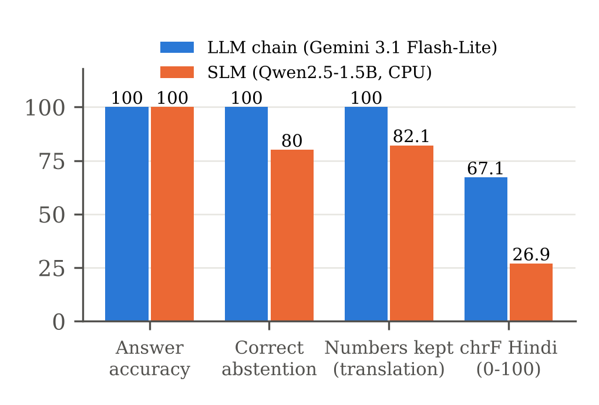
Fig. 2. Hosted LLM chain and SLM on the same test sets. Both answered every answerable question; the SLM falls behind on declining unanswerable questions and on translation.
On grounded questions the SLM was as accurate as the hosted chain: given the report, it quoted the right value for all ten answerable questions and invented no numbers. It was also quicker, with a median of 0.73 s against 1.92 s, because there is no network round trip. It was less careful about saying "this is not in your report": it did so for 4 of the 5 unanswerable questions, against 5 of 5.
Translation is where the small model falls apart. Its Hindi chrF of 26.9 is well under half the hosted chain's 67.1, it dropped or changed a number in 19% of the translations that contained one, and 6 of its 56 outputs, three of them in Telugu, degenerated into the same words repeated until the length limit. Reading the Hindi output shows the problem more plainly than the score: in "Your white blood cell count is 11500 per cumm, which is slightly high" the model kept the number and turned "slightly high" into a phrase meaning "very low". The number check would pass that sentence. This is a limit of number checking in general, not only of the SLM: it catches changed numbers and nothing else.
We also tried the SLM as a safety router, asking it to label each of the 60 chat messages (Table 6). It caught all 20 emergencies and 19 of 20 diagnosis requests, far better than the keyword list, but it called 11 of the 20 ordinary questions emergencies or diagnosis requests. Running the keyword list first and the SLM only on what the list lets through did not help, because the SLM's false alarms are on exactly those messages.
Table 6. Chat routing on 60 messages written for this review.
Router | Emergency (20) | Diagnosis (20) | General (20)
Keyword patterns (deployed) | 9 | 9 | 17
SLM labels | 20 | 19 | 9
Keywords, then SLM | 20 | 19 | 6

The comparison gives a clear division of labour. The SLM is usable offline for English questions about a report that is already in its context, and as a high-recall first pass for emergencies if a human-designed reply follows. It should not translate for patients, and, as Section 5 shows, it should not judge values. The practical cost is modest: 1.12 GB on disk, about 1.4 GB of memory while running, and 16 to 21 tokens per second on four laptop cores.
5. Ablation study
Table 7 lists fifteen ablations. Each removes or replaces one part of the pipeline and reruns the test set used for that part, with everything else unchanged.

Table 7. Ablation study. Each row changes one component; everything else is the full system.
# | Component removed or replaced | Test set | Full system | Ablated | What changed
A1 | Column parser removed | 42 values | R 81.0%, P 100% | R 52.4%, P 84.6% | 12 values lost, 4 wrong values added
A2 | Line parser removed | 42 values | R 81.0% | R 61.9% | Inline and thyroid layouts lost
A3 | Table parser removed | 42 values | R 81.0% | R 81.0% | No change on this set
A4 | Printed ranges deleted | 12 extracted values | 12 correct flags | 12 not classified | No guessing without a range
A5 | Rule flags replaced by SLM judgement | 30 printed lines | 26 correct, 4 unread, 0 wrong | 16 correct, 14 wrong | SLM never answered normal
A6 | Structured values removed from SLM prompt | 6 reports, 39 values | 82.1% cited, 2 contradictions | 43.6% cited, 5 contradictions | Flags invented without numbers
A7 | Report context removed (SLM chat) | 15 questions | 10/10 right, 4/5 declined | 3/10 said data missing, 2/5 declined | Textbook ranges replace the lab's own
A8 | Retrieval replaced | 23 queries | Recall@1 95.7-100% | BM25 82.6%; none 4.3% | Right passage rarely first
A9 | Name normaliser removed | 48 name pairs | 25/36 matched, 0/12 merged | 0/36 matched | No trend comparison
A10 | De-identification removed | 26 identifiers | 4 reach the model | 26 reach the model | Names and IDs sent out
A11 | Grounding verifier removed | 203 edited summaries | 145 caught | 0 caught | No warning shown
A12 | Digit normalisation removed | 36 Hindi variants | 36/36 correct | 30/36 correct | Devanagari numerals rejected
A13 | Translation number check removed | 24 corrupted translations | 24 rejected | 0 rejected | Changed numbers shown
A14 | Document gate removed | 8 non-medical documents | 0 reach the model | 8 reach the model | Bills sent for analysis
A15 | OCR input degraded (blur radius 2.5) | 4 reports, 20 values | 11 found (clean) | 7 found | Vertical layout lost

5.1. Extraction and flagging (A1 to A5)
The column parser carries the most weight: without it, recall on the sample PDF fell from 22 to 12 values and four wrong values appeared, because the remaining parsers misread the column layout (Fig. 3). The line parser is the only one that reads single-line rows, so removing it lost the inline and thyroid reports entirely. Removing the table parser changed nothing on this set. We are keeping it for now, because it was written for printed table layouts that a five-report set may not cover, but it is the first candidate for simplification if a wider test set confirms the result.
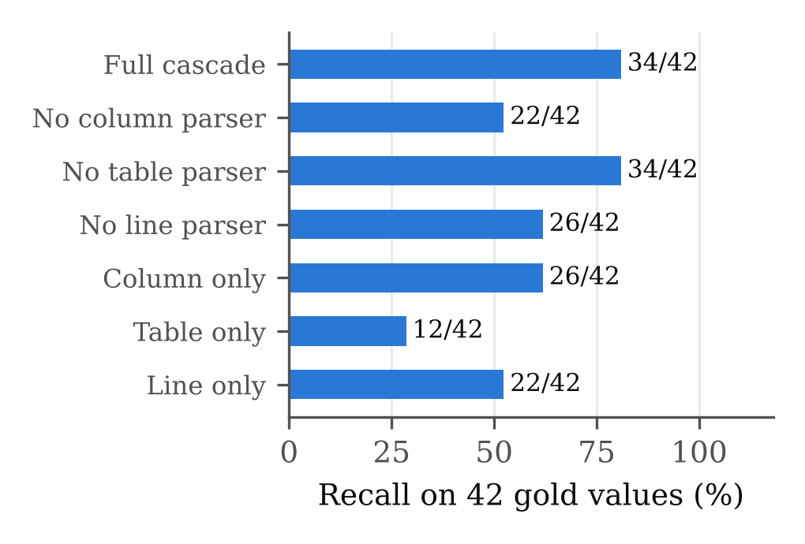
Fig. 3. Recall of the rule-based extractor on 42 gold values with parsers removed or used alone.
A4 and A5 test the decision we care most about. With the printed ranges deleted, all 12 extracted values were marked "not classified" rather than guessed. When the SLM was asked to judge 30 values against a printed range, it got 16 right, and all 16 were abnormal values. It labelled every one of the 14 normal values low or high; "Hemoglobin 14.2 g/dL, reference 13.0 - 17.0" came back LOW. The rules read 26 of the same 30 lines, flagged all 26 correctly and returned nothing for the other four. A wrong flag is worse than no flag, because a patient acts on it, and this result is the strongest argument for keeping flags out of the model.
5.2. What the model needs from the pipeline (A6 to A8)
A6 removed the block of structured lab values from the patient prompt and left only the report text. The SLM then cited 44% of the values in its summaries instead of 82%. For the 22-value sample PDF it cited none at all and wrote that white cells, platelets and MCV were high, none of which the report says. Value-level contradictions went from two to five. Even with the structured block, the SLM called a haemoglobin of 12.5 g/dL "within the normal range of 13.0 - 17.0". A7 removed the report context from chat. The SLM did not make up patient values, but it rarely admitted that it had none. Only 3 of the 10 report questions got a reply saying the report was missing; the rest got textbook answers, and six of those contained numbers that are not in the report, mostly general ranges in place of the laboratory's own, such as 70 to 110 mg/dL for fasting glucose where the report prints 70 to 99. One reply stated that vitamin D "is not typically measured in a blood test". The automatic score of 5 of 10 overstates it, since words such as "high" matched inside generic sentences, and it declined only 2 of the 5 unanswerable questions. A8 shows why retrieval quality matters for longer reports: returning passages in file order found the right one first for 4.3% of queries, BM25 for 82.6% and the dense embeddings for 95.7% to 100%.
5.3. Safety layers (A9 to A15)
Without the name normaliser, no pair of differently written test names lined up for trend comparison; with it, 25 of 36 did, and none of the 12 different-test pairs was wrongly merged. Two of the eleven misses, "HDL-C" and "T.Bili", are in the alias table exactly as written, but the code strips punctuation before the lookup and turns "HDL-C" into "hdlc", which is not a key. De-identification removed 22 of 26 identifiers. The four it missed were a name typed in capitals with no label, a guardian's name, a mother's name in "Baby of Sunita", and a mobile number followed by a full stop, which the phone pattern refuses because it forbids a trailing dot. It also removed the age and sex that followed a patient name on the same line.
The grounding verifier result needs the most attention (Fig. 4). On 203 edited summaries it caught 145, and it raised no false alarm on the five faithful ones. It caught almost every swapped digit and every listed diagnosis, but it missed 17 of 39 values multiplied by ten and 25 of 30 conditions outside its short list. Following these misses back to the code gave two faults.
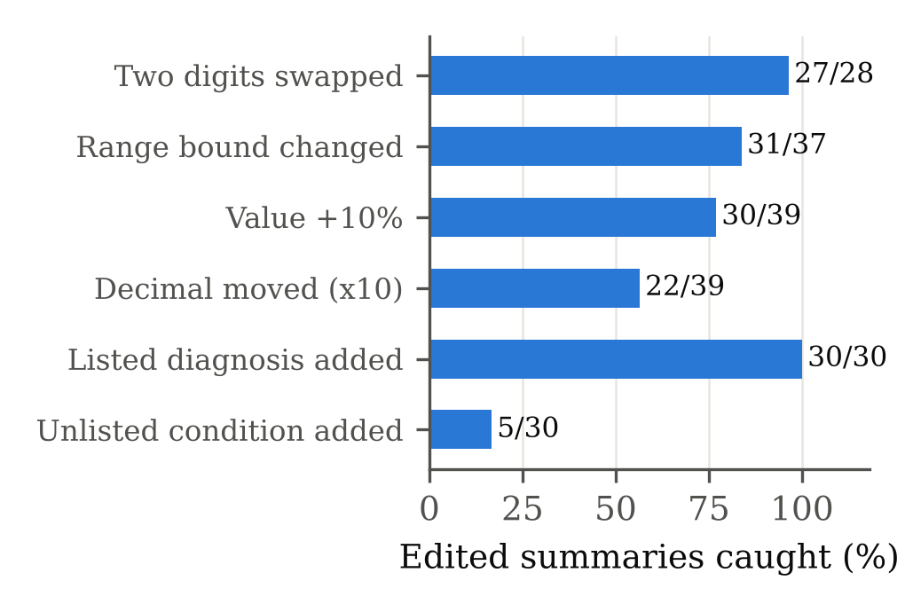
Fig. 4. Share of deliberately edited summaries caught by the grounding verifier, by type of edit.
• Substring matching. When a number is not found as a token, the verifier accepts it if it appears anywhere in the report text as a substring, and it ignores 0 to 5 altogether. A glucose of 112 changed to 1120 passes because the report also prints a white cell count of 11200, and a creatinine of 0.9 changed to 1 passes because 1 is ignored.
• An exemption that is always on. The diagnosis check is skipped for any summary containing the phrase "not provided", which was meant to spare sentences such as "a diagnosis is not provided". The patient prompt requires a section headed "Information Not Provided", so for real patient summaries the check never runs. All six SLM summaries in A6 passed the verifier although five named a condition that their report never mentions, most often diabetes. With the exemption removed, three of the six would have been flagged.
Both fixes are small: compare whole numeric tokens only, and test negation inside the sentence that names the diagnosis rather than across the whole summary. The edited summaries from this study can become regression tests for both. The translation number check, by contrast, did exactly its job. It rejected all 24 corrupted translations and accepted all 12 faithful ones; without digit normalisation it rejected the six faithful translations written in Devanagari numerals. Without the document gate, all eight non-medical documents would reach the language model. Finally, OCR recall stayed at 11 of 20 values under mild blur, half resolution, heavy JPEG compression and a 3 degree rotation, but heavier blur cut it to 7, losing the vertical layout entirely.
6. Conclusion and future work
MedNarrate explains medical reports in plain language while the values and their flags stay under the control of fixed rules. The ablations support that split. The rule-based flagger made no wrong call in 38 decisions, while a capable small model got the same kind of decision wrong almost half the time. Taking the structured values or the report context away from the model made its summaries and answers less complete and less faithful to the report. The comparison also settles our offline question: Qwen2.5-1.5B is a reasonable fallback for English questions about a report, but not for translation into Indian languages.
The study was equally useful for what it found wrong with our own safeguards. Two verifier faults, a document gate that rejects single-panel reports, a de-identifier that misses unlabelled names, and a keyword router that misses paraphrased emergencies all passed our earlier tests. Our planned next steps, in order of risk, are:
(1) fix the two verifier faults and keep the 203 edited summaries as regression tests;
(2) replace the keyword router with a trained classifier, using the SLM labels as a high-recall first stage and measuring false alarms alongside emergency recall;
(3) let the document gate accept a report with two or more lab-result lines for any known test, and look up aliases before stripping punctuation;
(4) add parsers for pipe-separated rows and comma-ordered names such as "T3, Total";
(5) test a dedicated translation model such as IndicTrans2 [20] for offline Hindi and Telugu instead of the SLM;
(6) run the remaining SLM experiments (S2, S4 to S6) against the hosted chain, which our script already supports, and apply the MRAD fixes proposed in our IEEE paper [27];
(7) have clinicians review explanations of de-identified real reports, with acceptance thresholds agreed before the review, before the app is offered to patients.
References
[1] K. Jeblick et al., "ChatGPT makes medicine easy to swallow: an exploratory case study on simplified radiology reports," European Radiology, vol. 34, pp. 2817-2825, 2024.
[2] Q. Lyu et al., "Translating radiology reports into plain language using ChatGPT and GPT-4 with prompt learning: results, limitations, and potential," Visual Computing for Industry, Biomedicine, and Art, vol. 6, art. 9, 2023.
[3] J. Zaretsky et al., "Generative artificial intelligence to transform inpatient discharge summaries to patient-friendly language and format," JAMA Network Open, vol. 7, no. 3, art. e240357, 2024.
[4] D. Van Veen et al., "Adapted large language models can outperform medical experts in clinical text summarization," Nature Medicine, vol. 30, pp. 1134-1142, 2024.
[5] J. W. Ayers et al., "Comparing physician and artificial intelligence chatbot responses to patient questions posted to a public social media forum," JAMA Internal Medicine, vol. 183, no. 6, pp. 589-596, 2023.
[6] K. Singhal et al., "Large language models encode clinical knowledge," Nature, vol. 620, pp. 172-180, 2023.
[7] Z. Ji et al., "Survey of hallucination in natural language generation," ACM Computing Surveys, vol. 55, no. 12, art. 248, 2023.
[8] P. Lewis et al., "Retrieval-augmented generation for knowledge-intensive NLP tasks," in Advances in Neural Information Processing Systems 33, 2020, pp. 9459-9474.
[9] C. Zakka et al., "Almanac: Retrieval-augmented language models for clinical medicine," NEJM AI, vol. 1, no. 2, 2024.
[10] G. Xiong, Q. Jin, Z. Lu, and A. Zhang, "Benchmarking retrieval-augmented generation for medicine," in Findings of the Association for Computational Linguistics: ACL 2024, 2024.
[11] J. Lee et al., "BioBERT: a pre-trained biomedical language representation model for biomedical text mining," Bioinformatics, vol. 36, no. 4, pp. 1234-1240, 2020.
[12] Y. Gu et al., "Domain-specific language model pretraining for biomedical natural language processing," ACM Transactions on Computing for Healthcare, vol. 3, no. 1, art. 2, 2021.
[13] V. Sanh, L. Debut, J. Chaumond, and T. Wolf, "DistilBERT, a distilled version of BERT: smaller, faster, cheaper and lighter," arXiv:1910.01108, 2019.
[14] S. Raza, D. J. Reji, F. Shajan, and S. R. Bashir, "Large-scale application of named entity recognition to biomedicine and epidemiology," PLOS Digital Health, vol. 1, no. 12, art. e0000152, 2022.
[15] S. M. Meystre, F. J. Friedlin, B. R. South, S. Shen, and M. H. Samore, "Automatic de-identification of textual documents in the electronic health record: a review of recent research," BMC Medical Research Methodology, vol. 10, art. 70, 2010.
[16] A. Stubbs, C. Kotfila, and O. Uzuner, "Automated systems for the de-identification of longitudinal clinical narratives: Overview of 2014 i2b2/UTHealth shared task Track 1," Journal of Biomedical Informatics, vol. 58, suppl., pp. S11-S19, 2015.
[17] Z. Lu et al., "Small language models: Survey, measurements, and insights," arXiv:2409.15790, 2024.
[18] M. Abdin et al., "Phi-3 technical report: A highly capable language model locally on your phone," arXiv:2404.14219, 2024.
[19] Qwen Team, A. Yang et al., "Qwen2.5 technical report," arXiv:2412.15115, 2024.
[20] J. Gala et al., "IndicTrans2: Towards high-quality and accessible machine translation models for all 22 scheduled Indian languages," Transactions on Machine Learning Research, 2023.
[21] A. Gayen, S. Chakraborty, J. Chakraborty, and A. Jana, "Trust@Health: A trust-based multilayered network for scalable healthcare service management," IEEE Access, vol. 13, pp. 167061-167079, 2025.
[22] Microsoft, "Dragon Copilot." https://www.microsoft.com/health-solutions/clinical-workflow/dragon-copilot. Accessed Oct. 2026.
[23] Oracle, "Oracle Health Clinical AI Agent." https://www.oracle.com/health/clinical-suite/clinical-ai-agent/. Accessed Oct. 2026.
[24] Google, "Health AI Developer Foundations." https://cloud.google.com/health-ai-developer-foundations. Accessed Oct. 2026.
[25] Philips, "Healthcare informatics." https://www.philips.com/healthcare. Accessed Oct. 2026.
[26] J. Kefeli et al., "TCGA-Reports: A machine-readable pathology report resource for benchmarking text-based AI models," Patterns, vol. 5, no. 3, art. 100933, 2024.
[27] G. M. Yoshitha, G. H. Chowdary, R. K. Teja, and D. J. Sandeep, "What the vocabulary reveals: An empirical characterisation of the MRAD corpus behind the MedNarrate medical report explainer," IEEE-format manuscript, Amrita Vishwa Vidyapeetham, Coimbatore, 2026.
[28] R. Smith, "An overview of the Tesseract OCR engine," in Proc. 9th Int. Conf. Document Analysis and Recognition (ICDAR), 2007, pp. 629-633.
[29] S. Robertson and H. Zaragoza, "The probabilistic relevance framework: BM25 and beyond," Foundations and Trends in Information Retrieval, vol. 3, no. 4, pp. 333-389, 2009.
[30] N. Reimers and I. Gurevych, "Sentence-BERT: Sentence embeddings using Siamese BERT-networks," in Proc. EMNLP-IJCNLP, 2019, pp. 3982-3992.
[31] G. Gerganov et al., "llama.cpp: LLM inference in C/C++," GitHub repository, https://github.com/ggml-org/llama.cpp. Accessed Oct. 2026.
[32] M. Popovic, "chrF: character n-gram F-score for automatic MT evaluation," in Proc. 10th Workshop on Statistical Machine Translation, 2015, pp. 392-395.
[33] J. P. Kincaid, R. P. Fishburne, R. L. Rogers, and B. S. Chissom, "Derivation of new readability formulas for Navy enlisted personnel," Naval Technical Training Command, Research Branch Report 8-75, 1975.
[34] R. Meyes, M. Lu, C. W. de Puiseau, and T. Meisen, "Ablation studies in artificial neural networks," arXiv:1901.08644, 2019.
[35] R. Geirhos et al., "Shortcut learning in deep neural networks," Nature Machine Intelligence, vol. 2, pp. 665-673, 2020.
About the authors
G. MANASWINI YOSHITHA (CB.SC.U4CSE24716) is a third-year B.Tech. student in Computer Science and Engineering at Amrita School of Computing, Amrita Vishwa Vidyapeetham, Coimbatore. In this case study she drafted the title and the abstract with the team. Email: cb.sc.u4cse24716@cb.students.amrita.edu.
G. HARSHA CHOWDARY (CB.SC.U4CSE24717) is a third-year B.Tech. student in Computer Science and Engineering at Amrita School of Computing, Amrita Vishwa Vidyapeetham, Coimbatore. He worked on the abstract and on the first part of the dataset description: why MRAD was needed, the three source datasets and their mapping to the common 15-attribute schema. Email: cb.sc.u4cse24717@cb.students.amrita.edu.
R. KRISHNA TEJA (CB.SC.U4CSE24743) is a third-year B.Tech. student in Computer Science and Engineering at Amrita School of Computing, Amrita Vishwa Vidyapeetham, Coimbatore. He wrote the second part of the dataset description, covering anonymisation, term standardisation, duplicate removal and the patient-level train, validation and test split. Email: cb.sc.u4cse24743@cb.students.amrita.edu.
D. JOY SANDEEP (CB.SC.U4CSE24765) is a third-year B.Tech. student in Computer Science and Engineering at Amrita School of Computing, Amrita Vishwa Vidyapeetham, Coimbatore. He worked on the abstract and selected the keywords. Email: cb.sc.u4cse24765@cb.students.amrita.edu.

Author contributions
S.No. | Name | Roll Number | Contributions
1 | G. Manaswini Yoshitha | CB.SC.U4CSE24716 | Abstract  Title
2 | G. Harsha Chowdary | CB.SC.U4CSE24717 | Abstract  Methodology (dataset description, part 1): why MRAD was needed, the three source datasets (health records, blood tests, TCGA pathology) and mapping them to the common 15-attribute schema
3 | R. Krishna Teja | CB.SC.U4CSE24743 | Abstract  Methodology (dataset description, part 2): anonymisation, standardising medical terms, duplicate removal and final record counts, and the patient-level train/validation/test split
4 | D. Joy Sandeep | CB.SC.U4CSE24765 | Abstract  Keywords

