PATTERN RECOGNITION | SEMESTER PROJECT | MONSOON 2026

Earthquake Building-Damage Grading
Feature extraction and class-balanced classical models for three-class damage prediction (Gorkha 2015, Nepal)
Team: Sri Harasha Adithya, KVNM Krishnavamsi, Kommi Vishal Venkat Vaibhav
Code repository: https://github.com/Krishnavamsi-codes/PR-Project-tbm
Dataset: Richter's Predictor (DrivenData / Kathmandu Living Labs), 5 November 2026

Abstract
We predict the damage grade (low, medium, high) of 260,601 buildings hit by the 2015 Gorkha earthquake from structural and geographic attributes. The problem is imbalanced (grade 1 is 9.6 %), so macro-F1 is our headline metric. We study how feature extraction (out-of-fold hierarchical target encoding of the geographic ids, engineered features, PCA, mutual-information and Fisher selection) and modification of classical methods (class-balanced training and nested-CV tuning) improve five model families: decision trees, random forests, SVMs, linear models and, as a deep-learning reference only, MLPs. All methods share one protocol: a fixed stratified 20,000-row subsample, stratified 5-fold CV repeated 3 times (15 runs), every learned step fitted on the training fold only, and Nadeau–Bengio corrected significance tests. Target encoding is the key step (macro-F1 +0.141 for the SVM, +0.113 for the MLP). A class-balanced random forest is best (0.658 ± 0.007 versus 0.581 for the best raw baseline), tied with a balanced linear SVM at one-sixth of the cost; PCA hurts and tuning helps only mis-specified models. On all 260,601 rows the balanced random forest reaches macro-F1 0.707 and accuracy 0.742, significantly ahead of the MLP (0.686), the balanced linear SVM and logistic regression.

1. Introduction
After the 2015 Gorkha earthquake, Nepal surveyed about 800,000 buildings and recorded for each its structure (age, floors, footprint, height, materials, foundation, roof), its location at three nested administrative levels and its damage grade: 1 (low), 2 (medium), 3 (near-complete destruction). Predicting the grade from cheap-to-record attributes helps rank buildings for inspection and shows which construction practices are most dangerous. It is a clean pattern-recognition problem: three classes, 38 mixed-type attributes, very high-cardinality identifiers and a skewed class distribution.
Always predicting grade 2 gives 56.9 % accuracy and finds no low-damage and no destroyed building. We therefore report macro-F1 (unweighted mean of per-class F1) next to accuracy, with per-class precision/recall and confusion matrices. Following the course brief, our contribution is classical pattern recognition; deep learning is a comparison only. We ask: RQ1 how much do feature-extraction steps improve classical classifiers, and which step matters? RQ2 do class-balanced training and nested tuning improve them? RQ3 which model family is best, and do the conclusions hold on all 260,601 rows? RQ4 is the 20,000-row subsample representative of the full data, and how do the conclusions change with training-set size? The study covers five families: decision tree, random forest, SVM (RBF, polynomial, sigmoid), linear models (logistic regression, linear SVM, ridge, SGD, perceptron) and MLPs.

2. Data and exploratory analysis
We use the labelled file of Richter's Predictor: 260,601 buildings, 38 attributes, no missing values: 3 geographic ids (31 / 1,414 / 11,595 distinct values), 5 numeric (floors, age, area, height, families), 8 categorical (foundation, roof, floor types, plan, position, land surface, ownership; 38 one-hot columns) and 22 binary flags (11 superstructure materials, 11 secondary uses). This meets the course requirements (at least 10 attributes, 1,000 instances, 3 classes).
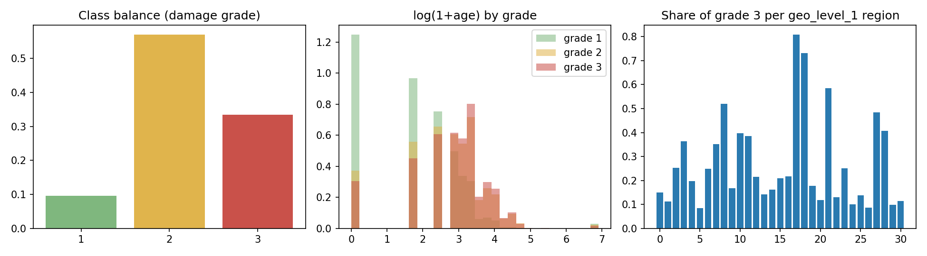
Figure 1. Class balance (left), log(1+age) by grade (middle) and share of grade-3 buildings per geo_level_1 region (right).
- Imbalance: grade 1 / 2 / 3 = 9.6 / 56.9 / 33.5 %, identical in the 20,000-row subsample.
- Geography is a strong but nominal signal: the grade-3 share per level-1 region ranges from 8.6 % (region 5) to 80.8 % (region 17). The ids are labels, not quantities, and the 11,595 level-3 ids (median 14 buildings, 27.6 % with five or fewer) cannot be one-hot encoded sensibly.
- Structure matters: 56.8 % of buildings on foundation type "i" are grade 1 and only 2.1 % grade 3 (37.8 % grade 3 on type "r"); engineered reinforced-concrete buildings are grade 3 in 1.8 % of cases against 34.0 % for the rest; younger buildings are over-represented in grade 1.

2.1 Is the 20,000-row subsample representative?
Because most experiments run on 20,000 rows (7.7 % of the data), we first check that the subsample reproduces the distributions of the full file, and where it cannot. It is a class-proportional random sample (seed 42), so marginal distributions should match; the open question is the geographic structure, because the target encoding learns one estimate per region.
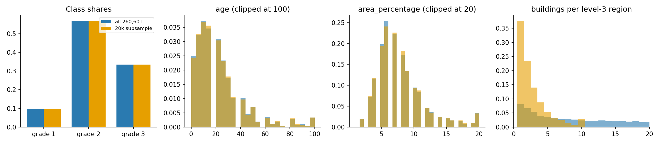
Figure 2. Subsample (orange) versus all rows (blue): class shares, building age, footprint area and the number of buildings per level-3 region (the last panel is on a density scale, so the sparsity of the subsample is visible).
Table 1. Subsample versus full data. KS = two-sample Kolmogorov–Smirnov statistic (all p > 0.1, i.e. no detectable difference).
Quantity | All 260,601 | 20k subsample | KS / |diff|
Grade 1 / 2 / 3 share | 9.6 / 56.9 / 33.5 % | 9.6 / 56.9 / 33.5 % | 0.000
floors (mean) | 2.13 | 2.13 | 0.0035
age (median) | 15.00 | 15.00 | 0.0025
area % (mean) | 8.02 | 8.01 | 0.0087
height % (mean) | 5.43 | 5.45 | 0.0024
families (mean) | 0.98 | 0.98 | 0.0007
8 categorical attributes: largest level-share gap | – | – | 0.78 %
22 binary flags: largest share gap | – | – | 0.34 %
Level-1 regions present / grade-3 share correlation | 31 | 31 | r = 0.995
Level-2 regions present (median buildings) | 1,414 (121) | 1,239 (11) | –
Level-3 regions present (median buildings) | 11,595 (14) | 7,076 (2) | –
Level-3 regions with ≤ 5 buildings | 27.6 % | 89.2 % | –
Buildings living in such regions | 3.1 % | 66.7 % | –
Test buildings whose level-3 region is unseen in training (80/20) | 0.5 % | 17.3 % | –

Marginals are preserved, geography is not. Class shares, all five numeric attributes (KS ≤ 0.0087), the eight categorical attributes (largest level-share gap 0.78 %) and the 22 flags (gap 0.34 %) are statistically indistinguishable. The coarse geography also survives: all 31 level-1 regions are present and their grade-3 shares correlate at r = 0.995 with the full-data values. The fine geography does not. Random sampling thins every region by a factor of 13: the median level-3 region drops from 14 to 2 buildings, 89 % of the regions that are present have five buildings or fewer (28 % in the full data), and 67 % of the buildings sit in such regions (3 % in the full data). In a 5-fold split of the subsample 17.3 % of the test buildings have a level-3 region that never occurs in training; with all rows that share is 0.5 %. Since the level-3 target encoding is the strongest feature group, the subsample is a pessimistic test bed for it: its estimates are noisier and fall back to the parent region far more often. We therefore expect absolute scores to rise on the full data, and Section 6 shows that they do, with the largest gains for the models that use the encoding best.

3. Experimental protocol
- Data: one fixed-seed (42) class-proportional subsample of 20,000 buildings for the main comparison (exact SVMs, forests and nested tuning scale poorly; the choice is ours, not a course rule). The methods that scale are repeated on all 260,601 rows (Section 6); Section 2.1 checks how representative the subsample is and Section 6.3 gives learning curves.
- Resampling: stratified 5-fold CV repeated 3 times (15 runs), identical splits for every method, so comparisons are paired. Mean ± std (n − 1) is reported; the full-data runs use 5-fold CV once (5 runs).
- Metrics: accuracy, macro-F1, per-class precision/recall/F1 and confusion matrices (summed over runs, row-normalised).
- Significance: paired t-test and the Nadeau–Bengio corrected resampled t-test, t = mean(d) / sqrt((1/k + n_test/n_train) var(d)), df = k − 1, because repeated-CV runs share data. We rely on corrected p-values; k = 15 (main) or 5 (full data).
- No leakage: every learned component lives in a scikit-learn Pipeline refitted on the training part of each fold (Table 2). Target encoding is out-of-fold inside the training fold.
Table 2. Learned components and where they are fitted ("training fold" = training part of the current outer split only).
Component | Fitted on | Safeguard
One-hot encoder, standard scaler | Training fold | Unseen levels map to zero; test data uses training statistics
Hierarchical target encoder (geo ids) | Training fold | Inner 5-fold out-of-fold for training rows; unseen regions fall back to the parent region
PCA, mutual-information / Fisher selection | Training fold | Refit in every fold
Class weights, SVM / forest / MLP parameters | Training fold | Class weights computed from training labels
Hyper-parameters (tuned models) | Inner 3-fold CV in each training fold | Nested CV: the outer test fold is never seen by the search

4. Methods

4.1 Feature extraction
Hierarchical smoothed target encoding. For region r at level l let n_r be the number of training buildings and n_{r,k} the number with grade k. The shrunk class probability is
p_l(k | r) = ( n_{r,k} + α · p_{l−1}(k | parent(r)) ) / ( n_r + α ), α = 20, p_0 = global class prior
so a sparse level-3 region borrows from its level-2 and level-1 parents, and an unseen region falls back to its parent. We use P(grade 1) and P(grade 3) at each level (six dense features). Training rows are encoded out-of-fold (inner 5-fold) so that no row is encoded with its own label; test rows use maps fitted on the whole training fold (cf. Micci-Barreca, 2001). Engineered features: log age, age-unknown flag, area × height, area / height, floors × height, height per floor, counts of materials and secondary uses, reinforced-concrete and mud/stone flags. Projection and selection: PCA keeping 95 % of the variance, and top-20 filters by mutual information and by Fisher score, applied after encoding ("te_eng" = target encoding + engineered features).

4.2 Models
Decision tree (depth 10, 20 samples per leaf); random forest (300 trees, at least 2 samples per leaf); SVM with RBF (C = 1, gamma = "scale"), polynomial (degree 2, 3, coef0 = 1) and sigmoid kernels; linear models: softmax logistic regression (C = 0.3), linear SVM (C = 0.05), ridge classifier (α = 10), SGD (hinge, modified Huber; α = 0.001) and perceptron; MLPs (one to three hidden layers, ReLU / tanh / logistic, optional L2; early stopping), used only as a deep-learning reference. Features are standardised; categoricals are one-hot encoded. "Raw" means the geographic ids are passed as plain numbers; every other pipeline uses the target encoding.

4.3 Modifications of the classical methods
Class-balanced training. Each class receives weight w_k = n / (3 n_k) in the loss (class_weight = "balanced_subsample" for the forest and "balanced" for the SVMs, logistic regression and linear SVM). Because grade 1 is only 9.6 % of the data, the accuracy-optimal rule gives it a high threshold; balancing moves the boundary towards the rare class, which is what macro-F1 rewards. Nested-CV tuning. For eight models a 3-fold grid search (macro-F1) runs inside every outer training fold; the winner is refitted and scored on the outer test fold, so reported scores estimate "tune, then deploy". Grids: SVM C × gamma (RBF) or C × degree (polynomial), linear SVM and logistic regression C × class weight, tree depth × leaf size, forest depth × leaf × max-features, MLP width × alpha, Nystroem gamma × C.

5. Results on the 20,000-row subsample
All values are mean ± std over 15 runs; MF1 = macro-F1; Rec 1 = recall of the rare grade-1 class; s = seconds for the 15 runs.

5.1 Model families
Table 3. All five model families on the 20,000-row subsample (TE+eng = target encoding + engineered features unless "raw").
Model | Accuracy | Macro-F1 | Rec 1 | s
Decision tree, raw (best raw baseline) | 0.661 ± 0.006 | 0.581 ± 0.009 | 0.370 | 1
Decision tree, TE+eng | 0.688 ± 0.009 | 0.609 ± 0.013 | 0.388 | 4
Random forest | 0.714 ± 0.005 | 0.640 ± 0.008 | 0.398 | 83
Random forest, balanced | 0.708 ± 0.006 | 0.658 ± 0.007 | 0.544 | 87
SVM-RBF, raw | 0.612 ± 0.004 | 0.477 ± 0.009 | 0.247 | 98
SVM-RBF, TE+eng | 0.710 ± 0.005 | 0.621 ± 0.009 | 0.350 | 322
SVM-RBF, balanced | 0.663 ± 0.005 | 0.633 ± 0.006 | 0.781 | 372
SVM polynomial degree 2 | 0.710 ± 0.005 | 0.626 ± 0.007 | 0.372 | 293
SVM sigmoid | 0.613 ± 0.007 | 0.545 ± 0.011 | 0.417 | 201
Logistic regression | 0.715 ± 0.006 | 0.641 ± 0.009 | 0.405 | 2
Logistic regression, balanced | 0.671 ± 0.005 | 0.641 ± 0.006 | 0.770 | 2
Linear SVM | 0.710 ± 0.005 | 0.629 ± 0.007 | 0.374 | 13
Linear SVM, balanced | 0.700 ± 0.004 | 0.656 ± 0.006 | 0.628 | 14
Perceptron | 0.634 ± 0.035 | 0.564 ± 0.031 | 0.429 | 1
MLP 128-64, raw (reference) | 0.617 ± 0.007 | 0.522 ± 0.018 | 0.341 | 43
MLP 128-64, TE+eng (reference) | 0.710 ± 0.004 | 0.635 ± 0.011 | 0.408 | 47
MLP 128-64, L2 (reference) | 0.711 ± 0.004 | 0.643 ± 0.011 | 0.441 | 12

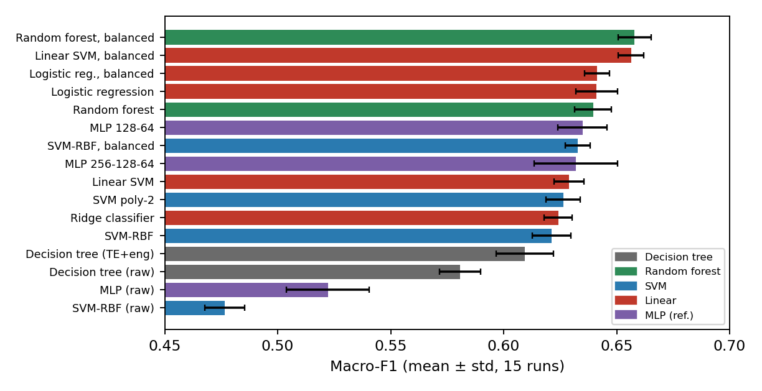
Figure 3. Macro-F1 (mean ± std over 15 runs) of the main models, coloured by family.
The best raw baseline is a decision tree (MF1 0.581). The balanced random forest is best overall (0.658 ± 0.007, +0.077, corrected p = <0.001). It is statistically tied with the balanced linear SVM (0.656; difference 0.002, p = 0.586), which needs 14 s instead of 87 s. Accuracy is almost flat across good models (0.70–0.715); the separation between them is in grade 1. Flexibility does not pay on 20,000 rows: the RBF-SVM (0.621), polynomial SVMs (≈0.625) and MLPs (0.632–0.643) are no better than plain logistic regression (0.641) and clearly below the balanced forest (p ≤ 0.002 against the balanced RBF-SVM and the MLP); the sigmoid kernel (0.545) and the perceptron (0.564) are unsuitable.

5.2 Feature extraction (RQ1)
Table 4. Ablation: macro-F1 as feature steps are added (steps after "+ TE + engineered" are applied on top of it; "–" = not run).
Feature set | SVM-RBF MF1 | SVM-RBF acc. | Tree MF1 | Tree acc.
raw ids | 0.477 | 0.612 | 0.581 | 0.661
+ engineered features | 0.488 | 0.612 | – | –
+ target encoding | 0.618 | 0.709 | 0.610 | 0.690
+ TE + engineered | 0.621 | 0.710 | 0.609 | 0.688
+ MI top-20 | 0.627 | 0.709 | 0.613 | 0.689
+ Fisher top-20 | 0.630 | 0.709 | 0.613 | 0.688
+ PCA 95 % | 0.610 | 0.700 | 0.588 | 0.672

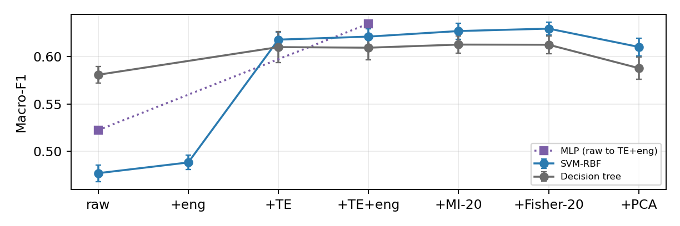
Figure 4. Ablation of the feature steps (macro-F1, mean ± std); the MLP is shown for raw versus TE+eng only.
Target encoding is the dominant step. Replacing the three raw ids by six out-of-fold regional probabilities raises macro-F1 by +0.141 for the SVM (accuracy 0.612 → 0.709), by +0.113 for the MLP (0.522 → 0.635) and by +0.029 for the tree (p = 0.008); the SVM and MLP use integer ids poorly, whereas a tree can split on them directly, hence its smaller gain. Engineered features alone change the SVM by only +0.011 and add at most 0.003 on top of encoding. Selection gives small gains for the SVM (MI-20 +0.006, p = 0.141; Fisher-20 +0.008) and none for the tree. PCA hurts (SVM -0.011, p = <0.001; tree −0.022): it keeps directions of high variance, mostly one-hot and flag columns that say little about damage.

5.3 Class balancing and tuning (RQ2)
Table 5. Effect of class-balanced training (20,000 rows, 15 runs): plain → balanced.
Model | MF1 plain → bal. | Δ MF1 | p (corr.) | Rec 1 | Accuracy
Random forest | 0.640 → 0.658 | +0.018 | <0.001 | 0.398 → 0.544 | 0.714 → 0.708
SVM-RBF | 0.621 → 0.633 | +0.012 | 0.035 | 0.350 → 0.781 | 0.710 → 0.663
Linear SVM | 0.629 → 0.656 | +0.027 | <0.001 | 0.374 → 0.628 | 0.710 → 0.700
Logistic regression | 0.641 → 0.641 | +0.000 | 0.981 | 0.405 → 0.770 | 0.715 → 0.671

Balancing raises grade-1 recall in every model (e.g. SVM 0.35 → 0.78) at the cost of accuracy and of grade-1 precision, so it improves macro-F1 only where the gain in recall outweighs the loss in precision: significantly for the forest (+0.018) and the linear SVM (+0.027), marginally for the SVM-RBF (+0.012, p = 0.035), and not at all for logistic regression (+0.000), whose grade-1 precision drops as much as recall rises. The forest is the only model that gains macro-F1 while losing under 1 point of accuracy (0.714 → 0.708).
Table 6. Nested-CV tuning: macro-F1 before and after (15 outer runs); p is the corrected paired test. Highlighted = significant gain.
Model | Untuned MF1 | Tuned MF1 | Gain | p (corr.)
Linear SVM (OvR) | 0.629 | 0.657 | +0.028 | <0.001
Decision tree depth 10 | 0.609 | 0.630 | +0.021 | 0.003
Nystroem RBF + logistic reg | 0.617 | 0.635 | +0.018 | 0.002
SVM RBF | 0.621 | 0.627 | +0.005 | 0.052
MLP 128-64 relu | 0.635 | 0.638 | +0.003 | 0.652
SVM polynomial deg 2 | 0.626 | 0.626 | -0.000 | 0.984
Logistic regression (softmax) | 0.641 | 0.639 | -0.002 | 0.695
Random forest | 0.640 | 0.636 | -0.003 | 0.396

Tuning helps models whose defaults were poor: the linear SVM (+0.028; strong regularisation C = 0.01 with balanced weights was selected most often), the depth-10 tree (+0.021; depth 4 with 50 samples per leaf chosen most often, i.e. a much simpler tree) and Nystroem-RBF (+0.018). It does not help the RBF-SVM (+0.005, p = 0.052), polynomial SVM, MLP or logistic regression, and is slightly negative for the random forest (−0.003), where the inner 3-fold search plausibly over-fits its own scoring noise. It is expensive: 4,289 s for the RBF-SVM and 3,237 s for the forest, against 87 s for a single balanced forest that beats every tuned model.

5.4 Per-class performance and significance
Table 7. Per-class precision (P) and recall (R), mean over 15 runs.
Model | P 1 | R 1 | P 2 | R 2 | P 3 | R 3
Decision tree (raw) | 0.538 | 0.370 | 0.673 | 0.801 | 0.662 | 0.507
Random forest, balanced | 0.556 | 0.544 | 0.733 | 0.777 | 0.705 | 0.637
Linear SVM, balanced | 0.494 | 0.628 | 0.744 | 0.747 | 0.701 | 0.642
MLP 128-64 (reference) | 0.609 | 0.408 | 0.712 | 0.832 | 0.730 | 0.589
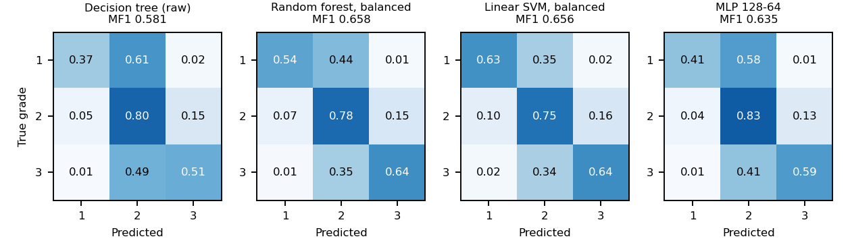
Figure 5. Row-normalised confusion matrices (summed over 15 runs).
Grade 1 is the hard class for every model: the raw tree finds only 37 % of low-damage buildings, the plain models 35–44 %, the balanced forest 54 % and the balanced linear SVM 63 %. Most errors are between adjacent grades (1 ↔ 2 and 2 ↔ 3); grade-1 and grade-3 buildings are rarely confused with each other (at most 2.3 % of grade-1 buildings are labelled grade 3 and at most 2.2 % of grade-3 buildings grade 1 for the four models shown).
Table 8. Selected comparisons on the 20,000-row subsample (15 paired runs, macro-F1). Positive = first method better.
Comparison | Mean diff. | p (paired) | p (corrected)
Balanced random forest vs raw decision tree | +0.077 | <0.001 | <0.001
Target encoding: SVM-RBF on TE vs raw | +0.141 | <0.001 | <0.001
Target encoding: tree on TE vs raw | +0.029 | <0.001 | 0.008
Feature extraction: MLP on TE+eng vs raw | +0.113 | <0.001 | <0.001
Mutual-information top-20 vs none (SVM-RBF) | +0.006 | 0.004 | 0.141
PCA 95 % vs none (SVM-RBF) | -0.011 | <0.001 | <0.001
Balancing: random forest | +0.018 | <0.001 | <0.001
Balancing: SVM-RBF | +0.012 | <0.001 | 0.035
Balancing: linear SVM | +0.027 | <0.001 | <0.001
Balancing: logistic regression | +0.000 | 0.958 | 0.981
Balanced RF vs balanced linear SVM | +0.002 | 0.244 | 0.586
Balanced RF vs balanced SVM-RBF | +0.025 | <0.001 | <0.001
Balanced RF vs MLP | +0.023 | <0.001 | 0.002
Balanced RF vs decision tree (TE+eng) | +0.048 | <0.001 | <0.001

5.5 Cost versus accuracy
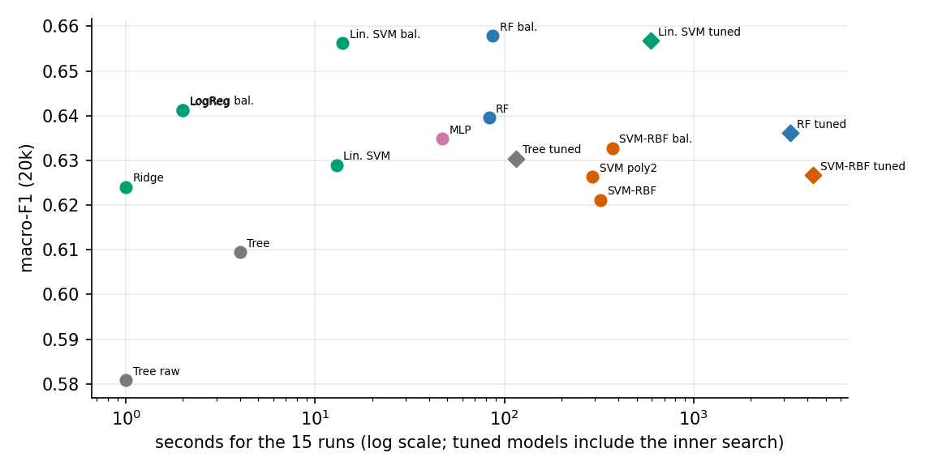
Figure 6. Macro-F1 versus run time (15 runs, log scale) for representative models of the five families on 20,000 rows; diamonds are nested-CV tuned models, which include the inner search.
The cheap models sit on the efficient frontier: a balanced linear SVM (14 s for 15 runs) matches the balanced forest (87 s) and every kernel or neural alternative, while nested tuning moves the same models two orders of magnitude to the right (the tuned RBF-SVM took 4,289 s) without lifting them above the untuned balanced forest. Within each family the cheapest balanced variant is therefore the sensible default, and the expensive options (kernel SVMs with grid search, MLPs) are justified neither by accuracy nor by macro-F1 on this tabular problem.

6. Confirmation on all 260,601 rows (RQ3)

6.1 Full-data results
The methods that scale were rerun on every building with stratified 5-fold CV (one repeat, five runs per method). The exact RBF-SVM, polynomial SVMs and the tuning grids need days at this size and stay on the subsample; the Nystroem-RBF + logistic regression stands in for a kernel SVM. Corrected tests have little power with five runs, so p-values are indicative.
Table 9. Full-data results (260,601 rows, 5 runs). MF1 20k = same model on the subsample; gain = full − 20k.
Model | Accuracy | Macro-F1 | MF1 20k | Gain | Rec 1
Random forest, balanced | 0.742 ± 0.002 | 0.707 ± 0.003 | 0.658 | +0.049 | 0.669
Linear SVM, balanced | 0.725 ± 0.002 | 0.686 ± 0.003 | 0.656 | +0.030 | 0.694
MLP 128-64, TE+eng (reference) | 0.741 ± 0.002 | 0.686 ± 0.004 | 0.635 | +0.051 | 0.513
Logistic regression | 0.738 ± 0.002 | 0.674 ± 0.004 | 0.641 | +0.033 | 0.464
Nystroem-RBF + logistic reg. (kernel approx.) | 0.735 ± 0.001 | 0.671 ± 0.003 | – | – | 0.469
Logistic regression, balanced | 0.699 ± 0.002 | 0.671 ± 0.002 | 0.641 | +0.029 | 0.810
Decision tree, TE+eng + Fisher-20 | 0.733 ± 0.001 | 0.674 ± 0.004 | 0.613 | +0.062 | 0.495
Decision tree, TE+eng | 0.732 ± 0.002 | 0.672 ± 0.006 | 0.609 | +0.063 | 0.483
Decision tree, TE+eng + PCA | 0.719 ± 0.001 | 0.650 ± 0.004 | 0.588 | +0.062 | 0.441
MLP 128-64, raw (reference) | 0.680 ± 0.002 | 0.611 ± 0.005 | 0.522 | +0.088 | 0.419
Decision tree, raw (baseline) | 0.685 ± 0.001 | 0.604 ± 0.009 | 0.581 | +0.023 | 0.356

Table 10. Significance on the full data (5 paired runs).
Comparison | Mean diff. | p (paired) | p (corrected)
Balanced RF vs raw decision tree | +0.103 | <0.001 | <0.001
Balanced RF vs balanced linear SVM | +0.021 | <0.001 | <0.001
Balanced RF vs MLP | +0.021 | <0.001 | <0.001
Balanced RF vs logistic regression | +0.033 | <0.001 | <0.001
Balanced RF vs decision tree (TE+eng) | +0.035 | <0.001 | <0.001
Target encoding: tree on TE vs raw | +0.066 | <0.001 | <0.001
Feature extraction: MLP on TE+eng vs raw | +0.076 | <0.001 | <0.001

What carries over: target encoding remains essential (tree +0.066, MLP +0.076 versus raw; p < 0.001), PCA remains the worst step (tree 0.650 versus 0.672), and the balanced random forest is again best, now by a clear margin: macro-F1 0.707, accuracy 0.742, ahead of the balanced linear SVM (+0.021), the MLP (+0.021), logistic regression (+0.033) and the tree (+0.035), all with corrected p < 0.001. What changes with ten times more data: every model gains 0.02–0.09 macro-F1, most for flexible and under-trained models (MLP +0.051, forest +0.049, tree on TE+eng +0.063) and least for the linear models (+0.03); the MLP now ties the balanced linear SVM (0.686) and beats plain logistic regression, so its earlier deficit was a small-sample effect; and balancing no longer helps logistic regression (0.671 balanced versus 0.674 plain, with accuracy down from 0.738 to 0.699) while it still helps the forest and the linear SVM.

6.2 Side by side: 20,000 rows versus all rows
Figure 7 puts the two protocols next to each other for the models that were run on both (20k: 15 runs; all rows: 5 runs; bars are ± one standard deviation across runs).
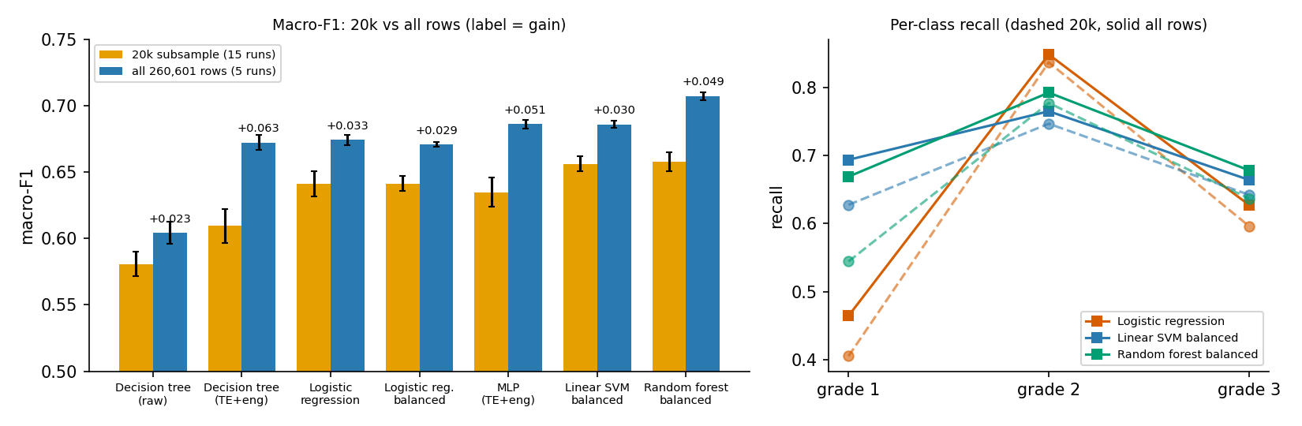
Figure 7. Left: macro-F1 on the subsample and on all rows, with the gain printed above the second bar. Right: per-class recall of three models (dashed = subsample, solid = all rows).
Every model improves, the ranking mostly survives, the spread between models shrinks at the bottom and grows at the top. Gains in macro-F1 are +0.023 for the raw tree, +0.033 for logistic regression, +0.030 for the balanced linear SVM, +0.051 for the MLP, +0.049 for the balanced forest and +0.063 for the tree on encoded features, the largest of all. The pattern follows capacity: models that can exploit the sharper regional estimates (tree and forest on the encoded space, MLP) gain 0.05–0.06, models that mostly add the regional probabilities linearly gain about 0.03, and the raw-id tree gains least (+0.023) because it never sees the encoding. The ordering of the best and worst models is unchanged (balanced forest first, raw tree last), but the middle changes: the tree with target encoding was 0.032 behind logistic regression on the subsample and is within 0.002 of it on all rows, and the MLP rises from fourth to joint second. The gap between the balanced forest and the balanced linear SVM, statistically unresolved on 20k (p = 0.586), becomes +0.021 with all rows. Grade-1 recall also moves: the balanced forest finds 54 % of low-damage buildings on 20k and 67 % on all rows, the balanced linear SVM 63 % and 69 %, while plain logistic regression stays low (41 % and 46 %) and gains accuracy rather than rare-class recall. Fold-to-fold standard deviations of macro-F1 are two to three times smaller on all rows for all models except the raw tree (the test folds are 13 times larger), so differences are measured more precisely per fold even though there are fewer folds.

6.3 Learning curves: how much data is enough?
To see the change with data size continuously, we trained four models on nested stratified training sets of 2,000 to 208,480 rows (the last is 80 % of all data) and scored them on one fixed, stratified 20 % hold-out of 52,121 buildings that is never used for training. Sizes up to 50,000 are averaged over three random draws; larger sizes use one draw. This is a single split, so differences below about 0.005 are not interpretable; the absolute values differ slightly from the cross-validated tables because the test set differs.
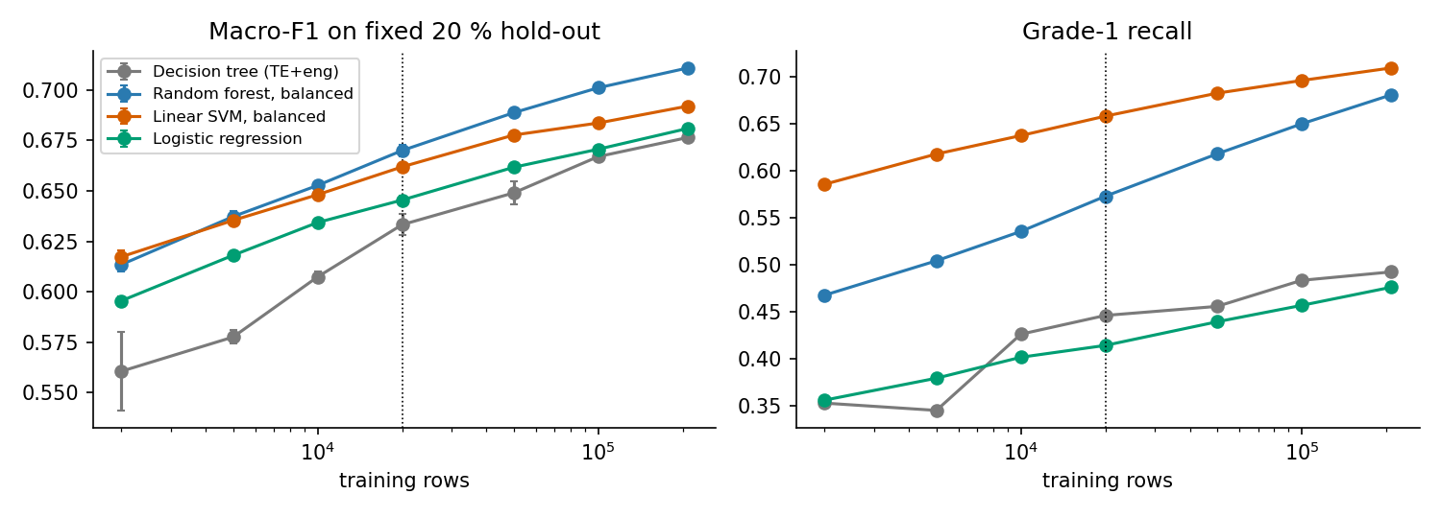
Figure 8. Macro-F1 (left) and grade-1 recall (right) on the fixed hold-out as the training size grows (log axis; dotted line = the 20k size used for most experiments).
Table 11. Macro-F1 on the fixed hold-out versus training size (grade-1 recall in brackets).
Training rows | Decision tree (TE+eng) | Logistic regression | Linear SVM bal. | Random forest bal.
2,000 | 0.561 (0.35) | 0.596 (0.36) | 0.617 (0.59) | 0.613 (0.47)
5,000 | 0.578 (0.35) | 0.618 (0.38) | 0.635 (0.62) | 0.637 (0.50)
10,000 | 0.607 (0.43) | 0.634 (0.40) | 0.648 (0.64) | 0.653 (0.54)
20,000 | 0.633 (0.45) | 0.645 (0.41) | 0.662 (0.66) | 0.670 (0.57)
50,000 | 0.649 (0.46) | 0.662 (0.44) | 0.678 (0.68) | 0.689 (0.62)
1,00,000 | 0.667 (0.48) | 0.671 (0.46) | 0.684 (0.70) | 0.701 (0.65)
2,08,480 | 0.676 (0.49) | 0.681 (0.48) | 0.692 (0.71) | 0.711 (0.68)

Three observations. (i) Nothing has saturated. From 20,000 to 208,480 rows the balanced forest still gains +0.041, the tree +0.043, the linear SVM +0.030 and logistic regression +0.035; the last doubling (100k → 208k) is still worth about +0.01 for the forest. The 20k results are therefore a conservative snapshot, not an asymptote. (ii) The model ranking depends on data size. At 2,000 rows the balanced linear SVM (0.617) is as good as the forest (0.613) and clearly ahead of the tree (0.561); the two are tied up to about 10,000 rows (differences within noise) and the forest pulls ahead from 20,000 rows; its lead grows from +0.008 at 20,000 to +0.019 at 208,480. The tree improves by 0.116 over the whole range, the forest by 0.097, the linear SVM by 0.075 and logistic regression by 0.085: capacity pays only with data. (iii) The two balanced models trade recall differently. Beyond 50,000 rows the balanced linear SVM keeps the higher grade-1 recall (0.71 versus 0.68) but the forest has the higher macro-F1 and the higher accuracy (0.745 versus 0.729); plain logistic regression stays at recall 0.48 at every size. Practical cost: at 208,480 rows one fit takes 33 s for the forest (16 cores) and 59 s for the linear SVM (one core), so the "six times cheaper" advantage of the linear SVM on 20k does not carry over to a multi-core machine.

6.4 What the balanced forest relies on
Impurity importances of the balanced random forest were summed per feature group and compared between a forest fitted on the 20k subsample and one fitted on 80 % of all rows (Table 12). Importances are descriptive only: impurity importance favours continuous, high-cardinality inputs and does not measure causal effect.
Table 12. Share of total impurity importance per feature group (balanced random forest).
Feature group | Fitted on 20k | Fitted on 208k
target-encoded geography | 54.6 % | 58.9 %
engineered | 16.6 % | 14.2 %
categorical (one-hot) | 12.1 % | 11.6 %
numeric (floors, age, area, height, families) | 11.1 % | 10.3 %
superstructure flags | 4.9 % | 4.4 %
secondary-use flags | 0.7 % | 0.6 %

Target-encoded geography carries more than half of the model in both cases (54.6 % on 20k, 58.9 % on all rows) and the four most important single features are all encodings (20k: te_g3_c3 (11.5 %), te_g2_c3 (10.3 %), te_g3_c1 (9.9 %), te_g2_c1 (8.5 %); all rows: te_g3_c3 (13.3 %), te_g3_c1 (12.6 %), te_g2_c3 (10.3 %), te_g2_c1 (9.6 %)). With more data the weight shifts towards the fine levels: the level-3 probabilities of grade 1 and grade 3 rise from 9.9 % and 11.5 % to 12.6 % and 13.3 %, while the level-1 features decrease. This matches Section 2.1: on the subsample most level-3 regions are too small for a reliable estimate, whereas on all rows they carry real information, which is also why encoding-based models gain most from more data. The structural groups (one-hot categoricals, raw numerics, engineered ratios, material flags) share the remaining weight in similar proportions in both fits (the engineered group loses about two points).

6.5 Where the extra data helps: errors by class and region
We fitted the balanced forest on 20,000 rows and on 208,480 rows (both from the training part of the fixed split) and scored both on the same 52,121 hold-out buildings (Figure 9). Accuracy rises from 0.714 to 0.745 and macro-F1 from 0.666 to 0.711. The predicted class distribution also moves towards the truth: grade 1 is predicted for 9.5 % versus 10.9 % of buildings (true share 9.6 %), grade 3 for 29.7 % versus 30.7 % (true 33.5 %) and grade 2 for 60.8 % versus 58.4 % (true 56.9 %). Grade 1 is predicted at about its true share by both models, but the small model over-predicts the majority grade 2 and under-predicts grade 3, and the large model is closer on both. The confusion matrices show that the gain comes from the diagonal of grades 1 and 3 (recall 0.56 → 0.68 and 0.63 → 0.68), while grade-2 recall changes little (0.79 → 0.79).
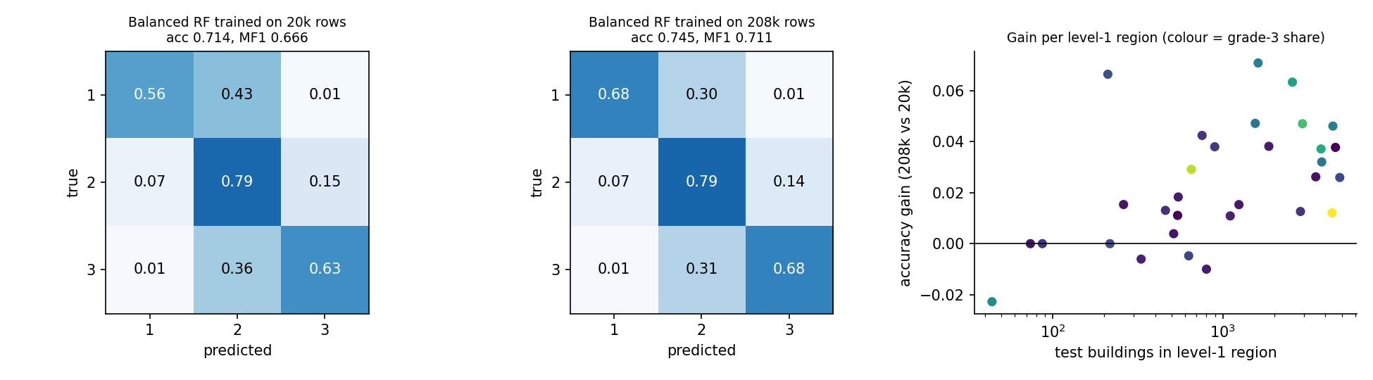
Figure 9. Balanced random forest trained on 20k versus 208k rows and tested on the same hold-out: row-normalised confusion matrices (left, middle) and accuracy gain per level-1 region against its hold-out size (right).
The gain is not uniform across regions. Accuracy improves in 24 of the 31 level-1 regions. In the 15 regions with at least 1,000 hold-out buildings the median gain is +0.037, in the 16 smaller regions only +0.007. Large regions contain many level-2 and level-3 sub-regions whose estimates were noisy at 20,000 rows and become usable with 208,480; small regions plausibly had little additional structure left to learn. This is the regional counterpart of the sparsity measured in Section 2.1.

7. Discussion
Table 13. Answers to the research questions at a glance.
Question | Answer | Evidence
RQ1 Which feature step matters? | Fold-safe hierarchical target encoding of the geo ids; PCA hurts; selection ≈ 0 | SVM +0.141, MLP +0.113, tree +0.029 (20k); tree +0.066 (all rows)
RQ2 Do balancing and tuning help? | Balancing: forest, linear SVM yes; logistic regression no. Tuning: only for poor defaults | Balancing +0.018 / +0.027 / +0.000; tuning +0.028 (linear SVM), +0.021 (tree), −0.003 (forest)
RQ3 Best family, and on all rows? | Class-balanced random forest, on both scales | 0.658 (20k), 0.707 (all rows); corrected p < 0.001 on all rows
RQ4 Is the subsample representative? | Yes for marginals and coarse geography; no for fine geography; learning curves still rising | KS ≤ 0.009; unseen level-3 regions 17.3 % vs 0.5 %; forest +0.04 from 20k to 208k rows

- Why target encoding wins. The geographic ids carry the strongest signal (grade-3 share 8.6 % to 80.8 %) but are nominal labels. Raw integers impose a false order on the SVM, the MLP and the linear models, and one-hot columns for 11,595 regions are mostly empty. Target encoding summarises each region by its local class mix in six dense features. Its hierarchy, smoothing (α = 20) and out-of-fold training encoding keep sparse regions from being trusted too much, so training and test encodings have the same noise level. Its benefit grows with data (tree +0.029 on 20k, +0.066 on all rows) as regions contain more buildings.
- Why PCA fails and selection barely helps. PCA maximises variance, not class separation, so it discards weak but discriminative directions; MI and Fisher filters remove noise columns, but the RBF-SVM already gives them little weight and the tree ignores them, hence gains within noise.
- Why class balancing is model-dependent. Macro-F1 values grade 1 as much as grade 2, whereas accuracy-optimal rules under-predict it. Balancing helps when the base model ranks grade-1 buildings well but is calibrated for the majority (forest, linear SVM, SVM-RBF); for logistic regression recall and precision trade off evenly, so F1 stays flat; at large n flexible models are better calibrated and the benefit shrinks.
- Why the random forest wins. Trees split on nominal-like ids and feature interactions without scaling, the ensemble reduces variance, and balanced weights add grade-1 recall (0.54 on 20k, 0.67 on all rows) while keeping grade-2 and grade-3 recall high. It also benefits most from more data. A strongly regularised linear SVM is almost as good on small data because, after encoding, most of the signal is additive; it is also about six times cheaper.
- Why tuning matters little. It removes bias from poor defaults (linear SVM, tree) but cannot beat sensible ones, and its inner 3-fold scores are noisy. Choosing the right features and decision rule gave far more than hyper-parameter search.
- Deep learning as reference. The MLP is poor on raw features (0.522 / 0.611 on 20k / all rows), gains +0.113 / +0.076 from the same feature extraction, and at best matches the balanced linear SVM on all rows; it never beats the balanced forest (p < 0.003 on both scales). On this tabular problem it offers no advantage over classical pipelines and is the least interpretable.
- What the 20k-versus-260k comparison teaches. The subsample matches the full data in every marginal distribution but has far sparser regions (median level-3 region 2 instead of 14 buildings; 17 % instead of 0.5 % of test buildings in unseen regions), so it understates every model that uses the encoding, most of all the tree, forest and MLP. Rankings at the top are stable, but the forest-versus-linear-SVM tie on 20k becomes a clear forest win with more data, and learning curves have not flattened at 208,480 rows. Conclusions about small differences between models should therefore be read as statements about the data size at which they were measured.
- Recommendation. Target encoding + engineered features, then a class-balanced random forest (best, 0.707 macro-F1 / 0.742 accuracy on all rows) or, on small data or tight budgets, a balanced linear SVM (0.656 in 14 s). Always report macro-F1 and per-class recall, and keep every learned step inside the CV fold.

8. Limitations and conclusion
- Subsample and fixed settings: the main comparison uses 20,000 of 260,601 rows (Section 6 confirms the key findings on all rows); apart from the eight tuned models, hyper-parameters were fixed a priori. Winner selection: "best" is chosen on the same folds it is reported on (slightly optimistic); we therefore test the winner against its rivals. Dependence: repeated CV reuses data (corrected tests used); full-data tests rest on five runs. Scope: one earthquake, nominal classifiers for an ordinal target, five model families. Explanations in Section 7 are consistent with the data but not isolated by separate experiments.
Conclusion. Fold-safe hierarchical target encoding of the geographic ids is the most important pattern-recognition step (macro-F1 +0.03 to +0.14 for every model family), PCA is harmful, and setting the decision rule for macro-F1 through class balancing is the second lever. Together they lift the best raw baseline from macro-F1 0.581 to 0.658 on 20,000 rows and the final model, a class-balanced random forest, to 0.707 (accuracy 0.742) on all 260,601 rows, significantly ahead of the SVMs, linear models and the MLP reference. Future work: exact kernel SVMs on all rows, ordinal-regression losses that respect the order of the grades, tuning of the encoding smoothing, spatial features, and transfer to another earthquake.

References
[1] DrivenData / Kathmandu Living Labs. Richter's Predictor: Modeling Earthquake Damage (data competition), 2019.
[2] Micci-Barreca, D. A preprocessing scheme for high-cardinality categorical attributes. ACM SIGKDD Explorations 3(1), 2001.
[3] Nadeau, C. and Bengio, Y. Inference for the generalization error. Machine Learning 52, 2003.
[4] Breiman, L. Random forests. Machine Learning 45, 2001.
[5] Hastie, T., Tibshirani, R. and Friedman, J. The Elements of Statistical Learning, 2nd ed. Springer, 2009.
[6] Pedregosa, F. et al. Scikit-learn: machine learning in Python. JMLR 12, 2011.

Appendix A. Individual contributions and reproducibility
Work was split into three equal tracks among Sri Harasha Adithya, KVNM Krishnavamsi and Kommi Vishal Venkat Vaibhav; each member presents their own track and commits under their own name.
Member | Track | Responsibilities and personal contribution
[member] | Data, evaluation, baselines | Data loading and EDA; stratified subsample; CV harness; leakage-free pipelines; metrics; raw baselines; integration into main.py; report Sections 1–3. [add personal contribution]
[member] | Feature extraction | Hierarchical out-of-fold target encoding; engineered features; PCA, MI and Fisher selection; ablation; Sections 4.1, 5.2, 7. [add personal contribution]
[member] | Models, balancing, tuning, DL reference | Tree, forest, SVM, linear and MLP families; class balancing; nested tuning; significance tests; full-data run; Sections 4.2–4.3, 5.1, 5.3–5.4, 6. [add personal contribution]
Reproducibility. Python 3.12, scikit-learn 1.6, pandas, NumPy, SciPy, matplotlib (requirements.txt), CPU only. Put train_values.csv and train_labels.csv in data/ and run `python code/main.py` (EDA, tracks, tables, figures; about one hour on 16 cores); `python code/run_ext.py` runs the extended model zoo and nested tuning; `python code/main.py --full` and `python code/full_data.py` run the full-data confirmation. Seed 42 everywhere; finished experiments are cached as JSON in results/. Repository: https://github.com/Krishnavamsi-codes/PR-Project-tbm (public until grades are awarded).

Appendix B. Additional models and tuned variants (20,000 rows, 15 runs)
All models of the five families that are not listed in Table 3, plus the eight nested-CV tuned models. Rec 1–3 are per-class recalls; s is the time for the 15 runs (tuned models include the inner search).
Table 14. Remaining linear, kernel, neural and tuned models.
Model | Accuracy | Macro-F1 | Rec 1 | Rec 2 | Rec 3 | s
Ridge classifier (least squares) | 0.709 ± 0.004 | 0.624 ± 0.006 | 0.358 | 0.841 | 0.585 | 1
SGD linear SVM (hinge) | 0.709 ± 0.006 | 0.621 ± 0.016 | 0.352 | 0.845 | 0.581 | 2
SGD modified Huber | 0.705 ± 0.005 | 0.622 ± 0.024 | 0.387 | 0.831 | 0.583 | 3
Perceptron | 0.634 ± 0.035 | 0.564 ± 0.031 | 0.429 | 0.698 | 0.585 | 1
SVM polynomial deg 3 | 0.708 ± 0.004 | 0.625 ± 0.006 | 0.375 | 0.844 | 0.572 | 210
SVM sigmoid (tanh) kernel | 0.613 ± 0.007 | 0.545 ± 0.011 | 0.417 | 0.680 | 0.556 | 201
Nystroem RBF + logistic reg | 0.707 ± 0.005 | 0.617 ± 0.007 | 0.339 | 0.845 | 0.579 | 10
Nystroem poly-2 + logistic reg | 0.715 ± 0.005 | 0.641 ± 0.007 | 0.412 | 0.836 | 0.595 | 23
MI-20 + degree-2 poly features + logreg | 0.711 ± 0.007 | 0.638 ± 0.008 | 0.418 | 0.832 | 0.588 | 129
MLP 1x64 relu | 0.711 ± 0.003 | 0.638 ± 0.009 | 0.414 | 0.828 | 0.597 | 25
MLP 128-64 tanh | 0.711 ± 0.005 | 0.639 ± 0.011 | 0.426 | 0.831 | 0.589 | 62
MLP 128-64 sigmoid | 0.712 ± 0.005 | 0.641 ± 0.011 | 0.426 | 0.831 | 0.593 | 71
MLP 128-64 relu, L2 alpha=0.1 | 0.711 ± 0.004 | 0.643 ± 0.011 | 0.441 | 0.827 | 0.593 | 12
MLP 256-128-64 relu (deep) | 0.710 ± 0.006 | 0.632 ± 0.018 | 0.391 | 0.826 | 0.605 | 107
Decision tree depth 10 [tuned] | 0.701 ± 0.007 | 0.630 ± 0.010 | 0.433 | 0.820 | 0.575 | 115
Random forest [tuned] | 0.714 ± 0.005 | 0.636 ± 0.009 | 0.389 | 0.839 | 0.593 | 3237
SVM RBF [tuned] | 0.711 ± 0.004 | 0.627 ± 0.006 | 0.370 | 0.852 | 0.568 | 4289
SVM polynomial deg 2 [tuned] | 0.710 ± 0.005 | 0.626 ± 0.006 | 0.371 | 0.855 | 0.563 | 2679
Linear SVM (OvR) [tuned] | 0.700 ± 0.004 | 0.657 ± 0.006 | 0.631 | 0.746 | 0.643 | 596
Logistic regression (softmax) [tuned] | 0.701 ± 0.020 | 0.639 ± 0.007 | 0.504 | 0.781 | 0.623 | 113
MLP 128-64 relu [tuned] | 0.710 ± 0.004 | 0.638 ± 0.010 | 0.422 | 0.830 | 0.588 | 267
Nystroem RBF + logistic reg [tuned] | 0.712 ± 0.005 | 0.635 ± 0.007 | 0.393 | 0.839 | 0.589 | 369

Within the linear family, ridge and the SGD linear SVM are within 0.02 of logistic regression (0.62 versus 0.64); the perceptron and the sigmoid kernel are the weakest models of the study. Polynomial degree 3 does not improve on degree 2, MLP variants (one layer, tanh, logistic, deeper, L2) span only 0.632–0.643, the same range as the 128-64 ReLU network, so none of these extra variants changes any conclusion of Section 5.

Appendix C. Nested-CV tuning: search results
Table 15. Hyper-parameter choices made by the inner 3-fold search (most frequent winner over the outer folds; "times" = number of searches in which it won). Inner F1 is the mean best inner-CV macro-F1.
Model | Inner F1 | Most frequent choice | Times | s / search
Tree | 0.628 | max_depth: 4, min_samples_leaf: 50 | 7/15 | 114
RF | 0.633 | max_depth: null, max_features: sqrt, min_samples_leaf: 3 | 3/15 | 3193
SVM rbf | 0.621 | C: 10, gamma: 0.003 | 11/15 | 2709
SVM poly2 | 0.621 | C: 1, degree: 2 | 9/15 | 1626
LinSVC | 0.651 | C: 0.01, class_weight: balanced | 10/22 | 526
LogReg | 0.634 | C: 0.3, class_weight: null | 7/15 | 110
MLP 128_64 | 0.632 | alpha: 0.01, hidden_layer_sizes: (128, 64) | 4/15 | 256
Nys RBF_LogReg | 0.625 | C: 1.0, gamma: 0.005 | 15/15 | 209

The searches often disagree between folds (the most frequent choice wins between 3 and 15 of the 15 searches; the 22 recorded linear-SVM searches include repeats from a restarted run), which is why tuning gains of a few thousandths cannot be distinguished from noise. The tree most often moves to a much shallower tree (depth 4, 50 samples per leaf); the linear SVM to strong regularisation (C = 0.01) with balanced weights; the forest to unlimited depth with 3 samples per leaf, i.e. close to its default.

