**SOFTWARE**

**REQUIREMENTS**

**SPECIFICATION`**

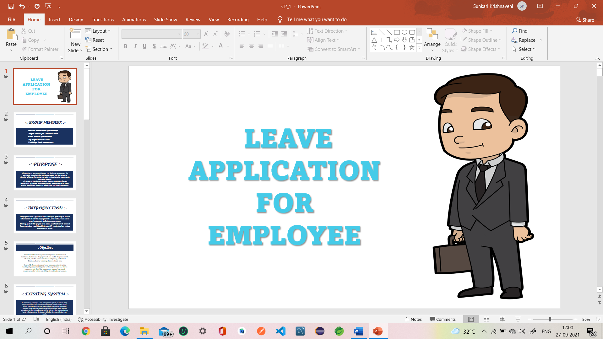



**-: PROJECT TITLE :-**

**EMPLOYEE LEAVE APPLICATION**

**VERSION : 1.0**

**GROUP NO : 3**

**-: GROUP MEMBERS :-**

**190101120014 – Prathikhya Devi**

**190101120027 – Chelli Harika**

**190101120070 – Sunkari Krishnaveni**

**190101120108 – Megha Kumari Jha**

**190101120116 – Raj Aryan**

***CONTENTS***

1. **Introduction**
2. **Purpose**
3. **Scope**
4. **References**
5. **Overview**
6. **Current Product (Existing System)**
7. **Proposed System**
8. **Product Functionality**
9. **Modules of the Project**
10. **Admin module**
11. **Employee module**

**4. Overview of the modules of the Product**

**5. Functional Requirements of the Modules**

**6. Detailed Functional Requirements.**

1. **ADMIN MODULE**
2. **Adding Employee**
3. **Reading Employee data**
4. **Updating Employee**
5. **Deleting Employee**
6. **Accepting or Rejecting Leave**
7. **Monitoring Employee Activities**
8. **Analytical Report of the Leaves**
9. **EMPLOYEE MODULE**
10. **View Profile**
11. **Apply leave**
12. **Cancel leave till Approval of leave by Admin**
13. **View Leave Dashboard**

**7. Non-Functional Requirements**

**8. Operating Environment**

1. **Hardware**
2. **Software**
3. **Network**

**9. Control Flow of the Application**

**10. Use cases**

**i. Admin Login**

**ii. Employee Login**

**iii.Employee Leave Application**

1. **Approval/ Rejection of Leave**

**11. Conclusion**

**-: INTRODUCTION :-**

**An Employee Leave Application is a web-based and android-based application that automates every step of the employee leave management process without compromising on functionality. Unlike on-premise leave management tools, an online leave management system gives employees the freedom to apply, approve, reject, and manage leave requests from any place, any time, and from any device.**

**Employee Leave Application was developed primarily to handle information about the employee and Leave Status. That serves as an instrument for better management.**

**The key goal of this project is to create an effective web-enabled framework that would be able to simplify workplace knowledge and management needs.**

**PURPOSE**

**The Employee Leave Application was designed to automate the Employee administration, management and the strategic planning of leaves for employees. This application also manages the Employee records.**

**It is meant to simplify the current manual framework for fast information collection, produce statistical reports and act as a data archive for efficient sharing of information and possible retrieval.**

**SCOPE**

**Scope of this project is limited to any particular organisation rather than used by a single person.**

**REFERENCES**

[**https://www.scribd.com/document/373512722/Employee-Leave-Management-System**](https://www.scribd.com/document/373512722/Employee-Leave-Management-System)

[**https://projectsgeek.com/2016/01/employee-leave-management-system.html**](https://projectsgeek.com/2016/01/employee-leave-management-system.html)

**https://www.phptpoint.com/projects/employee-leave-management-system-project-download**

**-: OVERVIEW :-**

**EXISTING SYSTEM**

**In the existing Employee Leave Management System, in almost every organization and firm, whenever an employee enters into the office, he/she has to either mark the attendance by themselves or else the manager came and take attendance which sometimes leads to extra attendance or short attendance as well as it is very time consuming too. In the existing system, the chances of losing the records are also very high.**

**And whenever an employee wants to apply a leave, he/she has to submit a hard copy of their leave request. They have to wait for their higher officials’ permission to know whether their leave request has been approved or cancelled. This is a long and time taking process.**

**PROPOSED SYSTEM**

**In the new proposed Employee Leave Application all the data is being maintained into the server as well regular updation will also takes place. In case, if there is some holiday, then the data is being updated automatically under well-defined graphical user interface and thus this software also makes the work load less for the department and management class as well as make easy access to the information for the authorized persons.**

**If an employee wants to apply for a leave, he/she can login into their profile and can apply for a leave by mentioning the purpose anytime rather than submitting a hard copy (paper type) in higher officials’ cabin. They can also view their leave application status in their “Apply Leave Interface”. This will also reflect in their “Leaves left” data.**

**PRODUCT FUNCTIONALITY**

**Some major product functionalities of the system are as follows:**

* **Information about the employee attendance**
* **Check for Leave Availability**
* **Maintain Employee leave record.**
* **Apply for leave**
* **Approve or reject leave application.**

**-: MODULES OF THE PROJECT :-**

**ADMIN MODULE**



**EMPLOYEE MODULE**



**-: OVERVIEW OF THE MODULES OF THE PROJECT :-**

**1) The Admin Module includes the following activities:**

1. **Adding Employee**
2. **Reading Employee data**
3. **Updating Employee**
4. **Deleting Employee**
5. **Accepting or Rejecting Leave**
6. **Monitoring Employee Activities**
7. **Analytical Report of the Leaves**

**2) The Employee Module includes the following activities:**

**a) View Profile**

**b) Apply leave**

**c) Cancel leave till Approval of leave by Admin**

**d) View Leave Dashboard**

**-: FUNCTIONAL REQUIREMENTS OF THE MODULES :-**

**1) Admin Module:**

* **Username and Password are required for Login**
* **Add Employee record**
* **Update Employee record**
* **Remove Employee record**
* **Keep Employee Records**
* **Notice Records**
* **Display Leave History**
* **Accept or reject leave based on the employee request and this will reflect into Employee’s leave status.**

**2) Employee Module:**

* **Employee can Login through their Credentials.**
* **Employee can enter the details of leave like start date, end date, purpose of leave.**
* **View the leave status.**
* **Can monitor his sanctioned leaves, leaves left to be taken, rejected leaves in his profile.**

**-: DETAILED FUNCTIONAL REQUIREMENTS :-**

1. **Admin Module:**

**Admin will log in to use our Leave Application to perform various functionalities.** **Admin accepts/rejects the request of an employee after evaluating their work performance. Admin is the main person who can manage everything (In our project, we will treat our Officials like HOD & DEAN as admins).**

**Firstly, the admin will log in and verify the employee leave requests list, their performance, monitors employee status, and he is the one who will grant/reject the leave to employees.** **After logging in to the system admin gets the request of Employees as “Leaves applied notifications”. In that interface, the admin gets two options as “ACCEPT” or “REJECT”. After evaluating the employee’s performance, Admin can accept or reject depending on their eligibility.**

**If admin accepts the request, then a unique id of the employee and his/her leave count will be generated by the system, and those details will be added to the database. Depending on the selection of Accept/Reject, a confirmation mail will be delivered to the respective Employee.**

1. **Admin Login:**

**An admin inputs his secure user id and password to enter into the application. The admin can log in multiple times as many times he wants.**

1. **Adding Employee:**

**Admin can add any employee at any time without asking any kind of permission from anyone. He has all rights to do anything according to their role terms.**

**Admin can add an employee information consisting of his/her personal details like Name, Father Name, Email id, Contact Number, role, age, and address of the employee as well as his/her assigned work details like Campus, Department and Branch.**

1. **Reading Employee:**

**Admin can read all employee details and leave status. So, he can monitor the employee performance like attendance, leaves taken.**

1. **Updating Employee:**

**Admin can update the employees’ details like his personal info and if needed leave status also.**

1. **Remove Employee:**

**Admin can delete any employee at any time. He has access to do the modifications.**

1. **Accepting or Rejecting Leave:**

**Admin can see the employees leave applications with their particular reasons. If the reasons were perfect and if admin is satisfied with that, then he will grant permission to take leave; if not he will reject the leave.** **Admin accepts/rejects the request of Employee after evaluating certain criteria.**

1. **Keep Records:**

**Admin have the right to access the database of Employee information and Leave applications. So, he can check the performance of the employee and his leave profile etc.**

**If the employee leaves limit hasn’t reached, then he can approve the leave request easily. If the leave limit has reached, then based on the employee leave purpose, admin decides whether he has to approve or reject the leave.**

1. **Monitoring Employee Activities:**

**Admin can monitor every employee activity. Admin can Add, Update, Remove & Delete any employee information.**

1. **Analytical Report of the Leaves:**

**Admin can access the leave report of every employee. Admin have the entire leave details of employees like how many days the employee is in leave, what is the purpose of the leave, how many leaves the employee requested/rejected/granted.**

1. **Employee Module:**

**An employee uses his username and password to log in to our Leave Application. Those details will be authenticated on the server side. Then the system navigates to the** **dashboard where the employee can do the desired operation like editing his profile, Attendance, Apply for Leave, Logout. If an employee wants to apply for leave, then he has to fill in the details like Reason, Start date, End date. After entering the leave details into the database, a message should be displayed as “Applied successfully”.**

**The leave application status will be handled by the admin. Depending upon the admin's decision, the employee's leave status will be changed.**

1. **Employee Login:**

**The employee inputs his secure user id and password and enters his profile after authentication. The employee can log in 20 times per day.**

1. **View Profile:**

**Employee can visit his profile but he has no access to modify anything. He just able to view the profile.**

1. **Apply Leave:**

**Here is the module for applying leave. Employee has to choose the dates of the leave, fill the purpose. Depending upon the user’s account and policy of the college, admin will handle the leave applications.**

1. **Leave review:**

**After successful submission of the leave application, it will come under scrutiny done by an admin. According to his need, he will review it and take necessary action in the next module.**

1. **Leave approval:**

**Here the leave status will appear as “Accepted” when the admin accepts the request. Until, employees can see only their leave requests there and all the real-time updates will be shown to the employees.**

1. **Leave Dashboard:**

**Employee can see working days, leave status like granted leaves, rejected leaves etc. He can see how many leaves are pending in the particular year.**

1. **Logout:**

**At the end, the employee can log out the application to release the resources held for the purpose of anything else.**

**-: NON-FUNCTIONAL REQUIREMENTS :-**

* **The user should register in the portal with his own set of attributes as required in the entity attributes.**
* **Then the user can log in with his credentials.**
* **The user should be able to enter all the details of the leave.**
* **He can apply for leave by entering into the "Apply Leave" interface, picking the date from date pickers, and filling the required attributes in that.**
* **Now he can confirm the leave request then the applied leave notification goes to the admin panel.**
* **Here admin has the option to see the pending requests and other approved requests.**
* **The same changes are reflected in the other interfaces too.**

**-: OPERATING ENVIRONMENT :-**

**i) Software Requirements:**

**-: CODE DEVELOPMENT :-**

**Frontend:**

**Visual Studio Code**

**Backend:**

**Spring Tools Suite IDE – 4.11.0**

**or Eclipse Java EE IDE**

**Mobile Application:**

**Android Studio**

**-: SERVER :-**

**Tomcat Server**

**-: DATABASE :-**

**MySQL**

**ii) Hardware Requirements:**

* **Processor - intel i3 or i5**
* **Operating system - Windows 7,8,10**
* **Ram**
* **1GB (minimum)**
* **2 GB (recommended)**
* **Hard Disk – 30 GB (required)**

**iii) Languages Used:**

* **REACT JS**
* **ADVANCED JAVA**
* **SPRING FRAMEWORK**

**-: CONTROL FLOW OF THE PROJECT :-**

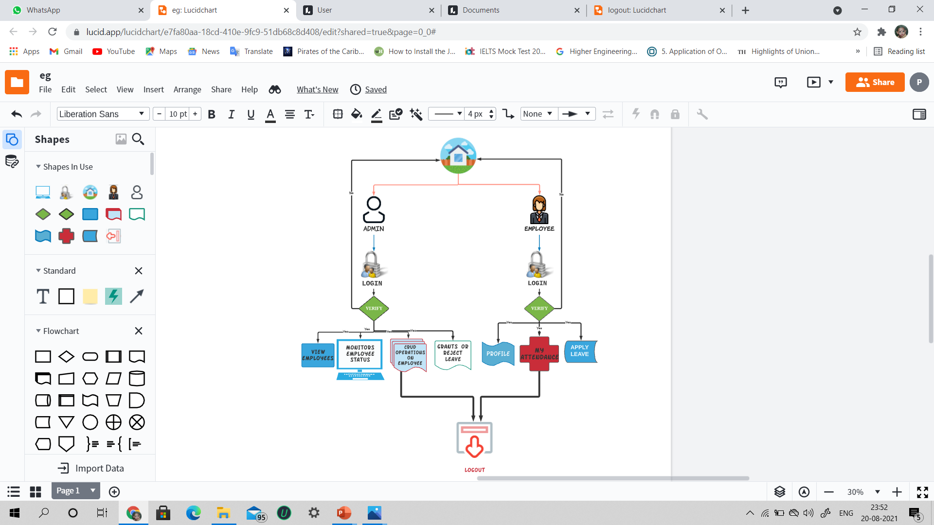

**-: USECASES :-**

**i) ADMIN Login**

**ACTIVITY DIAGRAM**

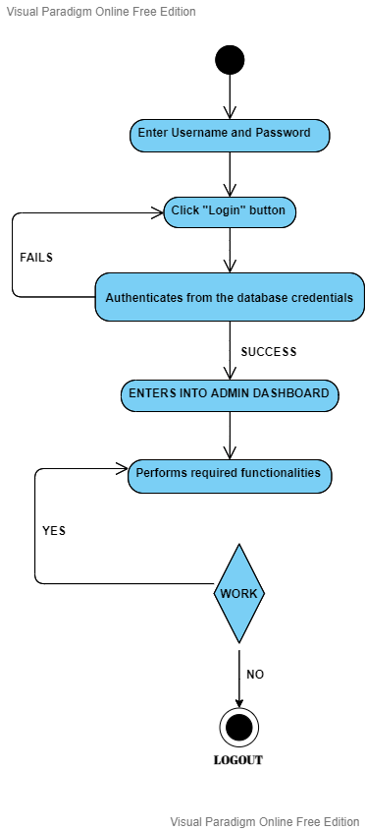

|  |  |
| --- | --- |
| **Use case id: 1** | **Use case name: Admin Login** |
| **Description** | 1. Admin will login to the application through any browser or any android device for performing their work. 2. It is mandatory to login to access the application and its functionalities. |
| **Actor** | Admin |
| **Pre-conditions** | Admin details will be authenticated and authorized |
| **Post-conditions** | Admin will be logged in |
| **Frequency of Use** | 40 per day |
| **Normal Course of Events** | 1. Admin will login to the Leave application through browser or android device 2. System prompts for username and password. 3. Admin submits the username and password for the authentication in server-side. 4. Then the system navigates to the dashboard where the admin can do the desired operation. |
| **Alternative Courses** | 1. Will be redirected to the home page. 2. Application sends an alert message to the real admin’s mail id and linked higher officials mail id’s. |
| **Associated**  **Use case diagram** |  |
| **Exceptions** |  |
| **Special Requirements** |  |
| **Assumptions** |  |
| **Test Plan Outline** |  |
| **Notes & Issues** |  |

**ii) Employee Login**

**ACTIVITY DIAGRAM**

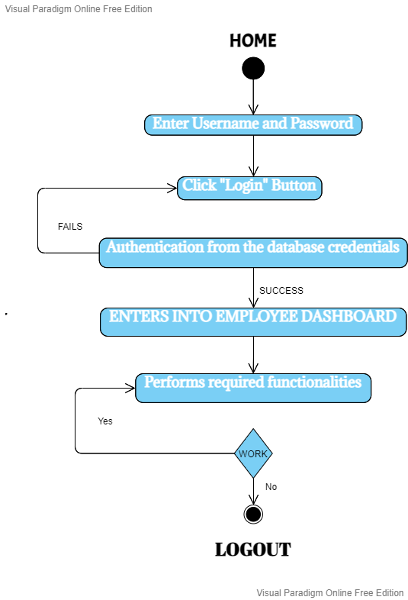

|  |  |
| --- | --- |
| **Use case id: 2** | **Use case name: Employee Login** |
| **Description** | 1. Employee will login to the application through any browser or any android device for applying leave. 2. It is mandatory to login to access the application and its functionalities. |
| **Actor** | Employee |
| **Pre-conditions** | Employee details will be authenticated |
| **Post-conditions** | Employee will be logged in |
| **Frequency of Use** | 20 per day |
| **Normal Course of Events** | 1. Employee will login to the Leave application through browser or android device 2. System prompts for username and password. 3. Employee submits the username and password for the authentication in server-side. 4. Then the system navigates to the dashboard where the employee can do the desired operation like edit own profile, Attendance, Apply Leave, Logout. |
| **Alternative Courses** | Will be redirected to the home page. |
| **Associated**  **Use case diagram** |  |
| **Exceptions** | Employee must be a registered user. If not, he/she can’t login to the application. |
| **Special Requirements** |  |
| **Assumptions** |  |
| **Test Plan Outline** |  |
| **Notes & Issues** |  |

**iii) Employee Applying for Leave**

**ACTIVITY DIAGRAM**

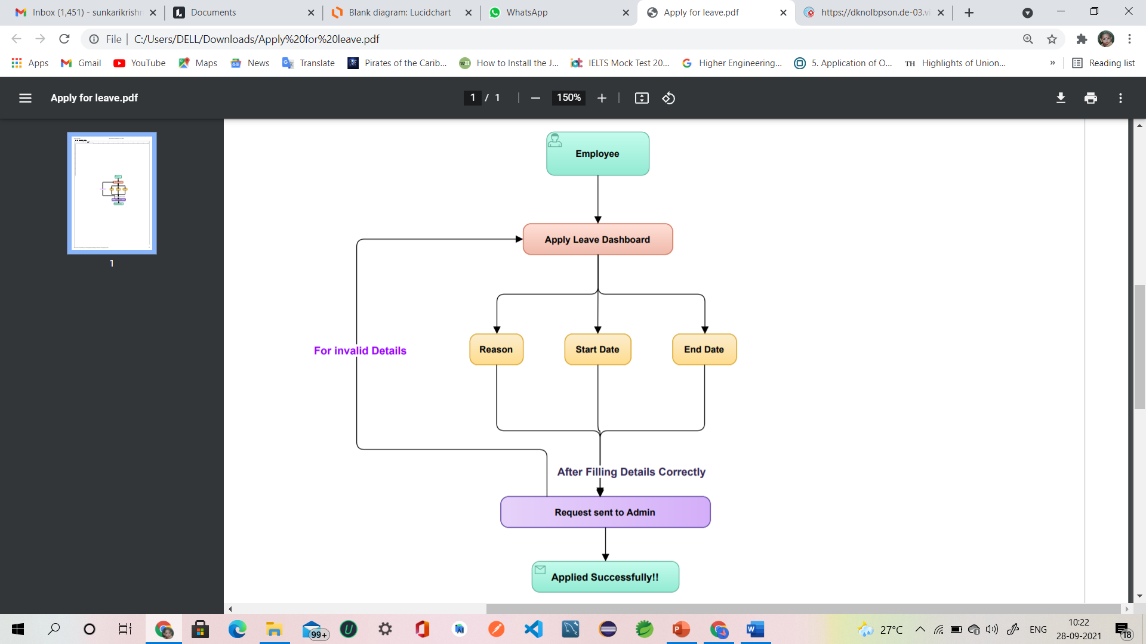

|  |  |
| --- | --- |
| **Use case id: 3** | **Use case name: Apply Leave** |
| **Description** | Employee has to fill all the necessary details like Leave start date, end date, purpose. |
| **Actor** | Employee |
| **Pre-conditions** | Employee must be logged in |
| **Post-conditions** | Employee’s leave request will be sent to admin. |
| **Frequency of Use** | Can apply leaves according to the policy |
| **Normal Course of Events** | 1. When Employee clicks on “Apply Leave” button, it will be directed to apply leave interface. 2. Employee has to fill Leave details like Reason, Start date, Leave Type, End date. 3. If admin grants/rejects leave, it is displaying the Leave balance, Leave taken, Request edit, Delete. 4. After entering the leave details into the database, a message should be displayed as “Applied successfully”. |
| **Alternative Courses** | If any of the details are not filled, leave application will not be submitted. |
| **Associated**  **Use case diagram** |  |
| **Exceptions** | 1. If any of the required details were kept empty or invalid, then a valid error message prompts. 2. If network failure happens, the leave application details will not be saved. |
| **Special Requirements** | * Casual Leave – 8 * Earned Leave – 86 * On duty Leave – 10 * Optional Leave – 2 * Medical Leave - 20 * Loss of Pay – 100 |
| **Assumptions** | Employee can’t apply another leave request in the same day. |
| **Test Plan Outline** |  |
| **Notes & Issues** |  |

**iv) Approval / Rejection of Employee leave request**

**ACTIVITY DIAGRAM**

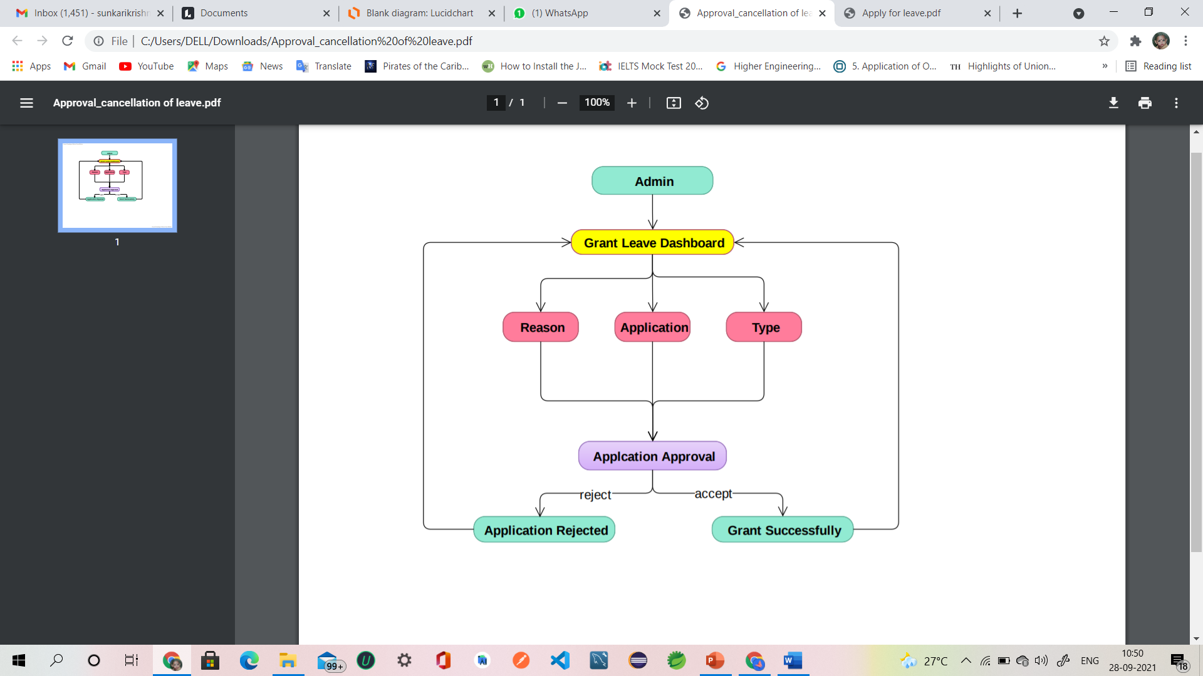

|  |  |
| --- | --- |
| **Use case id: 4** | **Use case name: Request Status** |
| **Description** | Employee’s leave request will be handled here. |
| **Actor** | Admin |
| **Pre-conditions** | Employee leave profile will be checked |
| **Post-conditions** | Employee will get a confirmation of their leave request |
| **Frequency of Use** | 1 per day per employee |
| **Normal Course of Events** | 1. Admin will login to the Leave application through browser or android device. 2. He can view all the employee leave requests in the “Employee leave requests” interface. 3. Based on the purpose, he will choose which one to be approved and rejected. |
| **Alternative Courses** | Employee leave requests status will be shown as “pending”. |
| **Associated**  **Use case diagram** |  |
| **Exceptions** | Admin has to either approve or reject the request, until then employee leave status will be pending. |
| **Special Requirements** |  |
| **Assumptions** | Employee can delete the leave request when the leave status is pending. |
| **Test Plan Outline** |  |
| **Notes & Issues** |  |

**-: CONCLUSION :-**

* **Further upgradation of the Employee Leave Application for various types of organisations with multiple hierarchies can help in reducing paperwork.**
* **So, here we are finally with a leave application management system that can take the request of the staff for leave to be applied very easily and fastly.**
* **Employees will read their past leave request & current leave application standing. Leave request will be saved within the draft mode by the employee & then will be submitted to the admin & the hierarchy for applicable action. The choice to regularize leave or cancel the applied leave at any time makes the leave request operate**

**“Employees’ delight”.**