**TASK-09(AWS-s3 bucket)**

**1) Create s3 bucket and upload some objects to s3.**

Login to root user ,search for s3 ,create bucket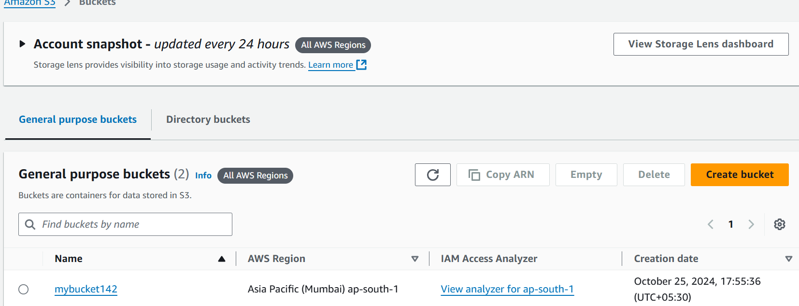

Created bucket(mybucket142)

Open mybucket142 to upload files

Click on upload

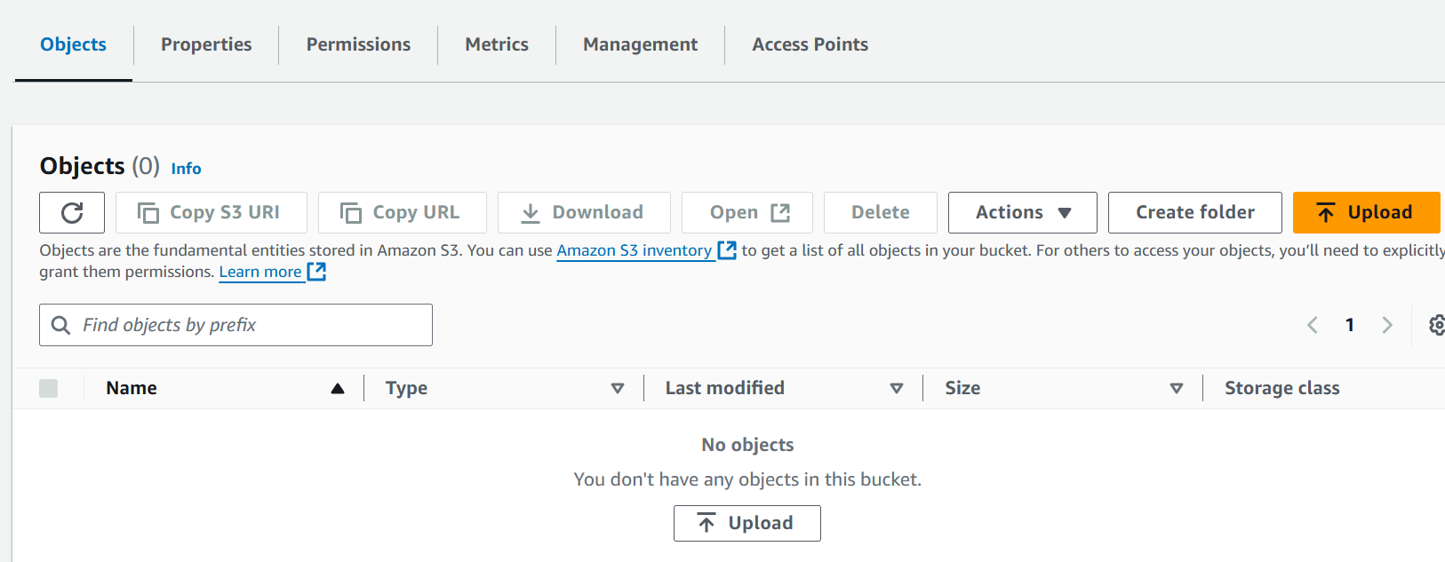

Add files,

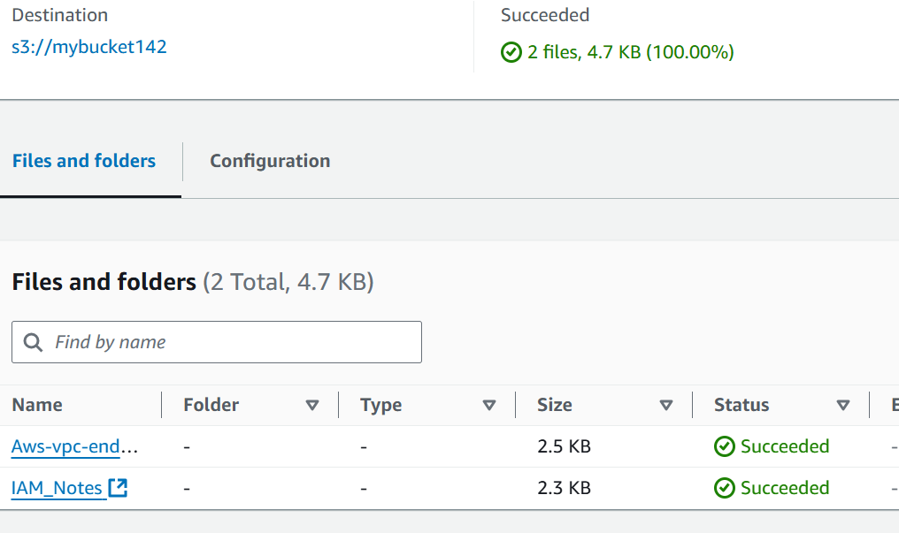

Making public to view the content

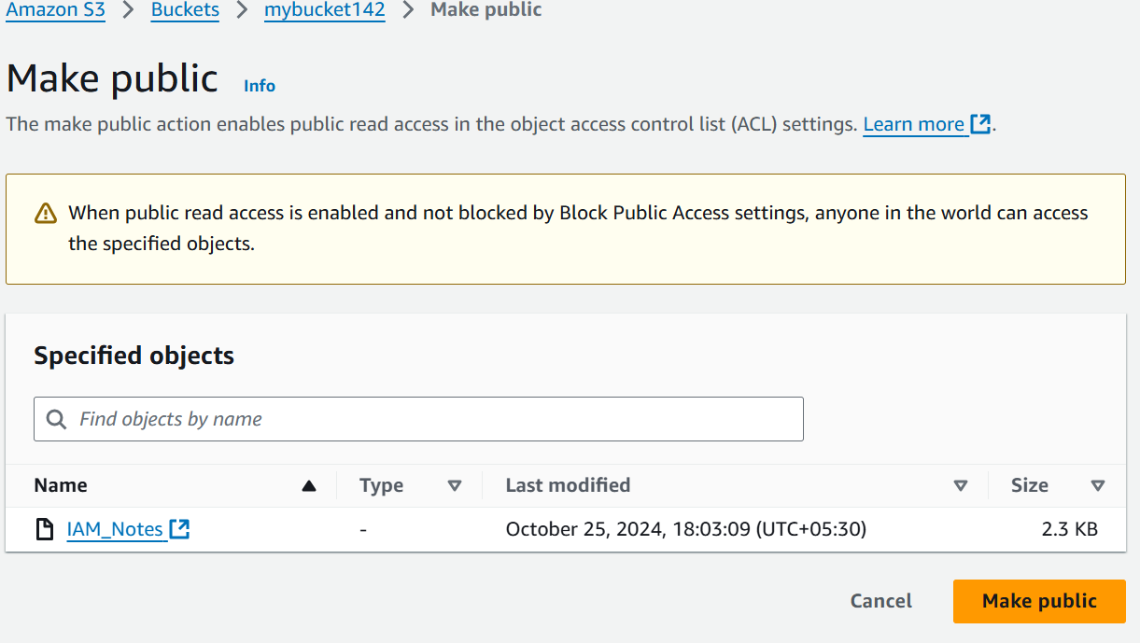

File got downloaded and can view in downloads

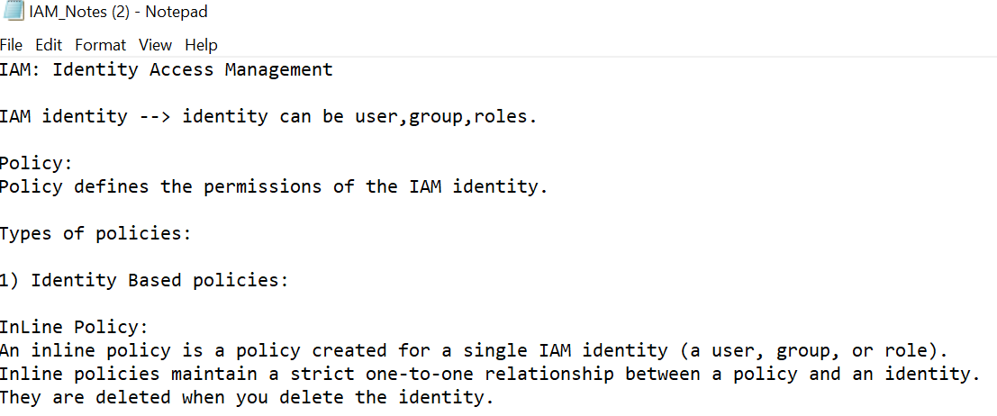

**2) Deploy static website in s3 bucket.**

Go to your bucket,

Select properties

Select static website hosting

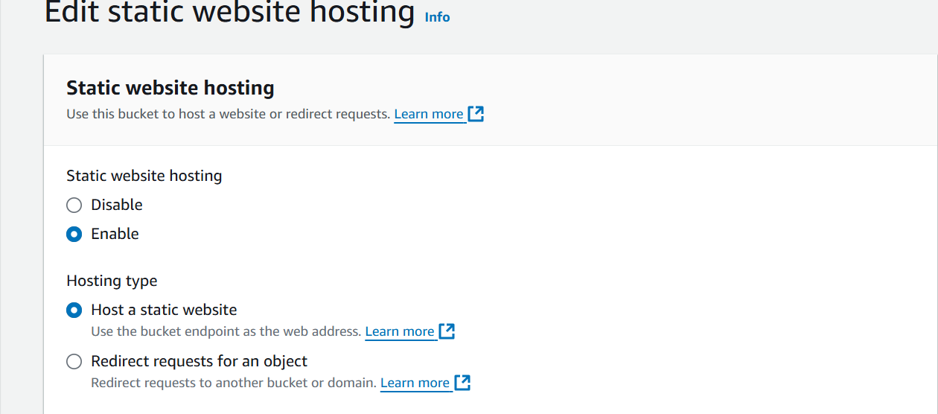

Created two files with index.html,error.html 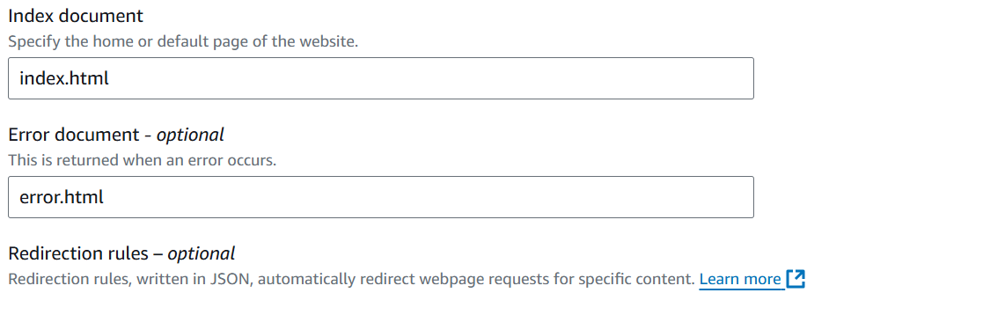

Save the changes

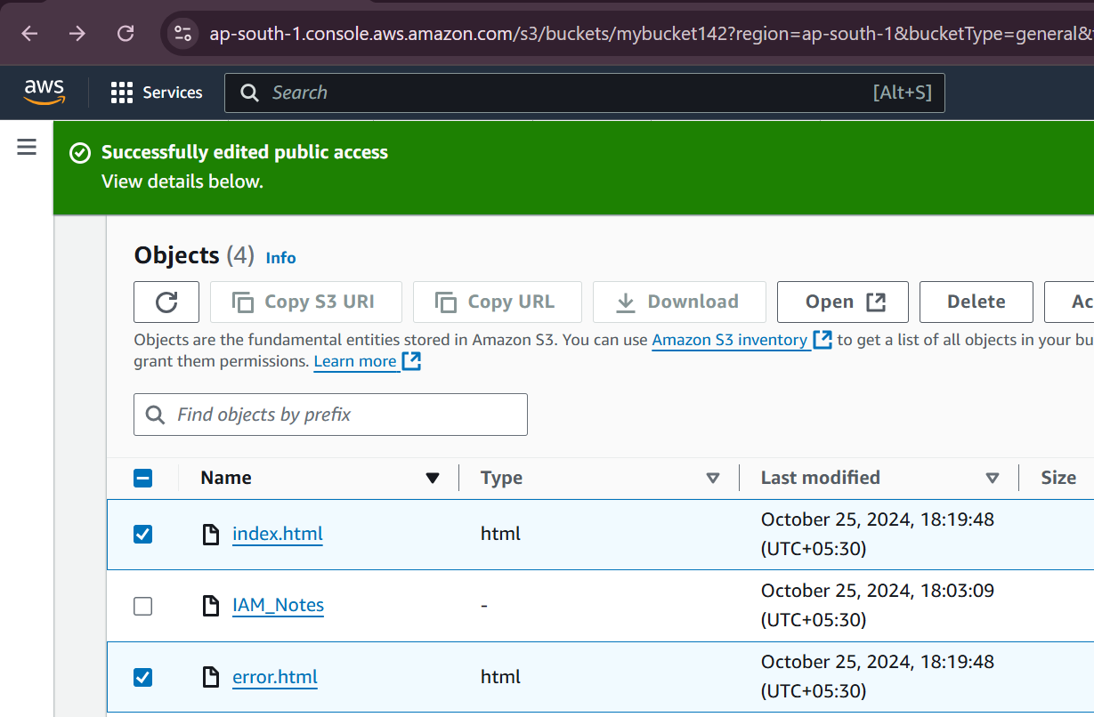

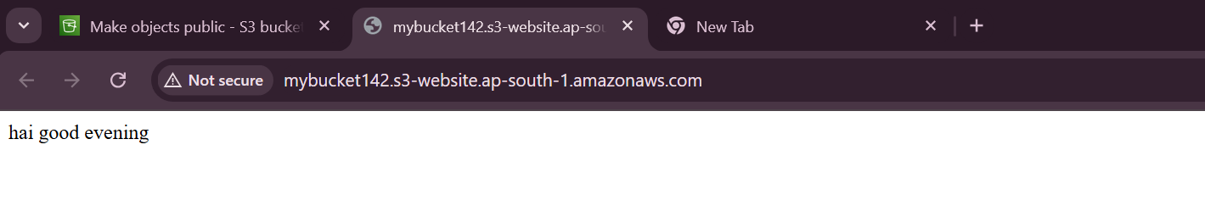

**3) Enable cross region replication on s3 buckets.**

Creating two buckets in different regions 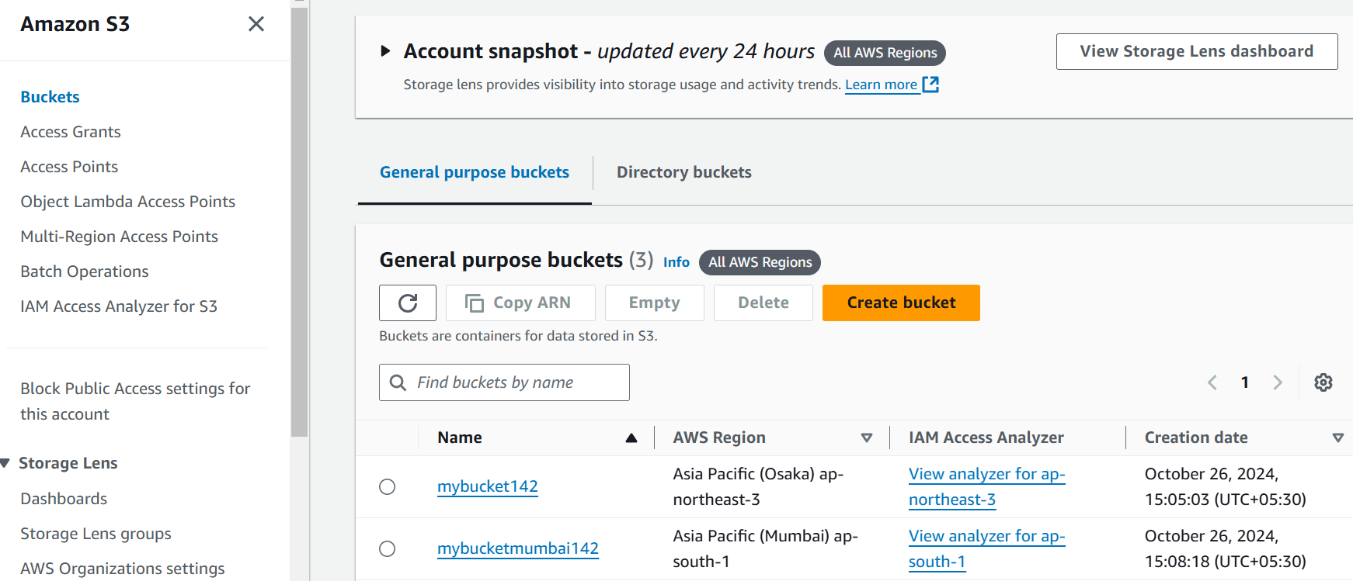

Mybucket-osaka region-source region-ACLS enabled-versioning enabled

Mybucketmumbai142-mumbai region-Destination- ACLS enabled-versioning enabled

1)selected mybucket

2)Management ->replication rules

3)created replication rule 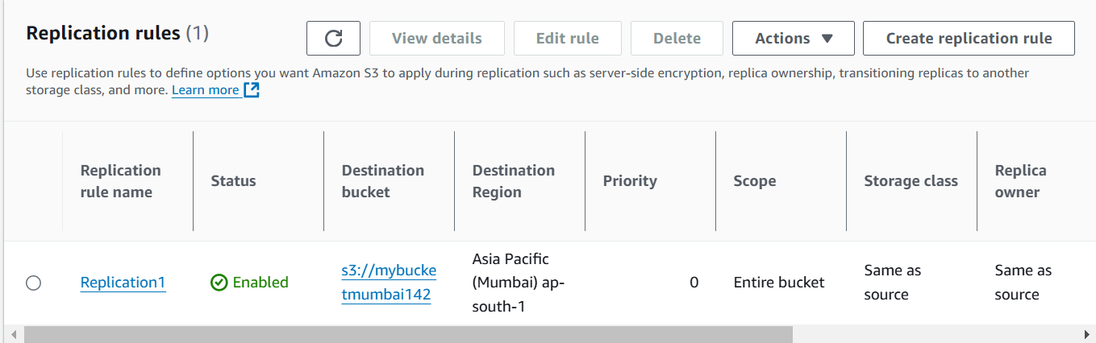

4)Uploaded one object in the source bucket(mubucket142) 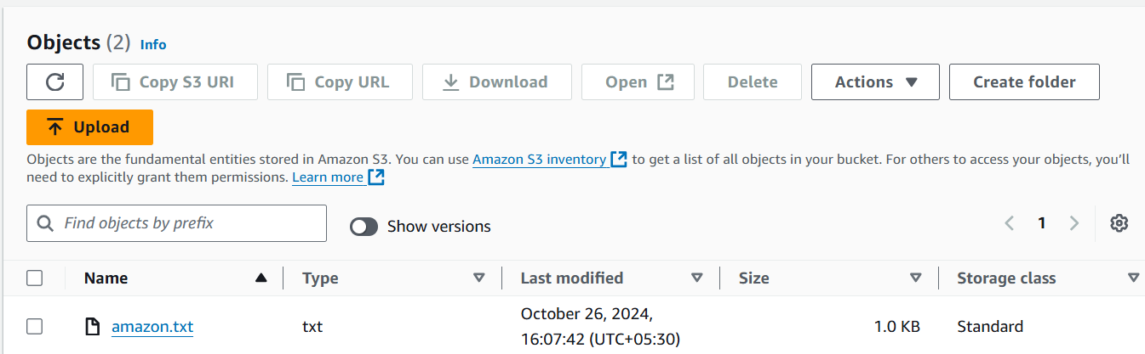

5)we can check in destination

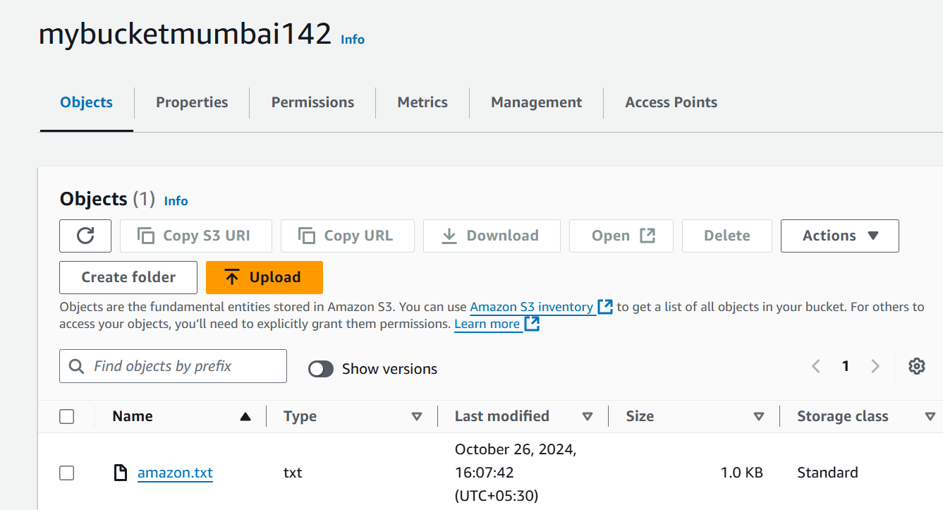

**4) Configure bucket policy, only Admin user can see the objects of s3 bucket.** 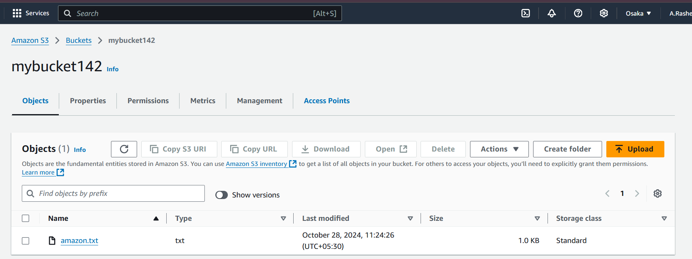

**Bucket details**

Step:1->created one admin user with administration access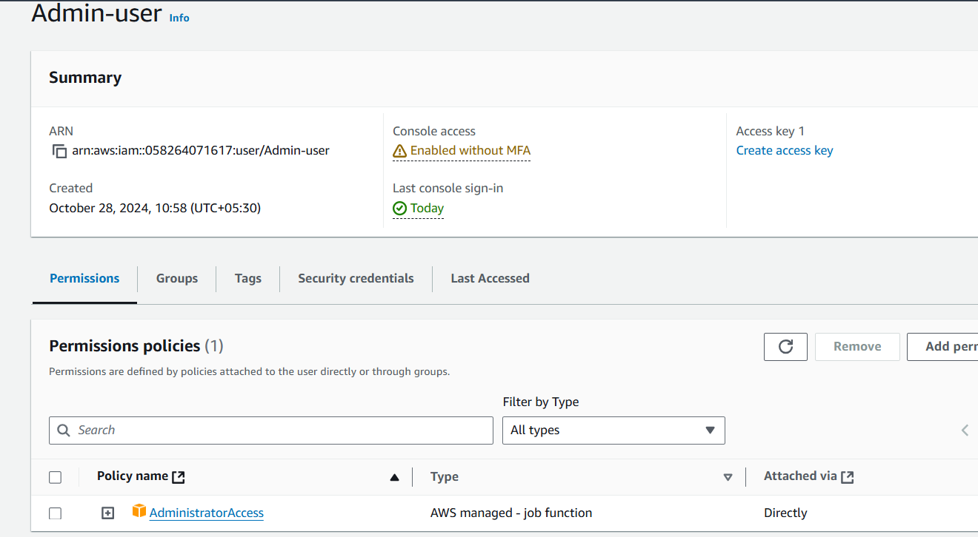

Step:2

Go to s3,select a bucket and add permission

Select edit bucket policy

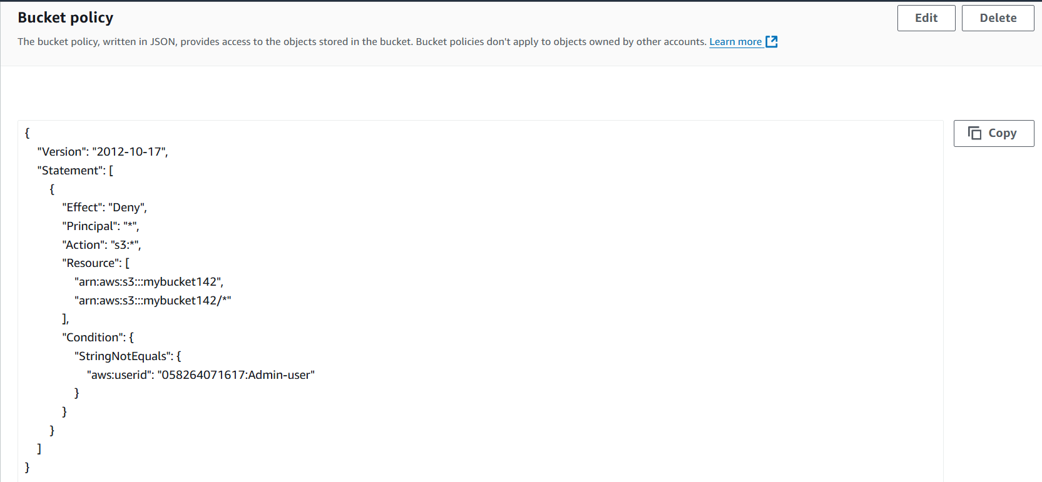

Save the changes.

Output :check whether other user can view the objects or not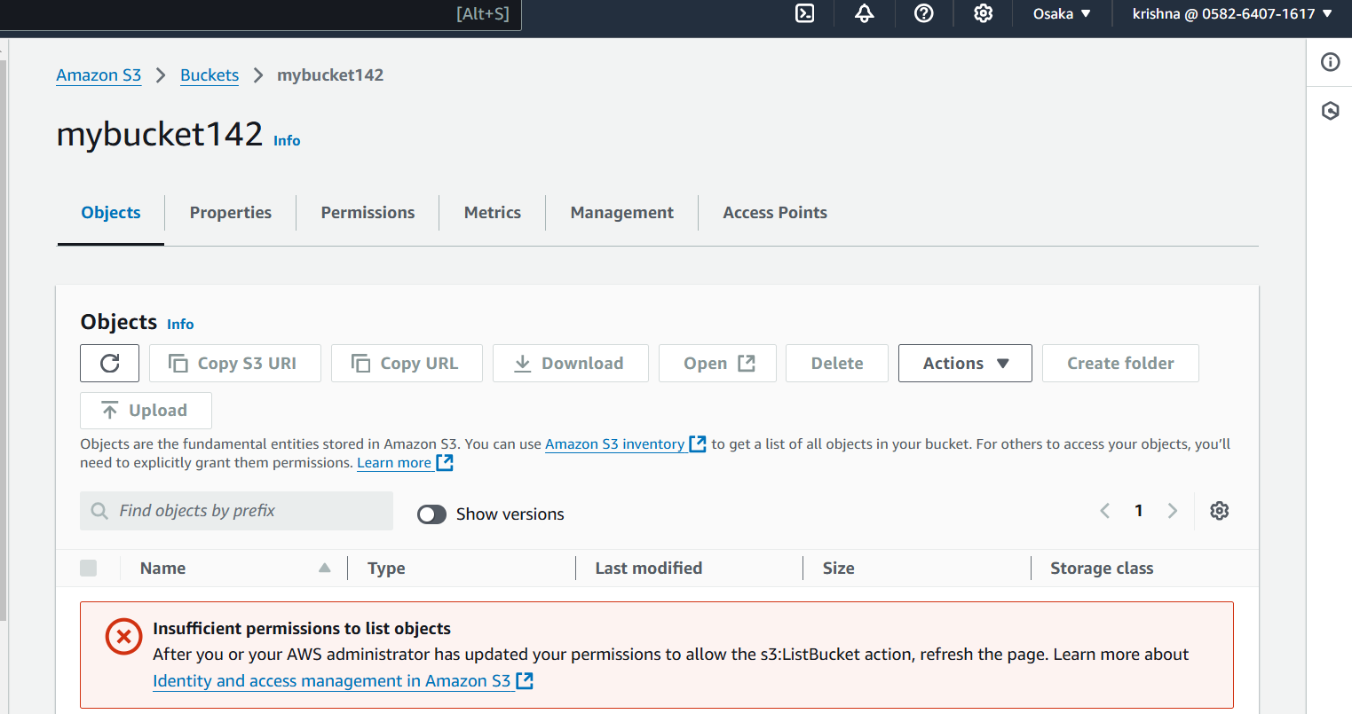

**5) Setup lifecycle policies to automatically transition or delete objects based on specific criteria**.

Step-1:choose one bucket

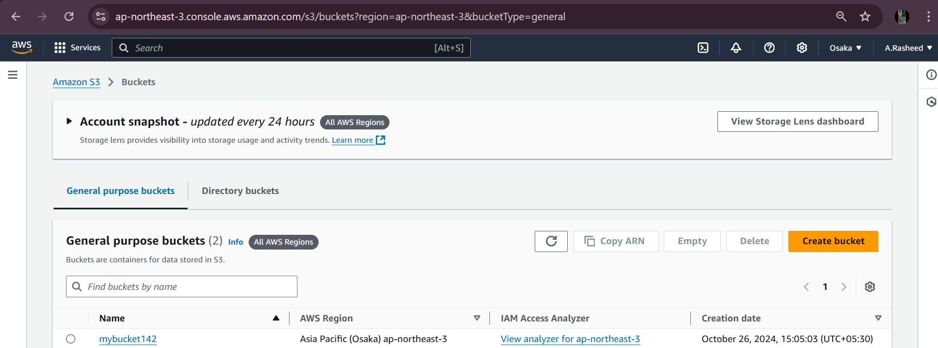

2) Go to the management

3)

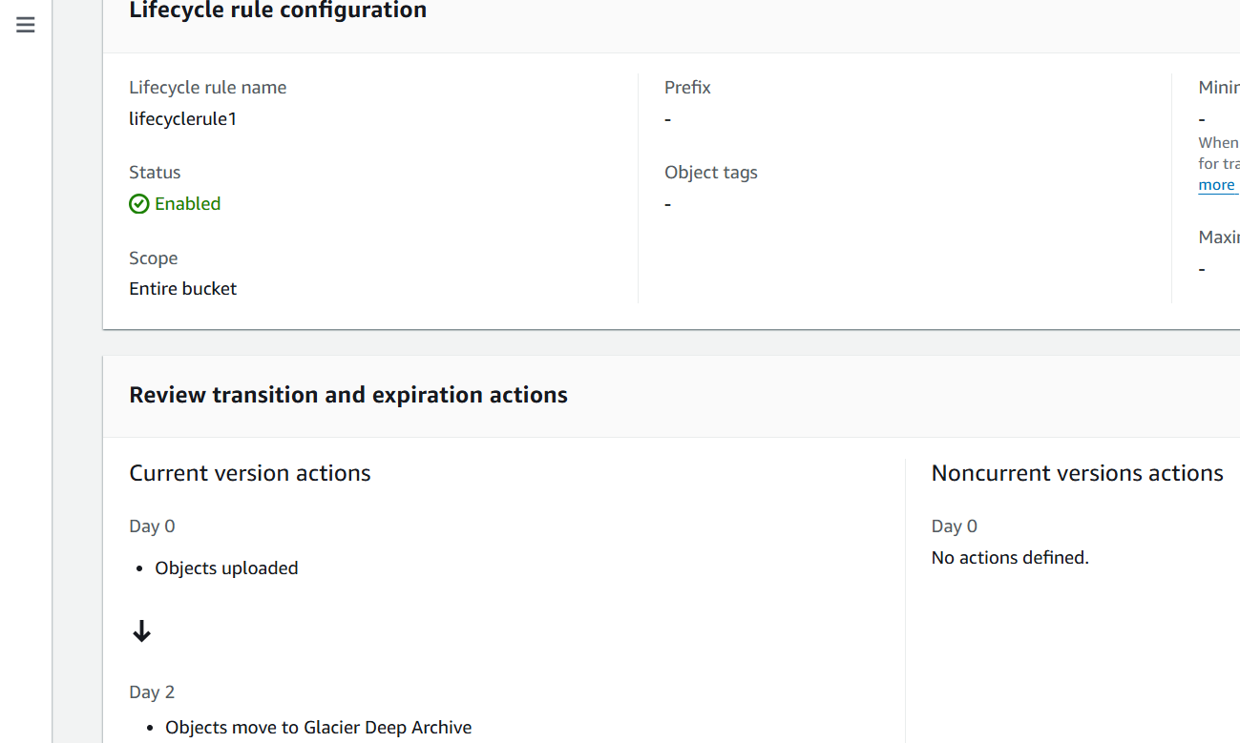This configuration is set to move all newly uploaded objects to Glacier Deep Archive within **2 days** of their upload. This setup is very cost-efficient if the data doesn’t require frequent access, as it minimizes storage costs by moving data to the lowest-cost tier almost immediately after upload.

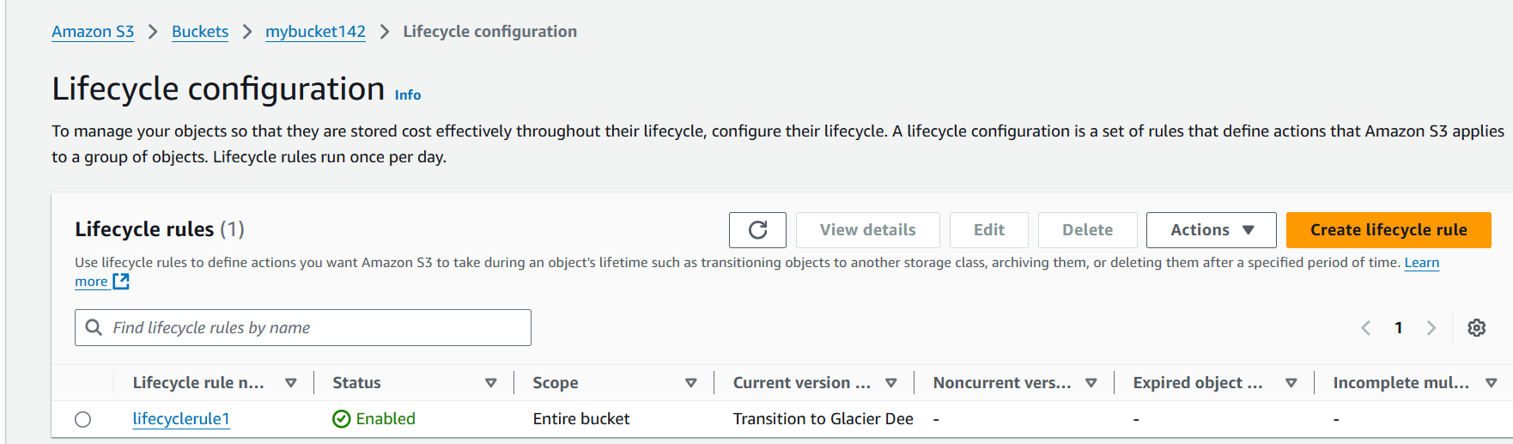

**6) Push some objects in s3 using AWS CLI.**

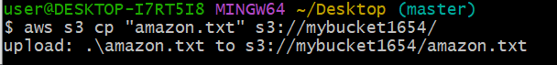

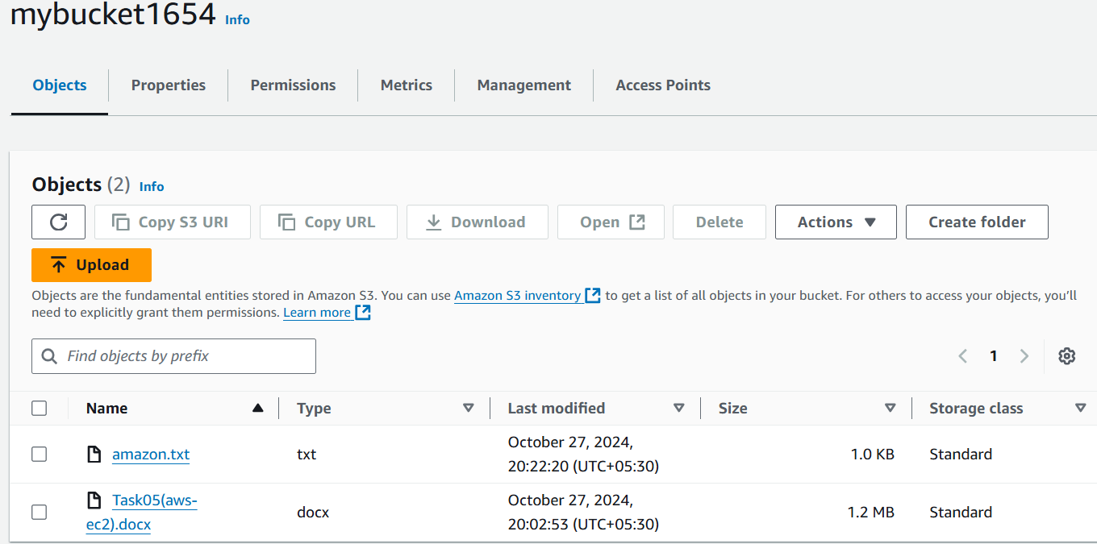

**7) Write a bash script to create s3 bucket.**

Step:1 –Go to gitbash and confirm aws cli has downloaded or not

Step-2:After downloading the aws cli, check using the command:aws –version

Step-3:connect with the aws connect using

Command: aws configure

It will ask for the access key and secret key

Step-4:creating a bash script

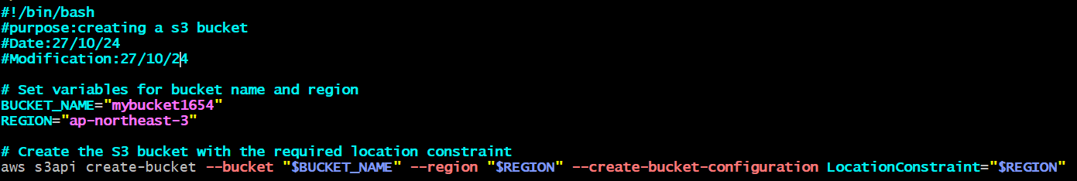

Step -5:change the permissons(chmod 755 s3.sh)

Step:6-execute the bash script

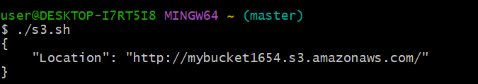

We can check in s3 buckets list,a new bucket will be added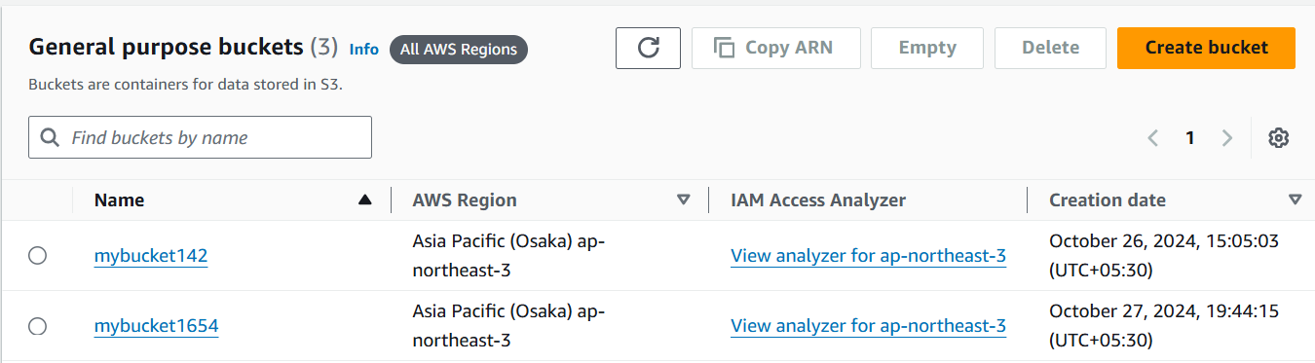

**8) Upload one 1 gb of file to s3 using cli.** 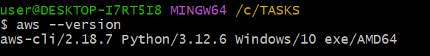

connect with the aws connect using

Command: aws configure

It will ask for the access key and secret key

