TERRAFORM[TASK-02]

1) Watch the terraform-02 video.  
2) Execute all the templates shown in video.

Terraform lifecycle rules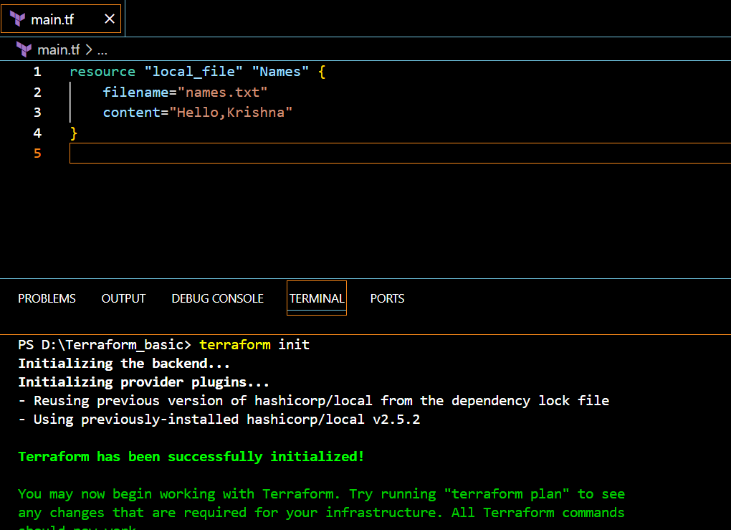

1)Create_before_destroy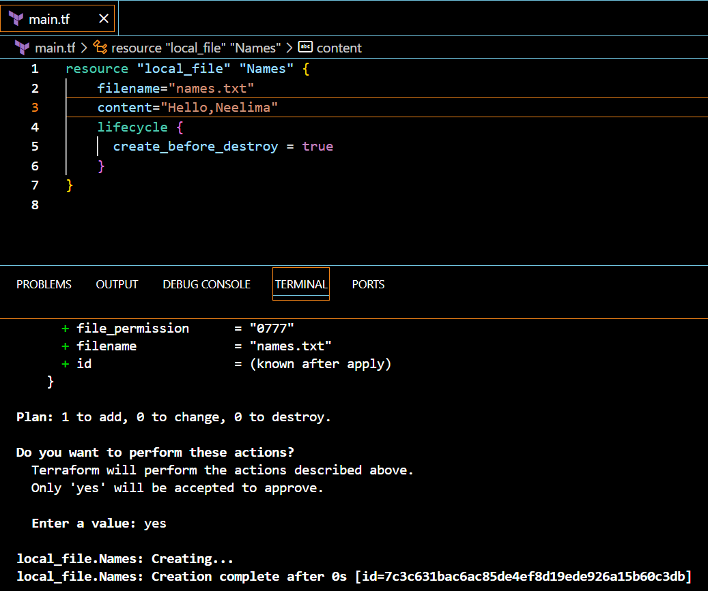

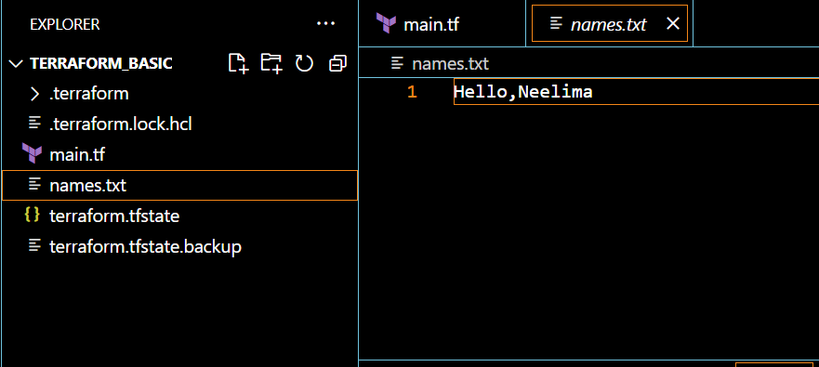

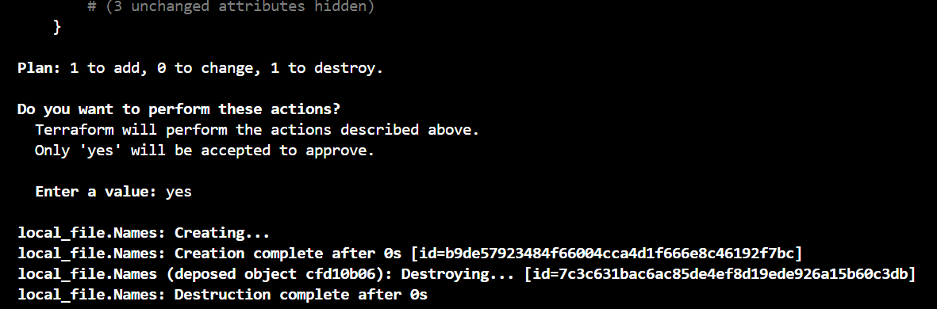

**2)prevent_destroy**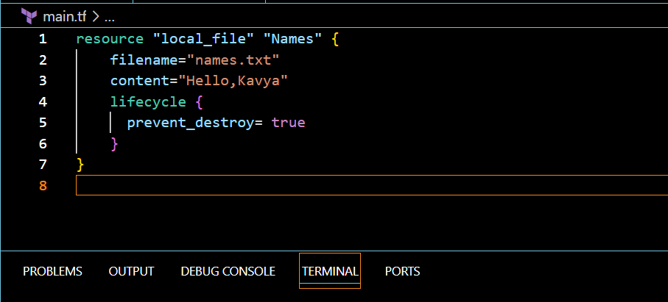

Step:2[terraform apply]

Step:3[terraform destroy]

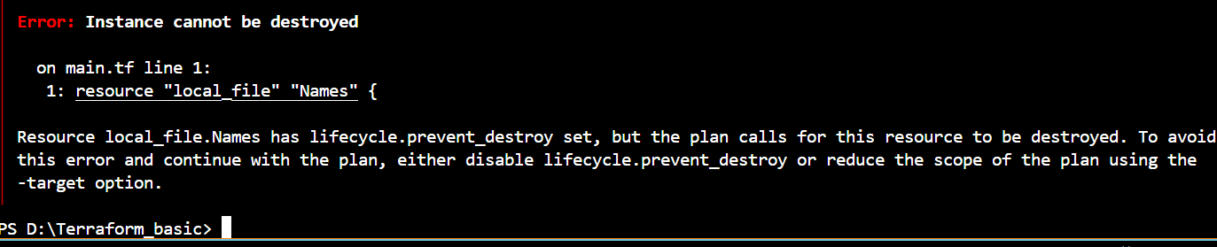

**3)ignore_changes**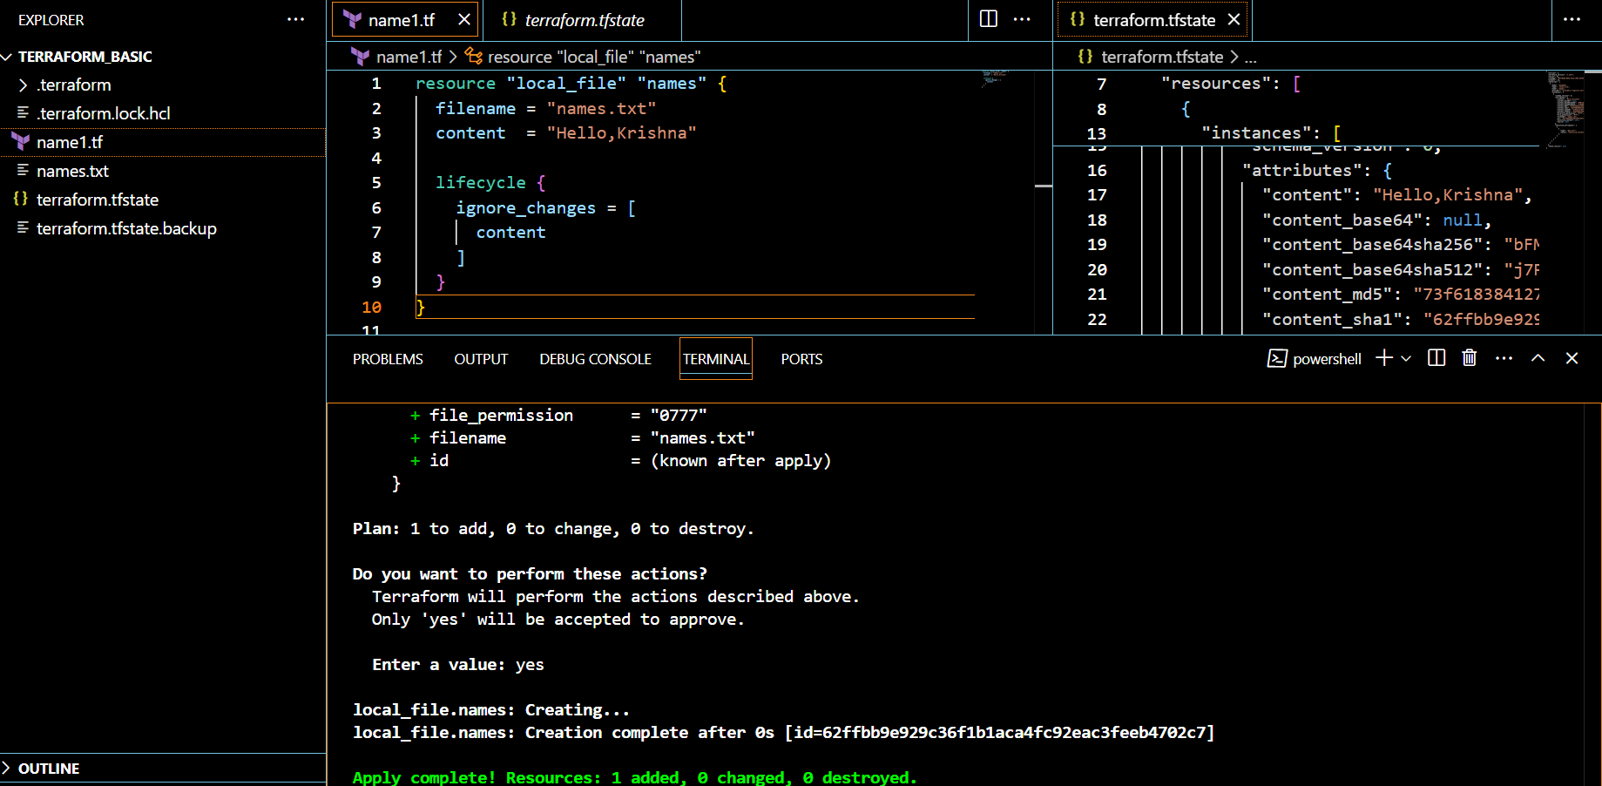

After changing the content of the file

If we did “terraform apply”

It will ignore all the changes

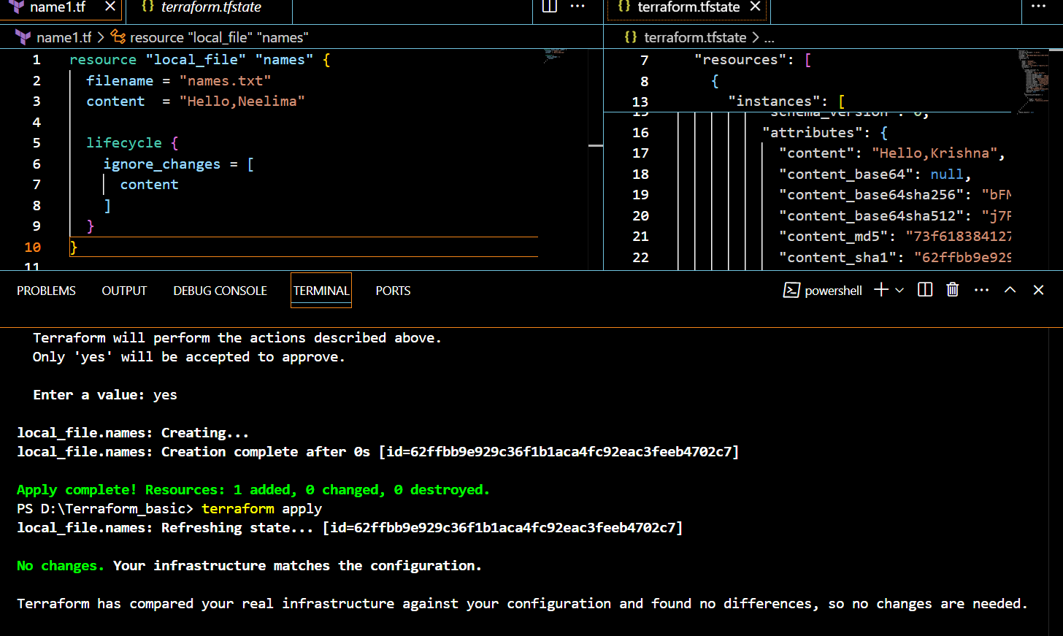

**Variables**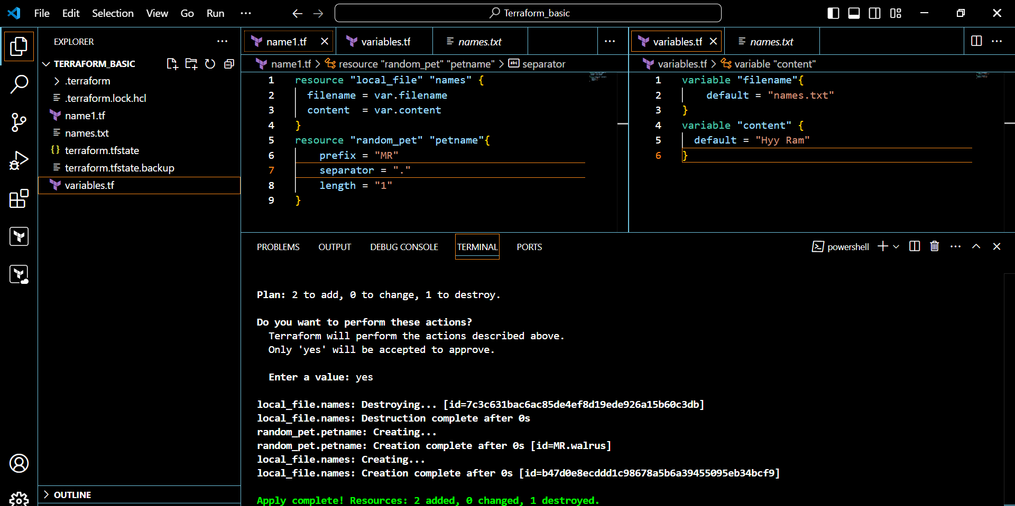

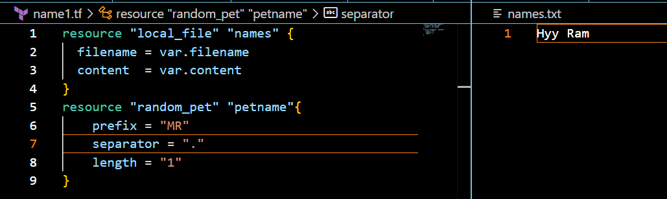

**Types of variables**:

Command line arguments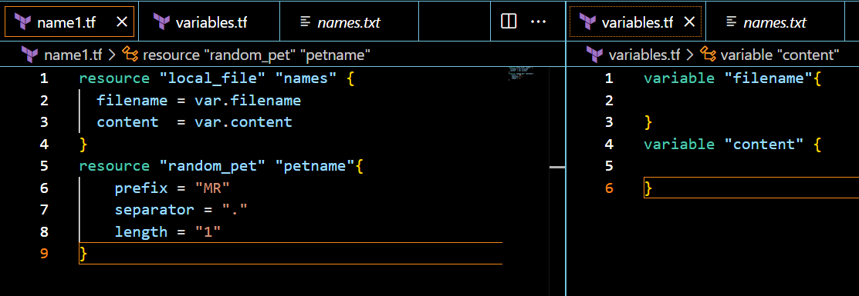

Output:

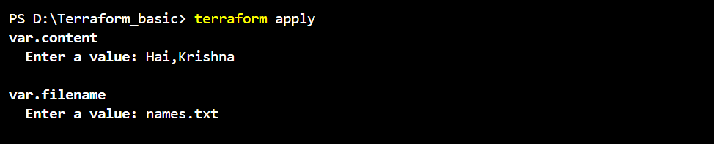

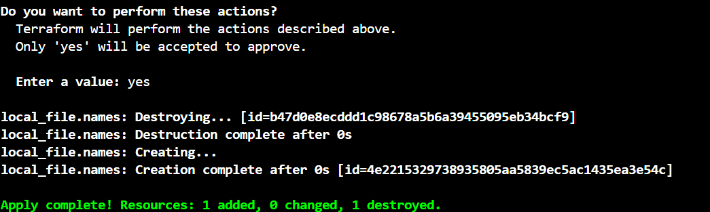

We can check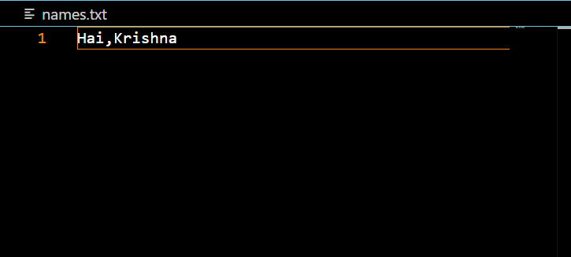

Without asking user prompt in cli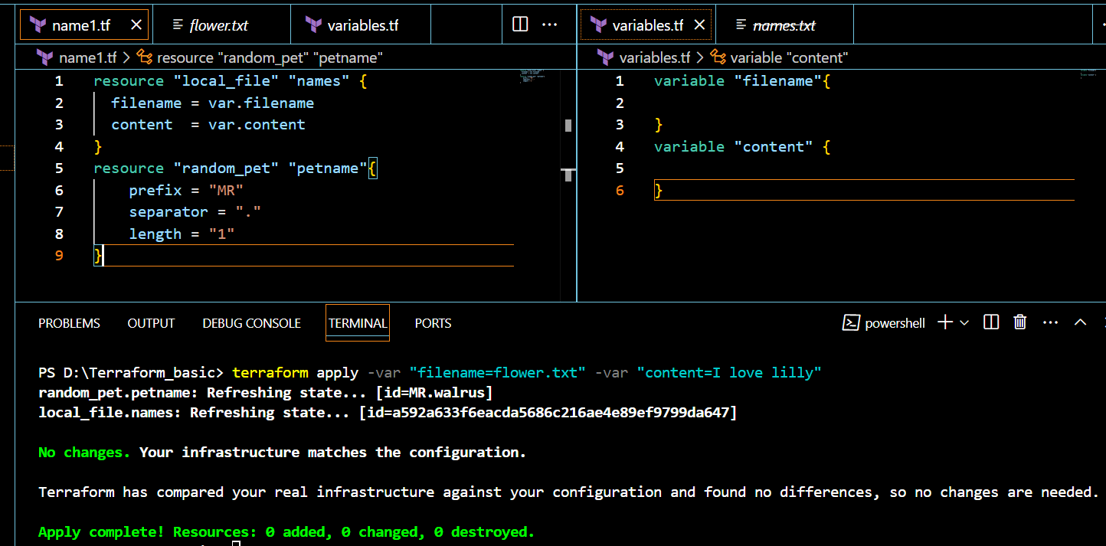

We can also check flower.txt file

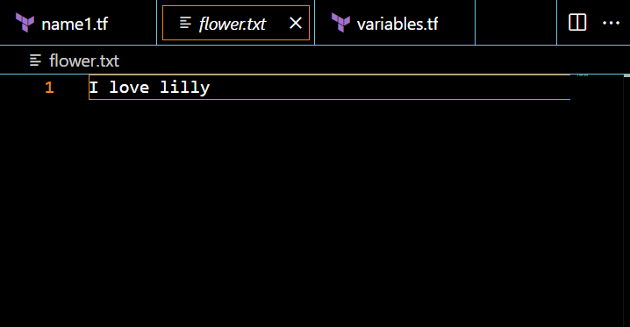

3) Integrate terraform in Jenkins using Terraform plugin

Steps:1

Installing terraform plugin in Jenkins

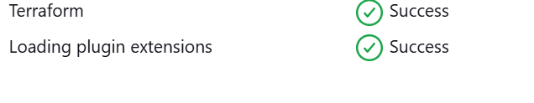

Step:2

Installing terraform in the jenkins

* sudo yum install -y yum-utils shadow-utils
* sudo yum-config-manager --add-repo https://rpm.releases.hashicorp.com/AmazonLinux/hashicorp.repo
* sudo yum -y install terraform

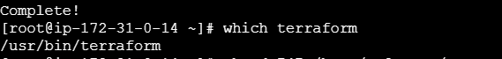

Step-3

Go to manage Jenkins>tools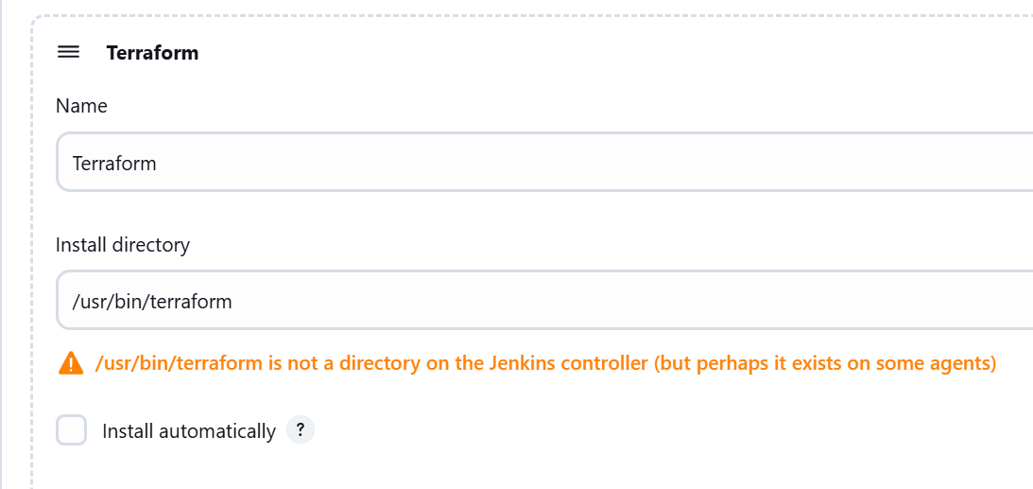

Now go to the github,

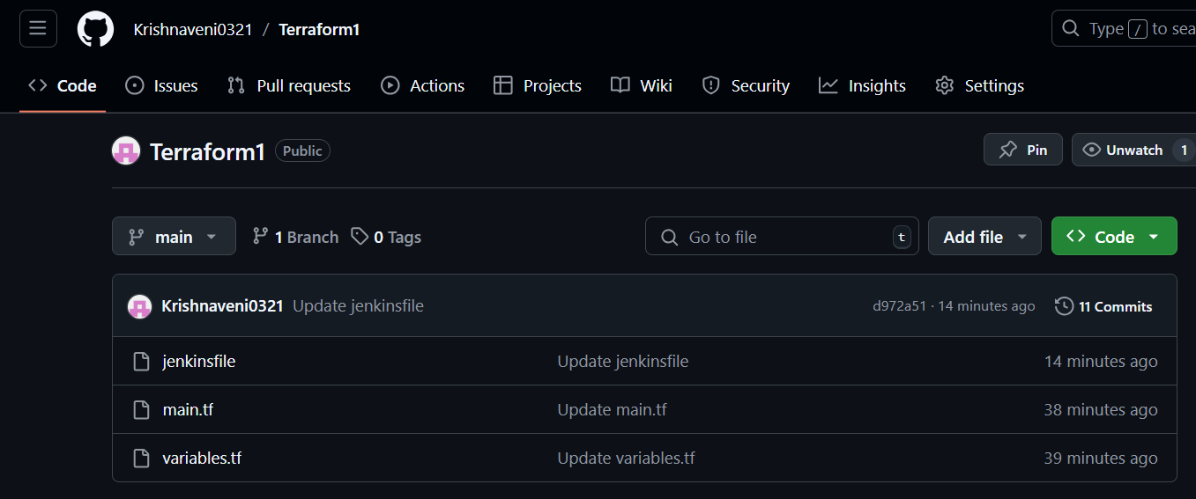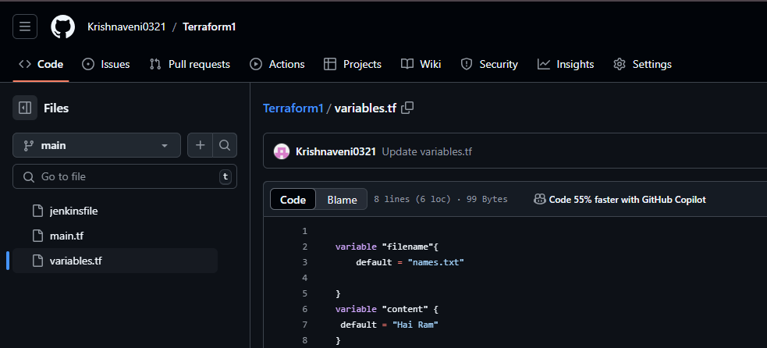

I have created jenkinsfile,main.tf,variables.tf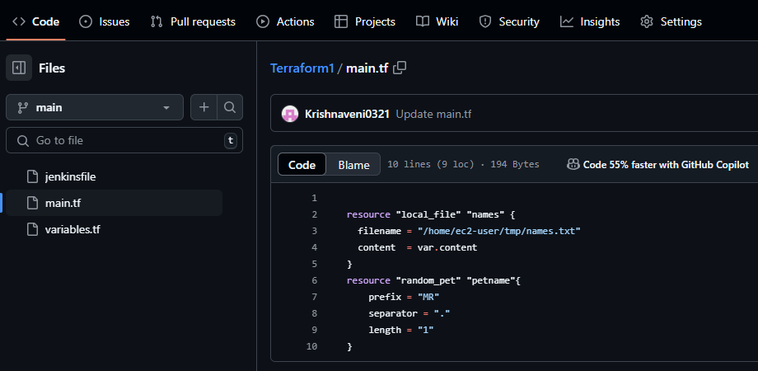

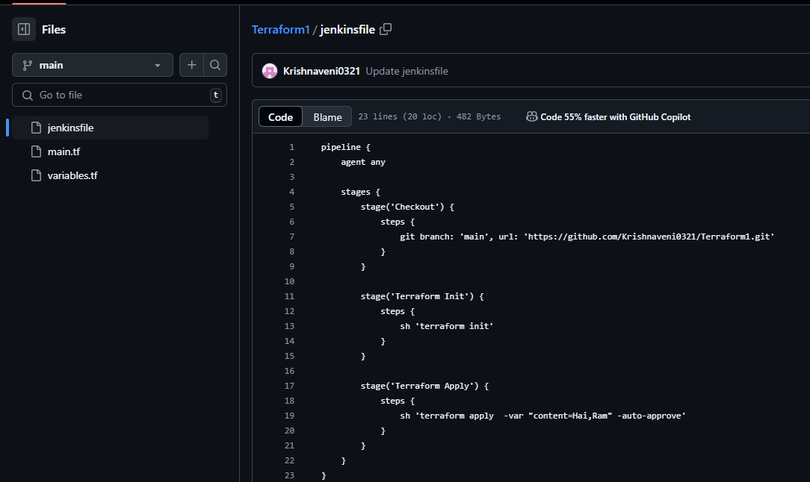

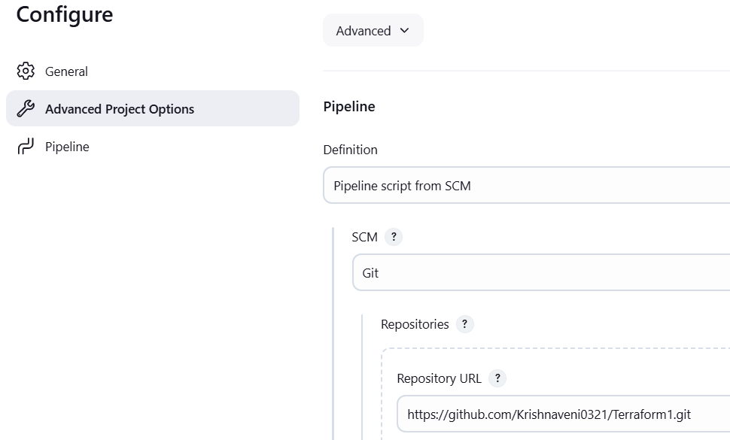

Build job