TERRAFORM[TASK-03]

**1) Watch terraform-03 video.**

**2) Execute the script shown in video.**

1)Variables

Instead of hardcoding all the variables in the same configuration file we can use variables so that it can be reuse again and again by only changing the variables file.

We need to create a file called variables.tf in the same directory variables.tf

1)First method

name1.tf

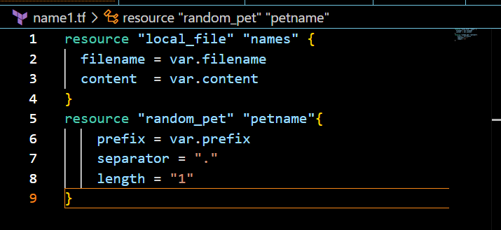

Variables.tf

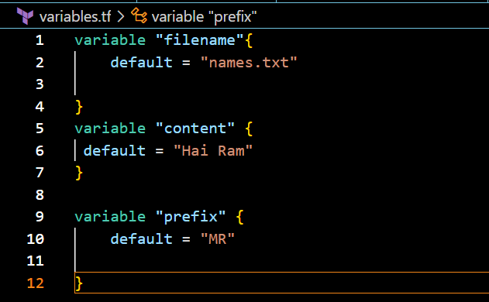

Now to check the output ,

We need to first use “terraform init”

Next “terraform apply”

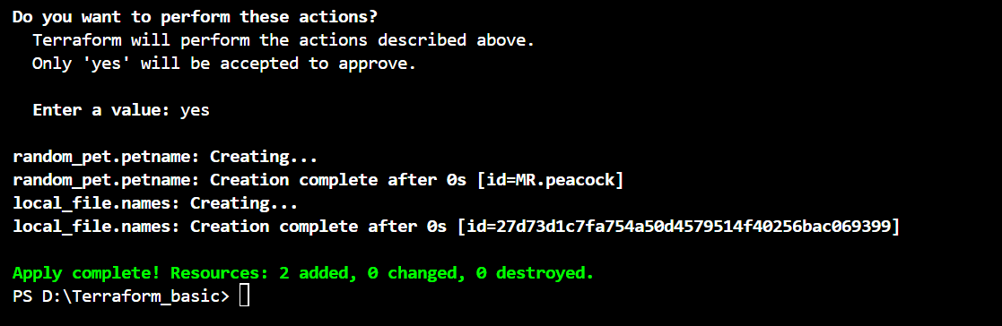

Output file

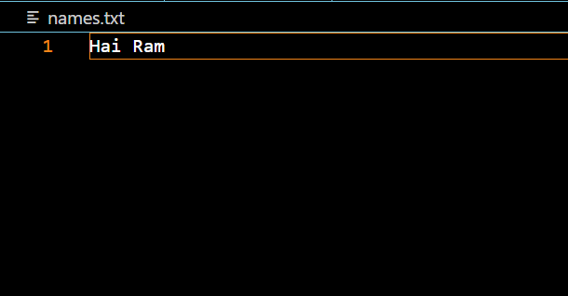

2)Interactive type

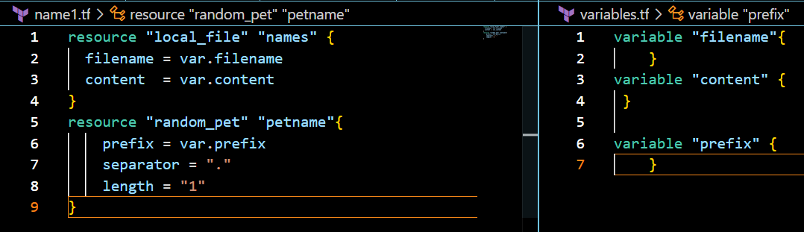

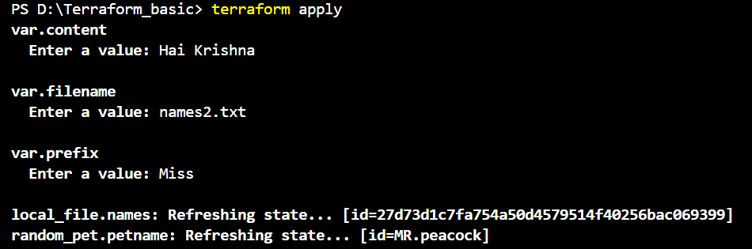

Output file

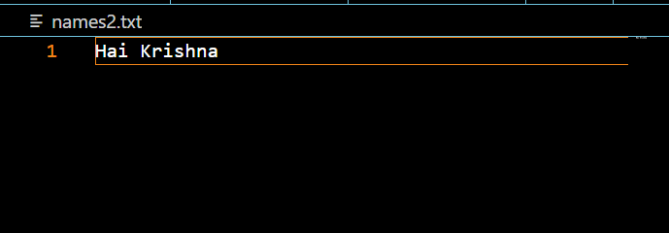

3)COMMAND LINE FLAG

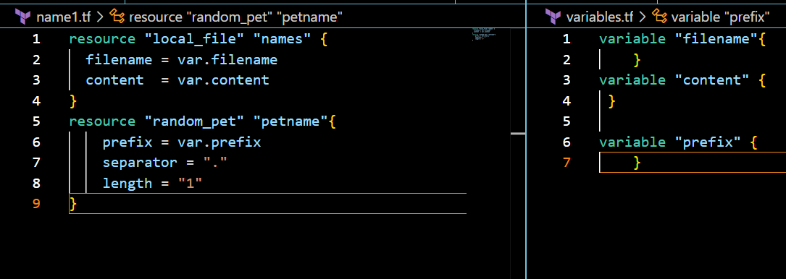

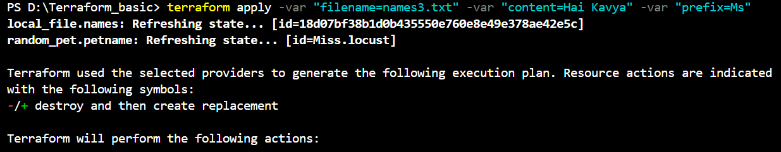

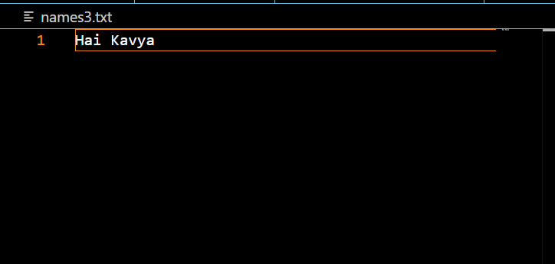

4)EnvironmentalVariables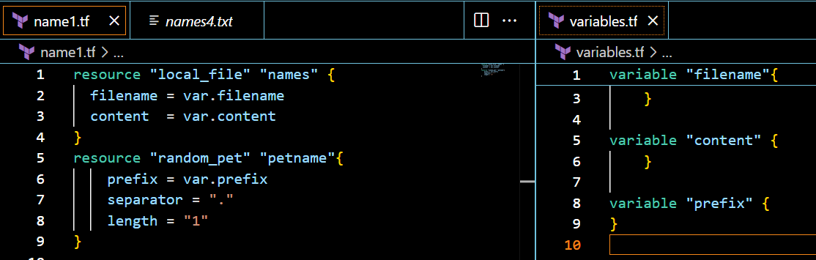

CLI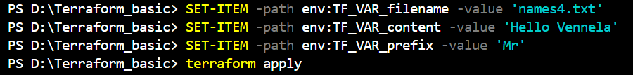

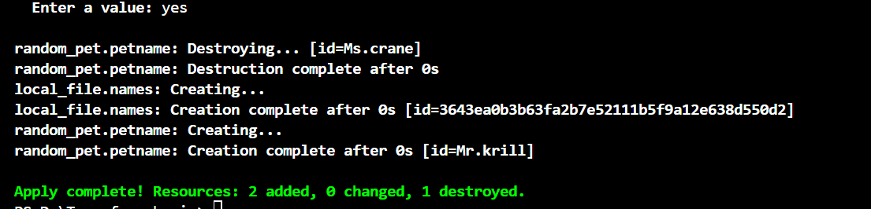

Output file

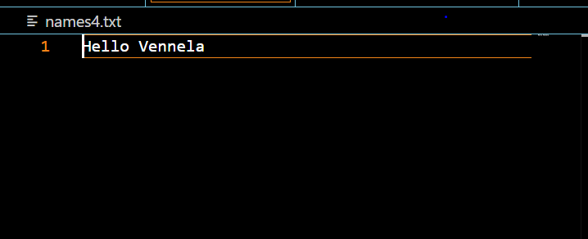

5)Variable definition file

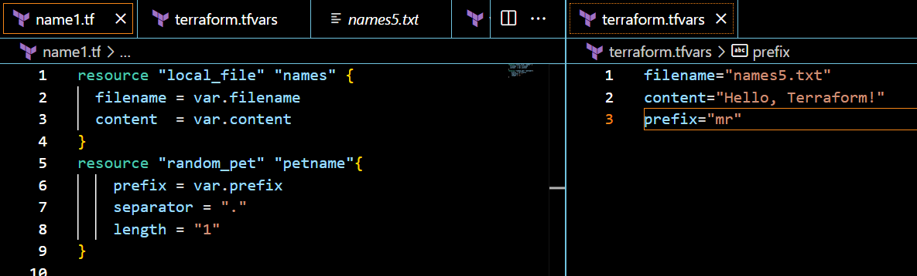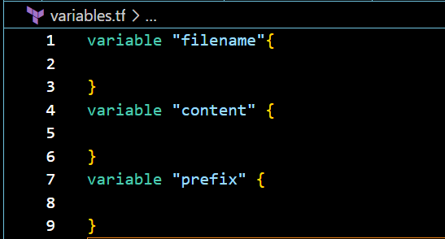

Output

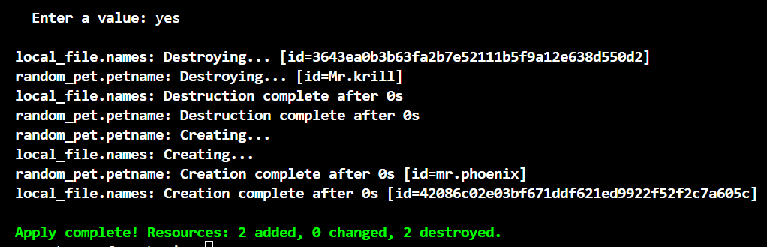

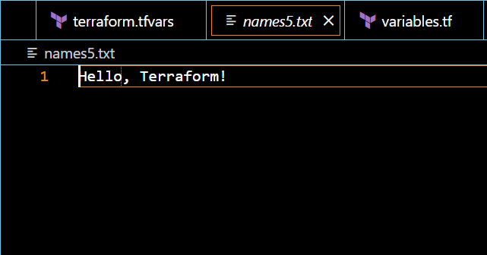

PRECEDENCE ORDER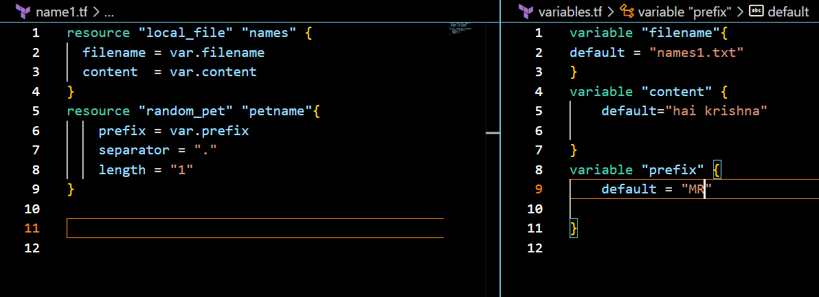

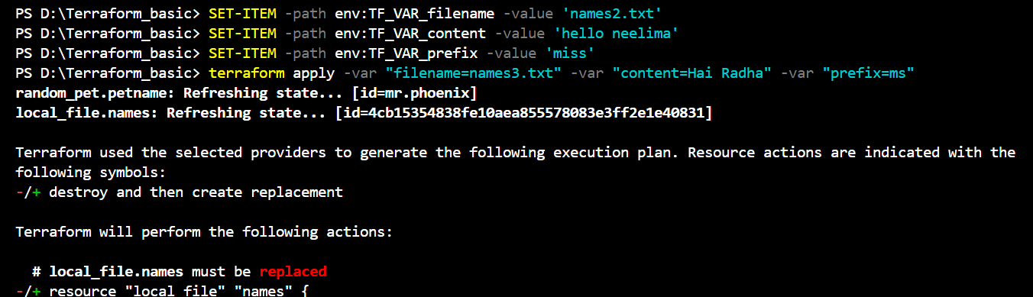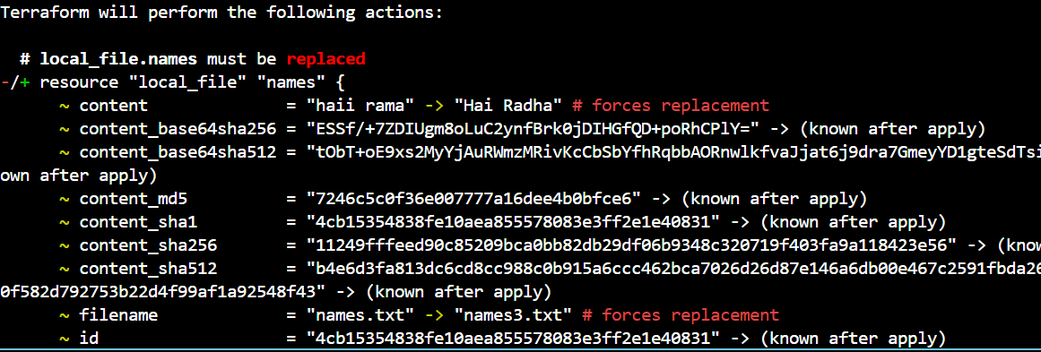

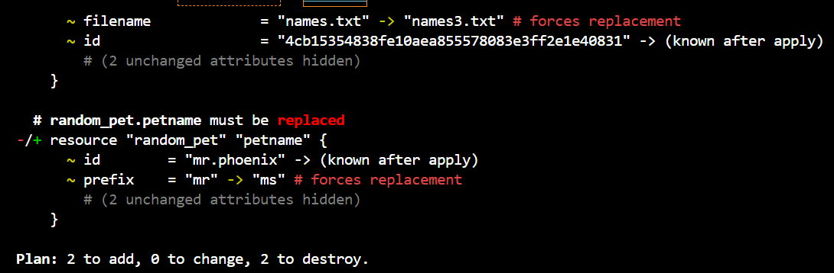

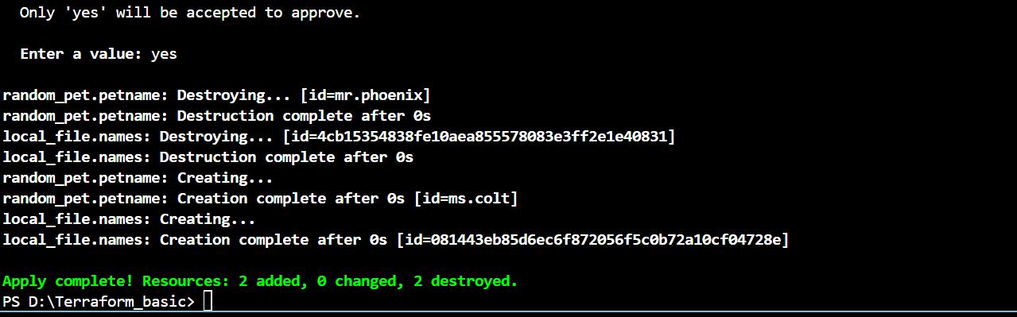

Output

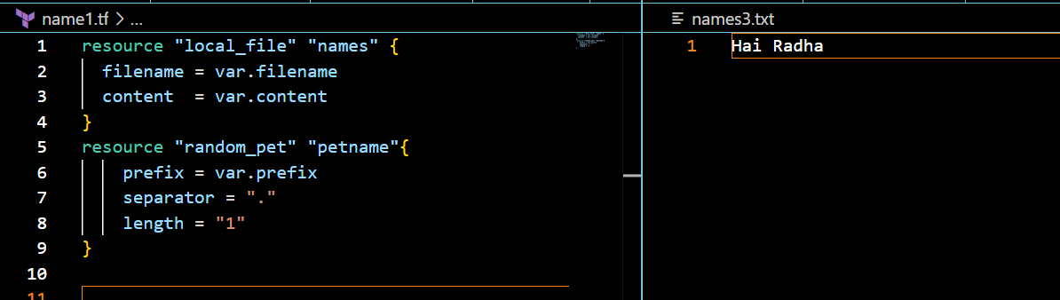

**Resource Attribute reference**

**IMPLICIT BEHAVIOUR**

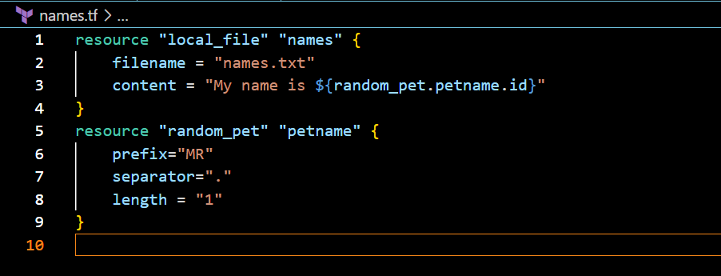

Output

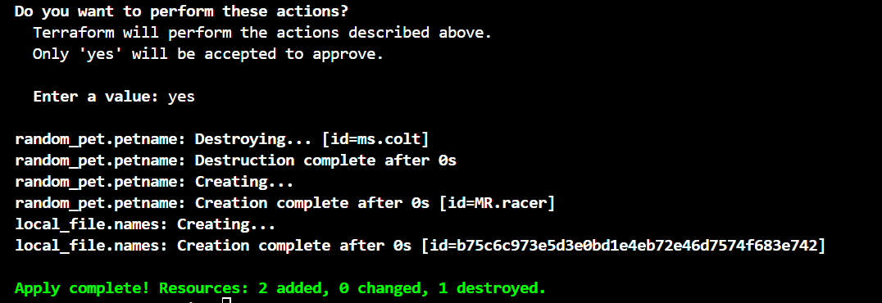

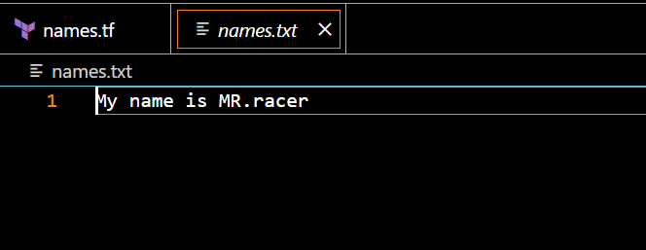

EXPLICIT BEHAVIOUR

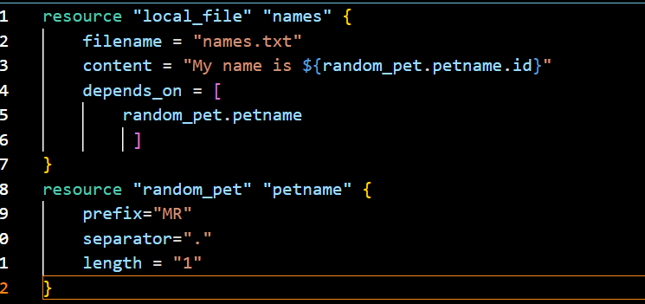

Output

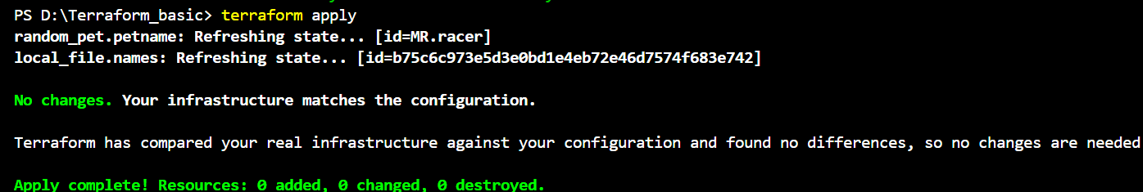

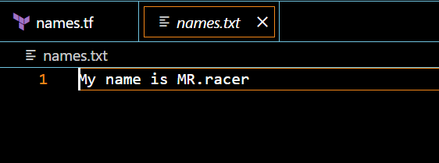

OUTPUT VARIABLES

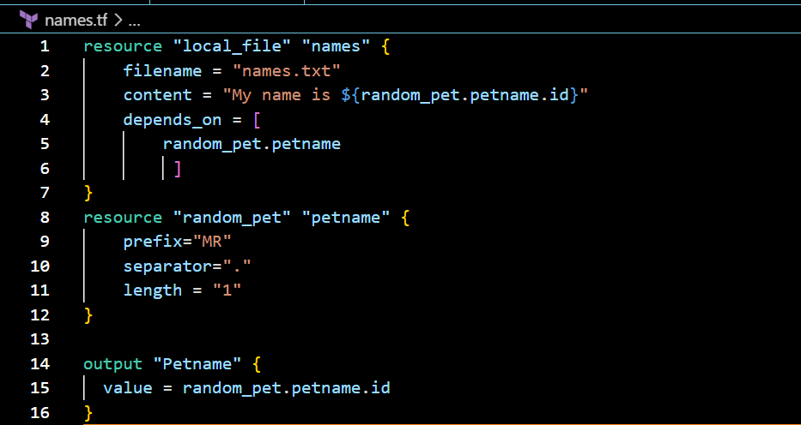

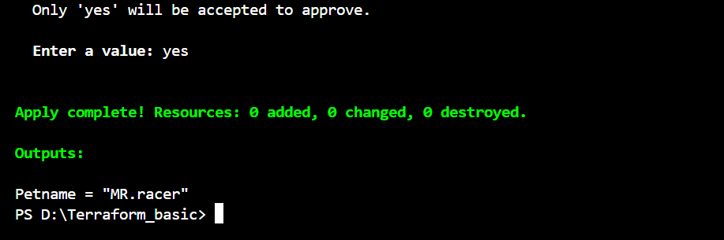

We can also check with the command

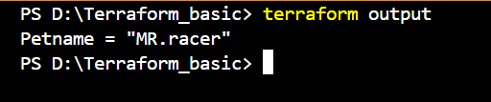

**3) Integrate terraform in Jenkins using Terraform plugin.**

**Steps:**

Installing Jenkins and terraform in ec2-server

* Need to install terraform plugin in Jenkins
* Need to configure the terraform path in the tool configuration in Jenkins page

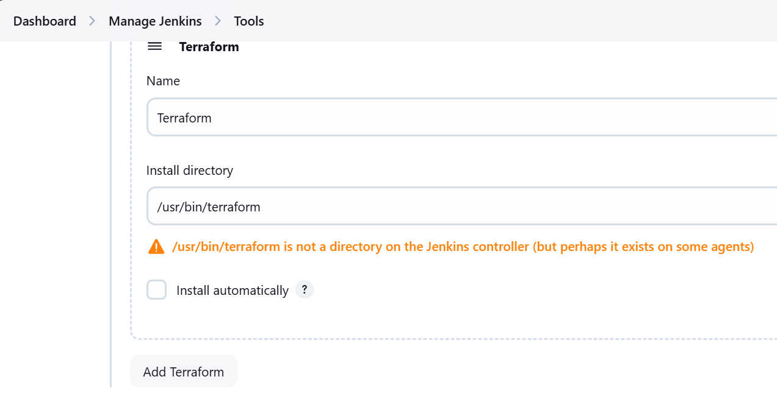

Go to the Github

Create one main.tf, variables.tf, jenkinsfile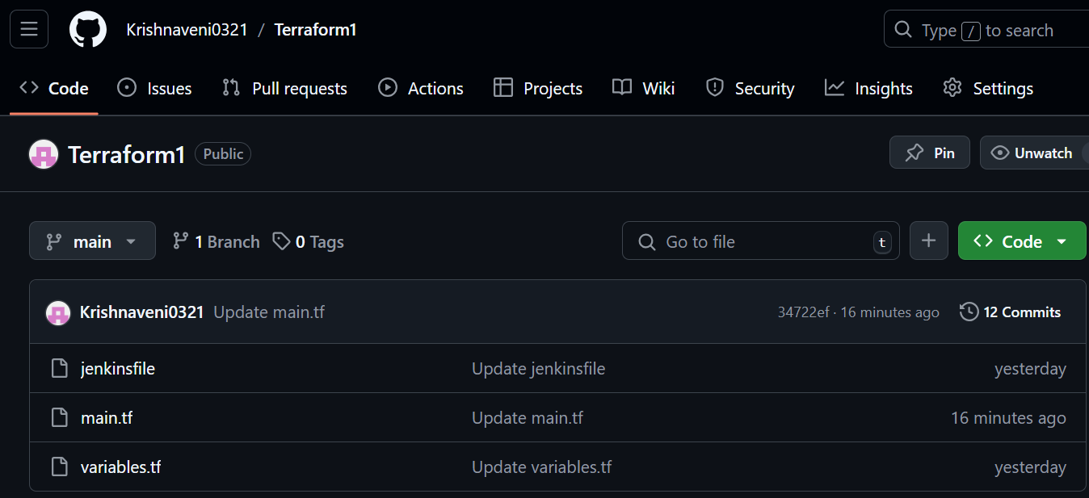

In jenkinsfile

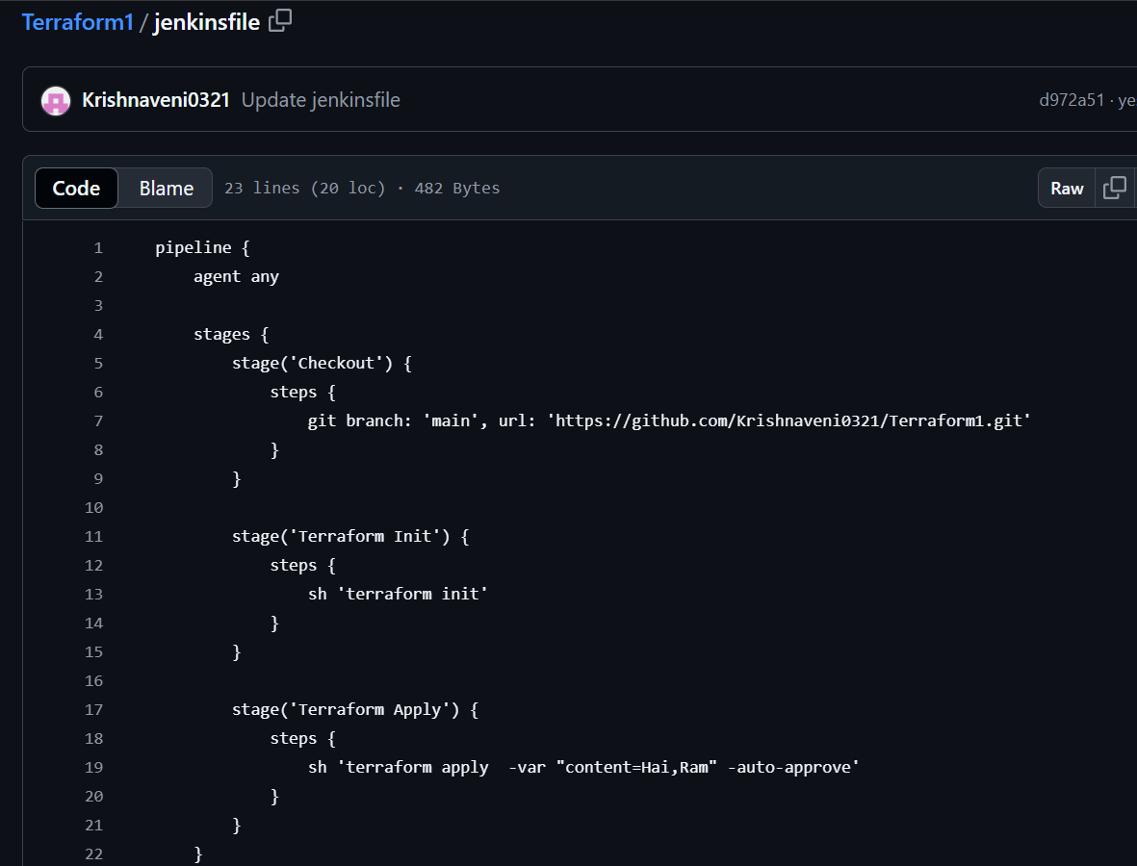

Main.tf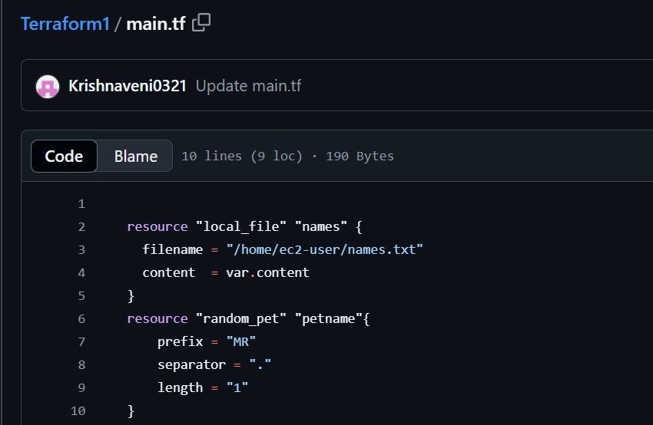

In Jenkins server ,we need to give permissions to execute the job



Variables.tf

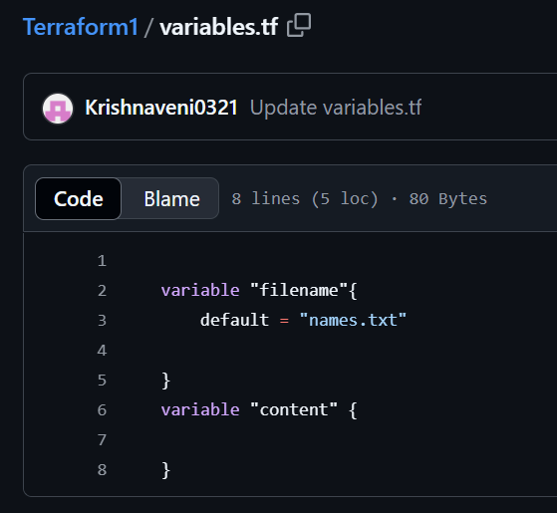

Execute the job in Jenkins

CONSOLE OUTPUT

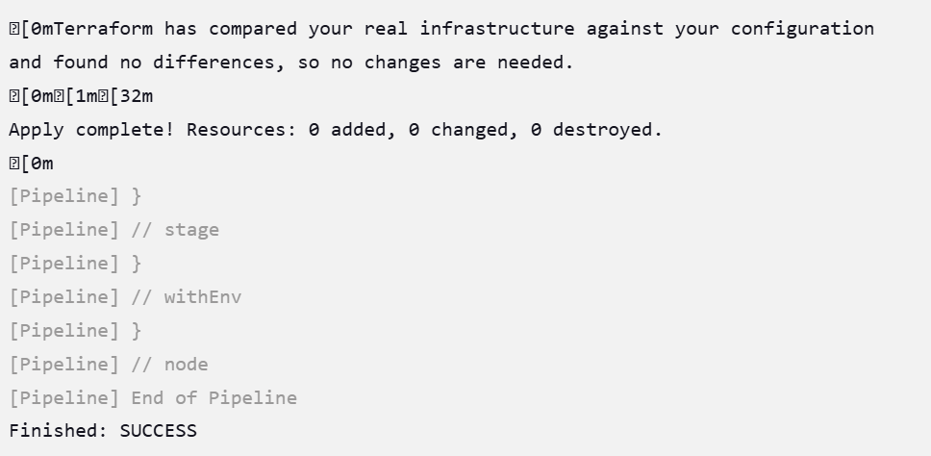

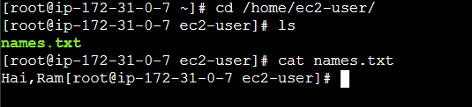

**4) Create one Jenkins job using MAVEN PROJECT for the below code with two stages.**

**Stage 1: Git clone stage**

**2: Maven Compilation Code:**

[**https://github.com/betawins/java-Working-app.git**](https://github.com/betawins/java-Working-app.git)

Steps:

Downloading the maven integration plugin

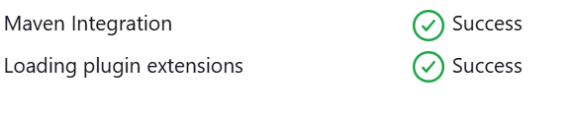

Step-2:

Go to Manage jenkins>tools

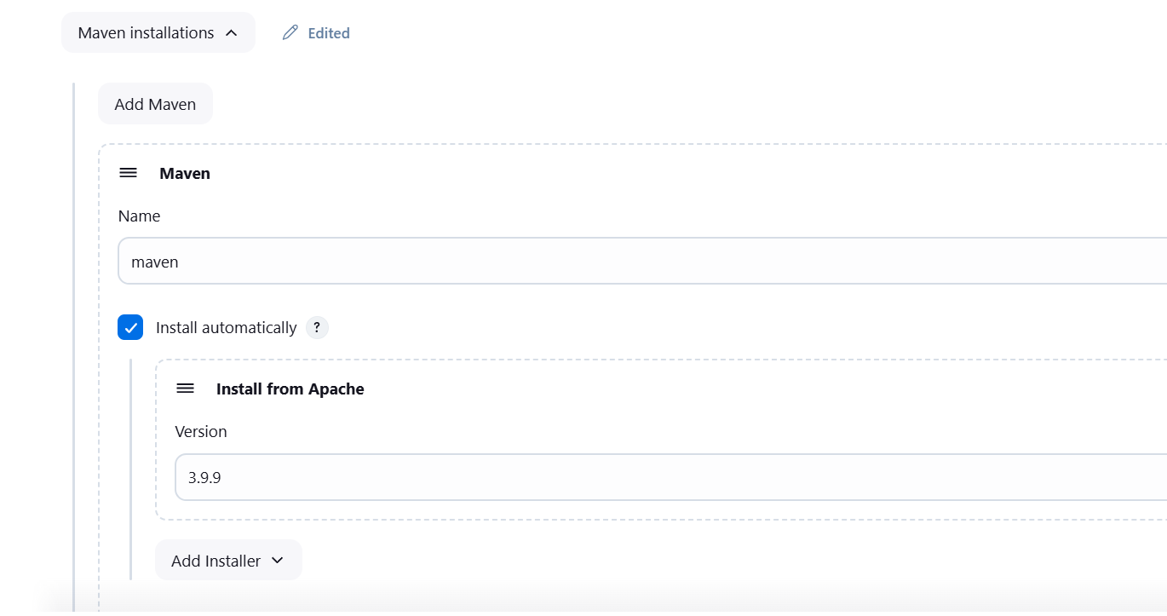

Now create a job, in “MAVEN PROJECT”

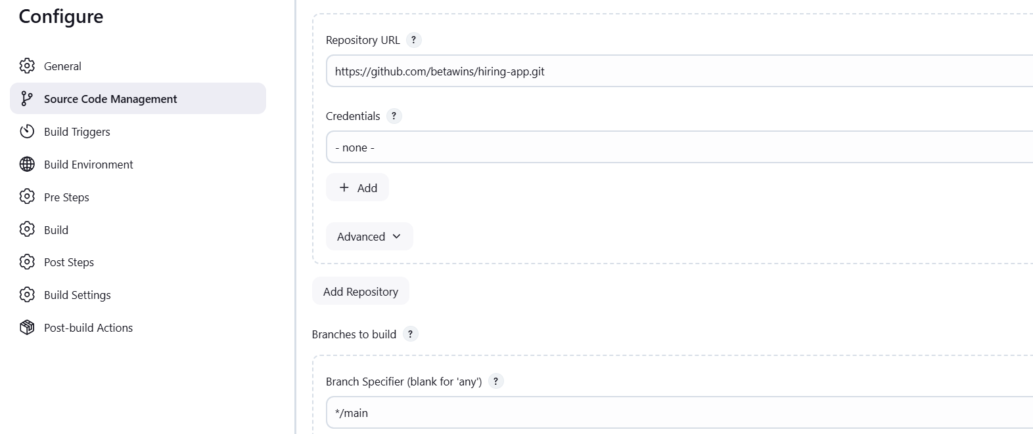

Save the changes and build now

Console Output

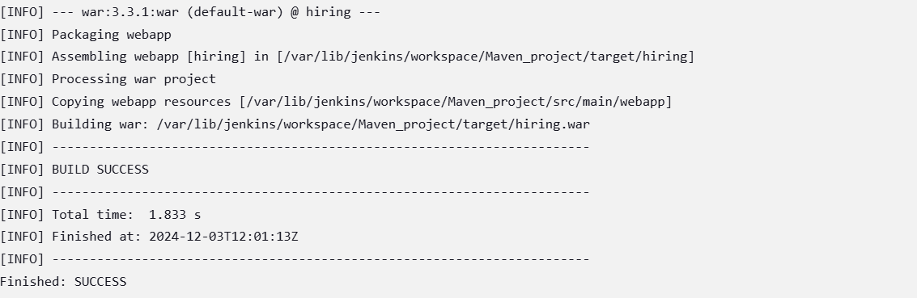

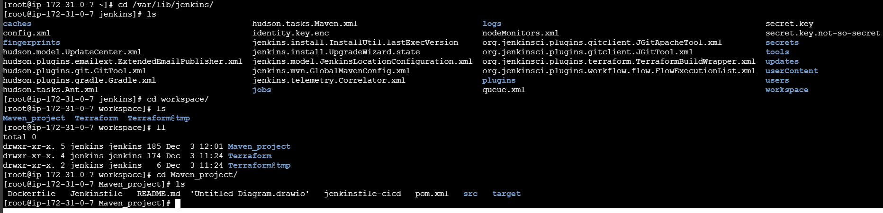

**5) Use the below code and create a parameterized job in Jenkins stage**

**1: Git clone stage**

**2: Maven Compilation Code:**

[**https://github.com/betawins/java-Working-app.git**](https://github.com/betawins/java-Working-app.git)

**Steps**

Downloaded the plugin “Maven Integrating plugin”

Creating the job in maven project

Now, go to job and configure the parameters [General]

Added the two parameters

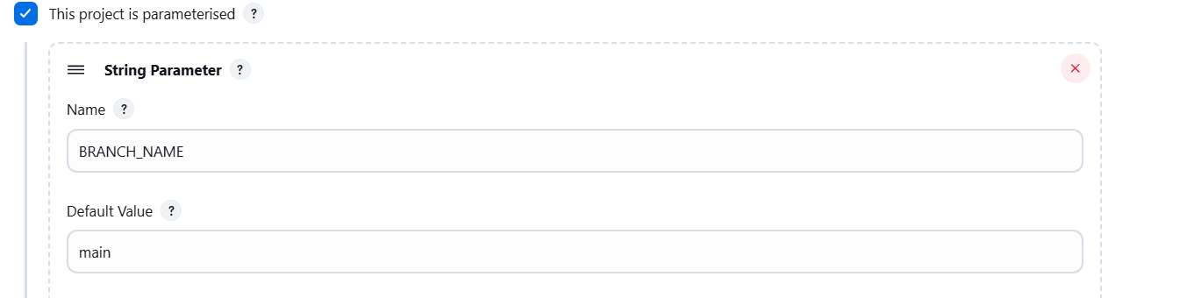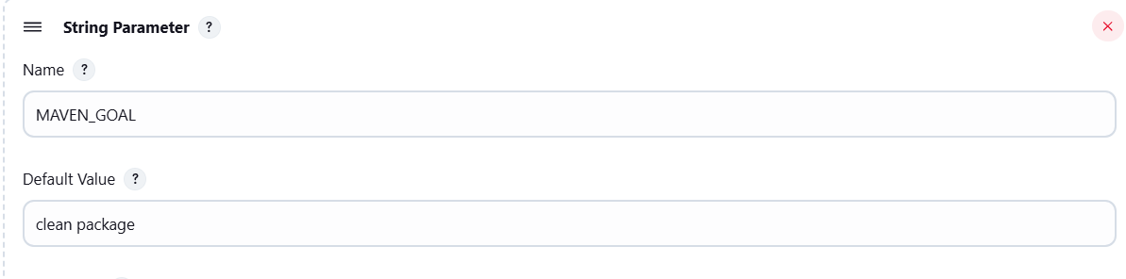

In SourceCodeManagement

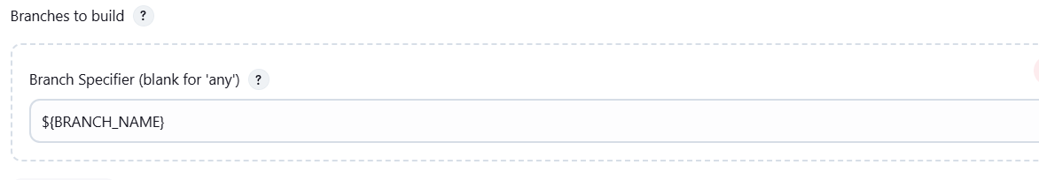

**Added post-build Step**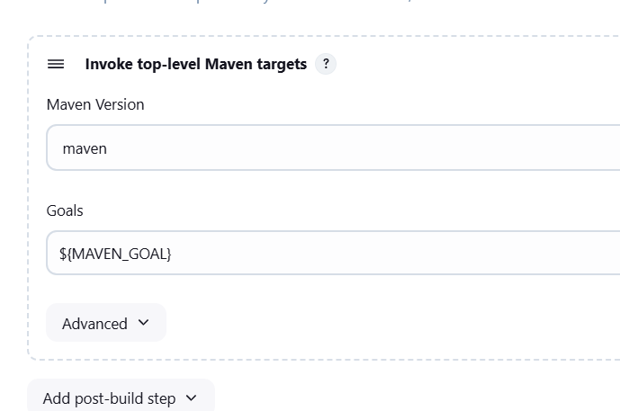

Save the changes

And Build with parameter

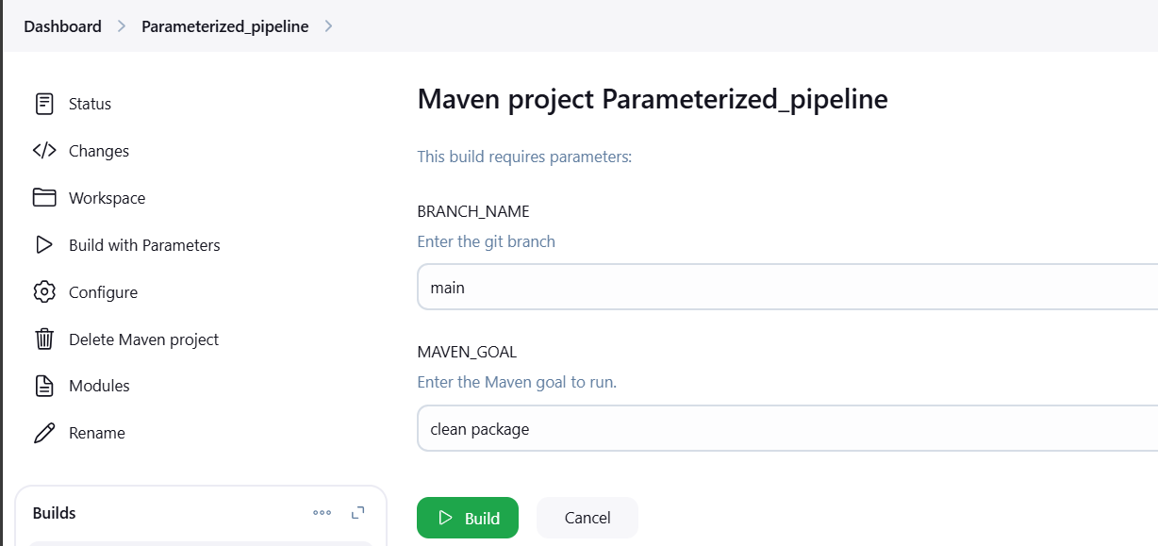

**Click on Build**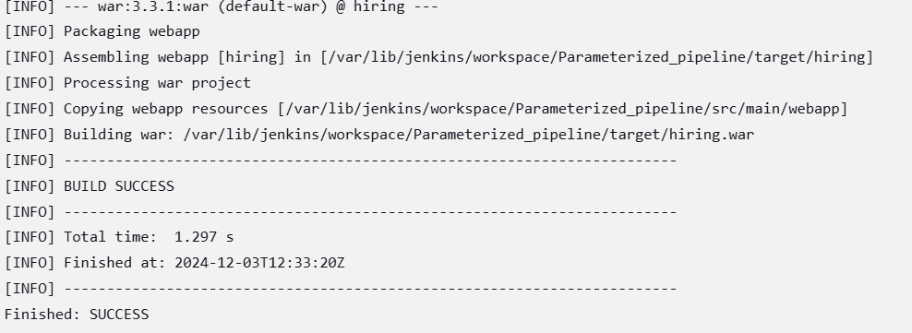

**In Jenkins**

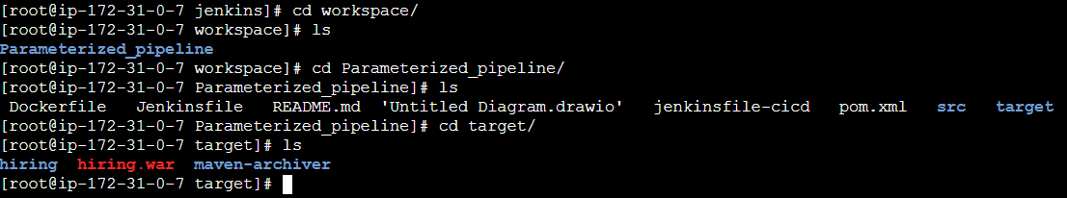

**6) What are the global variables in Jenkins?**

In the Jenkins pipeline, global variables are predefined objects or values accessible throughout the entire pipeline script. They're handy tools that Jenkins provides out of the box, ready for use whenever needed. These variables contain valuable information: build environment data. Here are some examples of global variables in Jenkins:

* **JOB_NAME**: Provides the name of the job in Jenkins
* **JOB_URL**: Gives the URL to the job in the Jenkins UI
* **BUILD_NUMBER**: Prints the build number in Jenkins console output
* **BUILD_TAG**: Gives a unique tag for a specific job name and build number
* **BUILD_ID**: The current build ID
* **BUILD_URL**: The URL where the results of this build can be found
* **EXECUTOR_NUMBER**: The unique number that identifies the current executor
* **JAVA_HOME**: If your job is configured to use a specific JDK
* **JENKINS_URL**: The full URL of Jenkins