Terraform[TASK-04]

**1) Watch terraform-04 video.**

**2) Execute the script shown in video.**

Version Constraints:

Changing in terraform providers version may get us into incompatability issues.

By default terraform will always try to download the latest version of provider available from registry.

To make sure to use the specific version provider we can add the provider block in configuration.

Default version[Latest version]

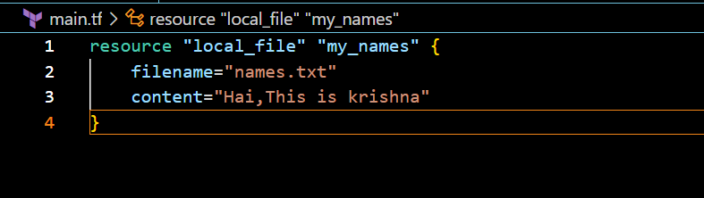

Version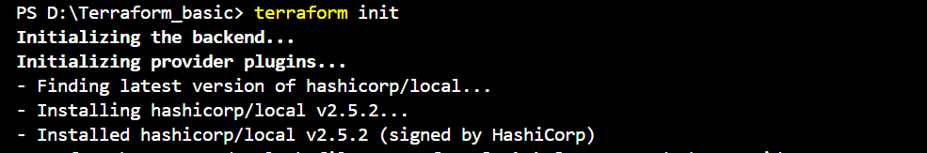

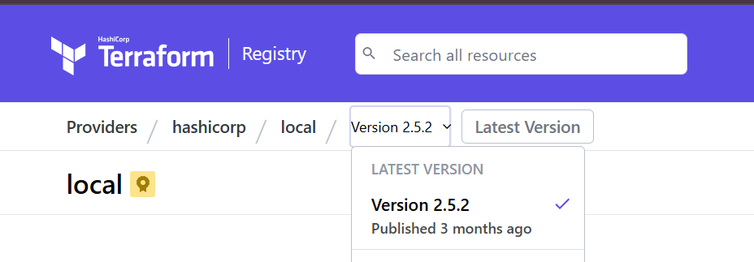

We can modify the version 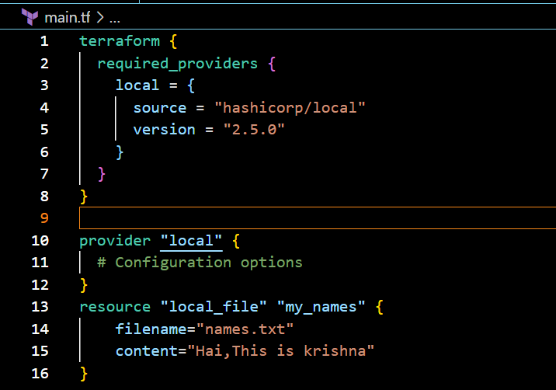

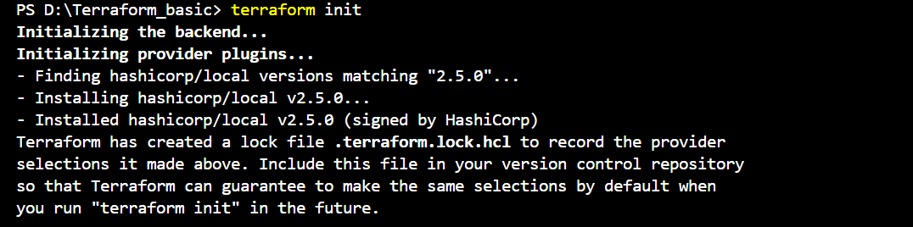

Here we can change the version is “2.5.0”

Different ways of configuring versions 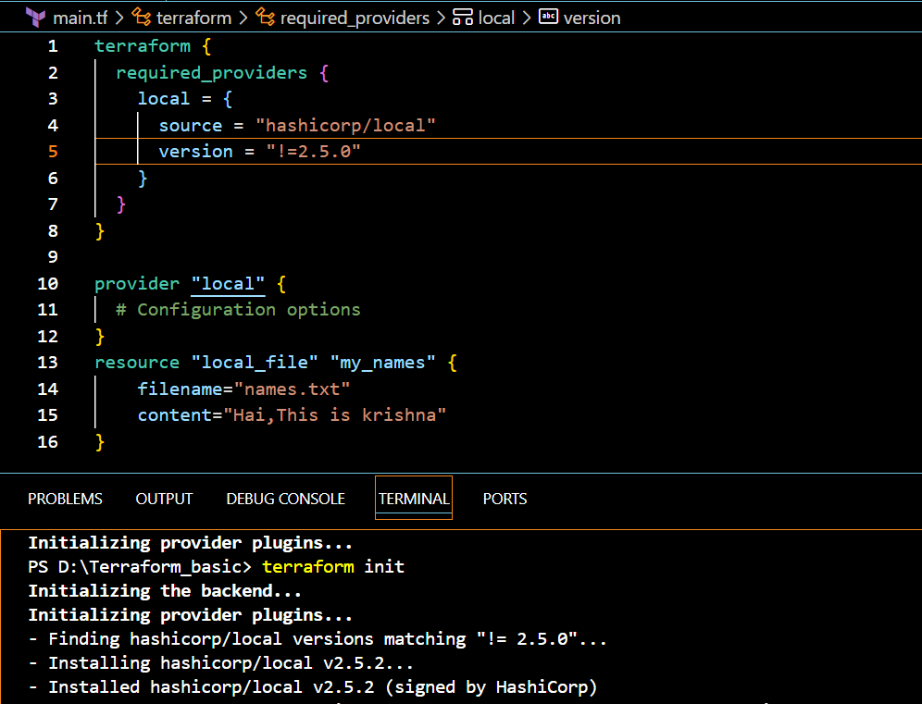

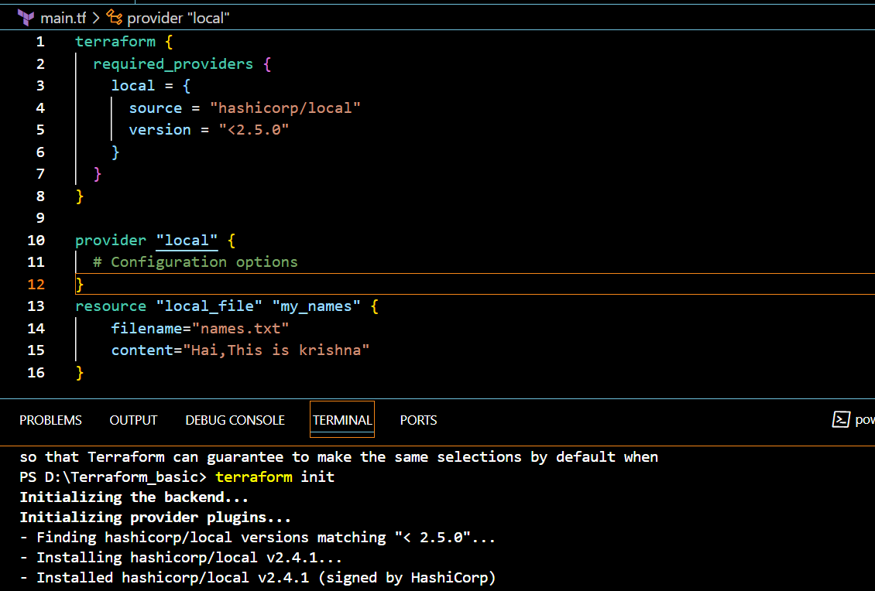

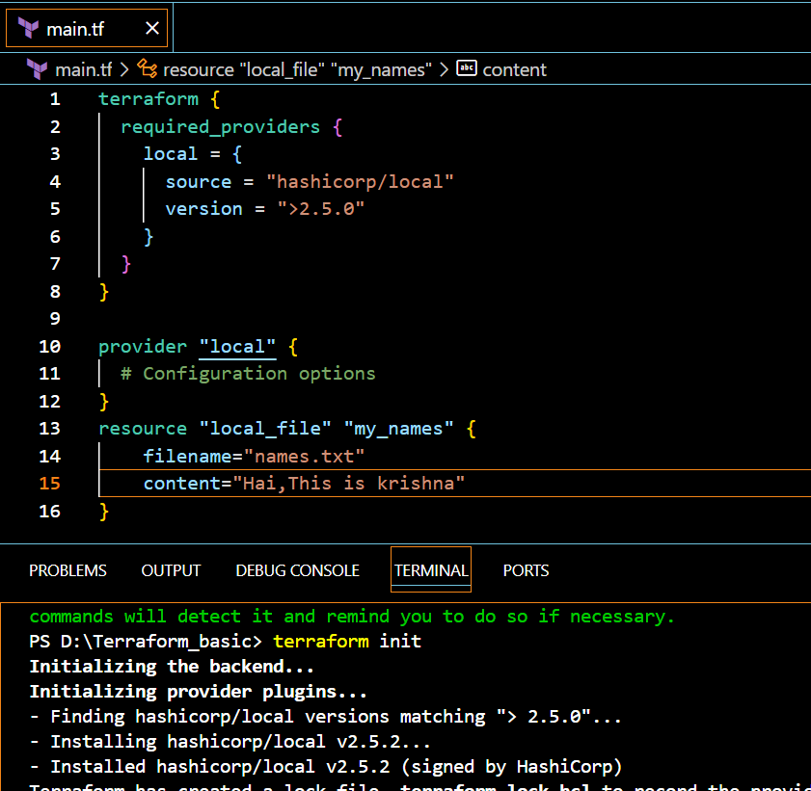

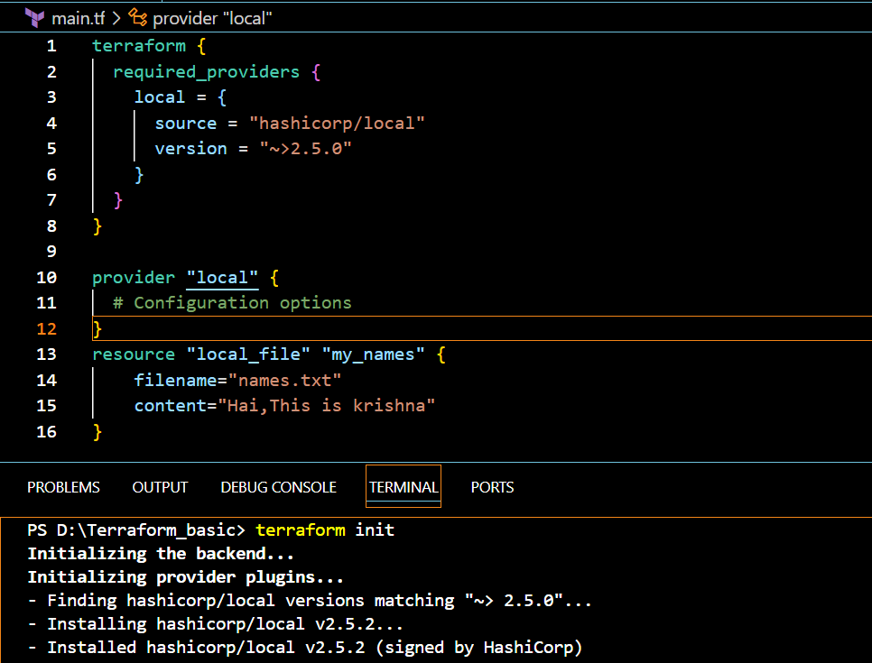

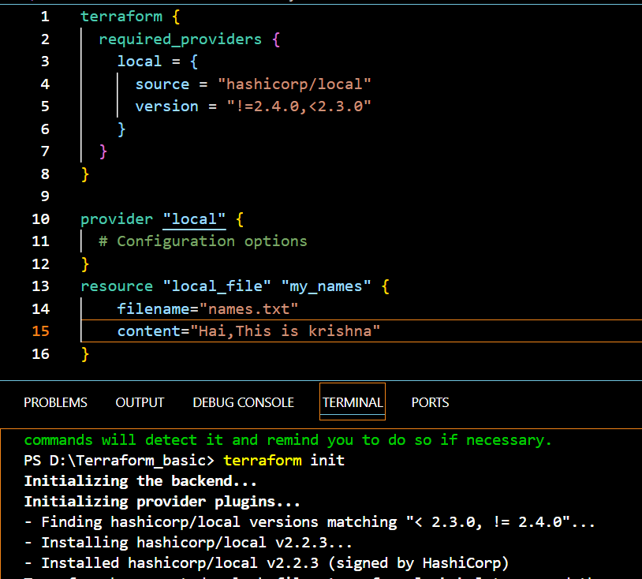

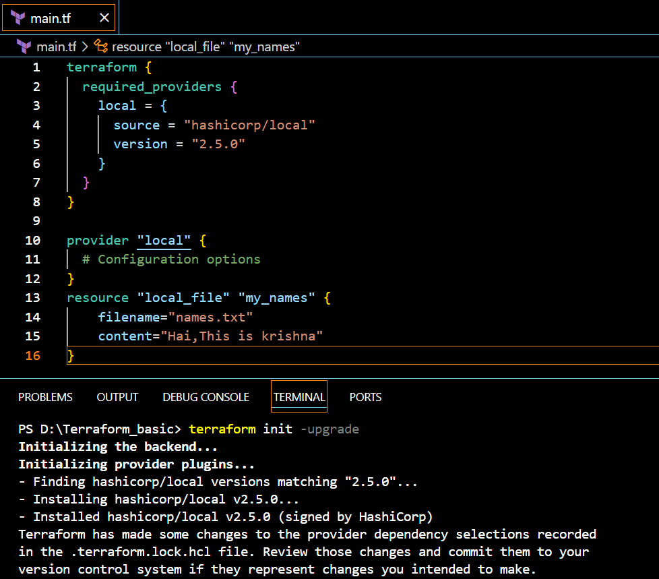

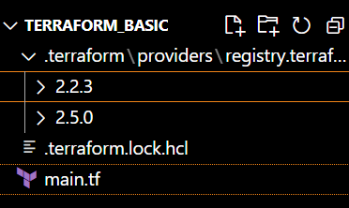

**2)DATA SOURCES**

Apart from terraform we have multiple other tools where the infra can be created.

Ex: ansible,salt,puppet,bash script,manual process**.** 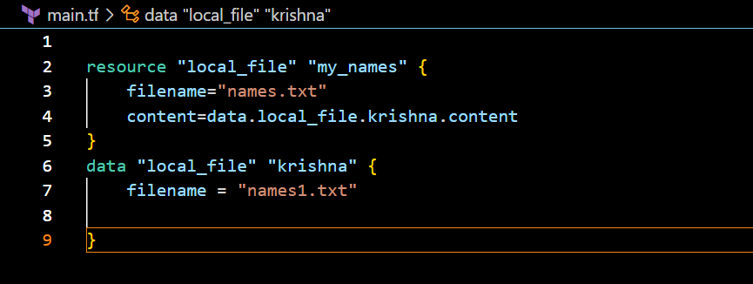

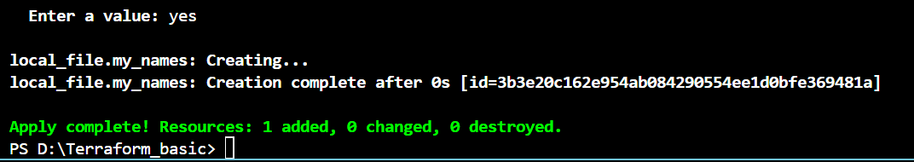

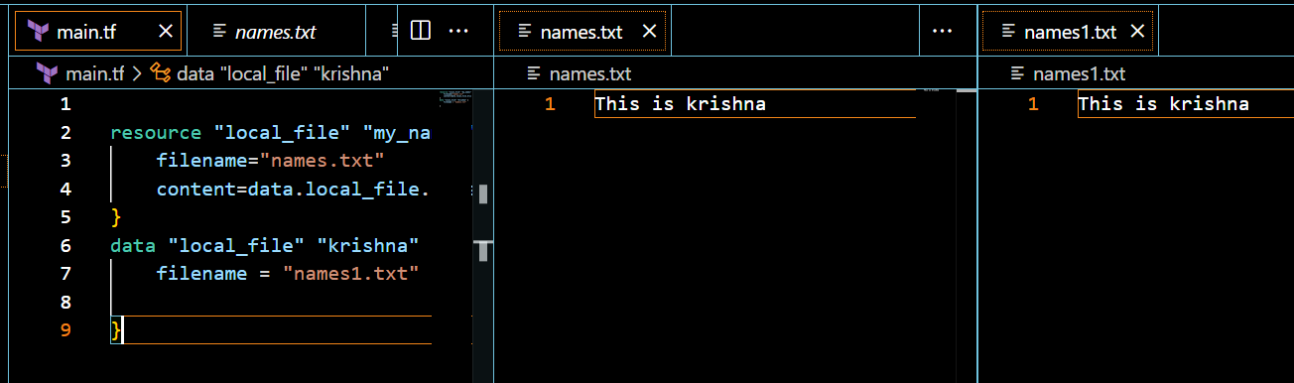

**Data sources are used to read the content of the infrastructure**

**3)Meta arguments**

Meta arguments are used if we want to create multiple resources.

Meta arguments can be used within any resource block to change the behaviour of the resources.

Examples for meta arguments:

1) Depends_on

2) lifecycle rules

3) Count

4) For_each

**Count**:

Creating multiple files

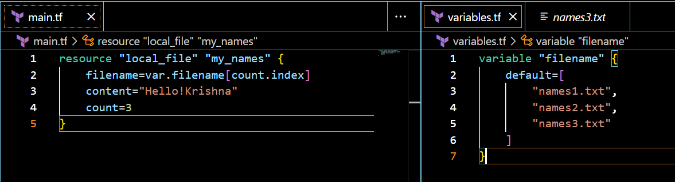

Terraform apply

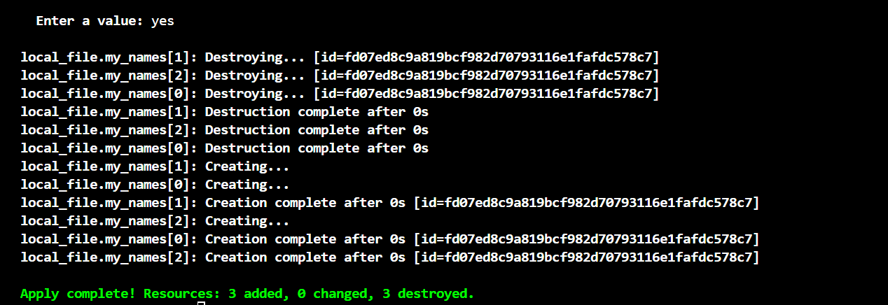

We can see new 3 files got created

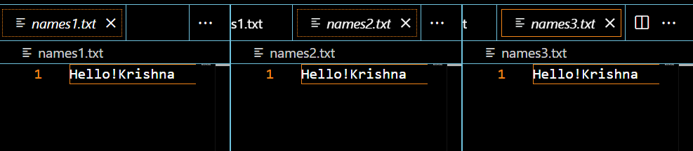

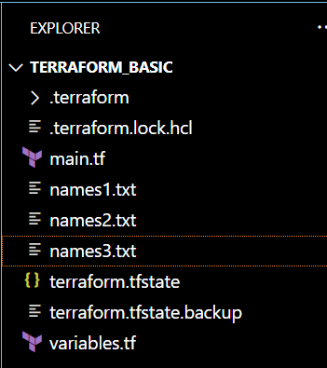

Changing the count values

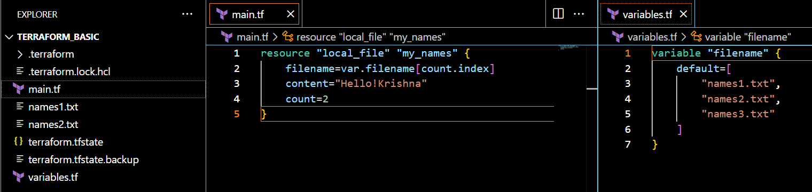

2)

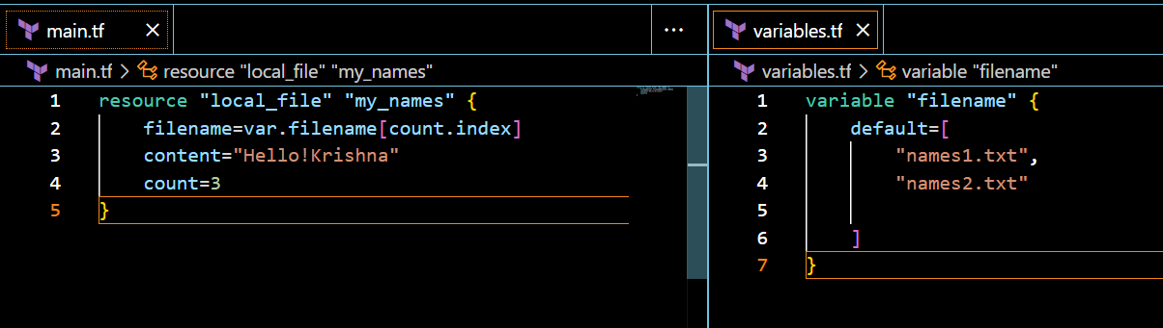

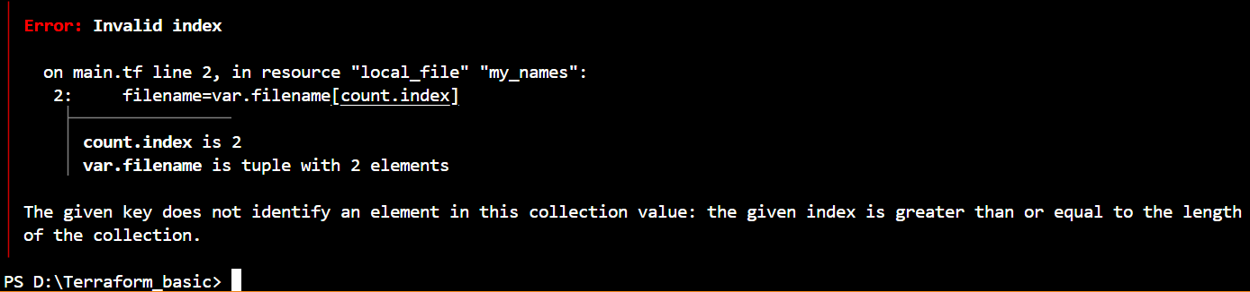

**3)**

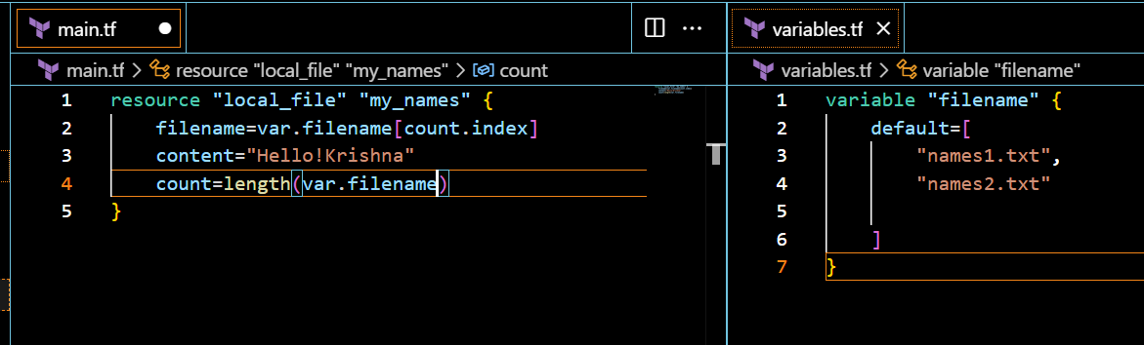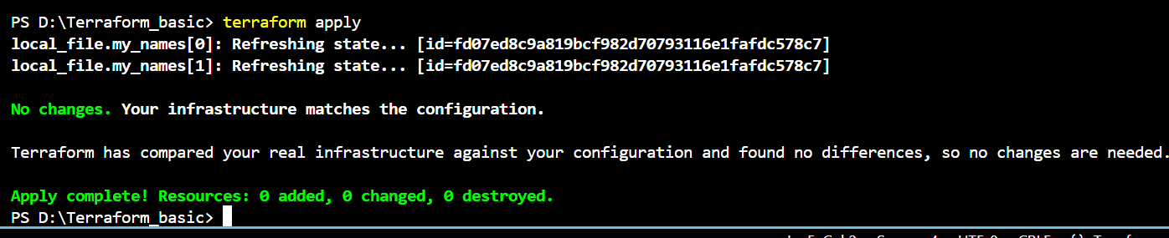

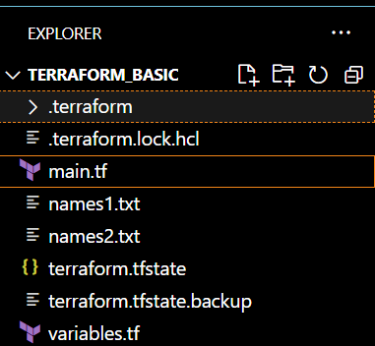

**FOR-EACH**

when we want to update/destroy any one file then we will see un wanted results in count as count will store the output in list and works on index number. To overcome the issue we have for_each meta argument.

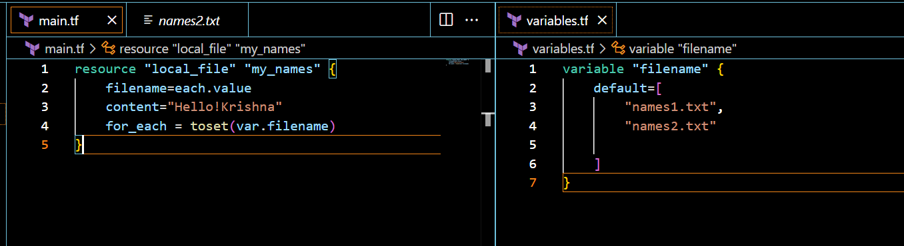

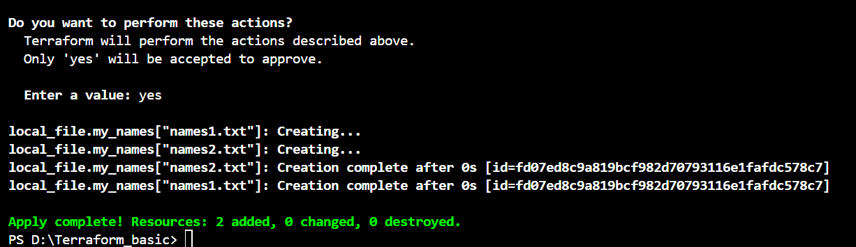

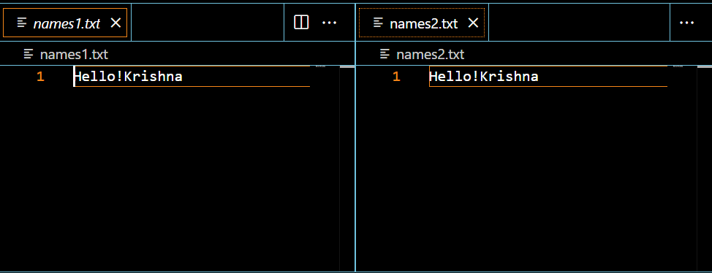

**CREATING AWS RESOURCES WITH TERRAFORM**

For creating an IAM user, first we need to configure cli

In the terraform

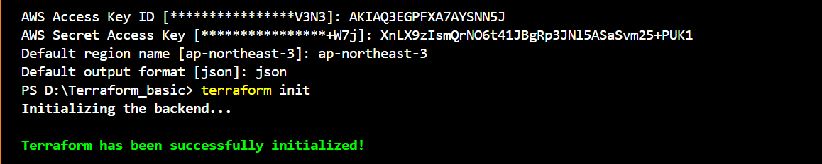

In the main.tf

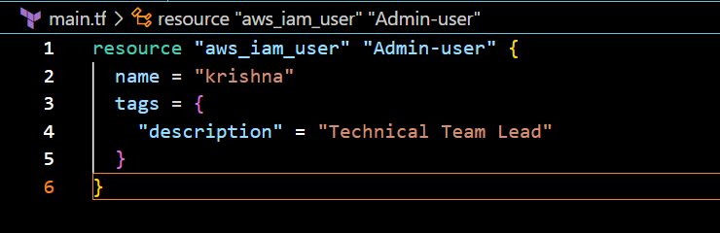

terraform apply

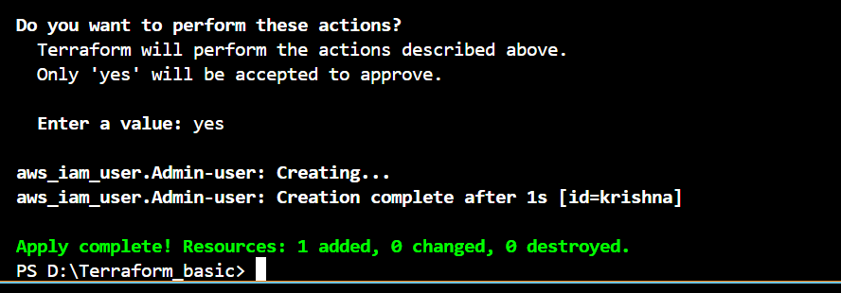

We can check in the aws console 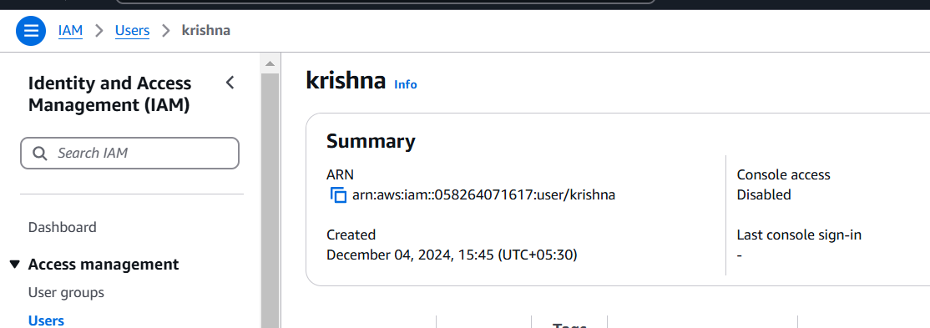

Now, attaching the policy to the user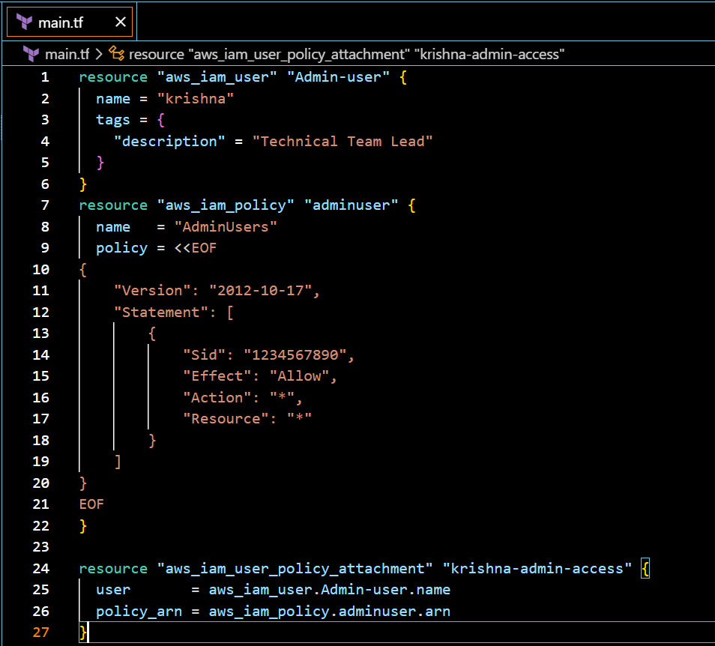

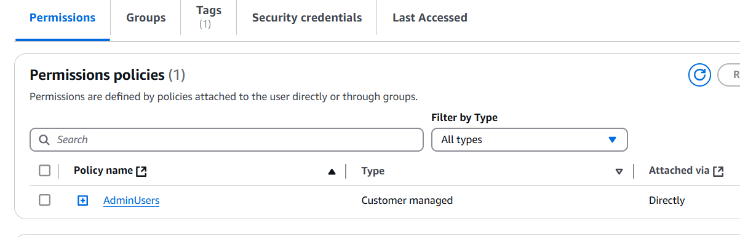

Another way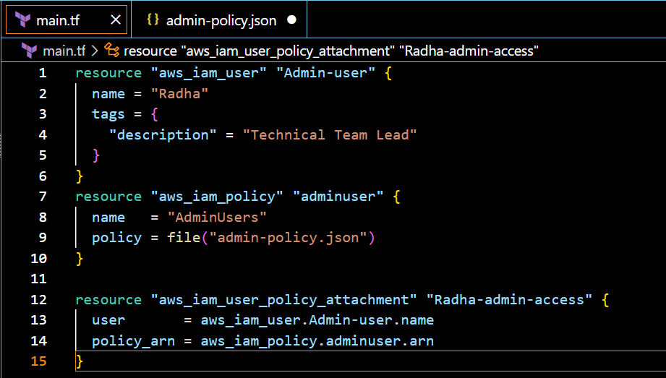

Created one “admin-policy.json” file

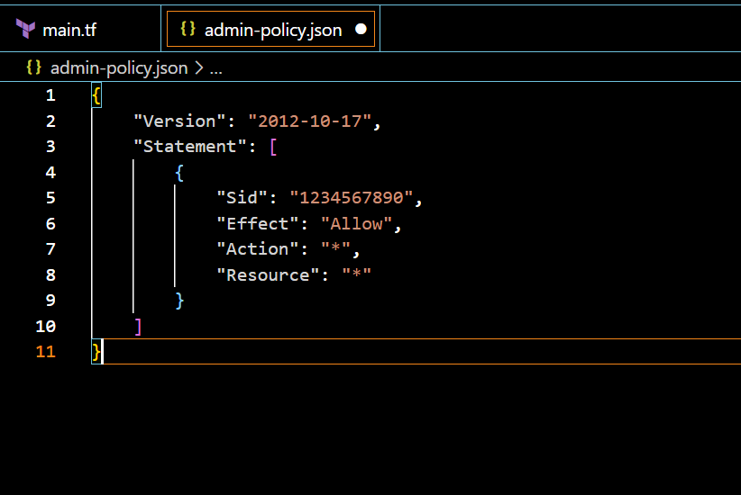



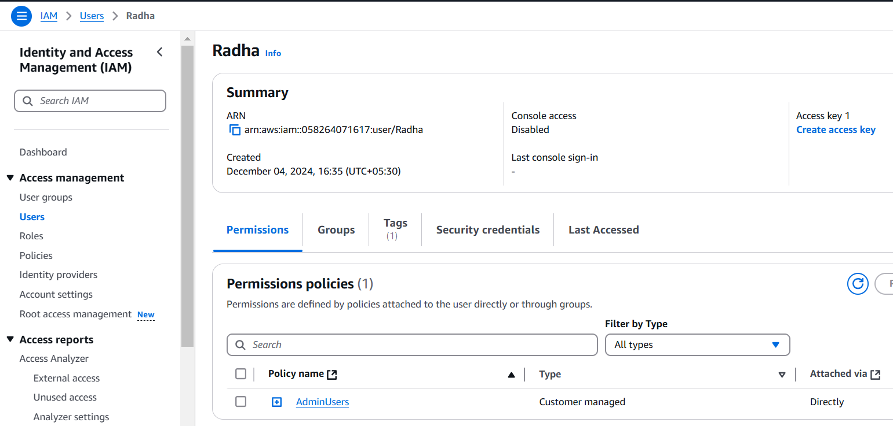

**3) Integrate terraform in Jenkins using Terraform plugin.**

Launching one Jenkins server

In Jenkins server, download the terraform plugin 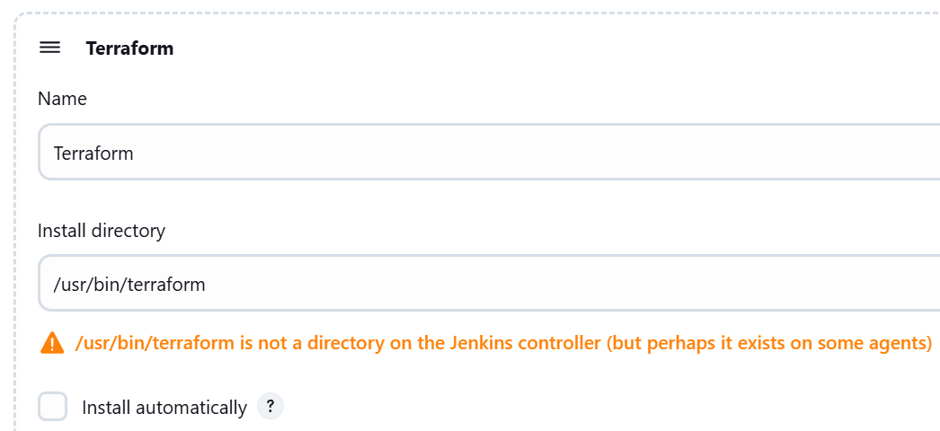

In Jenkins browser,added credentials for aws cli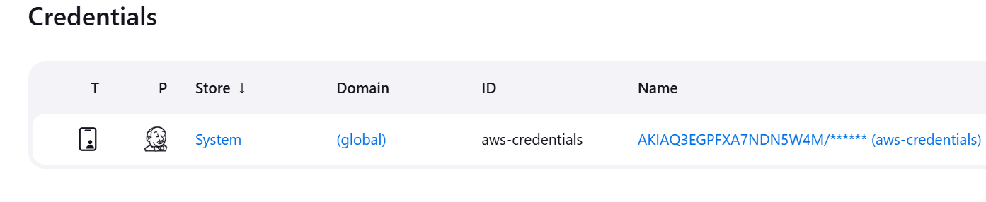

In github, created jenkinsfile,main.tf and admin-policy .json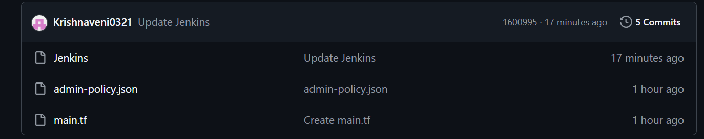

In Jenkins 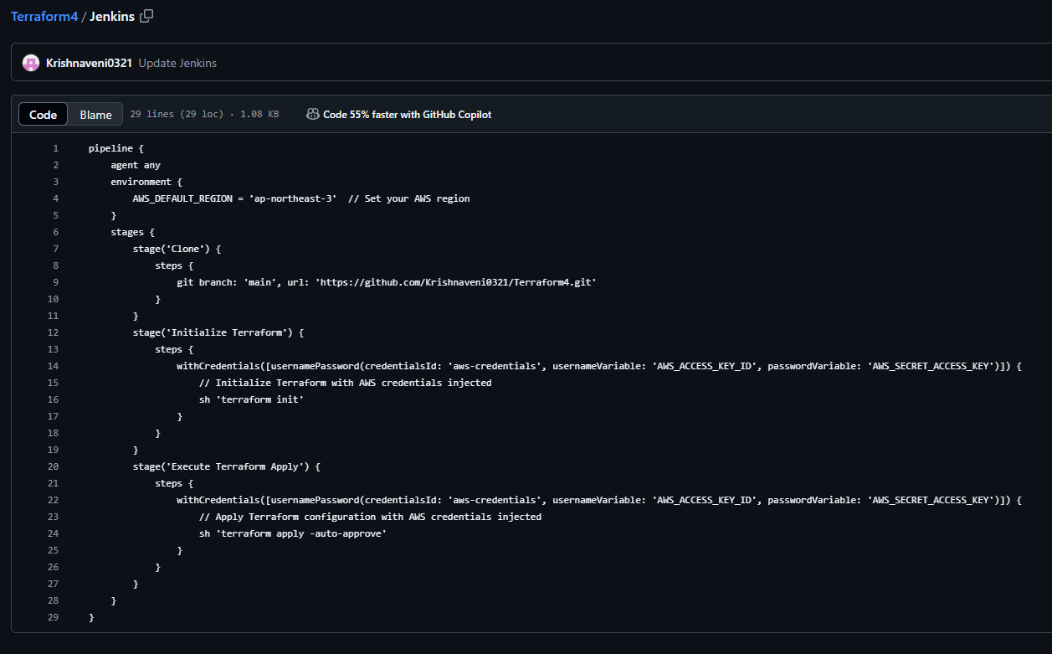

In main.tf

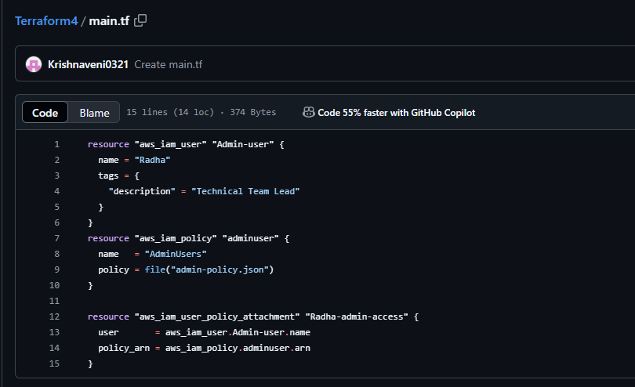

Admin-policy.json

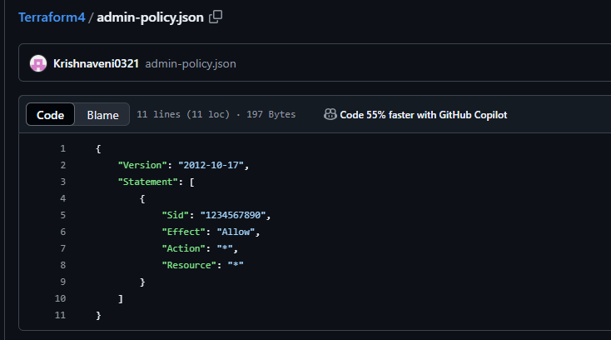

In Dashboard >job

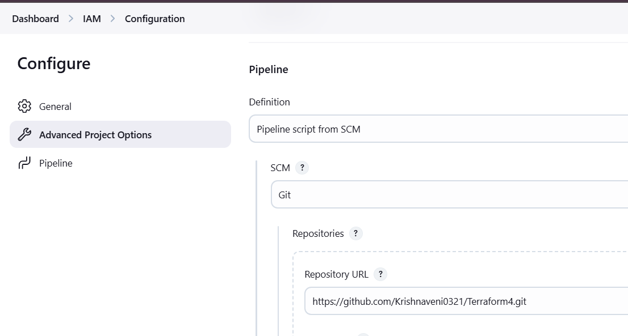

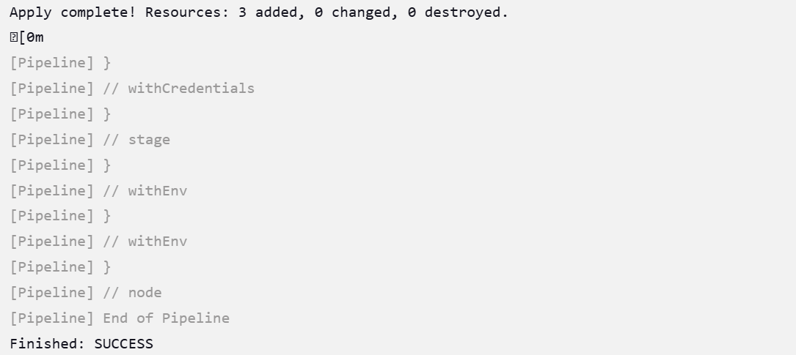

Now, we can check that IAM user created in the Aws account

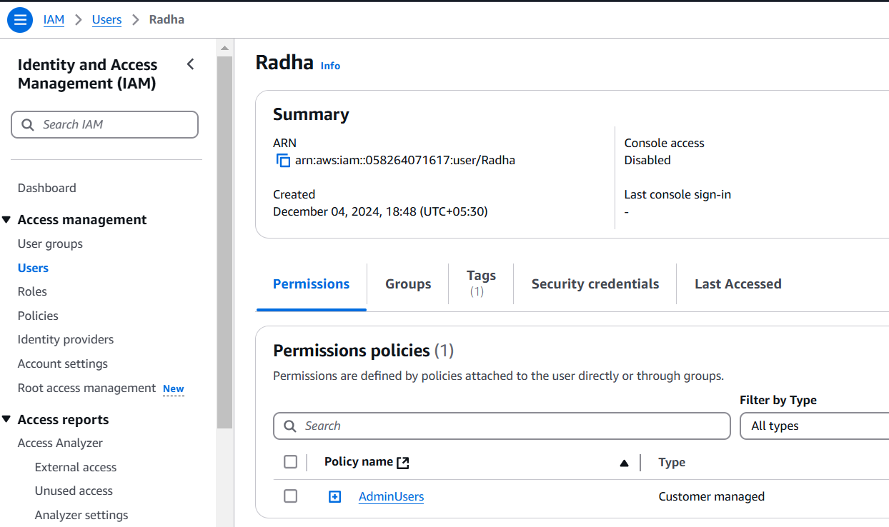

**4) Create CICD pipeline for Nodejs Application.**

[**https://github.com/betawins/Trading-UI.git**](https://github.com/betawins/Trading-UI.git)

**5) Explain 10 Maven commands**

* **mvn –version**

This should display the installed Maven version along with Java details.

* **mvn compile**

Compiles the source code of the project.

* **mvn package**

package: Packages the compiled code into a JAR or WAR file.

* **mvn clean**

This deletes the target directory where compiled and packaged files are stored.

* **mvn install**

install the built project into your local Maven repository, use the install command

This makes the project available for use as a dependency in other local projects.

* **mvn site**

This command generates a site with reports and project information.

* **mvn dependency:tree**

To list all the dependencies of your project, use the dependency:tree

This helps in understanding the dependency hierarchy and resolving conflicts.

* **mvn -B install**

To run Maven without any interactive input (useful in CI environments), use the -B or --batch-mode option

* **mvn clean install –X**

To debug Maven builds and get more detailed output, use the -X or –debug

* **mvn clean install –U**

To force Maven to update snapshots and releases, use the -U or --update-snapshots option

* **mvn source:jar**

To generate a source JAR file for your project, use the source:jar goal