Terraform[Task-06]

**1) Watch terraform-06 video.  
2) Execute the script shown in video.**

**Terraform Modules**

Modules is a collection of configuration files in a directory.

Created a project: Terraform_basic

In that project, Created two environments

aws_instance[Root Module]

In this created two files,main.tf,variables.tf

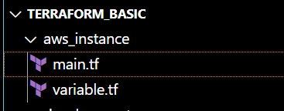

In main.tf

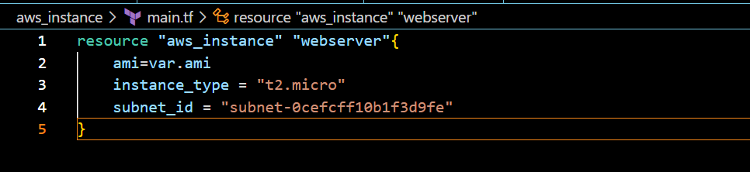

In variables.tf

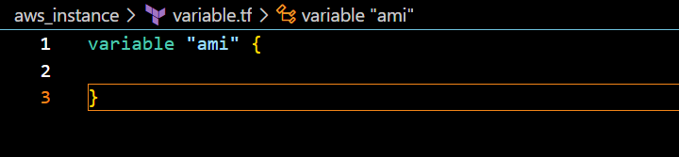

Another one,development environment

Created a module[in main.tf]

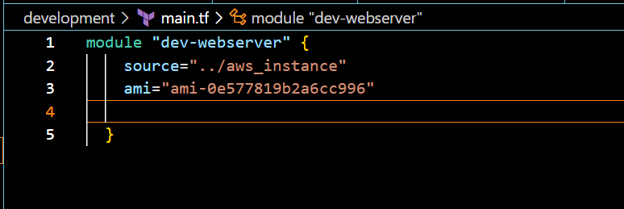

After saving the files,

Switching to the development environment

Cd .\development\

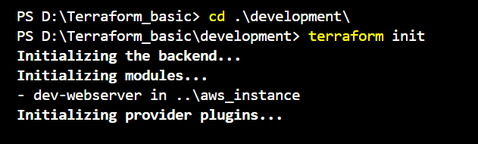

Step:1-terraform init

Step:2-terraform apply

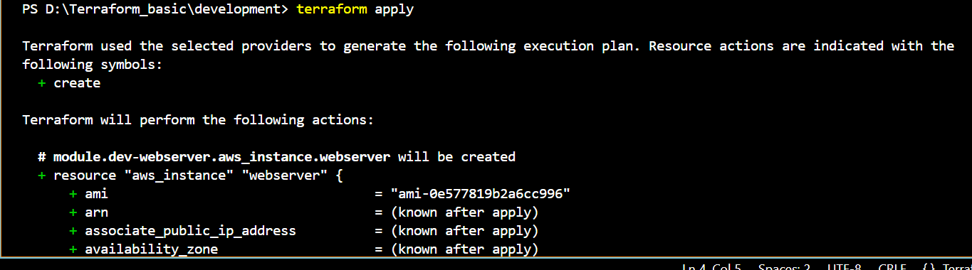

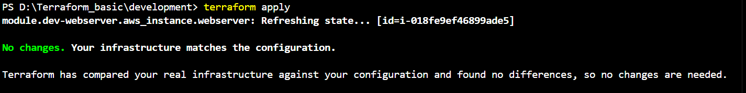

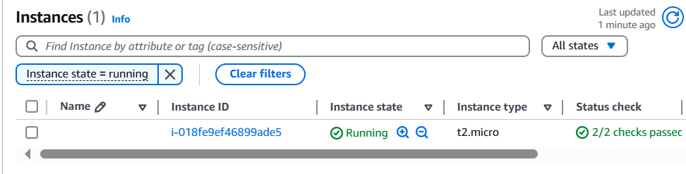

We can also replicate for production environment

**Terraform Workspaces**

Workspace can be used if we have multiple project/environments using the same configuration.

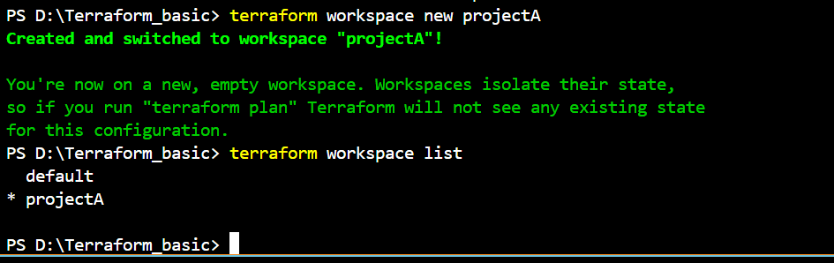

EXAMPLE:

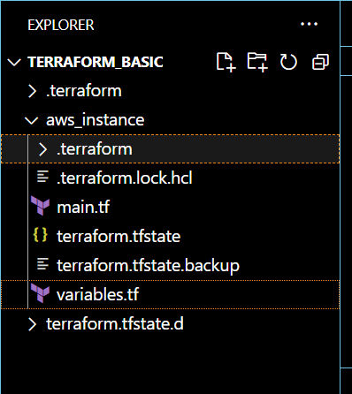

In main.tf

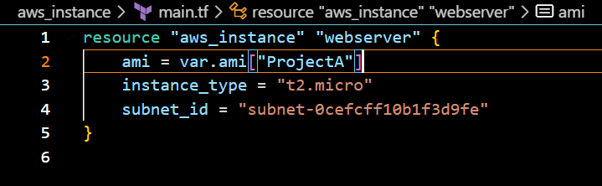

Variable.tf

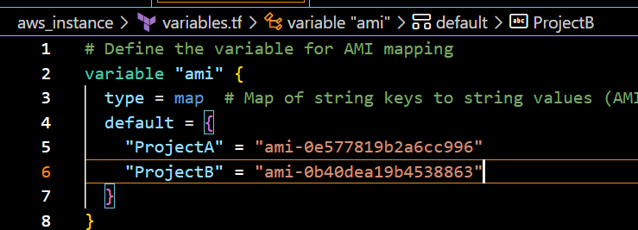

Terraform init

Terraform apply

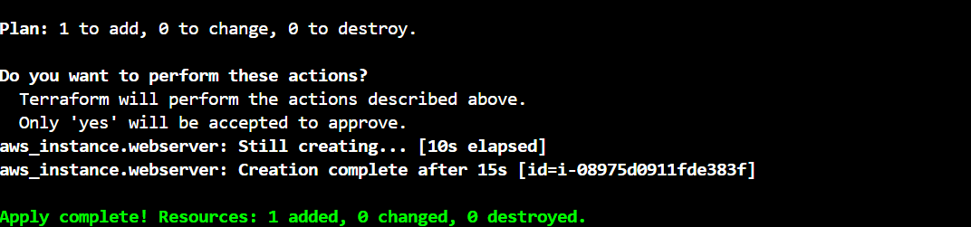

Final output

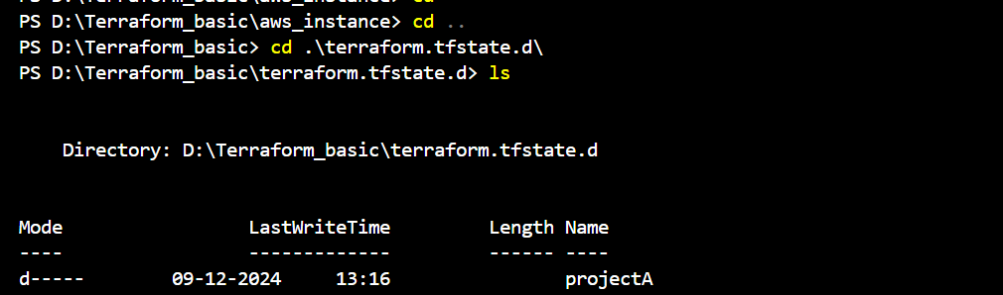

**3) Provision ec2, s3 and vpc using Terraform modules.**

Created the ec2,s3,vps [main.tf,variables.tf files]

Ec2.

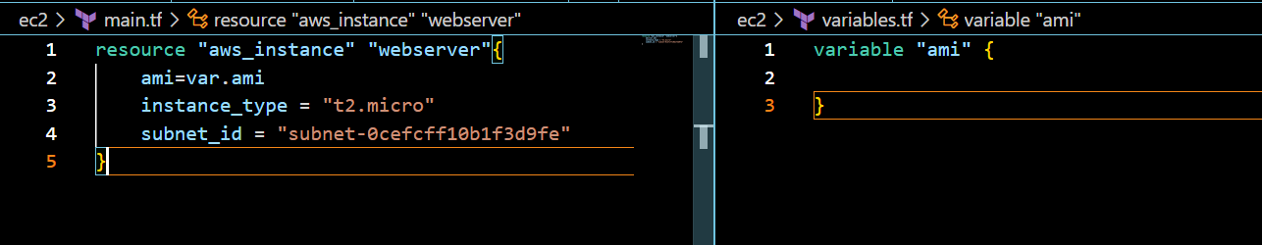

**S3**

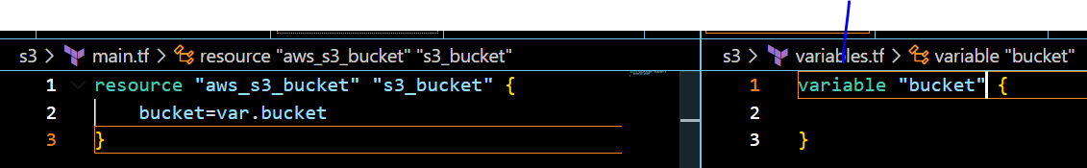

**Vpc**

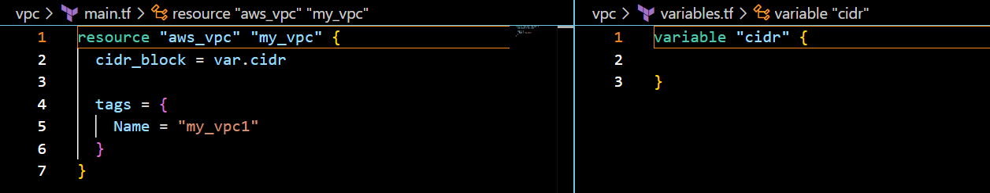

**Creating a module**

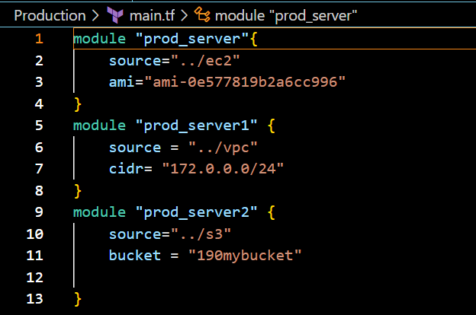

**Execution**

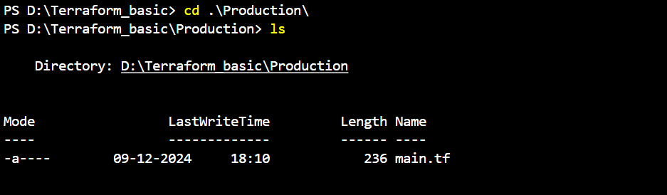

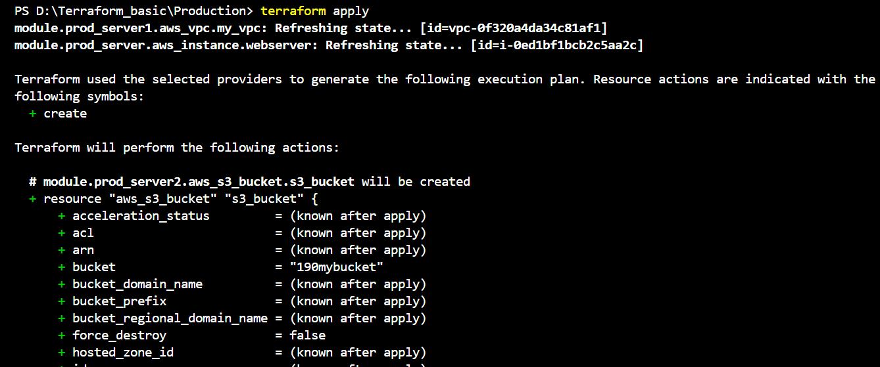

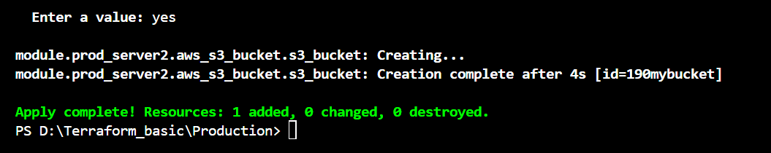

**Outputs of console**

**VPC[my-vpc1]**

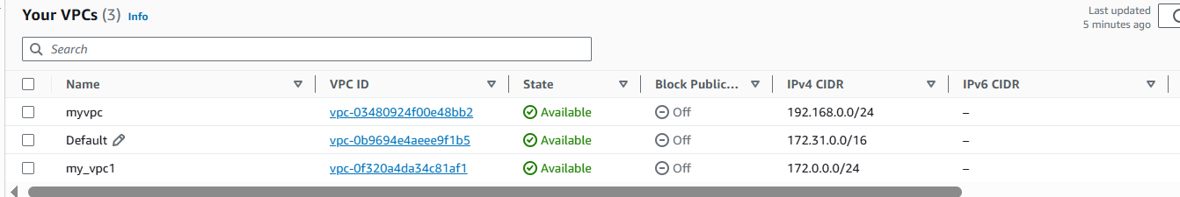

**S3**

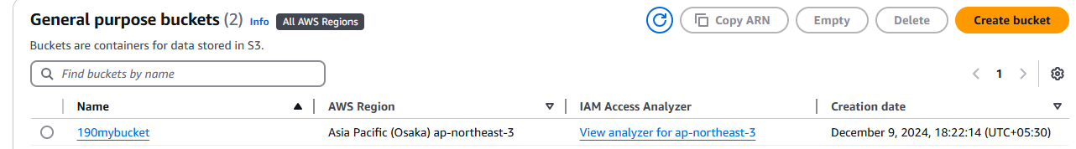

**Ec2**

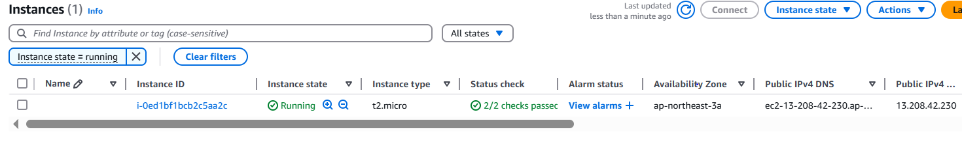

**4) Provision ec2 for 3 different environments (Dev, Staging and Prod) using terraform workspaces.**

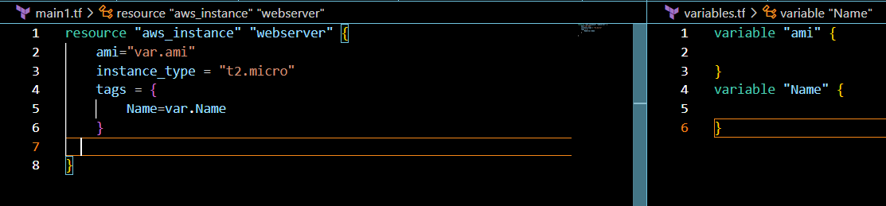

Creating 3 different environments using workspace

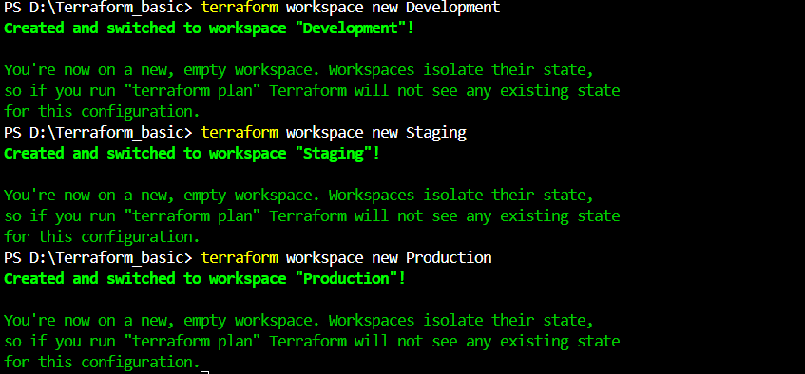

Checking the list of environments[workspaces]available

With the command

:terraform workspace list

**Switching to the dev environment**

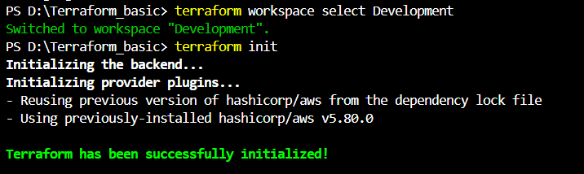

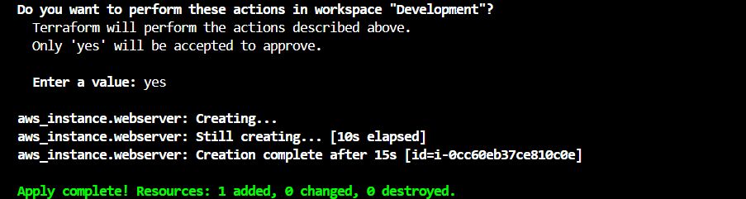

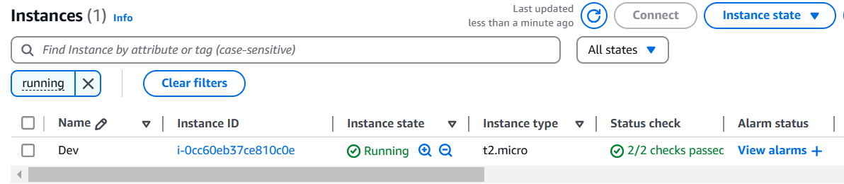

**Switching to the Staging environment**

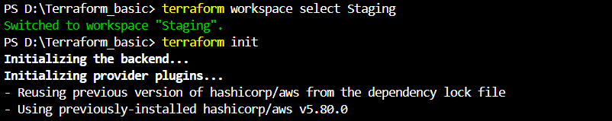

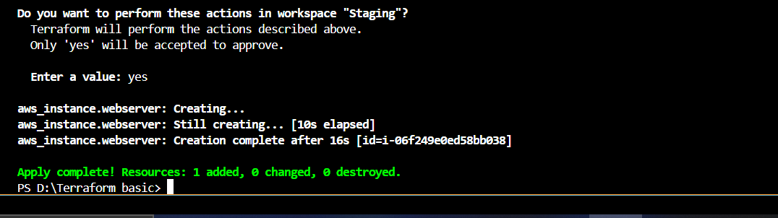

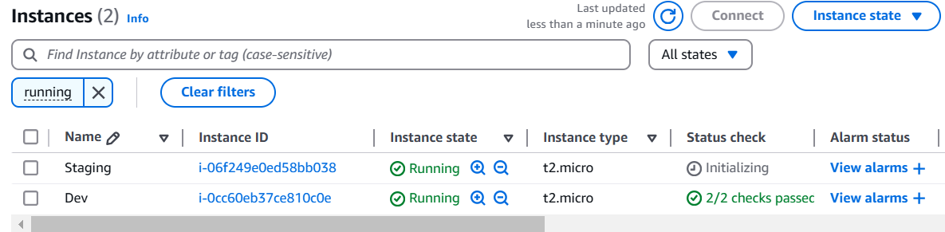

**Switching to the Production environment**

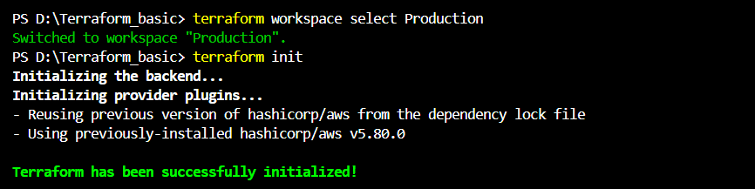

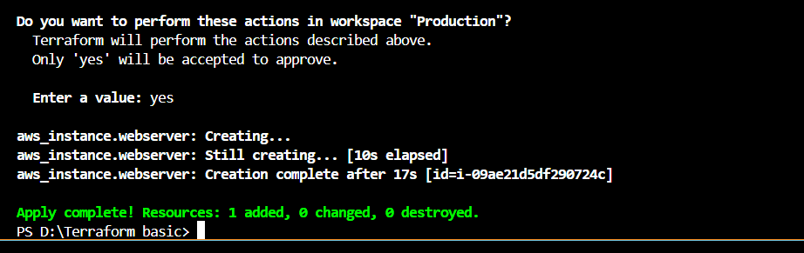

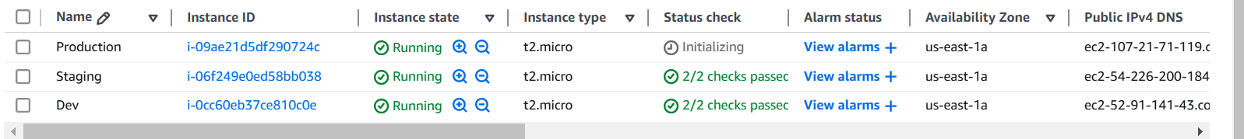

**The state files of these workspaces infra is created in  
“terraform.tfstate.d”**

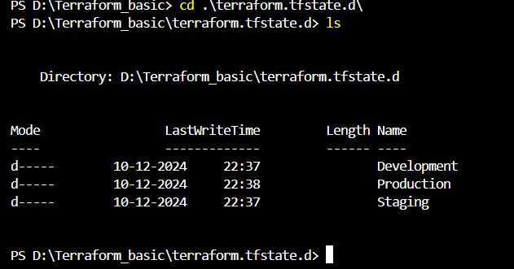

**In each workspace its statefile is present – development  
workspace statefile**

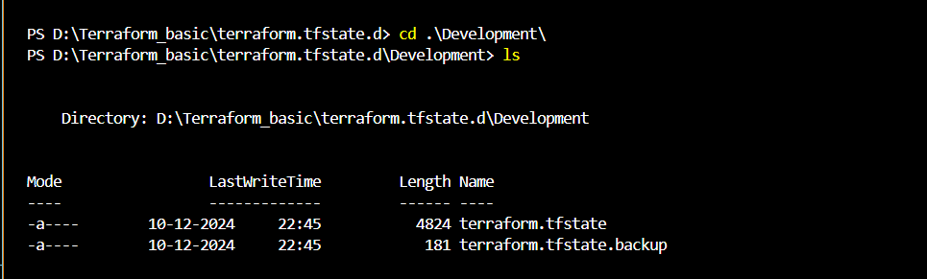

**In each workspace its statefile is present – Production workspace statefile**

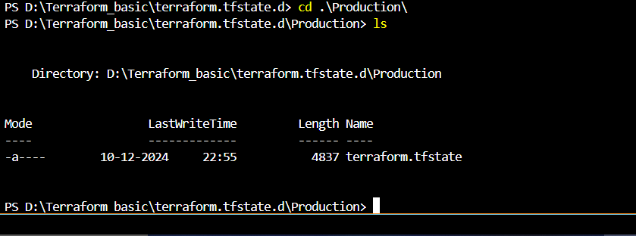

**In each workspace its statefile is present – Staging  
workspace statefile**

