Terraform[Final Task]

1) Create VPC

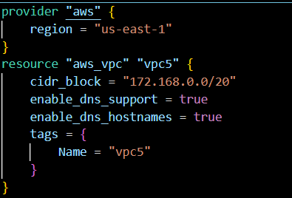

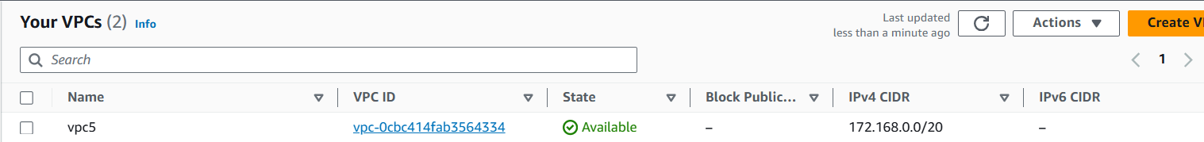

2) Create Internet gateway

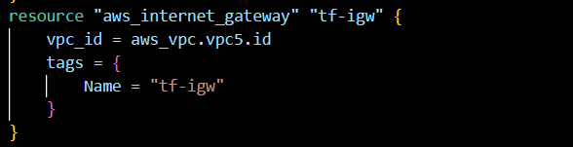

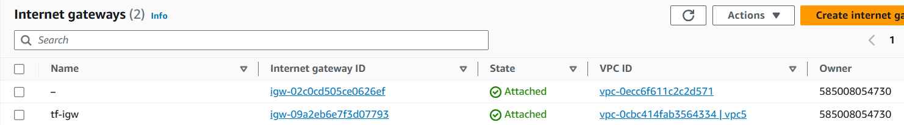

3) Create Custom Route Table

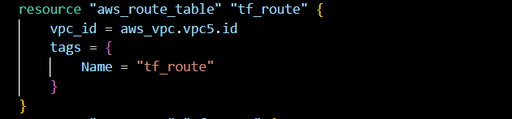

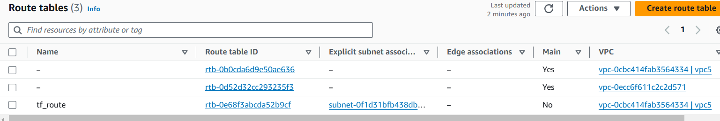

4) Create Subnet

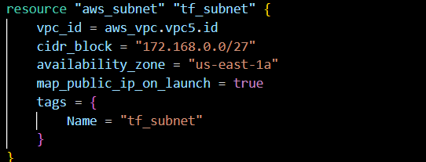

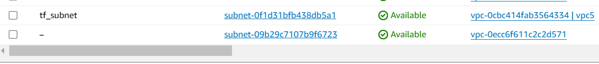

5) Associate subnet with Route Table

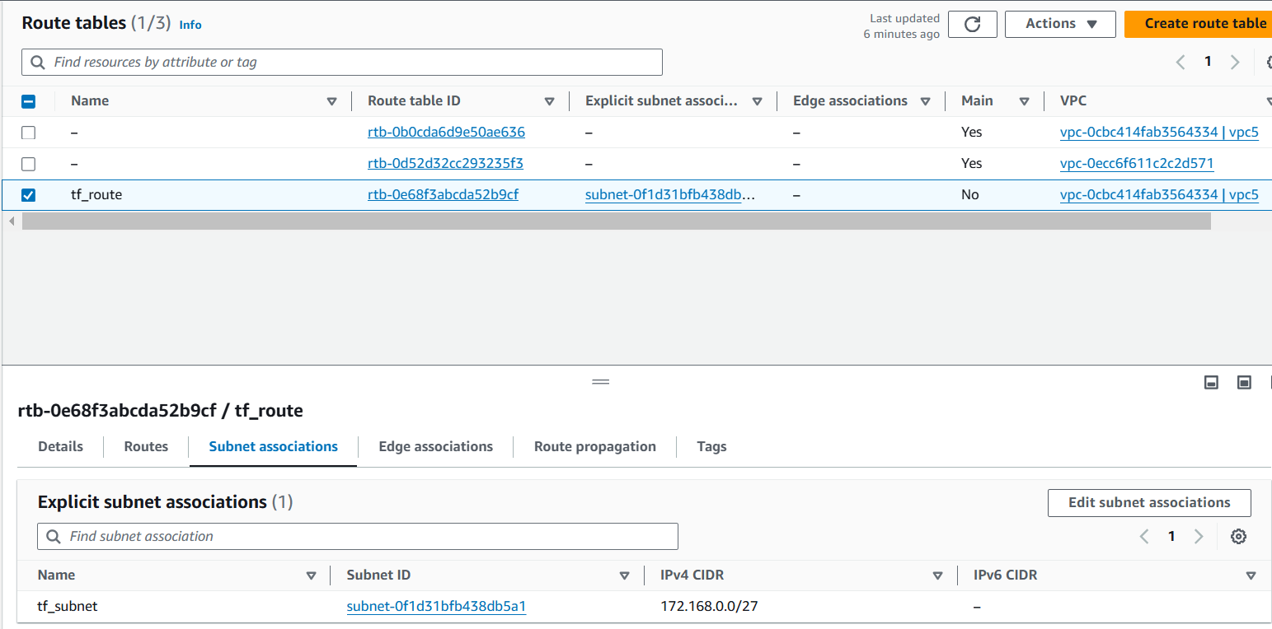

6) Create Security Group to allow port 22.80,443

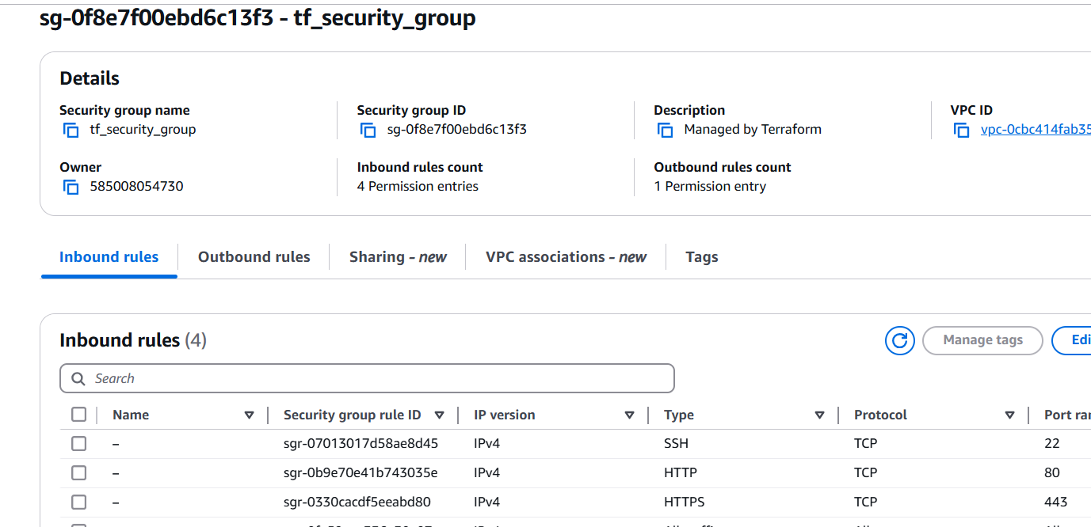

7) Create a network interface with an ip in the subnet that was created in step 4

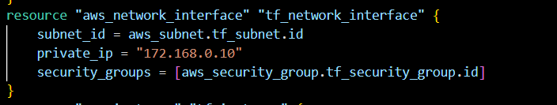

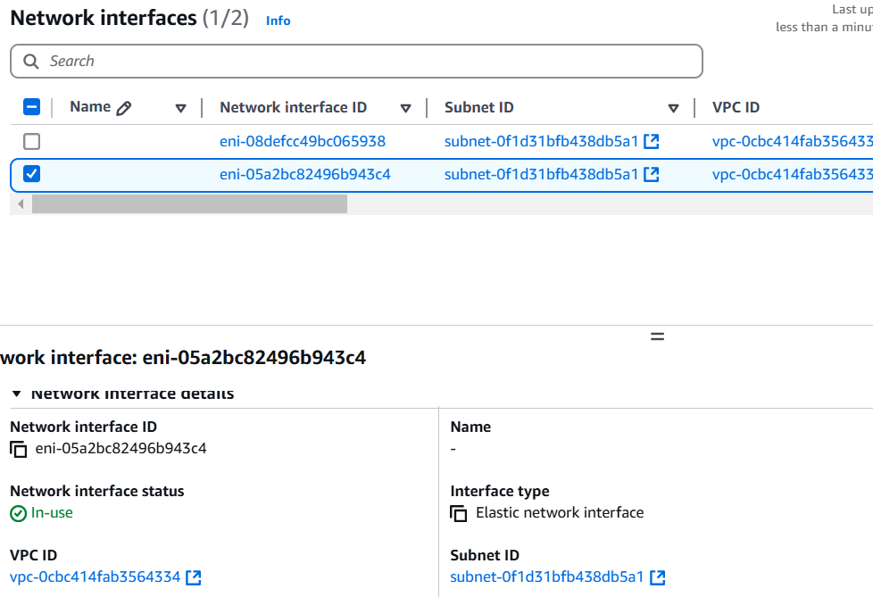

8) Assign an elastic IP to the network interface created in step 7

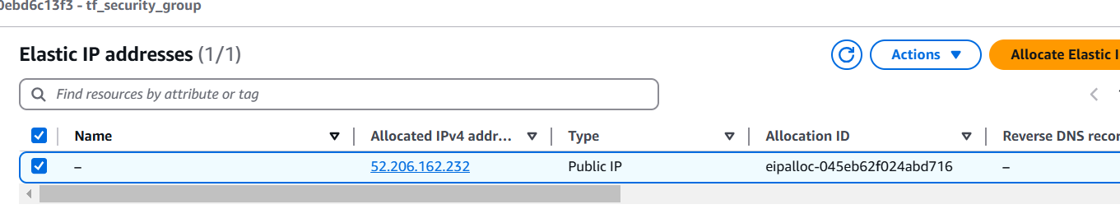

9) Create Ubuntu server and install/enable apache2

