Task -7 [AWS-VPC]

1) Create one VPC,with 1 one public subnet and 1 private subnet.

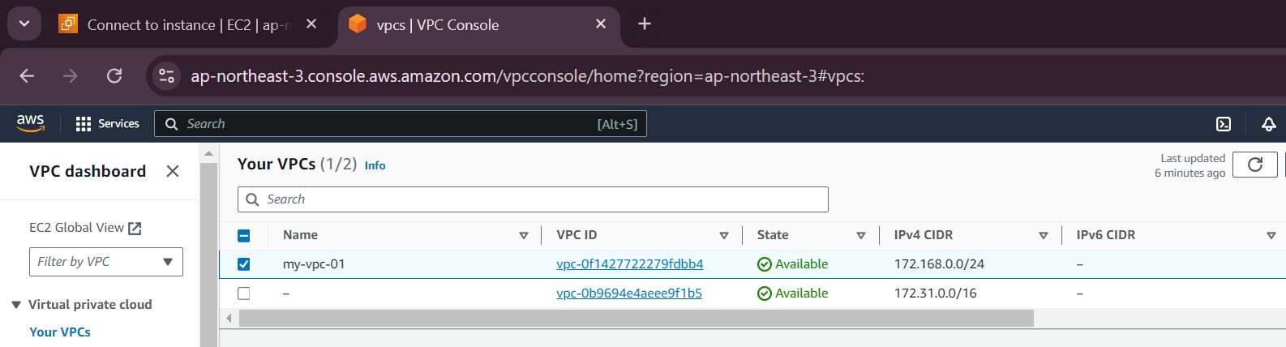

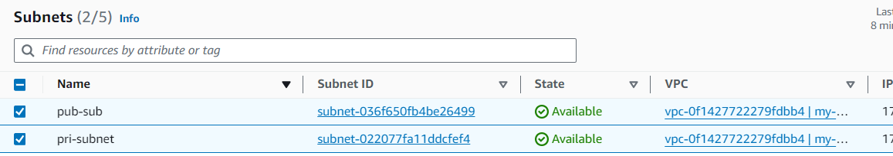

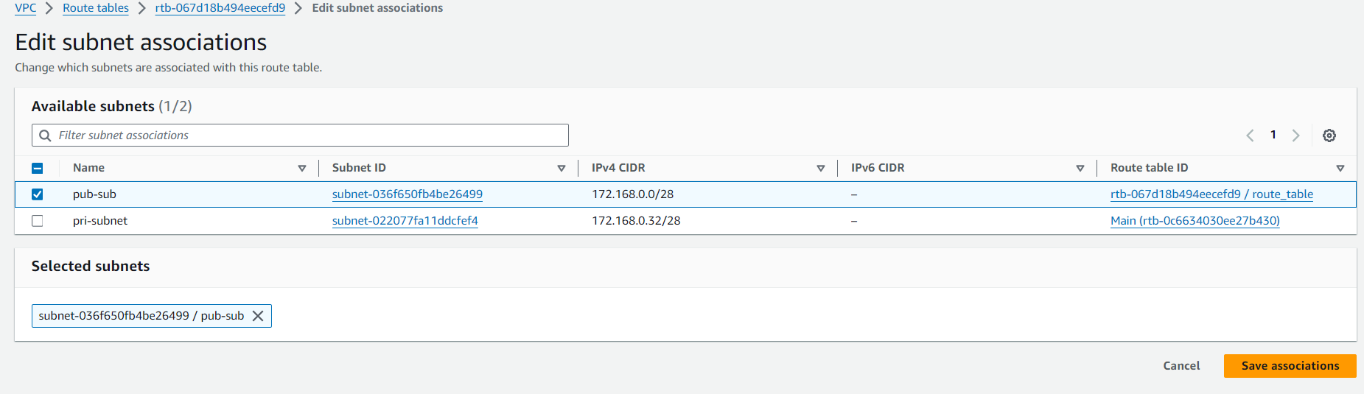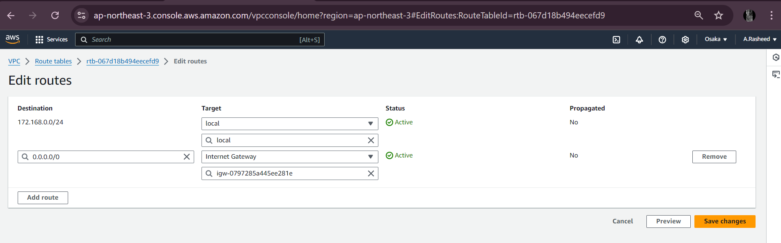

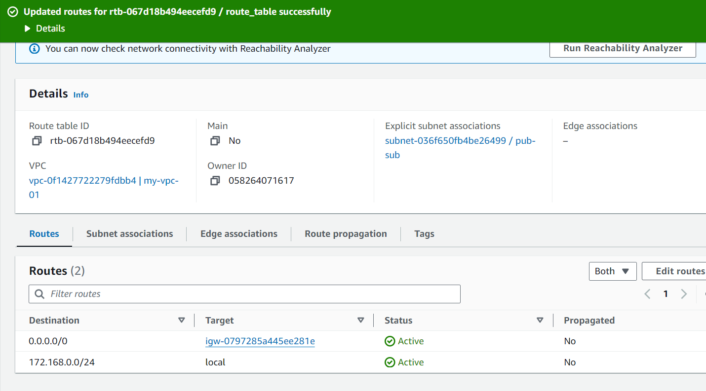

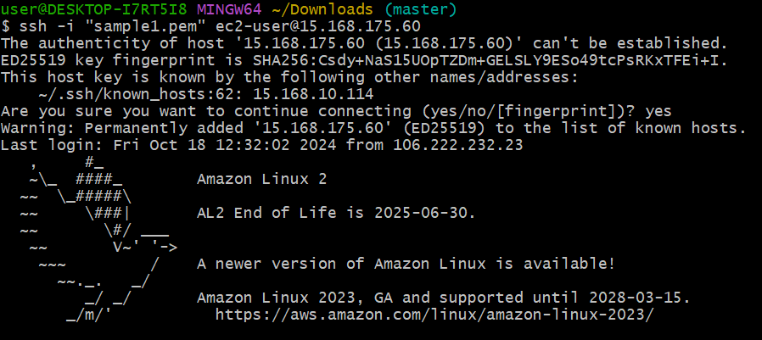

Private subnet:

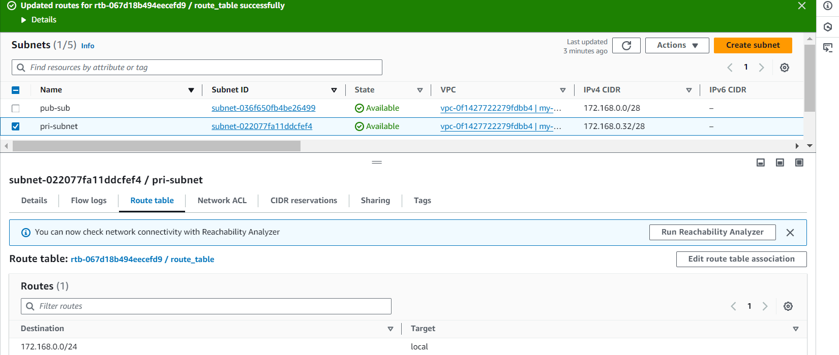

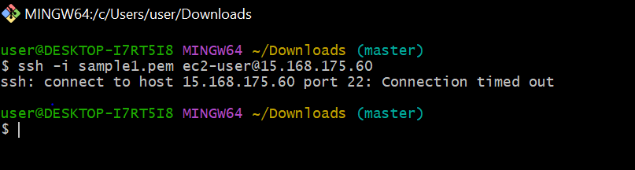

2) Enable VPC peering for cross region

creating a peering another from osaka to mumbai region

Step1:we need to create the peering request for both the regions .

C

I

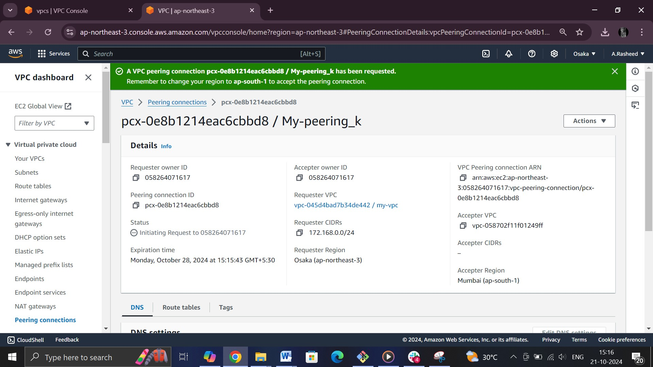

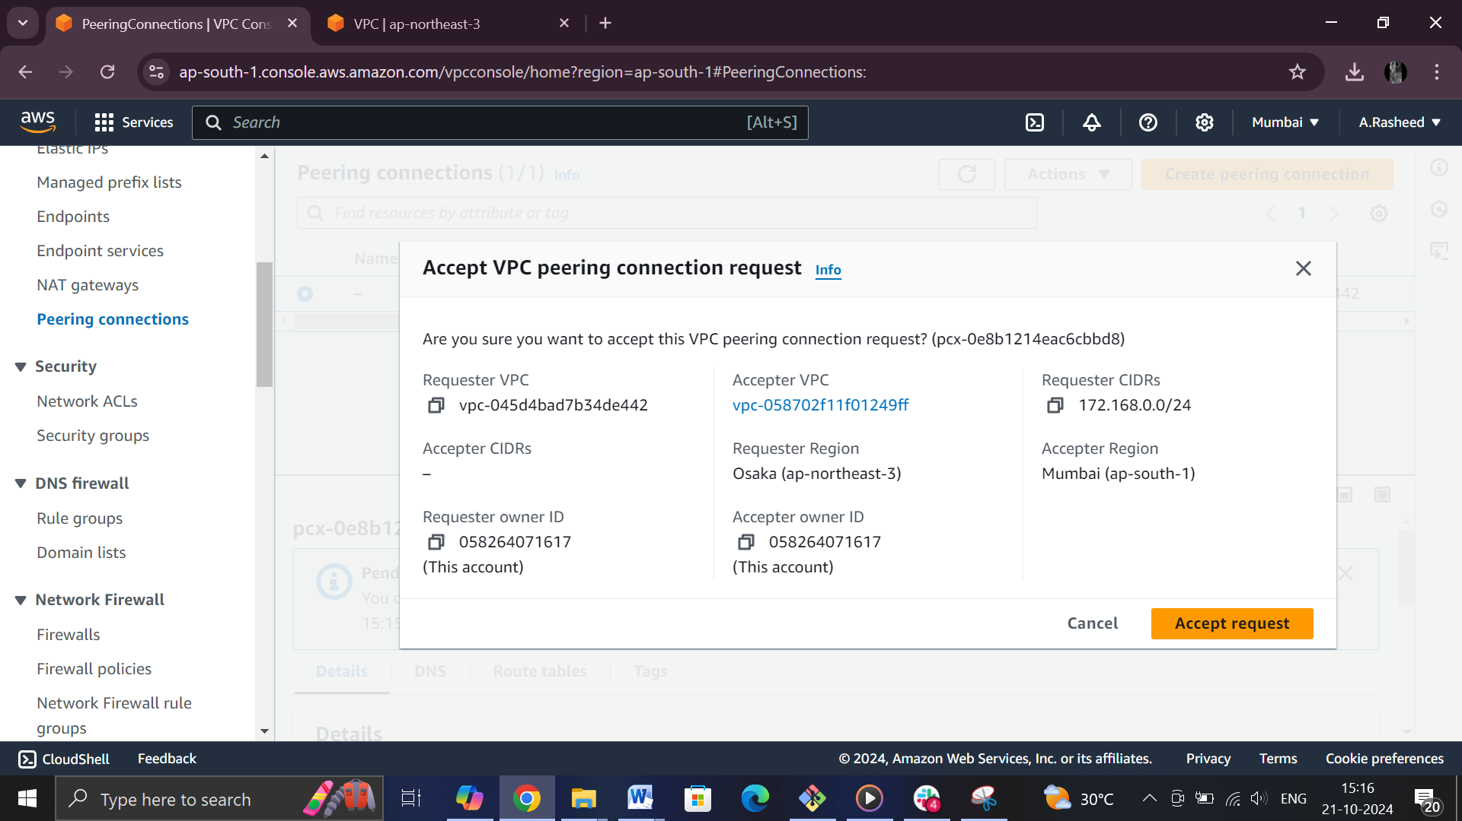

Peering connection is active at Osaka region

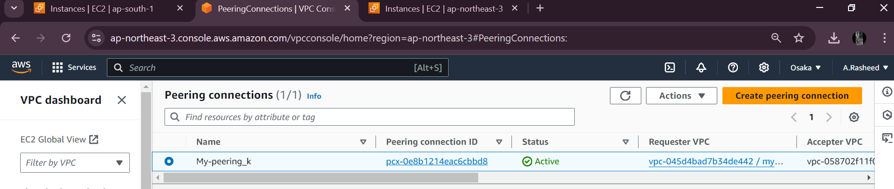

checking the peering connection for mumbai region

both regions are in active status 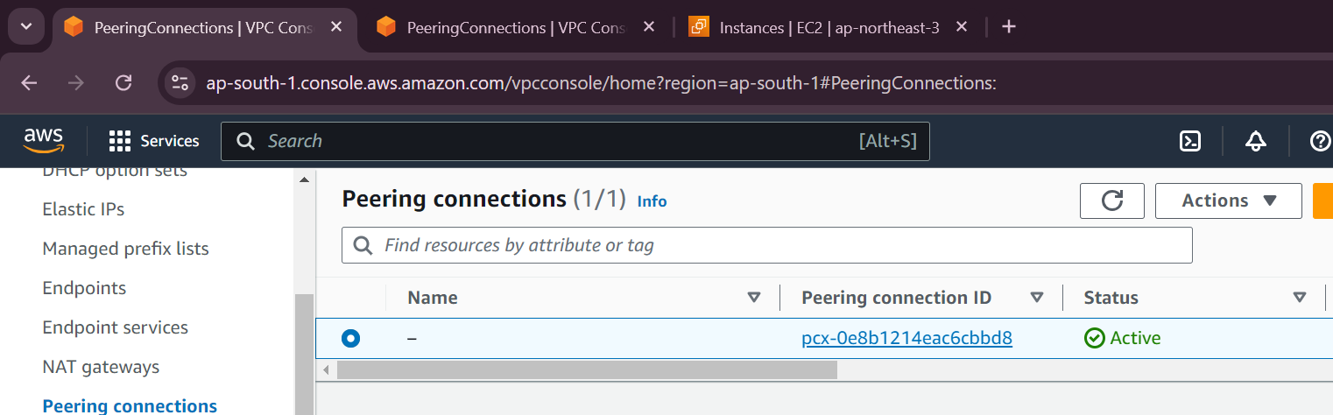

Editing the route and adding peering coonection in both regions

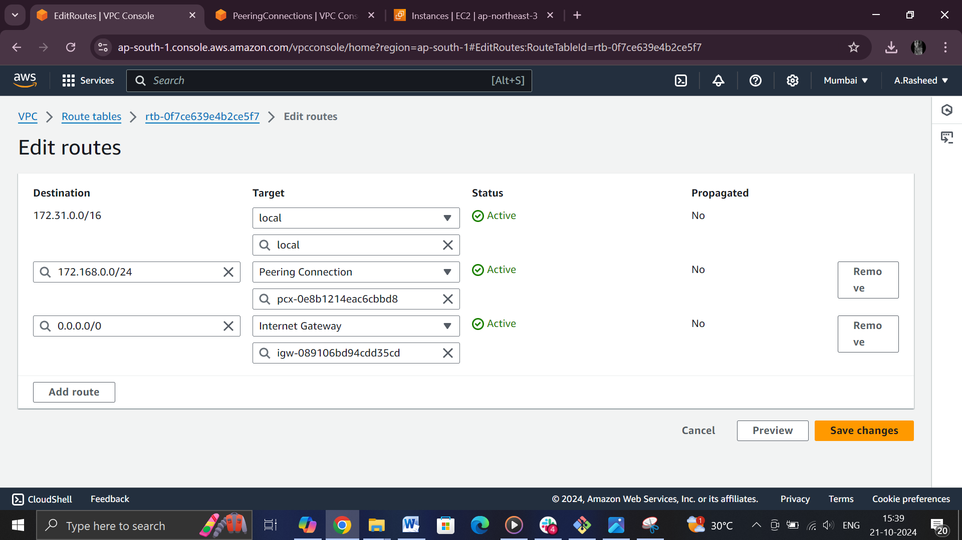

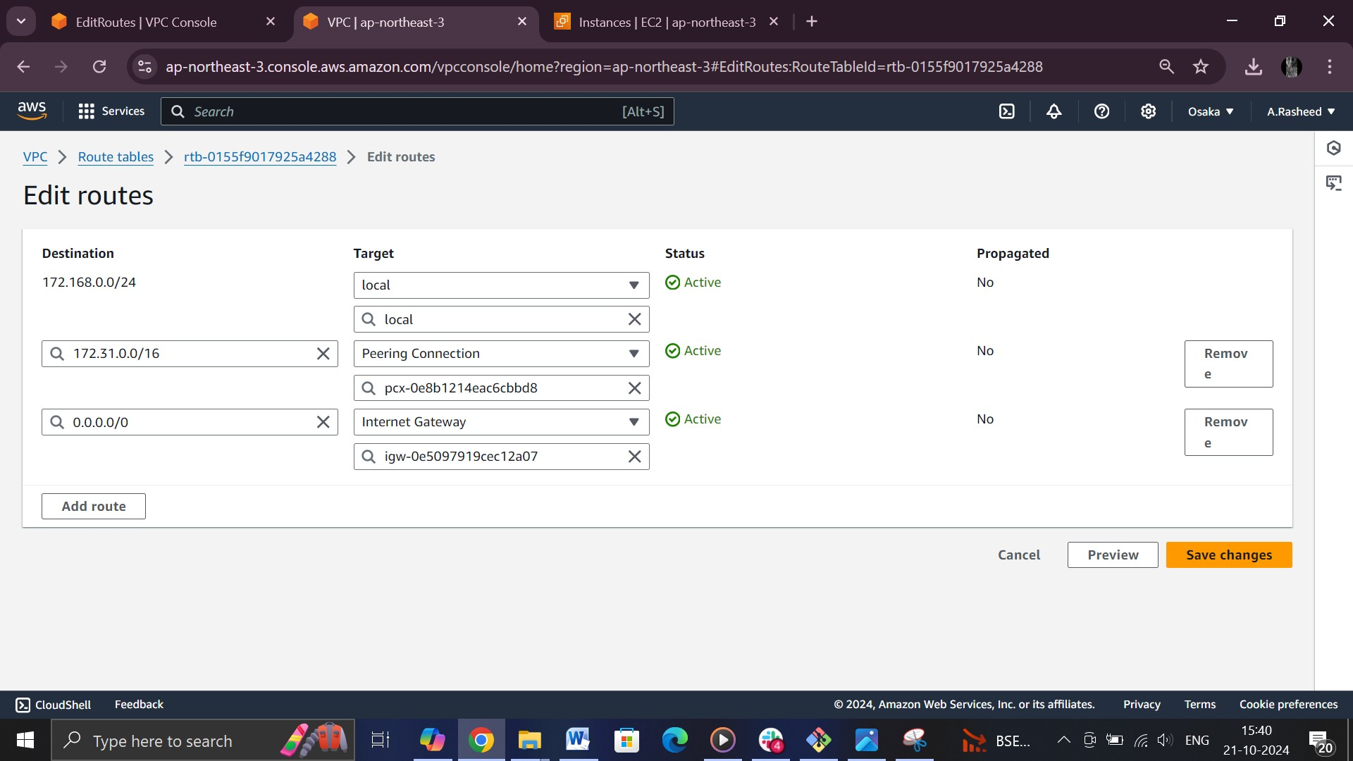

After completion of the above procee,we can able connect the two regions through private ip using

Peering connection

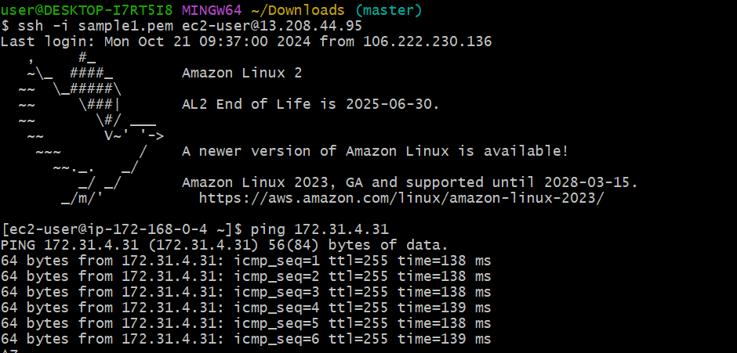

3) Enable VPC peering for cross account. (You can collaborate with your friend and do this task).

4) Setup VPC Transist gateway.

Step:1-created four vpc’s

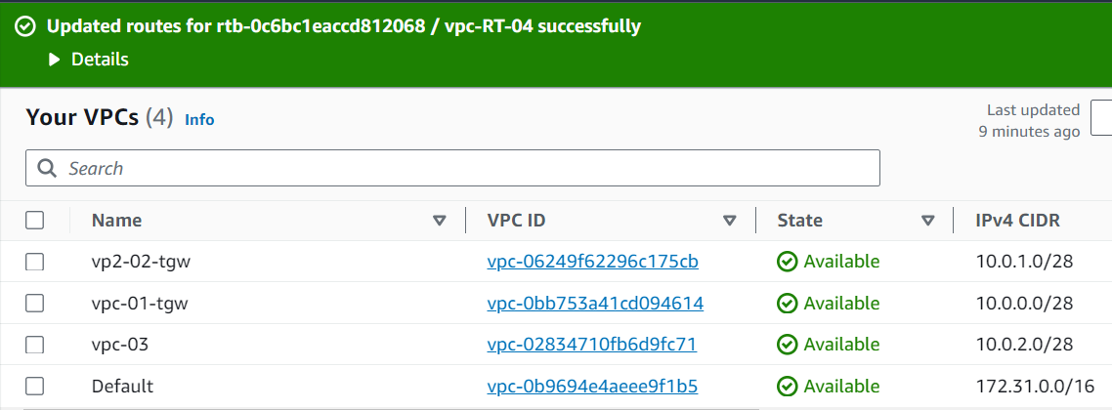

Step-2

Created Transit Gateway

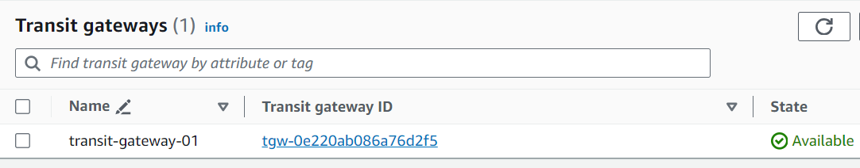

Step-3:

Added transit gateway attachments

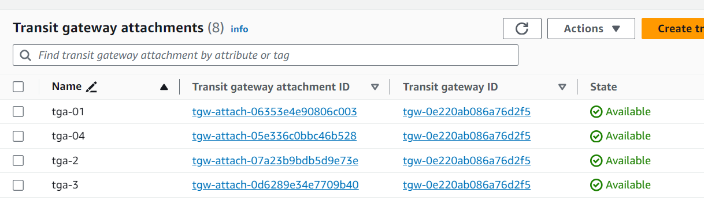

Default Transit gateway route table will be added in association

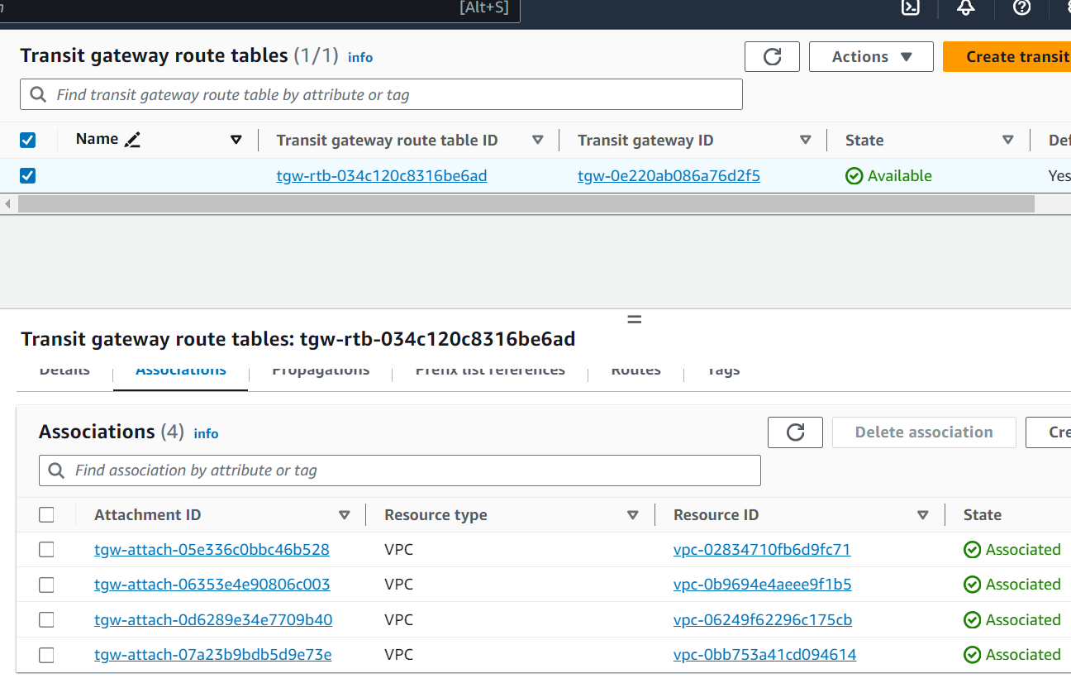

Added Internet gateways in the vpc

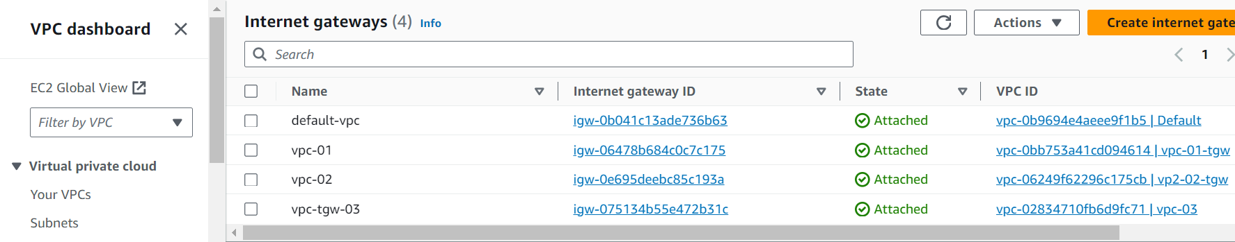

Adding in Route tables to the connectivity

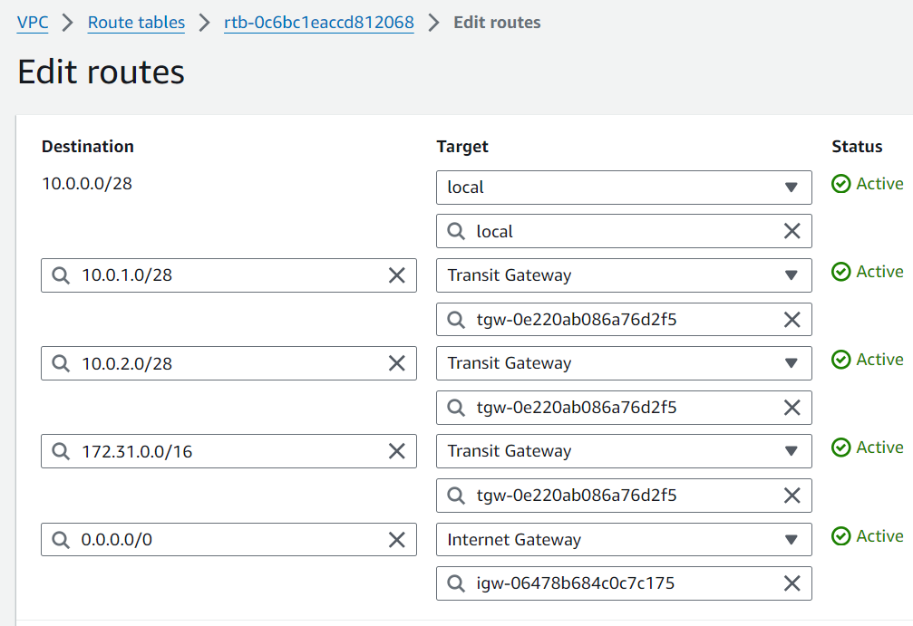

Step:

Now we can connect to the remote server

Connected to the remote server using public ip

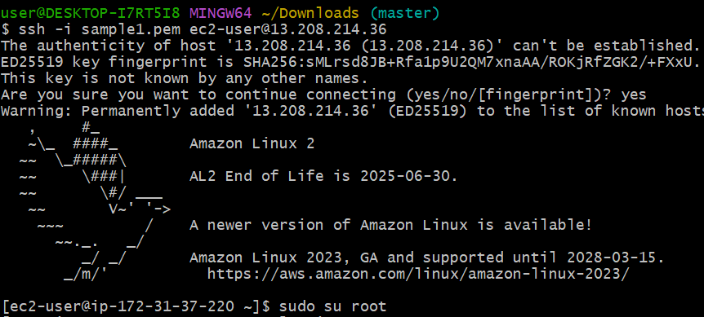

Checking the connectivety using ec2 -privateip

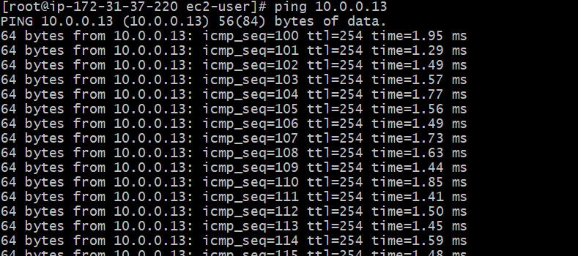

Successfully created Transit gateway

5) Setup VPC End Point

Step-1:creating the VPC

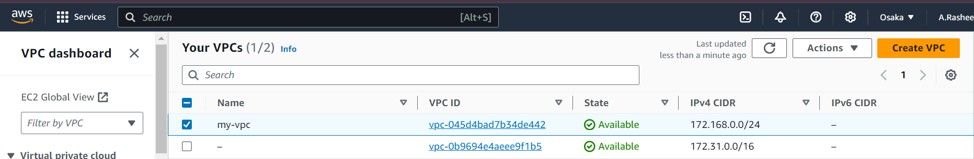

Step:2

Creating one public subnet

Creating one private subne

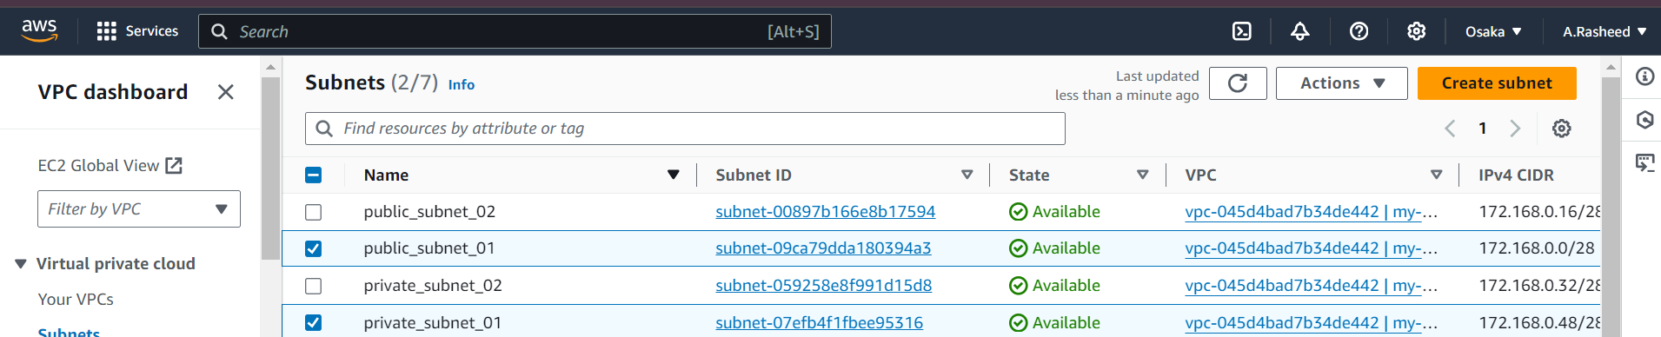

Created s3 bucket

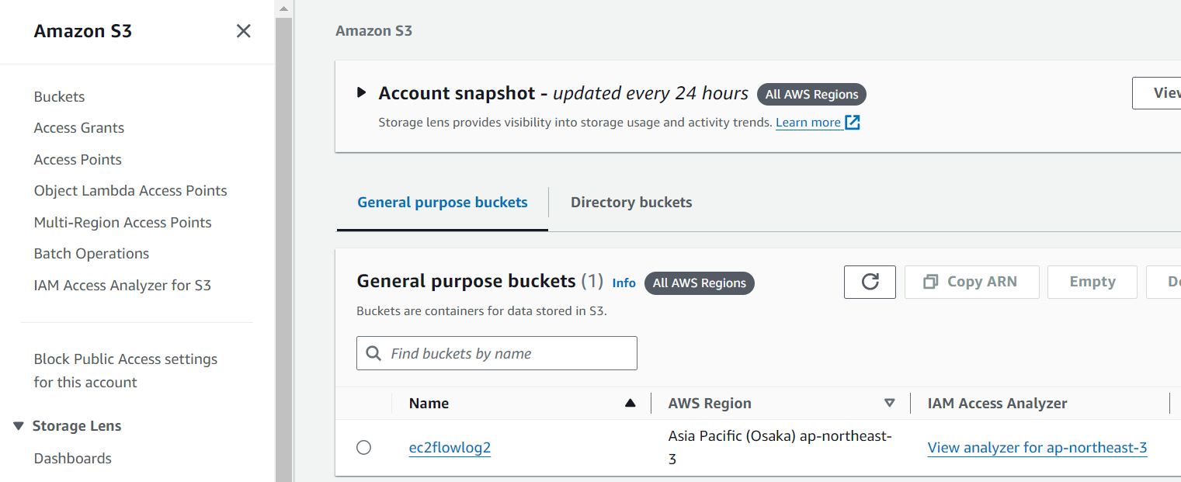

Creating end point[vpc endpoint service will help us to communicate with aWS services without internet] 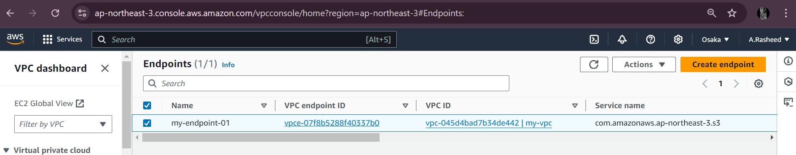

After creation of end point,default route table will added 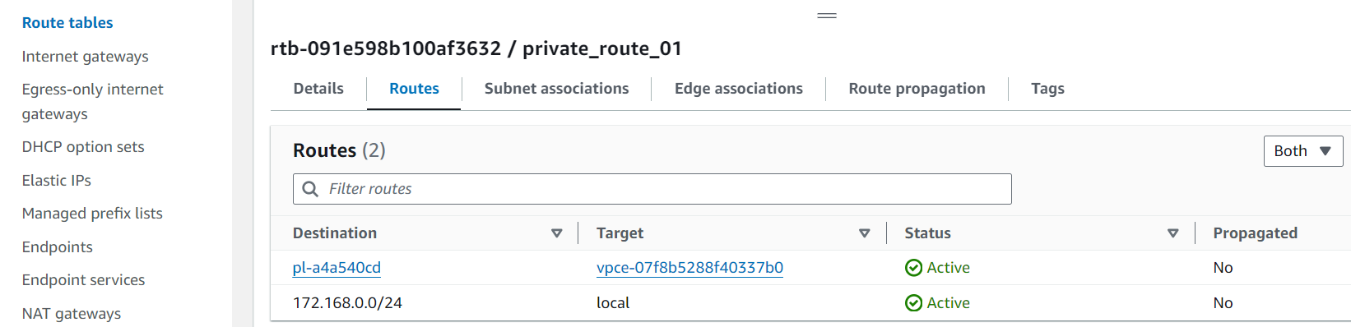

Accessing the private instance [using jump server]

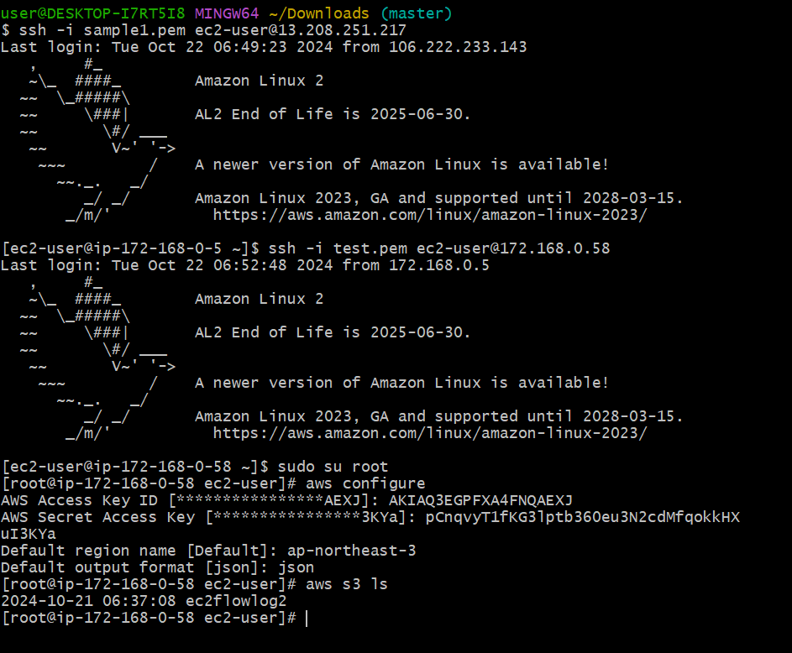

Through ENDPOINT service without internet we can able to access the service