Date:01/10/24

Daily tasks on linux commands.

1)Create user with name Techie and provide sudo access to user.

Techie added to the users list and provided sudo acess

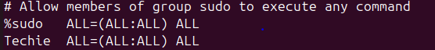



2) Navigate to the home directory.

  
3) Create a new directory.

4) List the contents of a directory.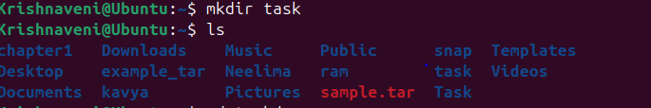

5) Change the current directory.



6) Create a new empty file.7) View the contents of a file. 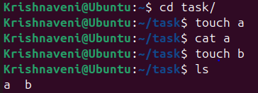

8) Copy a file to another location.

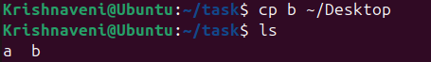

9) Move a file to another location.

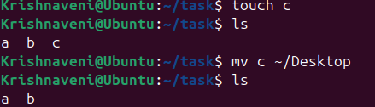

10) Rename a file.

  
11) Delete a file.



12) Grant or revoke permissions on a file or directory.

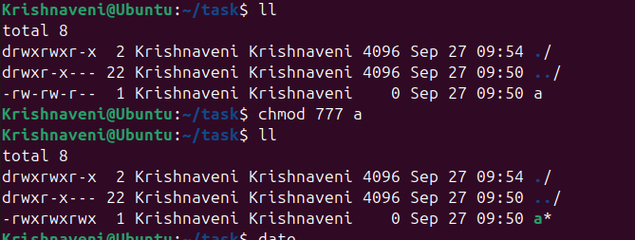

13) View the current date and time.



  
14) Check the system uptime.



15) View the running processes. 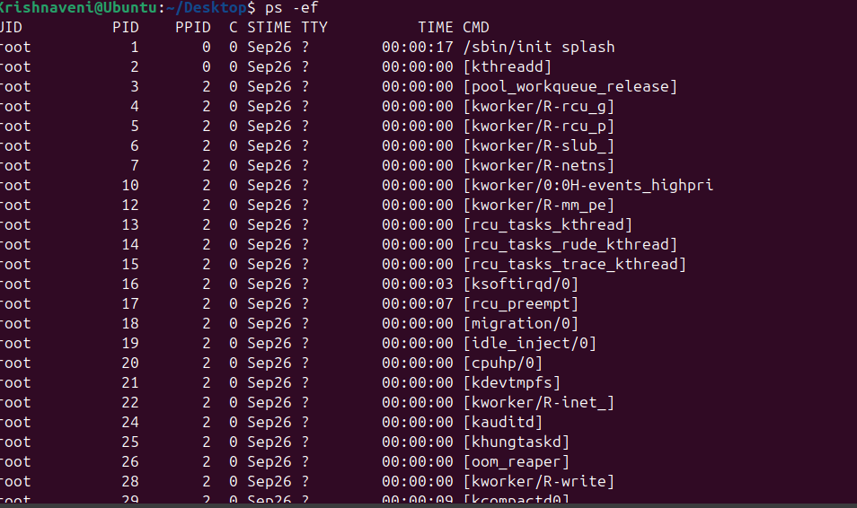

16) Kill a running process.

  
17) Install a package using the package manager (e.g., apt or yum).

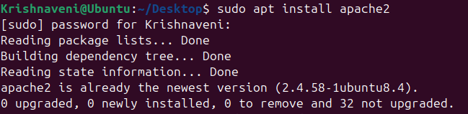  
18) Update the system packages.

Sudo apt update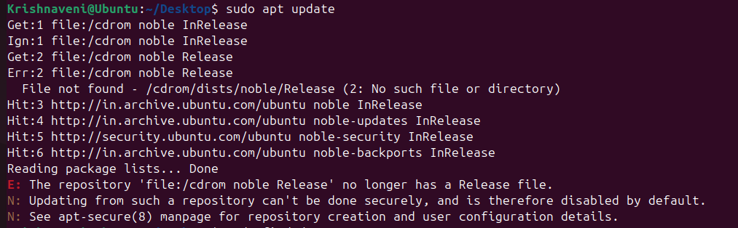

20) Search for files using the find command. 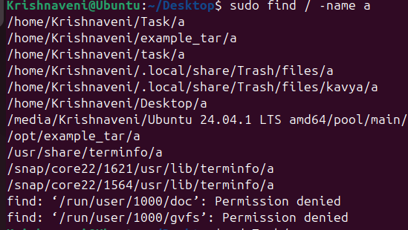

21) Compress and decompress files using tar. 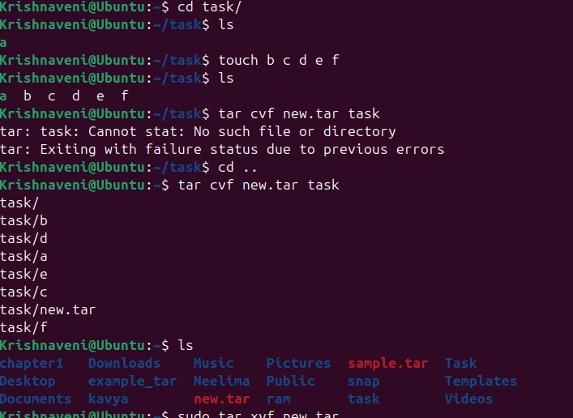

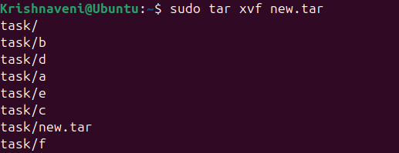

22) Monitor system resources with top or htop. 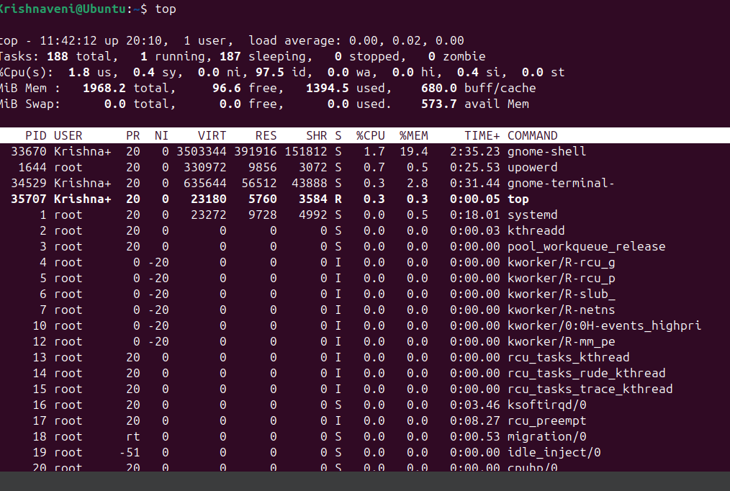

23) Create and manage user groups.

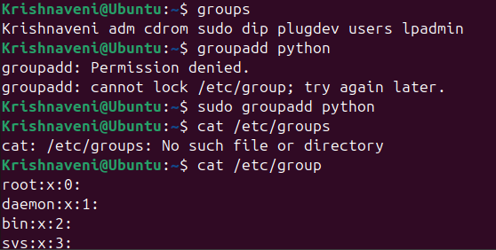

24) Set up SSH password less authentication. 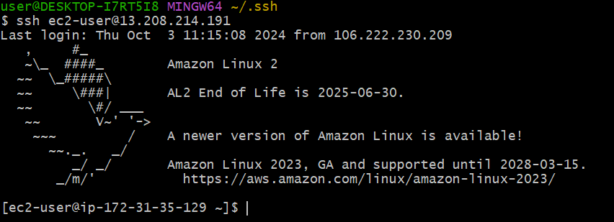

25) Monitor log files using tail or grep.

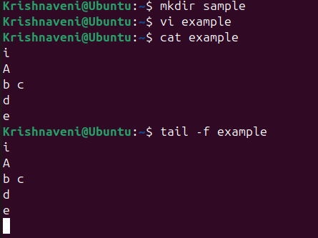

)

)30) Print specific columns from a delimited file. 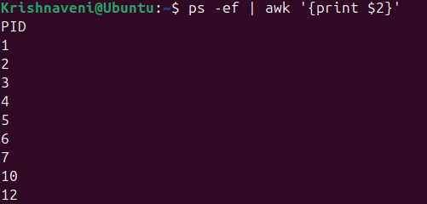

31) Filter and print lines based on a specific pattern or condition. 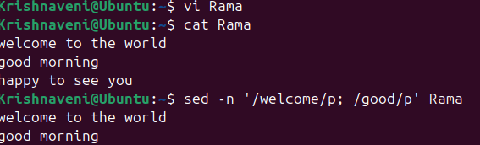

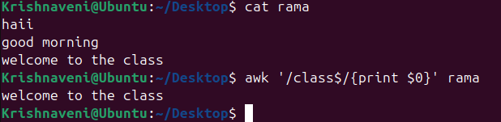



32) Calculate and print the average, sum, or other statistics of a column

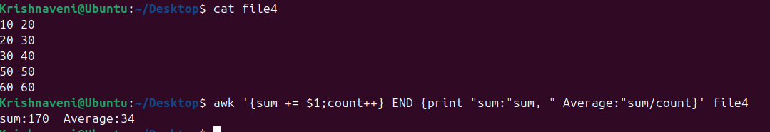  
  
33) Perform string manipulation, such as extracting substrings or changing case. 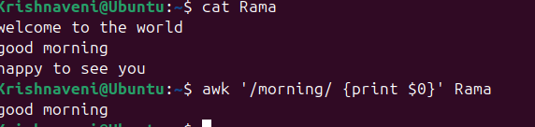

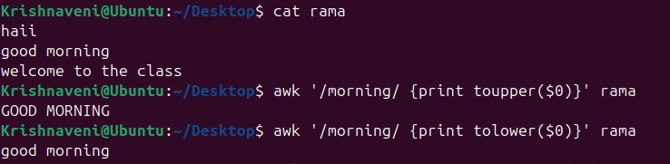

34) Count the occurrences of a specific pattern in a file. 

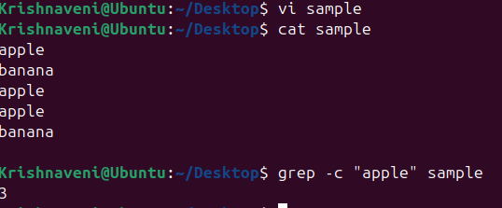

35) Sort lines based on a specific field or column. 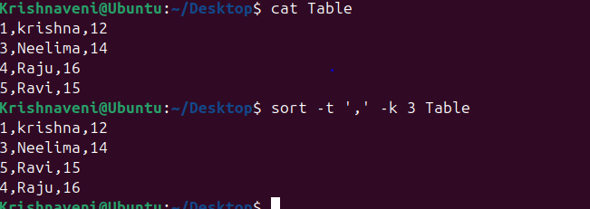

36) Merge multiple files based on a common field or column.

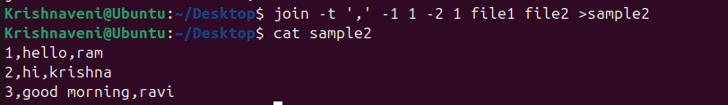  
  
37) Substitute text in a file using search and replace.

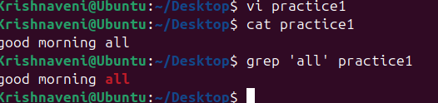

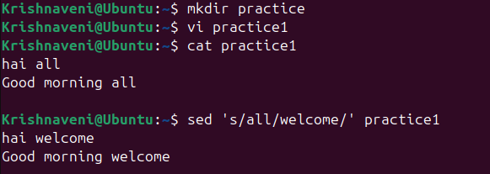

38) Delete specific lines based on a pattern or line number.







39) Append or insert text before or after a specific pattern or line. 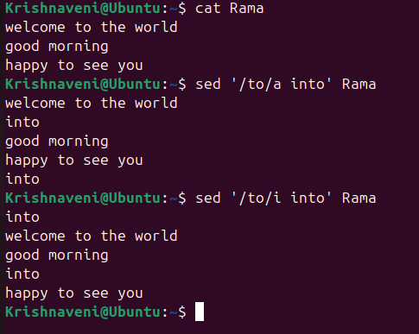

40) Print only specific lines from a file.

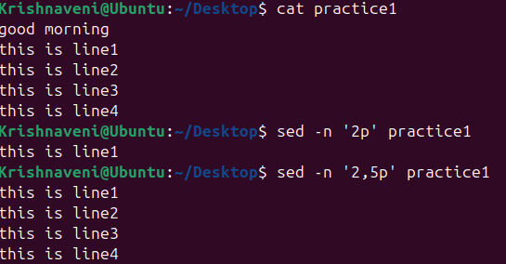

41) Delete leading or trailing whitespace from lines.

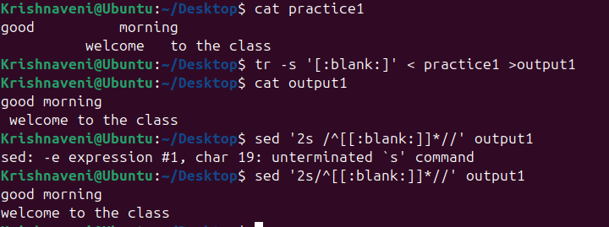

42) Edit files in-place, making changes directly to the file. 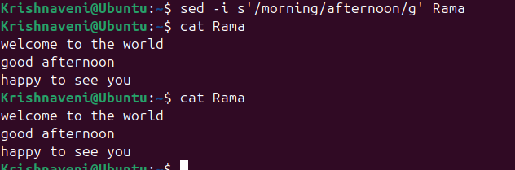

44) Copy file from linux to windows machine

Create a “example” file in remote server



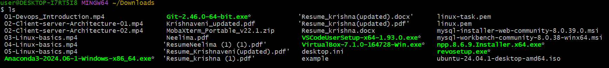

In windows,we can see the file in downloads

44) Copy file from windows to linux machine

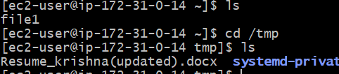

43) Join multiple lines into a single line or split a line into multiple lines.

