# TASK-10(s3, r53, cdn)

1) Configure VPC peering in cross regions.

2) Purchase one domain from Godaddy. 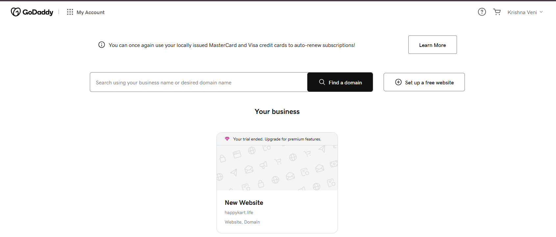

3) Deploy static website in s3. 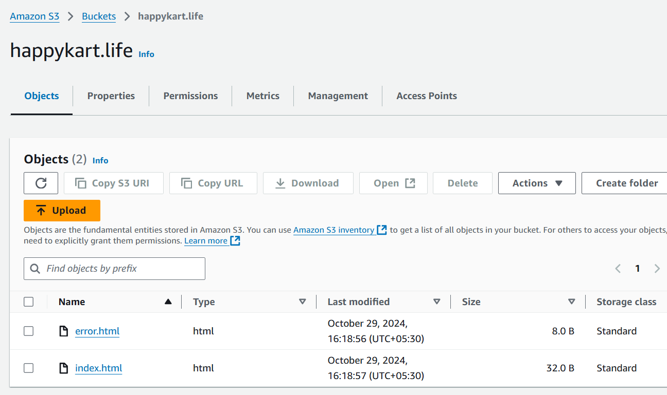

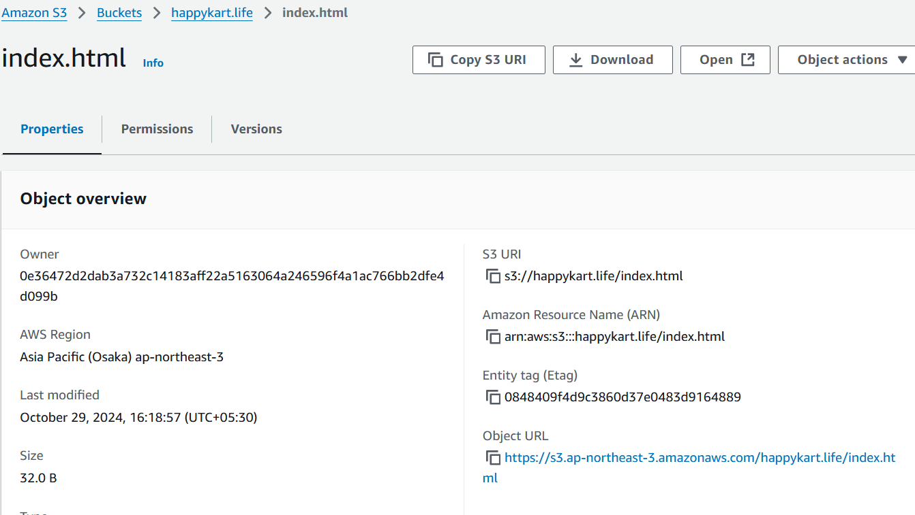

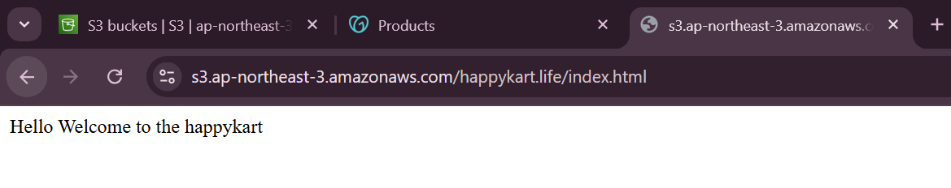

4) Create CDN and attach one SSL certificate.

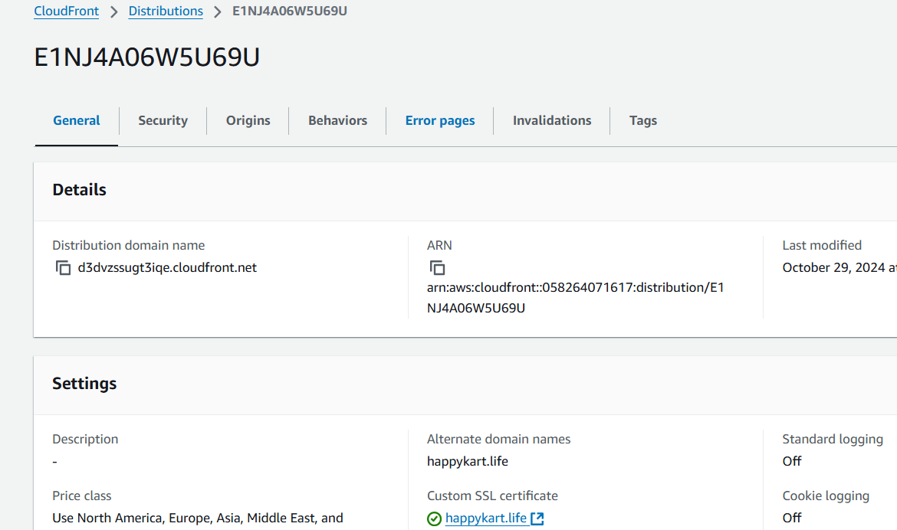

5) Create Route53 hosted zone and MAP the domain with CDN.

SSL certificate also added

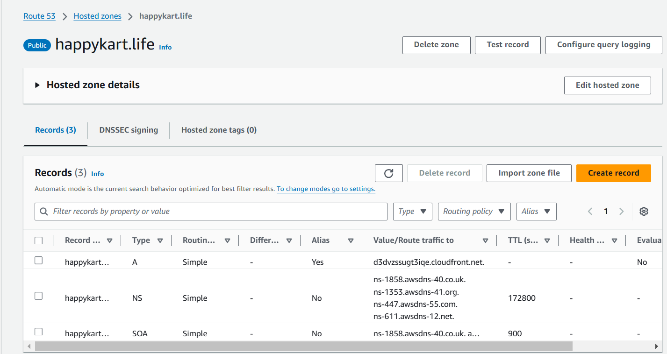

6) Update the index.html in s3 bucket and the updated file should be accessible by using domain name.

Without update of index.html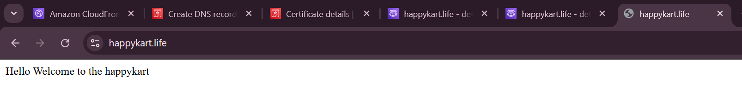

With update of index.html

Edited this in cloudfront

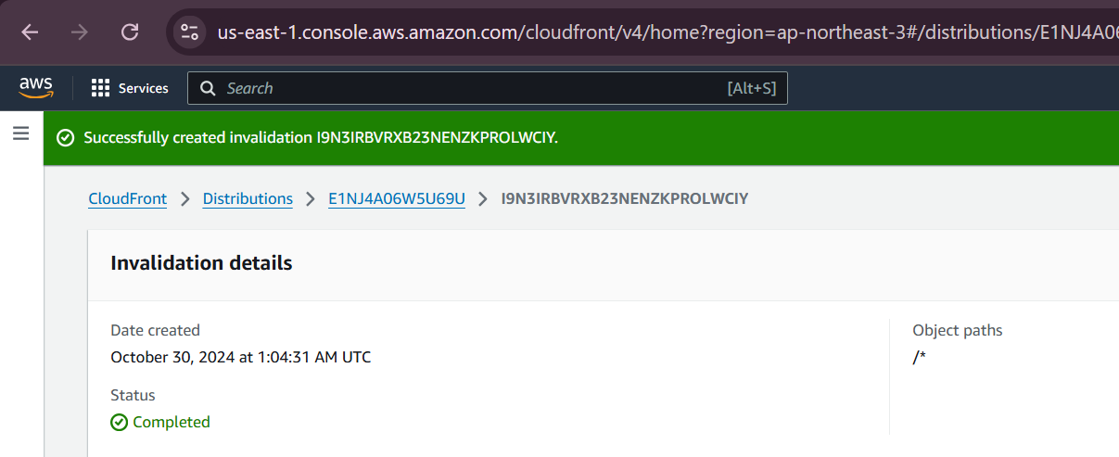

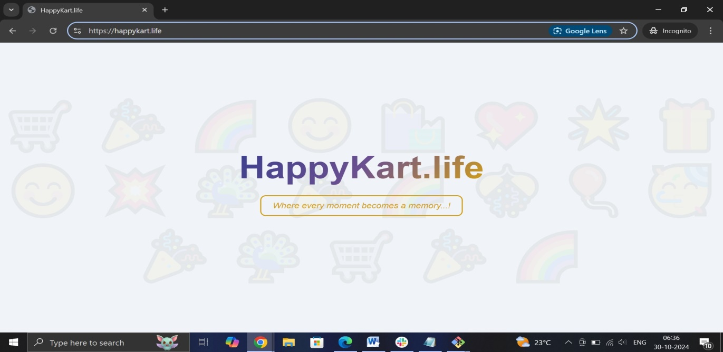

7) Share the Domain name in slack to test the connectivity.

https://happykart.life/