# Task-11[CLOUD TRAIL,CLOUD WATCH,SNS]

1) Enable cloudtrail monitoring and store the events in s3 and cloudwatch log events.

Steps:

Creating a trail in cloud trail

With new bucket and new cloudwatch details

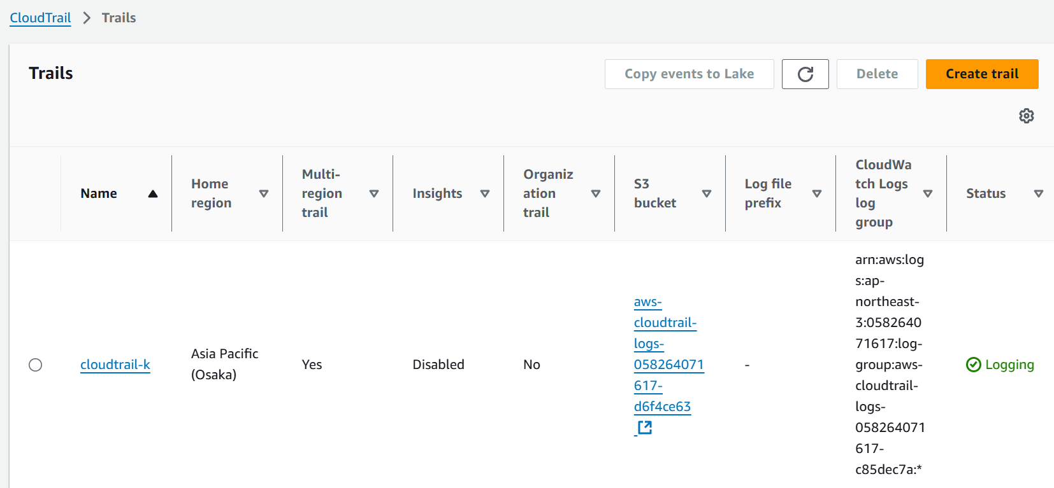

We can see some of the events stored in s3 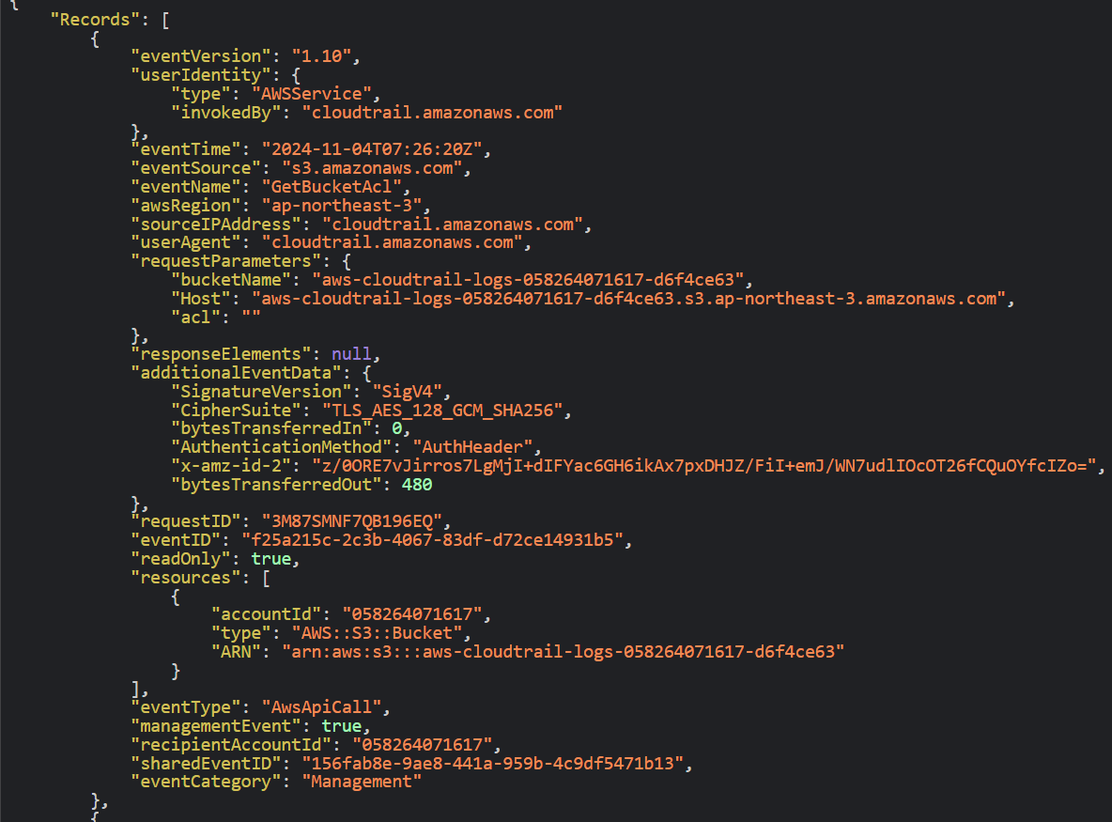

Also we can see the logs in cloudwatch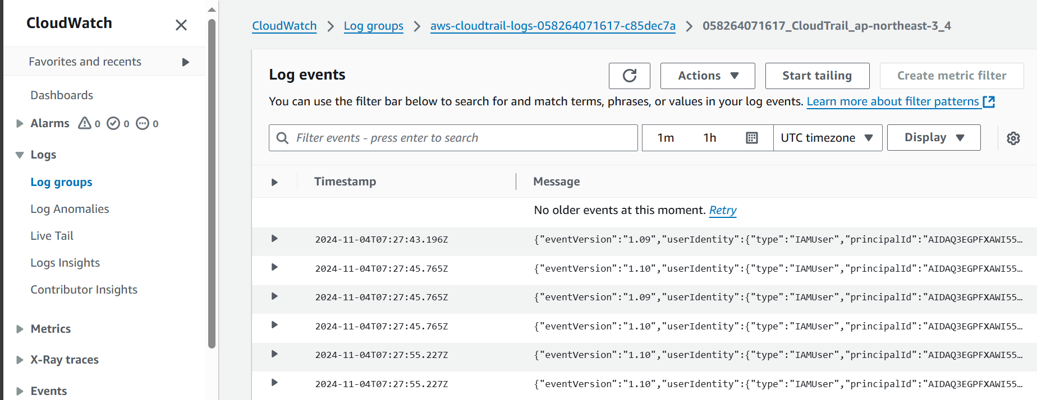

2) Enable SNS for cloudtrial to send alert on email.

Created one SNS service with topic name “ALERT_K”

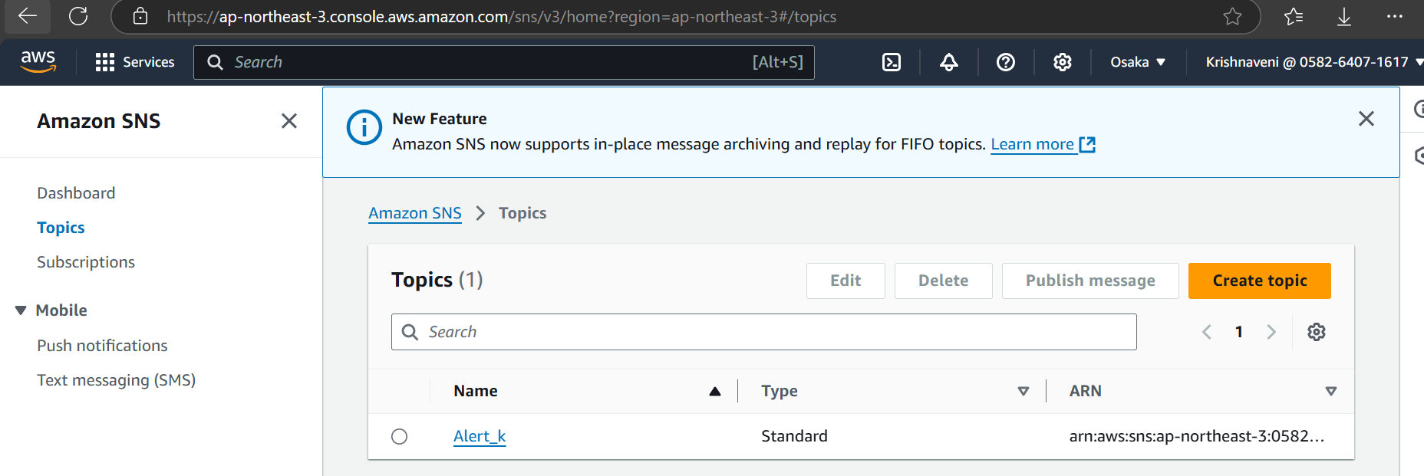

Created one subscription for the topic

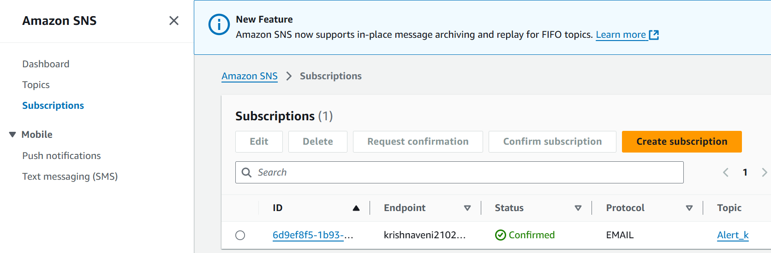

We need to confirm the mail 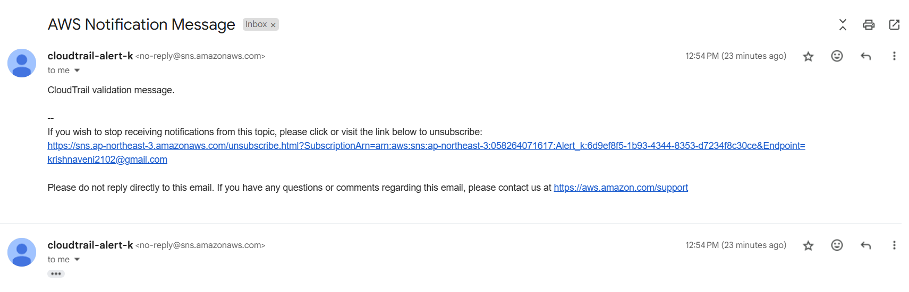

3) Configure cloud watch monitoring and record the cpu utilization and other metrics of ec2.

Steps: Launching one ec2 and connecting to the server

Step-2:go to monitoring and check the load for one minute

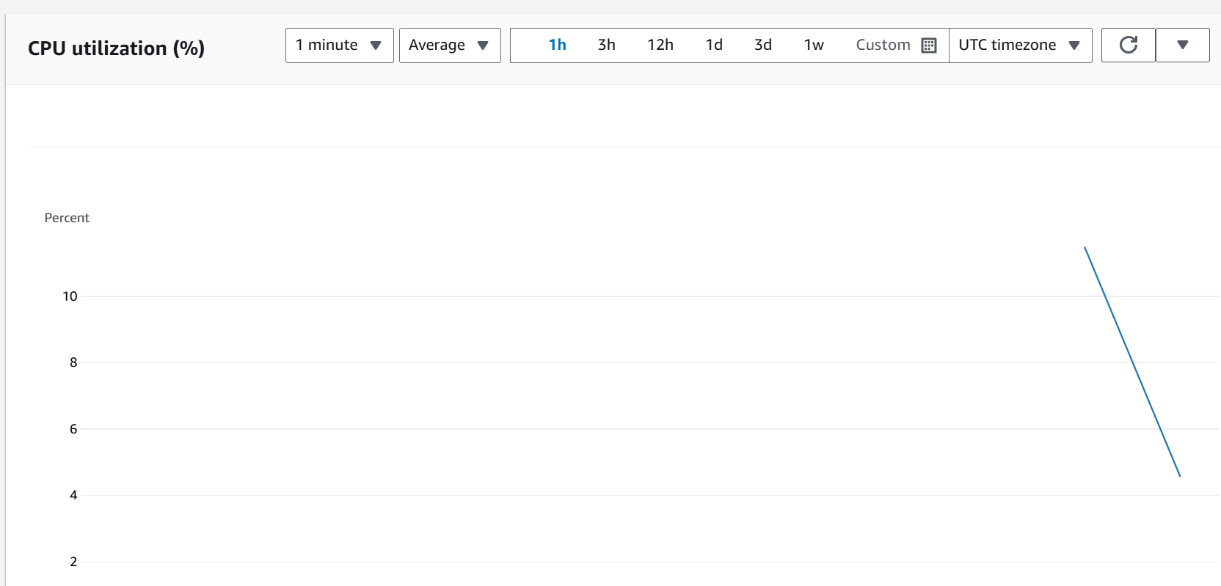

Adding some fake load

Command: yum install stress –y

Yes > /dev/null&

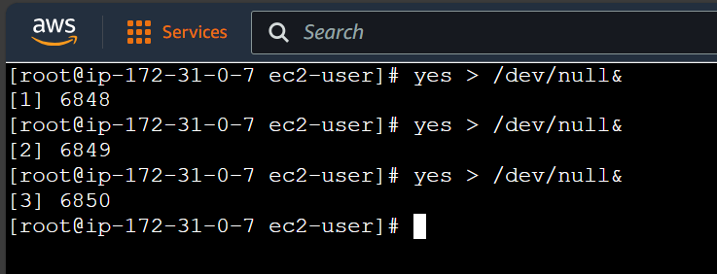

In cloudWatch we can see the CPU utilization

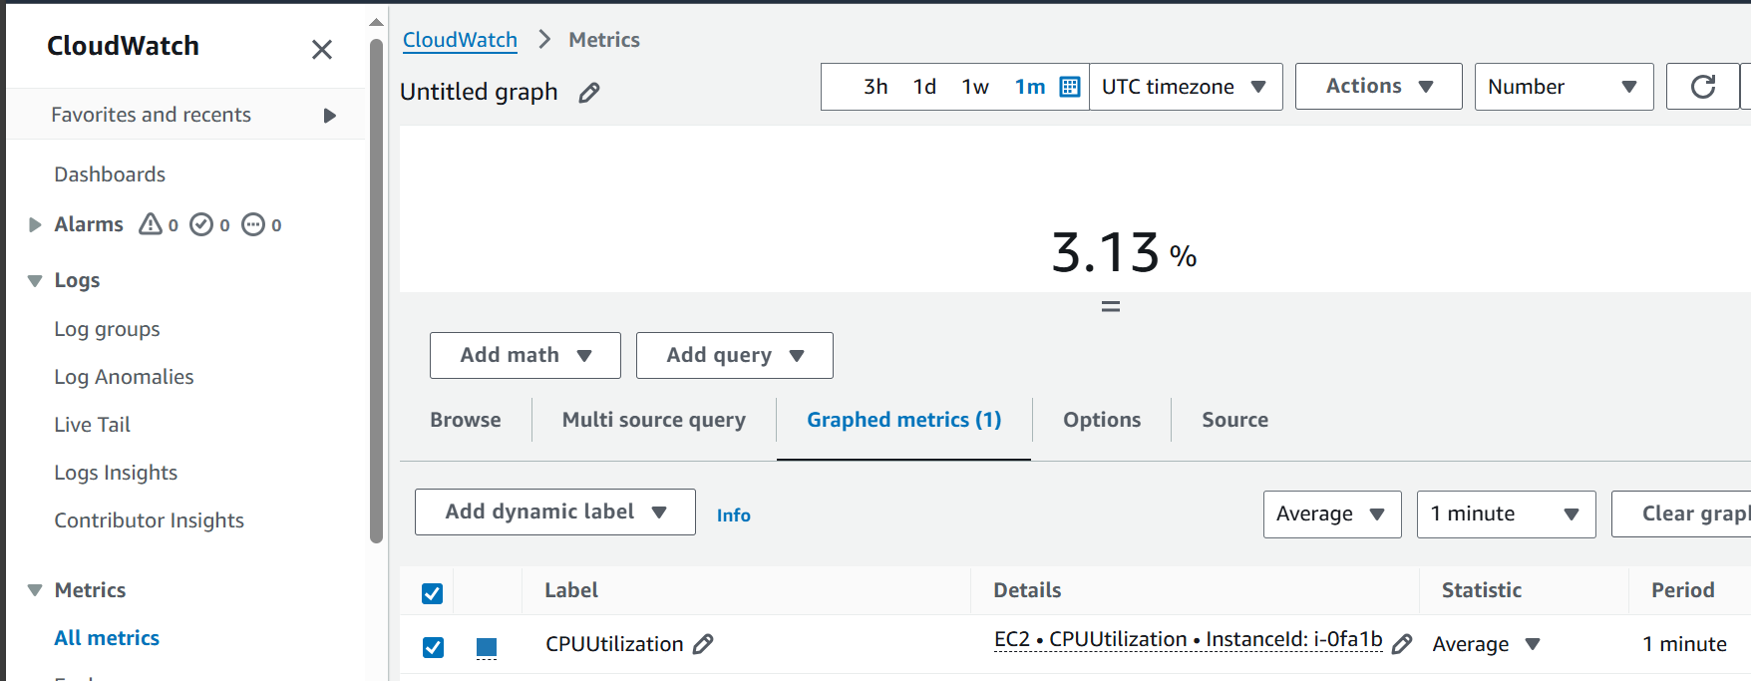

We can see the changed graph in monitering aswell

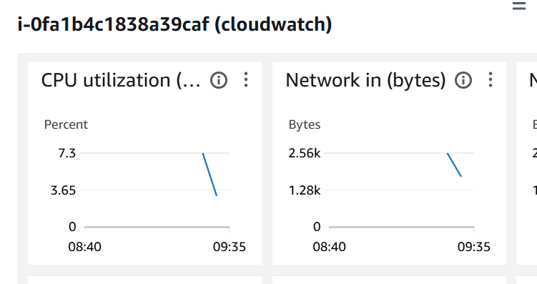

4) Create one alarm to send alert to email if the cpu utilization is more than 70 percent.

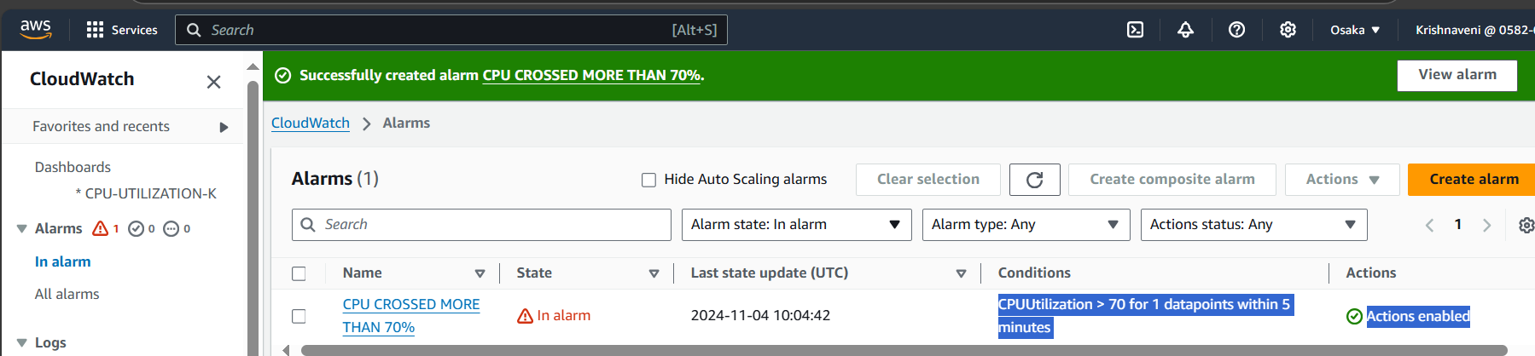

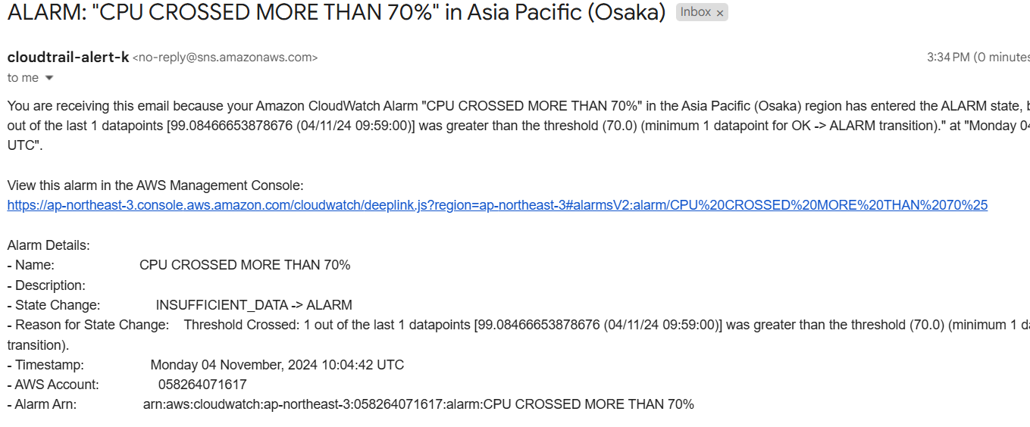

5) Create Dashboard and monitor tomcat service whether it is running or not and send the alert.

Steps:

Launching an ec2-service

And installing the apache tomcat

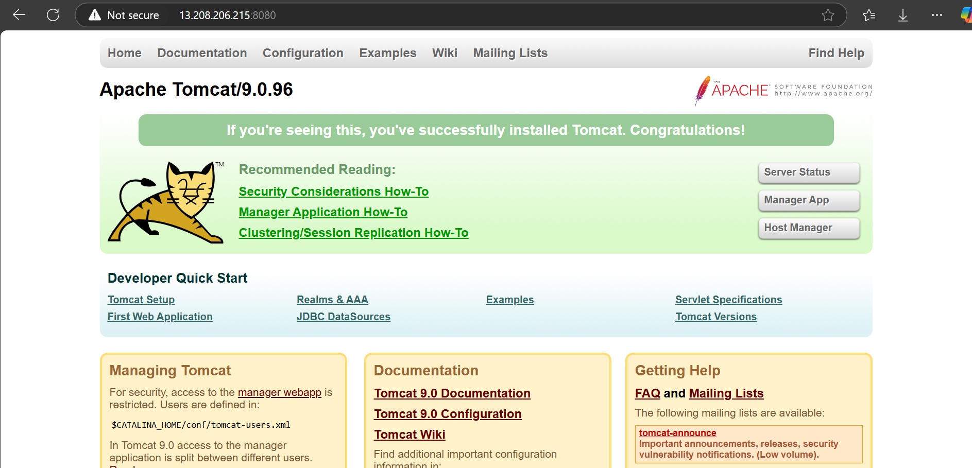

If we start the tomcat

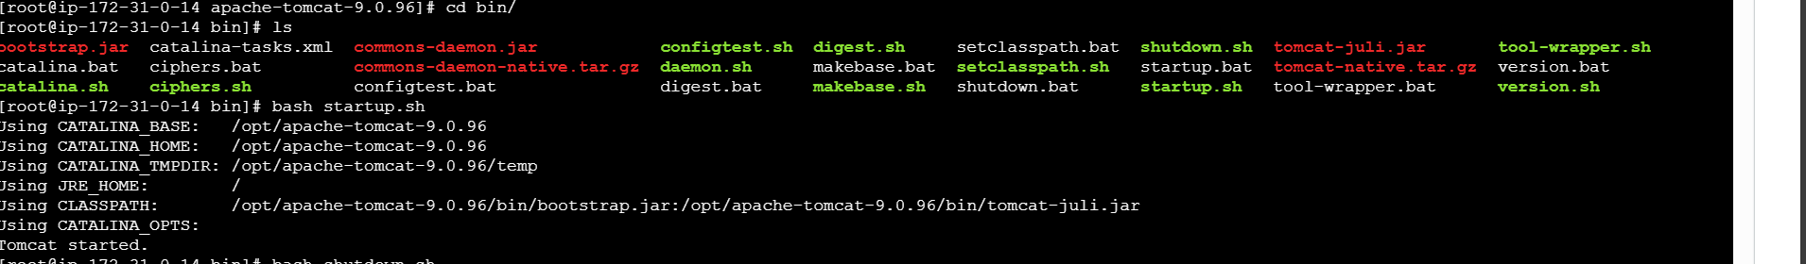

Created one bash script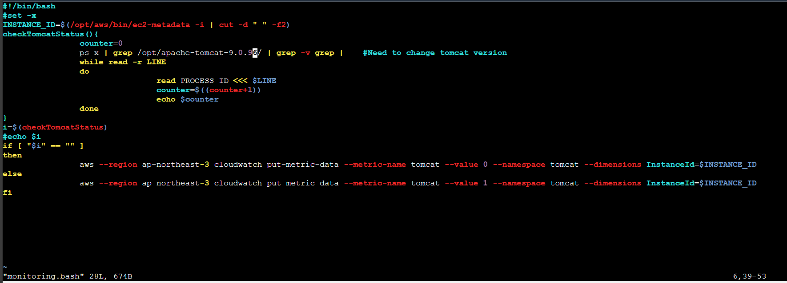

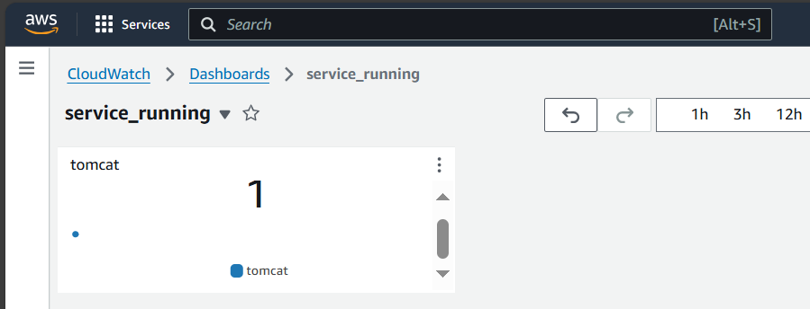 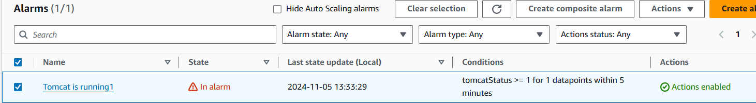

If we shutdown the process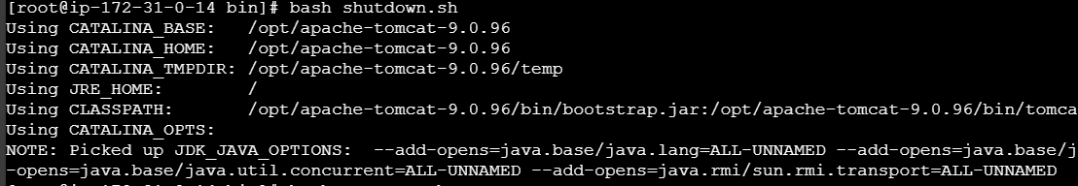

We need to execute the bash script

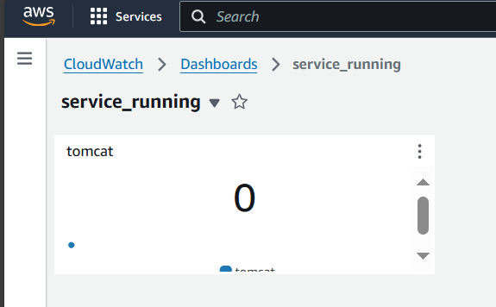

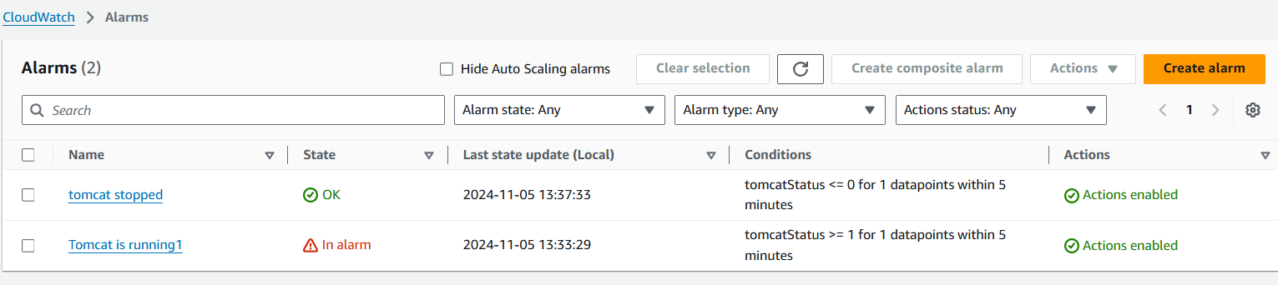

6) Create Dashboard and monitor nginx service to send the alert if nginx is not running

Installed nginx in remote server

It executes when we we not not running nginx

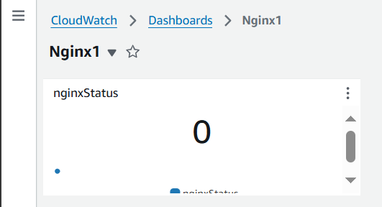

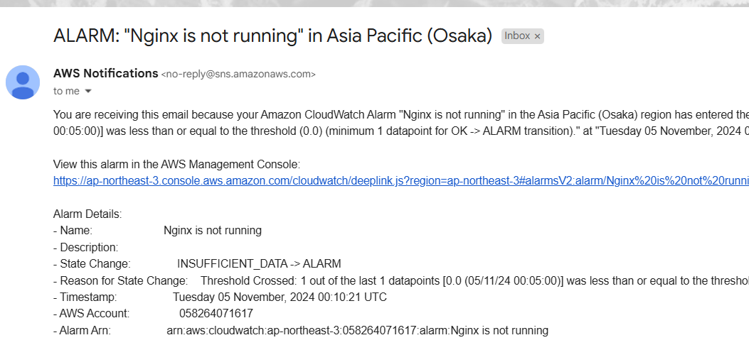

Created the alarms

It executes when we are running nginx

