Task-05[Ec2]

1)Launch one ec2 using Amazon Linux 2 image and add script in user data to install Apache.

Launching an ec2 using amazon linux 2 image

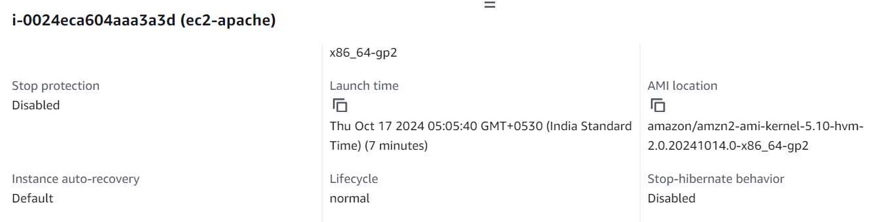

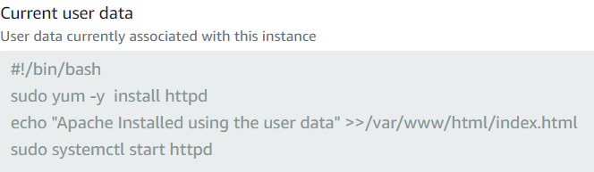

Connecting to the service

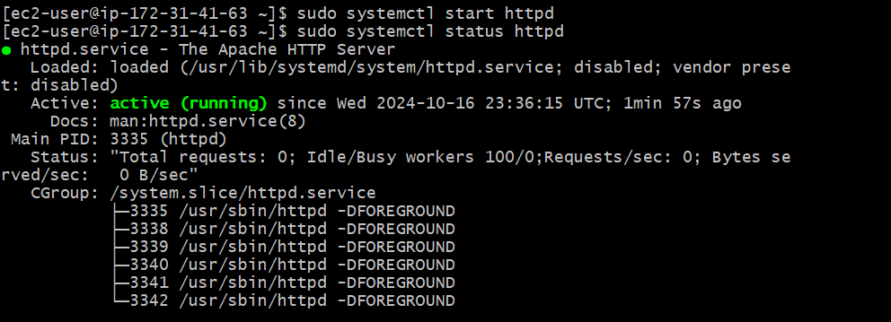

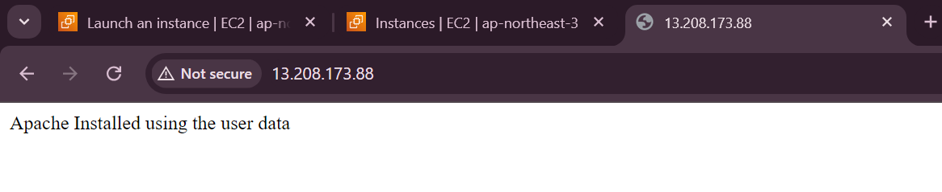

2) Launch one ec2 using Ubuntu image and add script in user data to install Nginx.

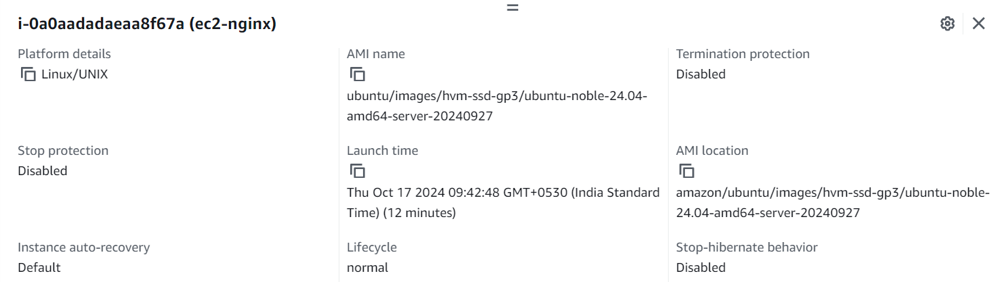

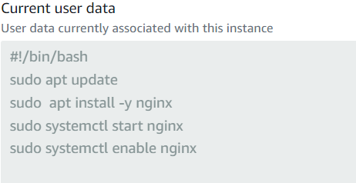

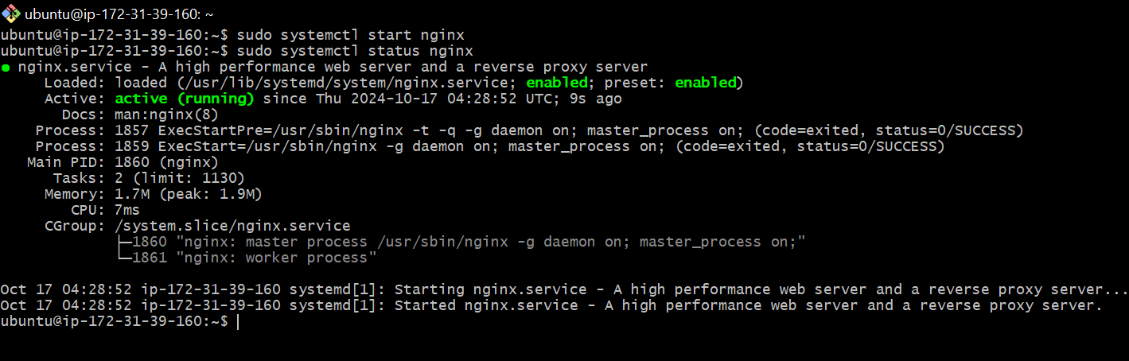

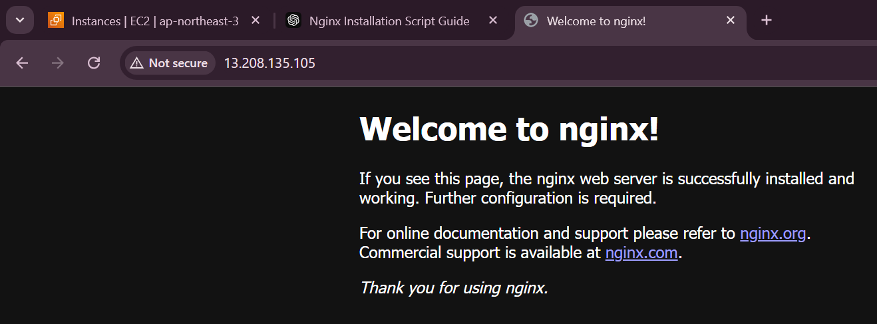

3) Launch one windows server and install tomcat in windows.

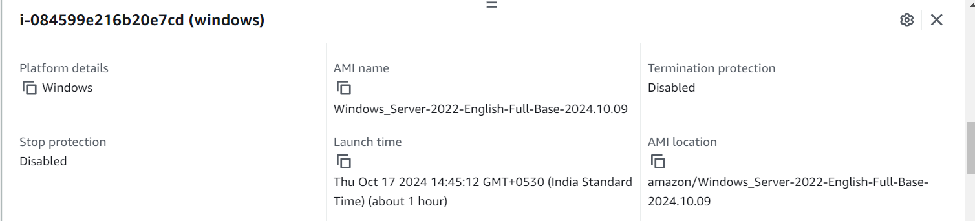

Connecting to Remote Desktop using the credentials

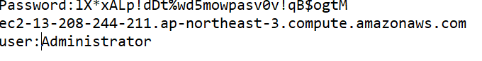

Connected to the remote

And installing the tomcat

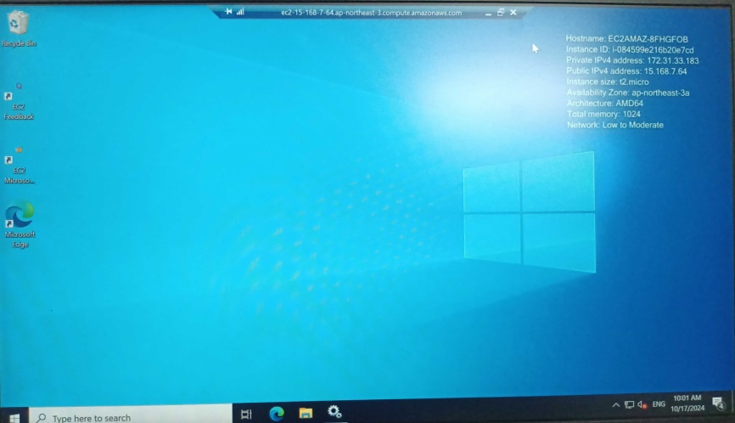

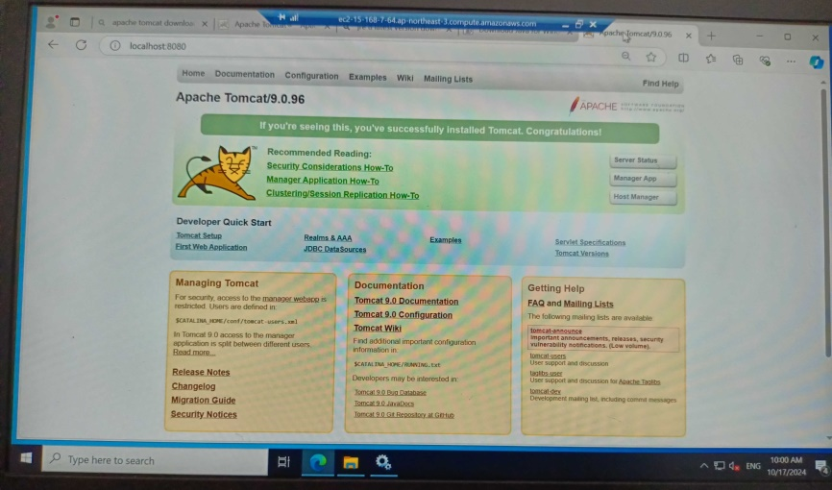

4) Take snapshot of the instance created in Task1(Apache)

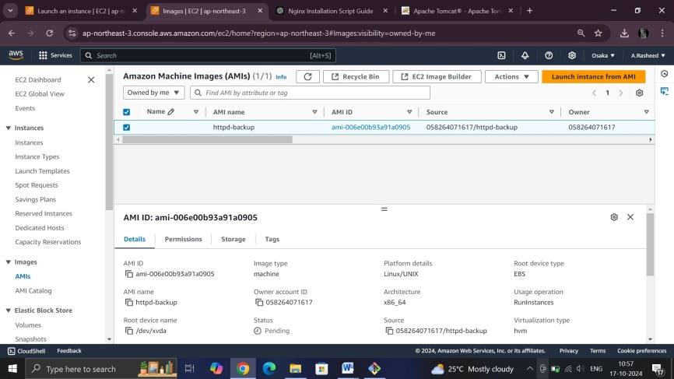.

5) Assign password less authentication for ec2 created on Task 2. 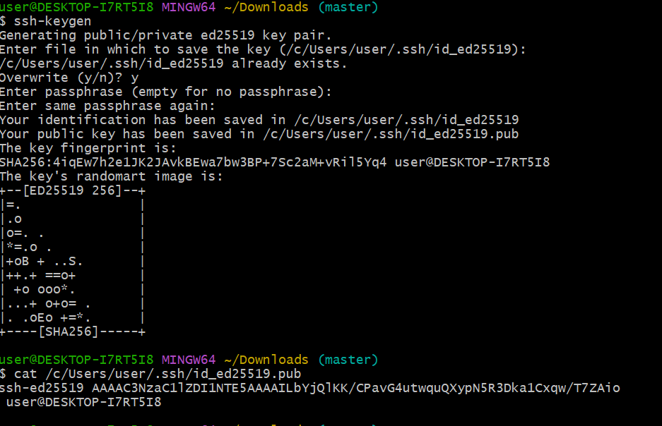

Connect to the remote server

Step-1:ssh –i sample1.pem [ubuntu@13.208.185.193](mailto:ubuntu@13.208.185.193)

then

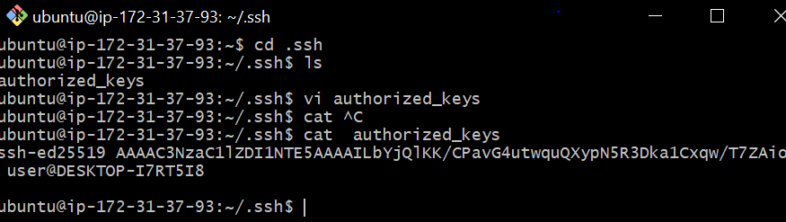

After above steps ,try coonecting without key-pair

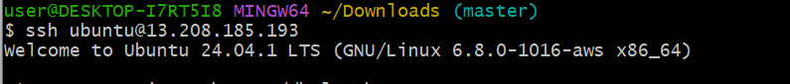

6) Launch any ec2 using spot purchasing option.

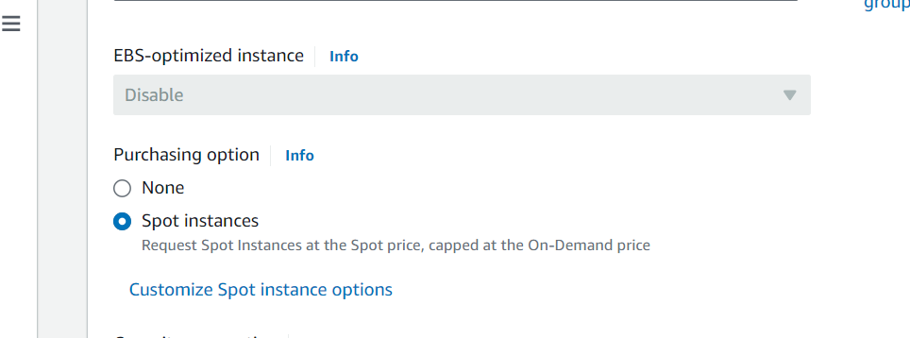

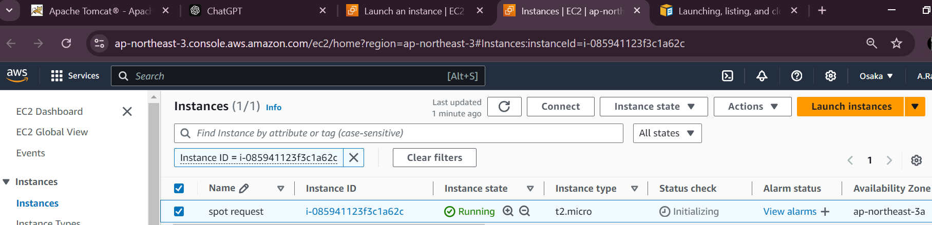

7) Enable Termination policy on ec2 created in Task 2.

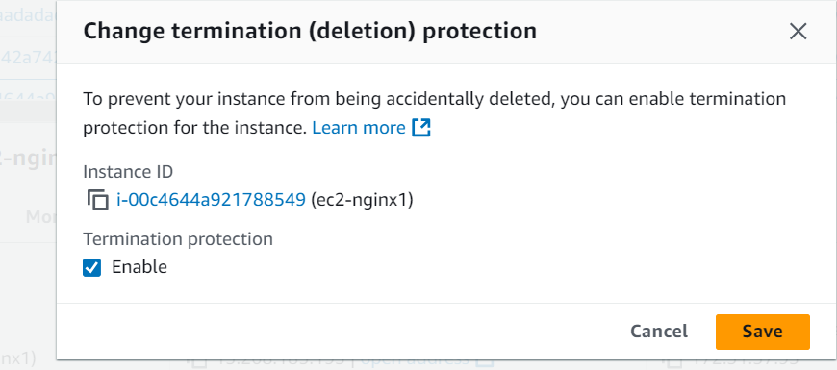

8) Launch one ec2 using Aws CLI.

Step:Download amazon cli

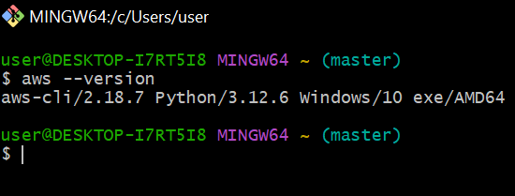

Step-2:aws configure

Step-3

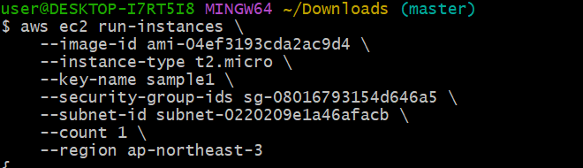

Output:

