JOIN

CREATE TABLE Students (
id INT,
name VARCHAR(50)
);
CREATE TABLE Marks (
id INT,
marks INT
);
INSERT INTO Students (id, name) VALUES
(1, 'Ravi'),
(2, 'Anu'),
(3, 'Karthik');
INSERT INTO Marks (id, marks) VALUES
(1, 90),
(3, 80),
(4, 70);

INNER JOIN
USE dummy;

SELECT s.name, s.id, m.marks
FROM Students s
INNER JOIN Marks m
ON s.id = m.id;


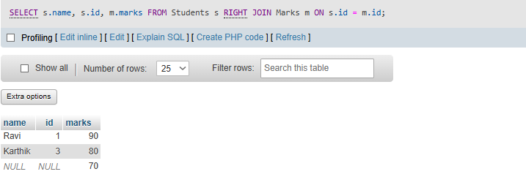
RIGHT JOIN
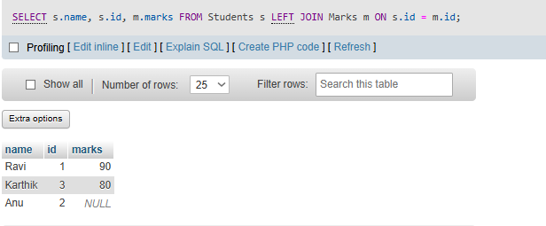
FULL JOIN
