JAGADHA BY PADANJALY
WooCommerce Data Preparation & Exploratory Sales Analysis

1. Project Overview
This report documents the preparation and exploratory analysis of Jagadha by Padanjaly’s WooCommerce order data. The work moved from reviewing the raw export to cleaning and standardising fields in Power Query, creating sales KPIs in Power BI, and building a dashboard to compare order activity, revenue patterns, product contribution, shipping locations and currency mix.

2. Dataset and Analysis Scope
The reviewed export contains 690 unique orders and 72 columns, with order dates spanning January 2023 to July 2026 in the latest analysis extract. Fields include order IDs, order and paid dates, order status, original subtotals, currency codes, payment methods, customer IDs, billing/shipping details, and product-item information. The main cleaned query used in Power BI is named 'Orders (2)'.

3. Final Dashboard
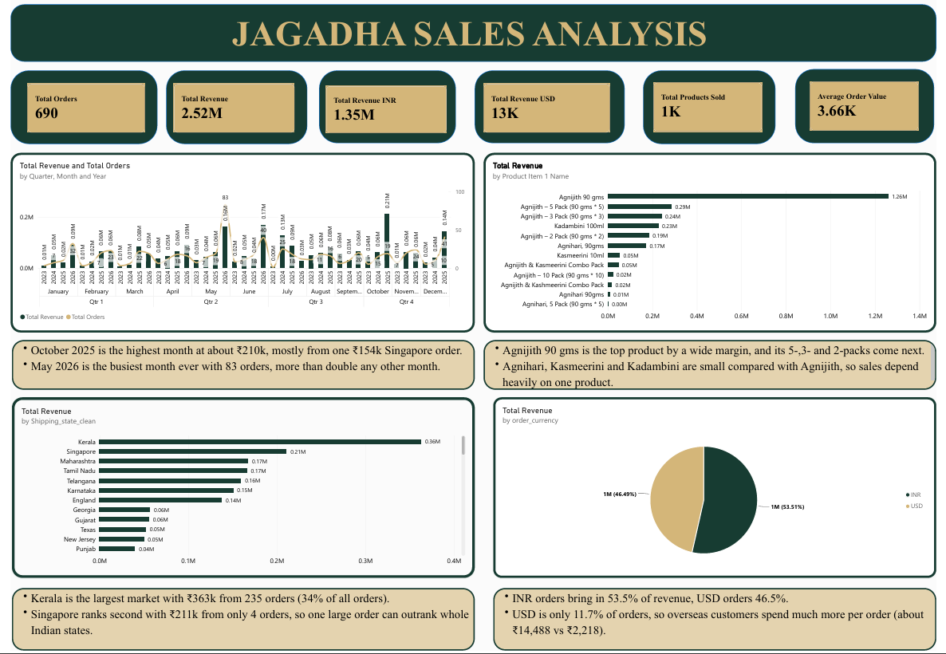
Figure 1. Final exploratory Jagadha Sales Analysis dashboard.
The dashboard combines KPI cards with a quarterly/monthly revenue and order-volume visual, product revenue ranking, revenue by cleaned shipping location, and a currency split. The adjacent insight notes explain the strongest visible patterns and flag areas that require further validation.

4. Data Cleaning and Transformation
The raw query was preserved and a separate working copy was used for transformations. This approach keeps the source available for comparison and audit, while the cleaned fields support more consistent analysis.

4.1 Data types and date fields
- Reviewed columns in Power Query and assigned appropriate data types: dates as Date, times as Time, amounts as Decimal Number, quantities as Whole Number, and descriptive fields as Text.
- Separated order_date and paid_date into date and time components to support date-based trends without losing time information.
- Kept postcodes, product IDs/SKUs and other identifiers as text where numeric conversion could remove leading zeros or change the identifier format.
- Checked order_id for duplicate values and order dates for missing values in the reviewed extract; no duplicate order IDs or missing order dates were identified.

4.2 Missing values and meaningful zeroes
- Retained zero tax, fee and discount values rather than replacing them with estimated amounts. These fields should be confirmed with the business before interpreting them as proof that no charges apply in every situation.
- Preserved customer_id = 0 as the guest/unknown customer marker; it was not treated as a distinct identified customer.
- Left unused product-item fields blank when orders did not contain those item positions. Blank Product Item 3 and 4 fields were not filled with invented product information.
- Reviewed the entirely blank 'Unnamed: 8' field and identified it as a removal candidate if confirmed empty in the full query.

4.3 Billing and shipping location merge
Billing and shipping city, state, country and postcode values were reviewed for inconsistencies. Cleaned/verified location values were stored in separate columns so that the original address values remained available for traceability. The cleaned location query was then merged into the main 'Orders (2)' query in Power Query using order_id as the matching key, and the relevant billing and shipping fields were expanded.
After the merge, the row count and uniqueness of order_id should be checked again. The lookup side should contain no more than one record per order_id; otherwise, expanding the merge could duplicate order rows and inflate revenue. Cleaned fields such as shipping_state_clean can then be used for geographic visuals instead of inconsistent raw text.

4.4 Currency and product preparation
- Identified that the extract includes INR and USD orders. Original amounts in different currencies must remain separate unless each transaction is converted using a documented exchange rate.
- Reviewed the converted INR amount field order_subtotal_INR2. The current analysis uses it as a candidate common-currency field, but conversion logic and unusually large values still need reconciliation.
- Reviewed packed product line-item fields and used the available product name, quantity, subtotal and total fields to support product-level analysis. Product-level revenue should use line-item amounts rather than repeating the entire order subtotal across every product in a multi-item order.

5. KPI Summary
The following values are displayed or reported in the current analysis. They are preliminary until the revenue definition and currency conversion have been validated.
KPI | Current value | Interpretation
Total Orders | 690 | Distinct order IDs in the extract.
Total Order Value | ≈ ₹2.52M | Sum of the selected converted INR field; not yet audited net revenue.
INR Order Value | ≈ ₹1.35M | Value associated with INR orders in the current dashboard.
USD Orders | ≈ $13K | Original USD value; compare only after using a consistent conversion basis.
Average Order Value | ≈ ₹3.66K | Validate that numerator and denominator use a consistent currency and sales definition.
Products Sold | ≈ 1K | Confirm whether the visual counts packs, line quantities or physical units.

6. Exploratory Insights: What the Dashboard Suggests

6.1 Revenue and order activity
- Insight: October 2025 is highlighted as a high-value month at roughly ₹210K, while May 2026 is highlighted as the busiest month with 83 orders.
- Why this may be happening: order volume and revenue measure different things. A month with fewer orders can still generate high value if one or more orders have a large basket value.
- Evidence to investigate: one Singapore order is shown at approximately ₹154K and materially affects the October result. Verify its original currency, conversion rate and line items before treating the month as typical.
- Recommendation: monitor revenue, order count and average order value together. Compare equivalent months across complete years before describing a recurring seasonal pattern.

6.2 Product contribution
- Insight: Agnijith 90 gms leads the current product revenue chart, with Agnijith multipacks also appearing among the leading products.
- Why this may be happening: the current product ranking is based on the revenue associated with product-name categories, and pack variants are shown as separate categories.
- Recommendation: protect stock availability for leading products, then compare revenue and units separately. Test whether multipacks encourage larger baskets, and review product visibility or bundling for lower-contributing items.

6.3 Shipping geography
- Insight: Kerala leads the displayed shipping-location revenue ranking at about ₹363K from 235 orders. Singapore is shown next at about ₹211K from only four orders.
- Why this matters: the ranking is based on total value, not number of customers or orders. A small number of high-value international orders can rank above regions with many orders.
- Recommendation: review both order count and average order value by region. Confirm postcode/city/state mapping and country classification before using the ranking to allocate marketing spend.

6.4 Currency mix
- Insight: the currency chart shows approximately 53.5% of displayed value associated with INR orders and 46.5% associated with USD orders.
- Why this matters: overseas orders may contribute a sizeable share of value even when they represent a smaller proportion of orders. This comparison is only meaningful if both categories are measured on the same converted currency basis.
- Recommendation: keep original-currency reporting separate and document the exchange-rate source, transaction date and conversion method used for the common-currency comparison.

7. Additional Findings from the Order Data
- Order status: the reviewed extract contains 405 completed orders (58.7%) and 285 processing orders (41.3%). The processing share warrants a check of order age, payment status and fulfilment stage before assuming that all are delayed.
- Payment method: Razorpay is recorded on 684 orders (about 99.1%) and COD on 6 (about 0.9%). This indicates strong dependence on one payment channel by order count, but the same percentages should not be assumed for revenue.
- Guest checkout: 340 orders (about 49.3%) have customer_id = 0. This limits repeat-purchase analysis because guest orders cannot automatically be linked to identified customers.
- Partial periods: the dataset begins in January 2023 and the latest extract ends in July 2026. The first/last years and the latest quarter may be incomplete, so period comparisons should be labelled carefully.
- Revenue outlier: the selected converted field totals approximately ₹2.52M while the original order_subtotal totals approximately ₹1.36M. Currency conversion may explain part of the difference, but the conversion logic and extreme values need a reconciliation check.

8. Conclusion
The project combined WooCommerce data profiling, Power Query cleaning, billing/shipping location standardisation, currency review and an exploratory Power BI dashboard. The dashboard highlights product concentration, regional differences, currency mix and months where revenue and order volume diverge. These patterns provide useful directions for further investigation, but the most important next step is to validate currency conversion and the unusual high-value order, confirm the business definition of revenue, and ensure product-level calculations use genuine line-item values. After these checks, the dashboard can provide a more dependable foundation for sales monitoring and business decisions.

