JAGADHA BY PADANJALI

Jagadha Regional Sales Analysis
Dashboard Report

1. Overview
The regional dashboard examines where Jagadha’s orders and revenue originate, including countries, shipping states and cities; domestic versus international order activity; and differences between billing and shipping cities. Revenue comparisons use INR-converted order values. The dashboard contains five KPI cards and six regional visuals.
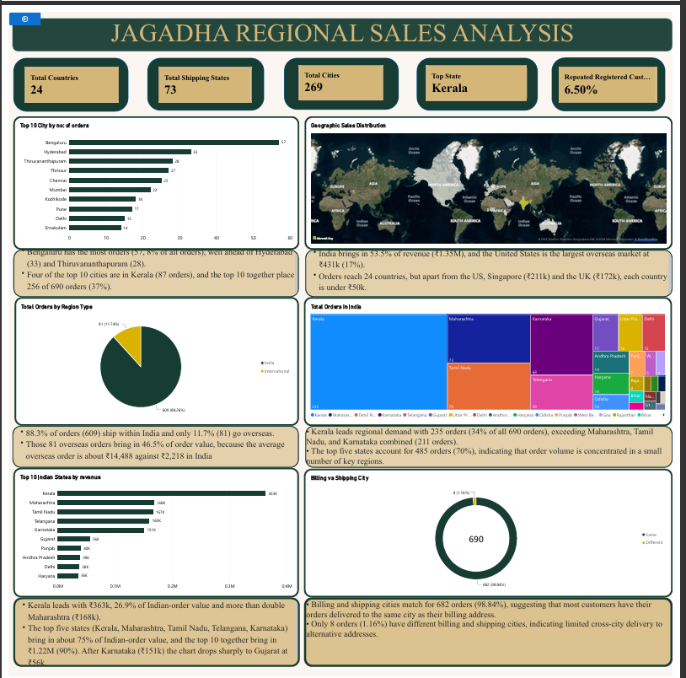
Figure 1. Jagadha Regional Sales Analysis dashboard

2. KPI cards
KPI | Value | Meaning
Total Countries | 24 | Distinct shipping countries represented in the dataset. India accounts for 609 of 690 orders.
Total Shipping States | 73 | Distinct shipping state/region values, including overseas regions such as England, Texas and Georgia.
Total Cities | 269 | Distinct shipping cities. 189 cities (70%) recorded only one order.
Top State | Kerala | State with the most orders: 235 of 690 (34%), with approximately ₹363k in order value.
Repeated Registered Customers | 6.50% | 21 of 323 identified customers have placed more than one order. Customer ID 0 (guest checkout) is excluded.

3. Data fields and DAX
The measures below use the Orders (2) table and cleaned shipping fields. If your Power BI model uses slightly different field names, replace the names in the formulas with the matching columns in your model.

3.1 Core measures
Total Orders =
DISTINCTCOUNT ( 'Orders (2)'[order_id] )
Total Revenue =
SUM ( 'Orders (2)'[order_subtotal_INR2] )
Total Countries =
DISTINCTCOUNTNOBLANK ( 'Orders (2)'[Shipping_country_clean] )
Total Shipping States =
DISTINCTCOUNTNOBLANK ( 'Orders (2)'[Shipping_state_clean] )
Total Cities =
DISTINCTCOUNTNOBLANK ( 'Orders (2)'[Shipping_city_clean] )
Top State =
MAXX (
TOPN (
1,
VALUES ( 'Orders (2)'[Shipping_state_clean] ),
[Total Orders],
DESC
),
'Orders (2)'[Shipping_state_clean]
)

3.2 Registered and repeat customer measures
A registered customer is counted when customer_id is not 0. Repeat registered customers are those with more than one distinct order. Guest checkouts are excluded because they cannot reliably be linked across orders.
Registered Customers =
CALCULATE (
DISTINCTCOUNT ( 'Orders (2)'[customer_id] ),
'Orders (2)'[customer_id] <> 0
)
Repeated Registered Customers =
COUNTROWS (
FILTER (
VALUES ( 'Orders (2)'[customer_id] ),
'Orders (2)'[customer_id] <> 0
&& CALCULATE ( [Total Orders] ) > 1
)
)
Repeated Registered Customers % =
DIVIDE (
[Repeated Registered Customers],
[Registered Customers]
)
Expected result from the current report: 323 registered customers, 21 repeat registered customers, and a repeat-customer percentage of approximately 6.5% (21 ÷ 323). Select the percentage measure, then use Measure tools → Format → Percentage and set decimal places to 1.

3.3 Domestic versus international orders
Create a calculated column in Power Query or DAX to classify each order by shipping country. For Power Query:
if [Shipping_country_clean] = "India" then "India" else "International"
The dashboard currently shows 609 India orders (88.3%) and 81 international orders (11.7%). Check that the country field is standardized before using this classification.

3.4 Billing versus shipping city
The City Match column compares the corrected billing and shipping city values. The formula below is a calculated column in the padanjaly_cleaned table, as provided.
City Match =
IF (
padanjaly_cleaned[Billing City (corrected)]
= padanjaly_cleaned[Shipping city (corrected)],
"Same",
"Different"
)
Use City Match as the legend in a donut chart and a count of order_id (or the appropriate order-count measure) as the value. In the current dashboard, 682 orders (98.84%) are marked Same and 8 (1.16%) Different. If blank city values are present, consider handling them explicitly rather than automatically classifying two blanks as Same.

4. Charts explained
Chart | Visual type | Fields / configuration | Purpose
Top 10 cities by order count | Horizontal bar chart | Shipping_city_clean; Total Orders. Top N = 10, sorted descending. | Highlights cities with the highest order volume.
Geographic sales distribution | Map | Shipping_country_clean as location; revenue as colour/size if supported. | Shows the geographic reach of orders and revenue.
Total orders by region type | Pie chart | Region Type as legend; Total Orders as value. | Compares domestic and international order volume.
Total orders in India | Treemap | Shipping_state_clean; Total Orders. Filter Region Type = India. | Compares order volume across Indian states.
Top 10 Indian states by revenue | Horizontal bar chart | Shipping_state_clean; Total Revenue. Filter Region Type = India; Top N = 10. | Ranks Indian states by converted order value.
Billing vs Shipping City | Donut chart | City Match as legend; order count as value. | Shows the share of orders whose corrected billing and shipping cities match.

5. Insights by chart
Chart | Insights
Top 10 cities by order count | • Bengaluru has the most orders (57, about 8% of all orders), ahead of Hyderabad (33) and Thiruvananthapuram (28).  • Four of the top 10 cities are in Kerala (Thiruvananthapuram, Thrissur, Kozhikode and Ernakulam; 87 orders). The top 10 cities together account for 256 of 690 orders (37%).
Geographic sales distribution | • India contributes 53.5% of revenue (approximately ₹1.35M); the United States is the largest overseas market at about ₹431k (17%).  • Orders reach 24 countries. Outside the US, Singapore (about ₹211k) and the UK (about ₹172k) are the next notable markets.
Orders by region type | • 609 orders (88.3%) are shipped within India, while 81 (11.7%) are international.  • The 81 international orders contribute about 46.5% of order value. Their average order value is much higher than that of India orders.
Orders in India by state | • Kerala accounts for 235 of 690 orders (34%), more than Maharashtra, Tamil Nadu and Karnataka combined (211 orders).  • The top five states account for 485 orders (70%), showing that order volume is concentrated in a small group of regions.
Top 10 Indian states by revenue | • Kerala leads with approximately ₹363k, around 26.9% of Indian-order value, and more than double Maharashtra.  • The top five states—Kerala, Maharashtra, Tamil Nadu, Telangana and Karnataka—contribute about 75% of Indian-order value.
Billing vs Shipping City | • Billing and shipping cities match for 682 orders (98.84%), suggesting that most orders are delivered to the same city as the billing address.  • Eight orders (1.16%) are marked Different. Review these records if cross-city delivery behaviour is an important business question.

6. Wider regional findings
- Revenue concentration: the top five Indian states contribute about 75% of Indian-order value. The four major southern states together contribute about 62%.
- Overseas revenue: five overseas locations—Singapore, England, Georgia, Texas and New Jersey—contribute about ₹510k (20% of total revenue). Singapore’s ₹211k comes from only four orders, including one unusually large order of approximately ₹154k; interpret the market total with caution.
- Value versus volume: Hyderabad generates more revenue than Bengaluru (approximately ₹147k versus ₹127k) despite fewer orders (33 versus 57), because its average order value is higher. Kerala’s regional lead is driven by order volume.
- Regional product preferences: Agnijith 90 gms leads in Karnataka, Maharashtra, Tamil Nadu and Telangana. Kerala differs, with Agnihari leading in the reported unit comparison.
- Customer loyalty: 21 of 323 identified customers placed more than one order. Many cities have only one recorded order, suggesting an opportunity to encourage repeat purchases.
- Billing and shipping: the current city comparison shows 682 Same and 8 Different records. Validate the eight different records and confirm how blank values are handled before making operational conclusions.

7. Conclusion
Jagadha’s regional order volume is concentrated in Kerala and a small group of other Indian states, while international orders contribute a disproportionately large share of order value. Bengaluru leads the city ranking by order count, whereas Hyderabad illustrates that fewer orders can still generate higher revenue when average order value is larger. The repeat registered customer rate is approximately 6.5%, making customer retention a potential opportunity. Regional growth efforts should combine maintaining strong markets, developing higher-value locations, and encouraging first-time customers to order again.

Prepared from the supplied Jagadha regional dashboard and DAX definitions.

