JAGADHA BY PADANJALI

Jagadha Product Sales Analysis
Dashboard Report

1. Overview
This report summarises the Jagadha Product Sales Analysis dashboard. It reviews product-level sales volume and revenue, revenue contribution by product, country-level revenue, performance across Indian states, and monthly changes in units sold and revenue. The report is based on the figures visible in the provided dashboard screenshot; it does not include DAX formulas.
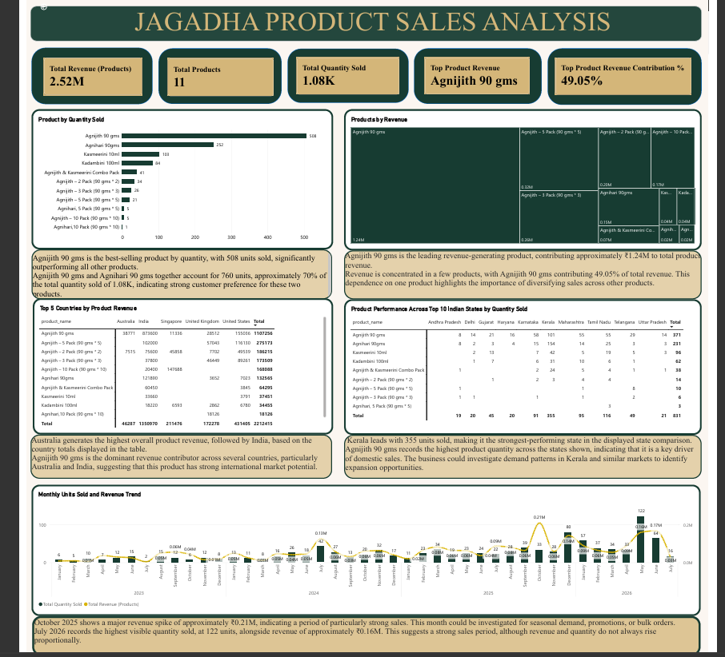
Figure 1. Jagadha Product Sales Analysis dashboard

2. KPI cards
KPI | Displayed value | Interpretation
Total Revenue (Products) | 2.52M | Total product revenue represented in the dashboard. Confirm the currency/unit used in the Power BI model before external reporting.
Total Products | 11 | The dashboard includes 11 distinct products, allowing product-level comparisons of volume and revenue.
Total Quantity Sold | 1.08K | Approximately 1,080 units were sold across the products in the current report view.
Top Product Revenue | Agnijith 90 gms | This is the highest revenue-generating product in the dashboard.
Top Product Revenue Contribution | 49.05% | Almost half of total product revenue is attributed to Agnijith 90 gms, indicating revenue concentration.

3. Charts explained
Chart | Visual type | Fields / comparison | Purpose
Product by Quantity Sold | Horizontal bar chart | Product name and quantity sold | Ranks products by unit volume and highlights the products with the strongest demand.
Products by Revenue | Treemap | Product name and product revenue | Compares each product’s share of total revenue; larger rectangles represent larger revenue contributions.
Top 5 Countries by Product Revenue | Matrix/table | Product, country and total revenue | Compares product revenue across the leading countries and shows which markets contribute most to sales.
Product Performance Across Top 10 Indian States by Quantity Sold | Matrix/table | Product, Indian state and quantity sold | Compares product quantities across Indian states and identifies strong regional product demand.
Monthly Units Sold and Revenue Trend | Combo chart | Month, total quantity sold and total product revenue | Shows monthly sales volume and revenue together to highlight peaks, dips and possible seasonality.

4. Insights by chart

Product by Quantity Sold
- Agnijith 90 gms leads unit sales with 508 units, well ahead of Agnihari 90gms at 252 units.
- The two leading products together account for 760 units, roughly 70% of the displayed total of 1.08K. This suggests that sales volume is concentrated in a small number of products.

Products by Revenue
- Agnijith 90 gms is the leading revenue-generating product, contributing approximately 1.24M in the displayed revenue units.
- Its 49.05% revenue contribution means nearly half of product revenue comes from one product. Growing the contribution of other products could reduce dependence on the current leader.

Top 5 Countries by Product Revenue
- Australia has the highest total product revenue in the table, followed by India.
- Agnijith 90 gms is a prominent revenue contributor in the country comparison, indicating that its performance is important across key markets. Country-level totals should be checked against the report filters before making expansion decisions.

Product Performance Across Top 10 Indian States by Quantity Sold
- Kerala leads the displayed state comparison with 355 units sold across the products shown.
- Agnijith 90 gms has the largest quantity total in the state matrix, at 371 units overall. Regional stock planning can prioritise high-demand products while checking whether product preferences vary by state.

Monthly Units Sold and Revenue Trend
- October 2025 shows a notable revenue peak of approximately 0.21M, suggesting a month worth investigating for promotions, bulk orders or seasonal demand.
- July 2026 shows the highest visible monthly quantity at 122 units, with revenue around 0.16M. The highest-volume month and highest-revenue month differ, so product mix and average selling value may affect monthly revenue.

5. Wider product sales findings
- Revenue concentration: Agnijith 90 gms contributes 49.05% of total product revenue, making it the most important product to monitor for availability and sales continuity.
- Volume concentration: Agnijith 90 gms and Agnihari 90gms together account for approximately 70% of total units sold. The remaining products may provide opportunities to broaden demand.
- Geographic opportunity: Australia ranks first in the country revenue table, while India is also a major market. Country performance should be interpreted alongside order counts and any unusually large transactions.
- Regional demand: Kerala leads the displayed Indian-state quantity comparison. Product-wise state performance can help guide inventory allocation and targeted marketing.
- Monthly fluctuations: Revenue and unit sales peak in different months, so both measures should be reviewed together rather than treating sales volume as a direct proxy for revenue.

6. Conclusion
The dashboard indicates that Agnijith 90 gms is the main driver of both quantity sold and product revenue, while a small group of products accounts for a large share of overall volume. Australia leads the country revenue comparison, and Kerala records the highest quantity in the displayed Indian-state matrix. Monthly patterns show that revenue and quantity do not always peak together. The business can use these findings to protect high-performing products, build sales for the rest of the product range, and target regional markets with decisions informed by both sales volume and revenue.
Prepared from the supplied Jagadha Product Sales Analysis dashboard screenshot.

