JAGADHA BY PADANJALI

Jagadha Product Sales Analysis
Dashboard Report

1. Overview
The product dashboard examines which Jagadha products drive sales volume and revenue, where they sell (countries and Indian states), and how sales have moved over time. Revenue comparisons use INR-converted values, with USD orders converted at the order-date rate. The dashboard contains five KPI cards and five product visuals, built on a Products table of 822 product lines taken from 690 orders (Product Item 1 to 4 combined, blank items removed).
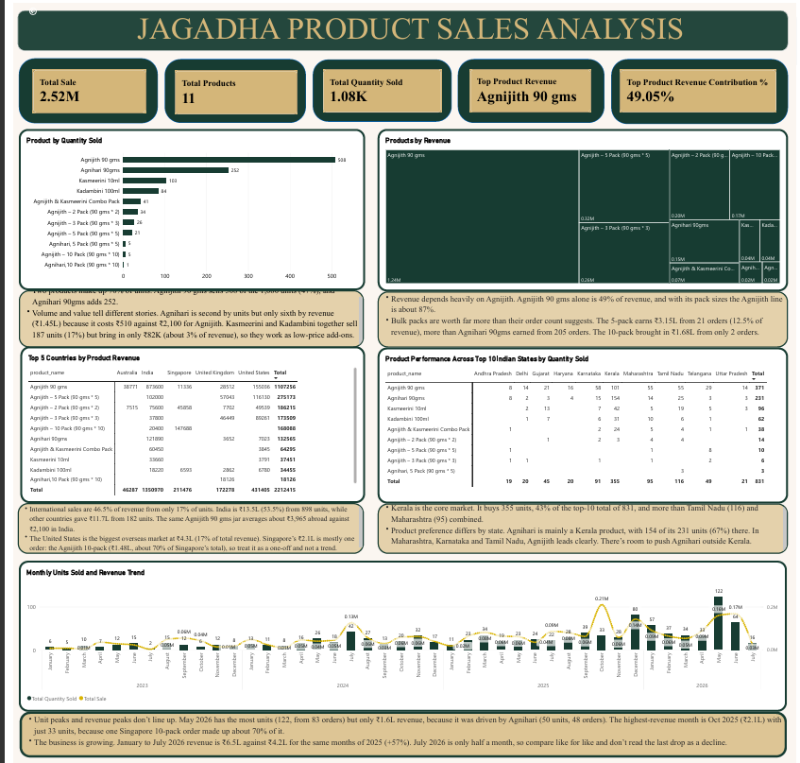
Figure 1. Jagadha Product Sales Analysis dashboard

2. KPI cards
KPI | Value | Meaning
Total Sale | 2.52M | Total revenue in INR (about ₹2,524,491) across all products. USD orders are converted at the order-date exchange rate; adding the raw totals would wrongly give ₹1.36M.
Total Products | 11 | Distinct product names sold, including pack variants (2, 3, 5 and 10 packs) and the Agnijith & Kasmeerini combo.
Total Quantity Sold | 1.08K | 1,080 units sold across 690 orders. A pack counts as one unit, so a 5-pack is 1 unit, not 5.
Top Product Revenue | Agnijith 90 gms | Product with the highest revenue (about ₹1.24M), from 386 orders and 508 units.
Top Product Revenue Contribution % | 49.05% | Share of total revenue generated by the top product. Almost half of revenue depends on one product.

3. Data fields and DAX
The measures below use the Products table. If your Power BI model uses slightly different table or column names, replace the names in the formulas with the matching ones in your model.

3.1 Data preparation and relationships
- In Power Query, change usd_inr_rate2 to Decimal Number after replacing the text value [Table] with null.
- Remove the empty columns at the end of the Products sheet (a stray cell creates four).
- Create a many-to-one relationship from Products[order_id] to the Orders (2) table’s order_id, with single-direction filtering. Shipping state, country and Region Type then filter the product measures.

3.2 Revenue column
converted_amount=
IF (
Products[order_currency] = "USD",
Products[total] * Products[usd_inr_rate2],
Products[total]
)
Expected result: the sum of Revenue INR is about ₹2,524,491, which matches the order-level INR subtotal.

3.3 Core and KPI measures
Total Sale =
SUM ( Products[Revenue INR] )
Total Products =
DISTINCTCOUNT ( Products[product_name] )
Total Quantity Sold =
SUM ( Products[quantity] )
Top Revenue Product =
VAR TopOne =
TOPN (
1,
VALUES ( Products[product_name] ),
[Total Revenue (Products)], DESC,
CALCULATE ( COUNTROWS ( Products ) ), DESC
)
RETURN
MINX ( TopOne, Products[product_name] )
Top Product Revenue Contribution % =
DIVIDE (
MAXX ( VALUES ( Products[product_name] ), [Total Revenue (Products)] ),
[Total Revenue (Products)]
)
Format the contribution measure as a percentage with two decimal places (Measure tools, Format, Percentage). Use it only in a card; on a visual already split by product it would show 100% for every bar.

3.4 Region type
Add Region Type to the Orders (2) table (Power Query or DAX) and filter the Indian-state matrix with Region Type = India.
Region Type =
IF ( 'Orders (2)'[Shipping_country_clean] = "India", "India", "International" )

4. Charts explained
Chart | Visual type | Fields / configuration | Purpose
Product by Quantity Sold | Horizontal bar chart | Y-axis: product_name. X-axis: Total Quantity Sold. Sorted descending. No Top N filter, since there are only 11 products. | Shows which products sell the most units.
Products by Revenue | Treemap | Category: product_name. Values: Total Revenue (Products). Tooltip: Revenue Share %. | Shows each product’s share of revenue and how concentrated sales are.
Top 5 Countries by Product Revenue | Matrix | Rows: product_name. Columns: Shipping_country_clean, filtered to Top 5 by Total Revenue (Products). Values: Total Revenue (Products). Totals on. | Compares product revenue across the five leading countries.
Product Performance Across Top 10 Indian States by Quantity Sold | Matrix | Rows: product_name. Columns: Shipping_state_clean, filtered to Top 10 by Total Quantity Sold. Values: Total Quantity Sold. Filter: Region Type = India. | Shows which products each major Indian state prefers.
Monthly Units Sold and Revenue Trend | Line and clustered column chart | X-axis: order_date (Year, Month) or Calendar Year-Month. Column y-axis: Total Quantity Sold. Line y-axis: Total Revenue (Products). Straight (not smoothed) line. | Shows how units and revenue change month by month.

5. Insights by chart
Chart | Insights
Product by Quantity Sold | - Agnijith 90 gms sells 508 of 1,080 units (47%). Together with Agnihari 90gms (252 units) it accounts for about 70% of all units.  - Agnihari is second by units but sixth by revenue (about ₹145k), because it sells at ₹510 against ₹2,100. Kasmeerini and Kadambini sell 187 units (17%) but only about ₹82k (3% of revenue), so they behave as low-price add-ons.
Products by Revenue | - Agnijith 90 gms contributes about ₹1.24M (49.05%). With its 2-, 3-, 5- and 10-pack variants, the Agnijith line is about 87% of revenue.  - Bulk packs earn more than their order counts suggest: the 5-pack brings about ₹315k from 21 orders (12.5% of revenue), more than Agnihari 90gms earned from 205 orders. The 10-pack earned about ₹168k from only 2 orders.
Top 5 Countries by Product Revenue | - India contributes about ₹1.35M (53.5% of revenue) from 898 units. The 182 units shipped overseas contribute about ₹1.17M (46.5%), because the same Agnijith 90 gms jar averages roughly ₹3,965 abroad against ₹2,100 in India.  - The United States is the largest overseas market at about ₹431k (17%). About 70% of Singapore’s ₹211k comes from a single Agnijith 10-pack line (about ₹148k), so treat it as a one-off.
Top 10 Indian States by Quantity Sold | - Kerala buys 355 units, 43% of the top-10 total of 831 and more than Tamil Nadu (116) and Maharashtra (95) combined.  - Preferences differ by state. Agnihari is mainly a Kerala product (154 of its 231 units in these states, 67%), while Agnijith 90 gms leads in Karnataka, Maharashtra, Tamil Nadu and Telangana.
Monthly Units Sold and Revenue Trend | - Unit peaks and revenue peaks differ. May 2026 has the most units (122 from 83 orders) but only about ₹161k, driven by lower-priced Agnihari (50 units). Oct 2025 is the highest-revenue month (about ₹210k) with just 33 units, and one Singapore 10-pack made up about 70% of it.  - Revenue is growing: January to July 2026 is about ₹654k against ₹417k for the same months of 2025 (+57%). July 2026 only covers data to 14 July, so its drop should not be read as a decline.

6. Wider product findings
- Revenue concentration: the Agnijith line (90 gms plus pack sizes) is about 87% of revenue, and Agnijith 90 gms alone is 49%. Any change in demand or pricing for this one line has a large effect on total sales.
- Overseas pricing: international orders are 11.7% of orders and 16.9% of units but 46.5% of revenue, because USD prices convert to roughly double the Indian rupee price for the same jar.
- Add-on products: Kasmeerini 10ml and Kadambini 100ml sell steadily in volume but add little revenue. 108 orders (15.7%) contain more than one product, so bundling these with Agnijith is a cross-sell opportunity.
- Regional product preferences: Kerala prefers Agnihari, while Karnataka, Maharashtra, Tamil Nadu and Telangana prefer Agnijith 90 gms. Agnihari has room to grow outside Kerala.
- Growth: revenue was about ₹300k in 2023, ₹597k in 2024 and ₹973k in 2025. By mid-July 2026 it is already about ₹654k, roughly 67% of the full 2025 total.
- Possible campaign: May 2026 has 83 orders against roughly 16 to 24 in nearby months, with about 33 product lines on 3 May alone. This is worth checking against promotions run that month.

7. Data notes and cautions
- The Products table has 822 lines from 690 orders (690 first items, 108 second, 22 third and 2 fourth items). It totals 1,080 units and about ₹2,524,491, and reconciles with the order-level totals.
- Product-level order counts add up to 822, not 690, because an order with two products counts once under each. The overall order count is still 690.
- 81 orders are in USD. Revenue must be converted line by line.
- Quantity counts packs, so a 10-pack is one unit.
- The Top 5 Countries matrix totals about ₹2.21M, which is the five countries only. The Total Sale card (₹2.52M) includes all 24 countries. Likewise the Top 10 states matrix covers 831 of India’s 898 units.
- Data ends on 14 July 2026, so July is a partial month.

8. Conclusion
Jagadha’s sales rest heavily on the Agnijith line, with Agnijith 90 gms alone generating nearly half of revenue and Agnihari 90gms adding most of the remaining volume, especially in Kerala. International customers buy fewer units but contribute almost half of revenue through higher prices, while bulk packs raise order value. Revenue has grown strongly each year, with 2026 on track to pass 2025. The main opportunities are to reduce dependence on one product, grow Agnihari outside Kerala, and bundle lower-priced products such as Kasmeerini and Kadambini with Agnijith.

