Jagadha by Padanjali
Jagadha Regional Sales Analysis: Dashboard Report

1. Overview
The regional dashboard shows where Jagadha’s orders and revenue come from: which countries, states and cities buy, how much of the business is domestic or international, and which places lead. All values are in Indian rupees. Orders from outside India were placed in US dollars and are converted to INR using the exchange rate on each order date. The page has five KPI cards and five charts.
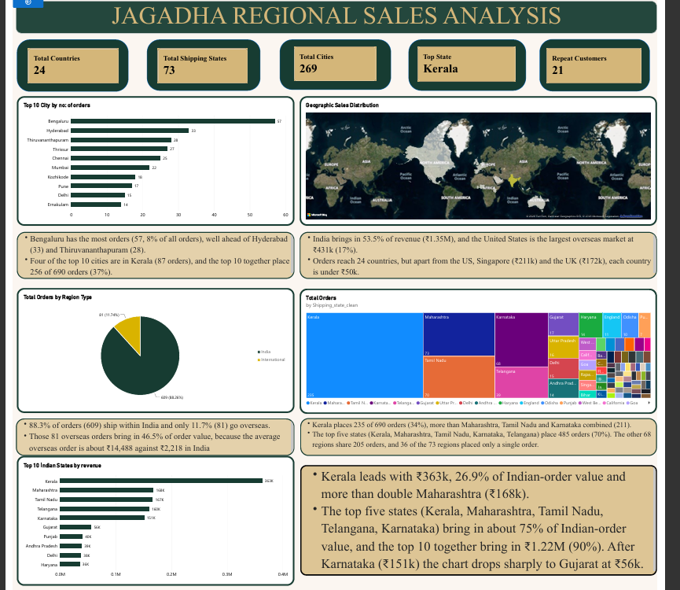
Figure 1: Jagadha Regional Sales Analysis dashboard

2. KPI cards
KPI | Value | Meaning
Total Countries | 24 | Distinct shipping countries. India accounts for 609 of 690 orders.
Total Shipping States | 73 | Distinct states or regions. It includes overseas regions such as Singapore, England, Texas and Georgia, so only 25 are Indian states.
Total Cities | 269 | Distinct shipping cities (199 in India). 189 of them (70%) ordered only once.
Top State | Kerala | State with the most orders: 235 of 690 (34%), worth ₹363k.
Repeat Customers | 21 | Identified customers (customer ID not 0) with more than one order. Only 6.5% of the 323 identified customers.

3. Columns and DAX used
3.1 DAX measures
Total Orders = DISTINCTCOUNT ( 'Orders (2)'[order_id] )
Total Revenue = SUM ( 'Orders (2)'[order_subtotal_INR2] )
Total Countries = DISTINCTCOUNTNOBLANK ( 'Orders (2)'[Shipping_country_clean] )
Total Shipping States = DISTINCTCOUNTNOBLANK ( 'Orders (2)'[Shipping_state_clean] )
Total Cities = DISTINCTCOUNTNOBLANK ( 'Orders (2)'[Shipping_city_clean] )
Top State =
MAXX ( TOPN ( 1, VALUES ( 'Orders (2)'[Shipping_state_clean] ), [Orders Count], DESC ),
'Orders (2)'[Shipping_state_clean] )
Identified Customers = CALCULATE ( DISTINCTCOUNT ( 'Orders (2)'[customer_id] ), 'Orders (2)'[customer_id] <> 0 )
Repeat Customers =
COUNTROWS ( FILTER ( VALUES ( 'Orders (2)'[customer_id] ),
'Orders (2)'[customer_id] <> 0 && CALCULATE ( [Orders Count] ) > 1 ) )
Region Type was created in Power Query (Add Column, Custom Column):
if [Shipping_country_clean] = "India" then "India" else "International"

4. Charts explained
Chart | Visual type | Fields
Top 10 cities by orders | Clustered bar chart | Shipping_city_clean; Orders Count
Geographic sales distribution | Map (filled) | Shipping_country_clean (location)
Orders by region type | Pie chart | Region Type; Orders Count
Orders by shipping state | Treemap | Shipping_state_clean; Orders Count
Top 10 Indian states by revenue | Clustered bar chart | Shipping_state_clean; Total Revenue

4.1 Top 10 Cities by number of orders (bar chart)
Fields: Shipping_city_clean on the axis and Orders Count as the value, filtered to the top 10 cities and sorted from highest to lowest. It shows which cities place the most orders, which suggests where to focus delivery, marketing and stock. Bengaluru (57 orders), Hyderabad (33), Thiruvananthapuram (28), Thrissur (27) and Chennai (25) lead. To build it, insert a clustered bar chart, add the two fields, apply a Top N filter of 10 on Orders Count, and sort descending. Kochi and Ernakulam are one metro area but appear as separate cities.
4.2 Geographic Sales Distribution (map)
Fields: Shipping_country_clean as the location. The map shows every country that has received an order, so the reach of the business is visible at once: India in the south of Asia, plus customers in the United States, United Kingdom, Singapore, Australia and other countries. Adding Total Revenue to the colour setting shades countries by sales value, where darker means more revenue. Map visuals must be enabled under File, Options, Security before the map will draw. Revenue shares: India 53.5%, United States 17%, Singapore 8%, United Kingdom 7%.
4.3 Total Orders by Region Type (pie chart)
Fields: Region Type as the legend and Orders Count as the value. It splits all 690 orders into India (609, 88.26%) and International (81, 11.74%). It shows how much of the business is domestic and how much is overseas. A pie is suitable here because there are only two slices. Region Type must exist as a column before the chart can be built.
4.4 Total Orders by Shipping State (treemap)
Fields: Shipping_state_clean as the group and Orders Count as the size. Larger boxes mean more orders, so the chart shows at a glance which states dominate order volume. The treemap includes overseas regions, so England (11 orders), Singapore and California appear beside Indian states. Kerala (235), Maharashtra (73), Tamil Nadu (70), Karnataka (68) and Telangana (39) are the five largest boxes. To show Indian states only, add a visual filter on Region Type equal to India. Hovering over a box shows its exact order count, and adding Total Revenue to the tooltip shows its value as well.
4.5 Top 10 Indian States by Revenue (bar chart)
Fields: Shipping_state_clean on the axis and Total Revenue as the value. The visual is filtered first to Region Type equal to India, so overseas regions are excluded, and then to the top 10 states by Total Revenue. Where the treemap above shows order volume, this chart shows order value. Kerala (₹363k), Maharashtra (₹168k), Tamil Nadu (₹167k), Telangana (₹160k) and Karnataka (₹151k) lead, followed by Gujarat, Punjab, Andhra Pradesh, Delhi and Haryana. Data labels are shown in thousands.

5. Insights
5.1 Insights by chart
Chart | Two insights
Top 10 cities by orders | Bengaluru has the most orders (57, 8% of all orders), well ahead of Hyderabad (33) and Thiruvananthapuram (28).  Four of the top 10 cities are in Kerala (Thiruvananthapuram, Thrissur, Kozhikode, Ernakulam; 87 orders), and the top 10 together place 256 of 690 orders (37%).
Geographic sales distribution | India brings in 53.5% of revenue (₹1.35M). The United States is the largest overseas market at ₹431k (17%).  Orders reach 24 countries, but beyond the United States, Singapore (₹211k) and the United Kingdom (₹172k), each country is under ₹50k.
Orders by region type | 88.3% of orders (609) ship within India and only 11.7% (81) go overseas.  Those 81 overseas orders bring in 46.5% of order value, because the average overseas order is about ₹14,488 against ₹2,218 in India.
Orders by state | Kerala places 235 of 690 orders (34%), more than Maharashtra, Tamil Nadu and Karnataka combined (211).  The top five states place 485 orders (70%). The other 68 regions share 205 orders, and 36 of the 73 regions placed only a single order.
Top 10 Indian states by revenue | Kerala leads with ₹363k, 26.9% of Indian-order value and more than double Maharashtra (₹168k).  The top five states bring in about 75% of Indian-order value, and the top 10 together bring in ₹1.22M (90%). After Karnataka (₹151k), the chart drops sharply to Gujarat at ₹56k.
5.2 Wider regional findings
- Concentration. The top five Indian states bring in 75% of Indian-order value: Kerala 27%, Maharashtra 12%, Tamil Nadu 12%, Telangana 12% and Karnataka 11%. The four southern states together bring in 62%.
- Overseas revenue. Five overseas places (Singapore, England, Georgia, Texas, New Jersey) bring in ₹510k (20% of revenue). Singapore’s ₹211k comes from only 4 orders, one of them ₹154k.
- Value versus volume. Hyderabad earns more than Bengaluru (₹147k against ₹127k) from fewer orders (33 against 57), because its average order is about twice as large (₹4,450 against ₹2,220). Kerala’s average order is the lowest of the major states at ₹1,546, so its lead comes from volume.
- The 2026 surge is Kerala-led. Kerala orders rose from 28 in 2026 Q1 to 89 in Q2, 64% of that quarter’s 139 orders. The other four main states combined stayed flat at 26 and 29. Kerala’s share of orders was 21% to 28% in 2023 to 2025 and is 53% in 2026 so far.
- Products by region. Agnijith 90 gms leads in Karnataka, Maharashtra, Tamil Nadu and Telangana (88% of Telangana’s units). Kerala is the exception: Agnihari leads there with 154 units against 107 for Agnijith.
- Customer loyalty. Only 21 of 323 identified customers ordered more than once (48 orders), and 19 of them stayed in one city. Hyderabad has the most repeat orders (10 from 3 customers), followed by Noida (6). 49% of orders come from guests with no customer ID.
- Billing and shipping. Billing and shipping city, state and country match on all 690 orders in the cleaned data, so ship-to-different-address orders cannot be identified.
- Wide but shallow. 189 of 269 cities (70%) placed a single order, so growth depends on turning one-off buyers in new cities into repeat buyers.
5.3 Conclusion
Jagadha’s sales are concentrated in a small number of places. Kerala and four other Indian states supply most domestic orders, and a small group of overseas customers supplies almost half of order value. The business grows fastest in Kerala, where recent volume is high but the average order is small. Repeat purchasing is low everywhere. The clearest opportunities are to keep Kerala’s momentum, grow the higher-value cities such as Hyderabad, and bring back first-time buyers in the many cities that have ordered once.

