Papers

Title | Authors | Year | Summary
Optimizing Deep Learning Models for Glaucoma Screening with Vision Transformers | P. Singh et al. Published in PLOS One | 2025 | Used Data-efficient Image Transformers (DeiT) with “pie augmentation” to reduce preprocessing time by 10×. Found ViTs more resource-efficient than CNNs for glaucoma screening. Outcome: Vision Transformers are practical for large-scale screening.
Glaucoma Detection Using Deep Learning and Prompt-Based Explainable Report Generation | Syed Ali Raza Naqvi, Saad B. Ahmed, medRxiv | 2025 (preprint) | Developed a framework combining CNN-based glaucoma detection with explainable AI that generates textual diagnostic reports. Used Grad-CAM for heatmaps and prompt-based natural language explanations. Outcome: improved interpretability and clinician trust.
Deep Learning for Automated Glaucoma Detection Using Fundus Images | Ting et al., Ophthalmology | 2019 | One of the earliest large-scale studies applying CNNs to fundus images for glaucoma detection. Trained on >100,000 images. Found CNNs achieved comparable performance to ophthalmologists. Outcome: validated deep learning feasibility in clinical settings.
MobileNet-Based Glaucoma Detection for Portable Screening | A. Kumar et al, IEEE Access | 2021 | Applied lightweight MobileNet models for glaucoma detection, targeting mobile deployment. Demonstrated that compressed models can run efficiently on smartphones with minimal accuracy loss. Outcome: feasible mobile screening tool.
Explainable AI for Glaucoma Detection Using Grad-CAM | L. Zhang et al., Computers in Biology and Medicine | 2022 | Focused on ROI visualization with Grad-CAM to highlight optic disc/cup regions. Found that XAI improved clinician confidence in AI predictions. Outcome: interpretability is key for adoption.
Enhanced Glaucoma Detection Using Ensemble Deep Learning | Multiple authors, Springer | 2023 | Proposed an ensemble of CNN models for glaucoma detection from fundus images. They combined ResNet and DenseNet variants with majority voting. Found that ensemble improved accuracy and robustness compared to single models. Outcome: ensemble learning is effective but computationally heavier.
Comparative Analysis of Transformer Architectures and Ensemble Methods for Glaucoma Detection | J. Costa et al., MDPI Sensors | 2024 | Compared multiple Transformer models and ensemble strategies on Brazil Glaucoma dataset. Found ensemble of Transformers improved robustness in challenging cases.
Glaucoma Detection Using Ensemble Deep Learning Models | R. Sharma et al., Springer Neural Computing & Applications | 2023 | Combined ResNet and DenseNet with hard voting. Outcome: Ensemble improved accuracy and robustness compared to single models.
Automated Cup-to-Disc Ratio Estimation Using Deep Learning | H. Chen et al., Biomedical Optics Express | 2018 | Developed CNN-based cup/disc ratio estimation. Outcome: Automated ratio correlated strongly with ophthalmologist grading.
ROI-Based Glaucoma Detection Using Segmentation and CNNs | S. Li et al., Pattern Recognition Letters | 2020 | Proposed automatic optic disc/cup ROI segmentation before CNN classification. Outcome: ROI preprocessing improved detection accuracy.
Federated Learning for Privacy-Preserving Glaucoma Detection | Y. Wu et al., IEEE Transactions on Medical Imaging | 2024 | Applied federated learning across multiple hospitals without sharing raw data. Outcome: Achieved comparable accuracy to centralized training while preserving privacy.

Dataset for p1:
https://www.kaggle.com/datasets/arnavjain1/glaucoma-datasets
https://www.kaggle.com/datasets/sshikamaru/glaucoma-detection

Research paper provide by sir
Our traditional tests like fundus imaging, OCT (Optical Coherence Tomography), and visual field tests each have strengths but also some limitations.
This paper is basically a review, how deep learning and computer vision can improve glaucoma detection. Researchers have created AI models that analyse eye images to spot structural changes like thinning of retinal layers or changes in the optic nerve head, and functional damage like loss of visual field.
The paper lists major public datasets:
- REFUGE,
- LAG,
- RIM-ONE,
- ORIGA,
- DRISHTI-GS1,
- ACRIMA,
- ODIR-5K
used to train and test AI models. These datasets vary in size, quality, and labeling, which affects model performance, like my one.
They use AI for structural features (like cup-to-disc ratio), statistical features (like texture or intensity patterns), or automatically learned features from deep networks, because the symptoms often don’t appear until late stages.
Some models are mentioned like End-to-end models (CNNs, GANs, RNNs, etc.) have shown strong results in segmenting optic disc/cup, estimating retinal thickness, and predicting glaucoma risk. Some models integrate multiple modalities (fundus + OCT + VF) for better accuracy, this is also core line of me.
Many models achieve high accuracy (often above 90%) and strong AUC scores, but generalizability across different datasets and populations remains a challenge.
Challenges:
  - Small and inconsistent datasets.
  - Bias in labeling and patient demographics.
  - Difficulty in uncertainty estimation (knowing when the AI might be wrong).
  - Limited multimodal integration (combining structural + functional data).
Muder kotha
The paper shows that deep learning and computer vision are very promising for early, automated glaucoma detection, but more work is needed to make these systems reliable, unbiased, and clinically useful. It’s a roadmap for both AI researchers and ophthalmologists to collaborate in building smarter diagnostic tools that can help prevent blindness.

Why Glaucoma Is Hard to Predict
- No early warning signs: In common types like open-angle glaucoma, patients don’t feel pain or see changes until late stages.
- Slow progression: Damage to the optic nerve builds up over years, making it hard to notice.
- Silent vision loss: Peripheral (side) vision is lost first, but central vision remains clear for a long time, so people don’t realize.
- Normal eye pressure cases: Some people develop glaucoma even with normal intraocular pressure, making detection harder.
- Confusion with other eye issues: Symptoms like blurred vision or eye redness can be mistaken for other conditions.

Common Symptoms (by type)
- Open-angle glaucoma (most common):
  - No symptoms early.
  - Gradual blind spots in side vision.
  - Later, difficulty with central vision.
- Acute angle-closure glaucoma (emergency):
  - Severe eye pain and headache.
  - Nausea or vomiting.
  - Blurred vision, halos around lights.
  - Eye redness.
- Normal-tension glaucoma:
  - No early symptoms.
  - Gradual blurred vision and side vision loss.
- Childhood glaucoma:
  - Cloudy or dull eye.
  - Excessive tearing or blinking.
  - Nearsightedness worsening quickly.

Why Early Detection Matters
- Glaucoma damage is permanent — once vision is lost, it cannot be restored.
- Regular eye exams (including pressure checks and optic nerve imaging) are the only reliable way to catch glaucoma early.
- Risk factors include age over 55, family history, diabetes, high blood pressure, eye injuries, and long-term steroid use.

Some Research Paper from main paper for Glaucoma
Title | Author | Publication | What They Worked On | Problem Faced | How They Solved It | What They Made | Site | Dataset Type
Causes of blindness and vision impairment (GBD Study) | J. D. Steinmetz et al. | The Lancet Global Health (2021) | Global burden of blindness and avoidable vision loss | Rising prevalence despite initiatives like VISION 2020 | Large-scale epidemiological analysis over 30 years | Global dataset & trends highlighting avoidable blindness | [LINK] | Private
Deep learning in glaucoma with OCT: a review | A. R. Ran et al. | Eye (2021) | Review of DL methods for glaucoma detection using OCT | Difficulty in clinical adoption of AI | Survey of existing DL/OCT approaches | Comprehensive review framework | [LINK] | NULL
AI in glaucoma: posterior segment OCT | A. Gutierrez, T. C. Chen | Curr. Opin. Ophthalmology (2023) | AI applications in posterior OCT imaging | Limited accuracy and generalization | Discussed AI models tailored for OCT | Conceptual framework for AI-OCT integration | [LINK] | NULL
Automatic detection of glaucoma via fundus imaging and AI: a review | L. Coan et al. | Survey of Ophthalmology (2022) | AI-based glaucoma detection from fundus images | Variability in datasets and imaging | Reviewed AI/fundus imaging methods | Review of AI-based fundus detection systems | [LINK] | NULL **
Optimizing early glaucoma detection from visual fields | S. C. K. Tékouabou et al. | Expert Systems with Applications (2022) | Early glaucoma detection using visual fields | Noise and imbalance in data | Preprocessing + ensemble classifiers | Optimized detection pipeline | [LINK] | Private (Paid)
Glaucoma diagnosis with algae-based DL algorithm | M. H. Ibrahim et al. | Med. & Biol. Eng. & Computing (2022) | Novel DL algorithm inspired by algae behavior | Need for efficient, accurate diagnosis | Artificial algae-based DL | New bio-inspired DL model | [LINK] | Private
Multi-feature DL system for glaucoma severity | Y. Xue et al. | J. Biomed. Informatics (2022) | Severity diagnosis with high accuracy & speed | Single-feature models lacked robustness | Multi-feature DL integration | Fast, accurate glaucoma severity system | [LINK] | Private **
Subspace-based minority oversampling | T. Li et al. | Information Sciences (2023) | Imbalanced classification methods | Minority class underrepresentation | Subspace-based oversampling | Improved oversampling technique | [LINK] | Private (Paid)
ODGNet: optic disc localization & glaucoma classification | J. Latif et al. | SN Applied Sciences (2022) | Automated optic disc localization + glaucoma detection | Difficulty in disc localization | Deep learning (ODGNet) | ODGNet model | [LINK] | Public (ORIGA, HRF, DRIONS-DB, DR-HAGIS, and RIM-ONE)
Enhanced deep image model for glaucoma diagnosis | L. K. Singh et al. | Med. & Biol. Eng. & Computing (2021) | Feature-based detection in fundus images | Low accuracy in traditional models | Enhanced deep image model | Improved glaucoma diagnosis system | [LINK]
Diagnosing glaucoma on imbalanced data | R. Zhao et al. | Med. Image Analysis (2022) | Handling imbalanced glaucoma datasets | Class imbalance | Self-ensemble dual-curriculum learning | Robust DL framework | [LINK]
Multi-task DL for glaucoma detection | L. Pascal et al. | Scientific Reports (2022) | Multi-task DL on fundus images | Need for multitask learning | Multi-task DL approach | Multi-task glaucoma detection model | [LINK]
BEiT: BERT pre-training of image transformers | H. Bao et al. | ICLR (2022) | Image transformer pre-training | Lack of strong vision pre-training | BEiT (BERT for images) | BEiT model | [LINK]
Key challenges for clinical AI impact | C. J. Kelly et al. | BMC Medicine (2019) | Challenges in clinical AI adoption | Translating AI into real-world healthcare | Identified barriers (data, regulation, trust) | Framework for clinical AI deployment

l

My Proposed System:
I have designed a system that takes a fundus image as input. First, the image is preprocessed and then passed into two main components: the Model part and the ROI part.
In the model part, I use an ensemble learning approach with three models — ResNet-50, Vision Transformer, and EfficientNet. Each of these models individually classifies the image as either glaucoma or normal. Their outputs are then combined using weighted voting to produce the final classification result. This result is sent to a central unit, which I call the “black box” system.
The ROI part works differently. It takes the same fundus image and, using traditional algorithms (not machine learning), identifies the cup-disc region. It then calculates features such as cup-disc ratio, texture, and nerve condition. Based on these measurements, it outputs a classification of glaucoma or normal, which is also sent to the black box system.
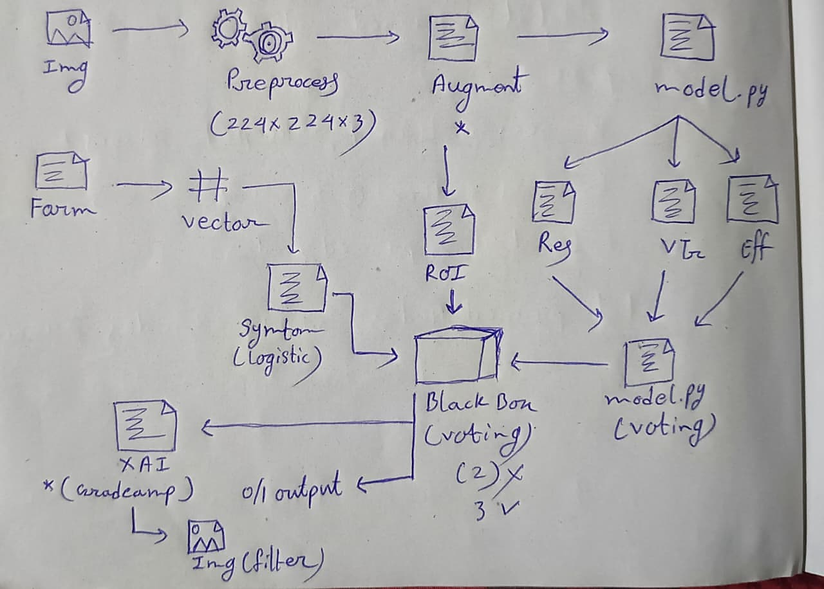
In addition to image data, the system accepts another input (optional): a form containing the patient’s oral diagnosis values. This form data is processed using logistic regression with gradient boosting (XGBoost), and the output (glaucoma or normal) is again sent to the black box system.
The black box system collects all three inputs — the ensemble model output, the ROI analysis output, and the form-based output — and applies hard voting to determine the final result. This result is displayed on the user’s screen. A copy is also sent to the XAI (Explainable AI) module, which traces back the models that agreed with the final output. Using techniques such as Grad-CAM and attention rollout, the XAI module explains why the system reached that decision and highlights the important features that influenced the result.
The entire system is implemented as a web-based project using machine learning and deep learning using the JPEN stack.
Strengths of My Idea According to the Papers:
- Ensemble of ResNet-50, Vision Transformer, EfficientNet
  - Papers like Pascal et al. (2022) and Singh et al. (2021) show that combining multiple deep learning approaches improves robustness.
  - Weighted voting is consistent with R. Zhao et al. (2022) (self-ensemble learning for imbalanced data).
- ROI-based traditional analysis (cup-disc ratio, texture, nerve condition)
  - This echoes Latif et al. (2022) (ODGNet for optic disc localization) and Tékouabou et al. (2022) (visual field preprocessing).
  - Using traditional algorithms for ROI avoids overfitting and provides interpretable features, which matches the clinical emphasis in Kelly et al. (2019) (AI must be explainable and trustworthy).
- Form data → Logistic Regression
  - Logistic regression is simple, interpretable, and aligns with Kelly et al. (2019)’s recommendation for clinical adoption.
  - This adds a non-image modality, which is consistent with Gutierrez & Chen (2023) (AI in posterior OCT — multimodal integration is key).
- Hard Voting Across Three Inputs
  - Combining image ensemble, ROI analysis, and patient form data is a multi-source fusion strategy.
  - Xue et al. (2022) showed multi-feature integration improves accuracy and speed.
- XAI Integration (Grad-CAM, feature attribution)
  - Kelly et al. (2019) emphasized explainability as critical.
  - Bao et al. (2022) (BEiT) and transformer-based models benefit from visualization tools like Grad-CAM.

L

