

**MOCK MANTRA**

**(CBSE Class 12 MOCK EXAMINATION)**

**MOCK PAPER 1**

**Mathematics**

## Time Allowed: 3 hours Maximum Marks: 80

**General Instructions:**

1. This Question paper contains 38 questions. All questions are compulsory.
2. This Question paper is divided into five Sections - A, B, C, D and E.
3. In Section A, Questions no. 1 to 18 are multiple choice questions (MCQs) and Questions no. 19 and 20 are Assertion-Reason based questions of 1 mark each.
4. In Section B, Questions no. 21 to 25 are Very Short Answer (VSA)-type questions, carrying 2 marks each.
5. In Section C, Questions no. 26 to 31 are Short Answer (SA)-type questions, carrying 3 marks each.
6. In Section D, Questions no. 32 to 35 are Long Answer (LA)-type questions, carrying 5 marks each.
7. In Section E, Questions no. 36 to 38 are Case study-based questions, carrying 4 marks each.
8. There is no overall choice. However, an internal choice has been provided in 2 questions in Section B, 3 questions in Section C, 2 questions in Section D and one subpart each in 2 questions of Section E.
9. Use of calculators is not allowed.

## Section A

1. Two matrices A = [aij] and B = [bij] are said to be equal, if they are of same order and for all i and j, their elements are
   1. aij = -bij b) aij = bij

c) aij = bji d) aij + bij = 0



## [1]

1. For any 2 × 2 matrix, If A(adj A) = 10

[

# 0

0 , then |A| is equal to **[1]**

# 10

]

1. 20 b) 10

c) 0 d) 100

1. If A and B are square matrices such that B = - A- 1 BA, then (A + B)2 = **[1]**
   1. O b) A + B

c) A2 + B2 d) A2 + 2AB + B2

1. Let f(x) = −3

{

# *x*2 − 3

−3 ≤ *x* < 0 and g(x) = |f(x) + f(|x|) then which of the following is true?

0 ≤ *x* ≤ 3

**[1]**

1. At x = 0, g(x) is continuous as well as differentiable and at x = √3, g(x) is continuous but not differentiable.
2. At x = √3, g(x) is neither continuous nor differentiable
3. At x = 2, g(x) is neither continuous nor differentiable
4. None of these

a) Option (iii) b) Option (iv)

c) Option (ii) d) Option (i)

1. The vector equation of the x-axis is given by **[1]**
   1. *r*⃗ = *j* + *k*^

c) *r*⃗ = *i*

* 1. *r*⃗ = *j* − *k*^

d) *r*⃗ = *λi*

1. Integrating factor of the differential equation ( *d*2 *y* )2 − ( *dy* ) =

*y*3 , is **[1]**

*dx*2 *dx*

* 1. cos x b) sin x

c) tan x d) sec x

1. Maximize Z = 100x + 120y , subject to constraints 2x + 3y ≤ 30, 3x + y ≤ 17, x ≥ 0, y ≥ 0. **[1]**
   1. 1260 b) 1280
2. 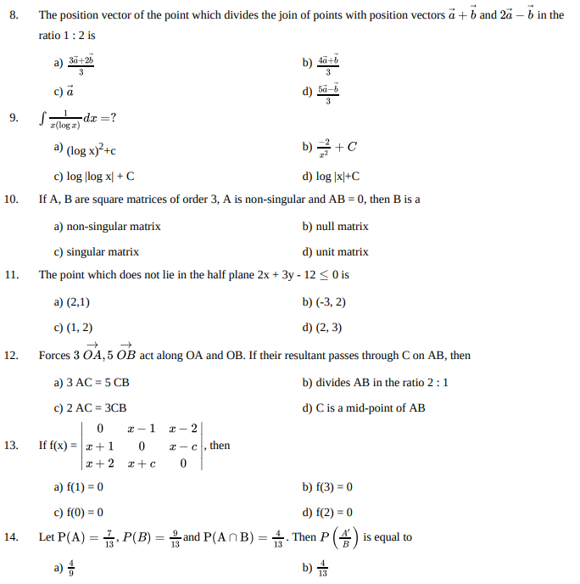1300 d) 1200
3. The position vector of the point which divides the join of points with position vectors *a* +⃗ *b*⃗ and 2*a* −⃗ *b*⃗ in the ratio 1 : 2 is

## [1]

* 1. 3*a*+⃗2*b*⃗

3

* 1. 4*a*+⃗*b*⃗

3

* 1. *a*⃗

1. 1 *dx* =?

∫

*x*(log *x*)

1. 5*a*−⃗*b*⃗

3

## [1]

a) (log x)2+c b)

−2 + *C*

*x*2

c) log |log x| + C d) log |x|+C

1. If A, B are square matrices of order 3, A is non-singular and AB = 0, then B is a **[1]**
   1. non-singular matrix b) null matrix

c) singular matrix d) unit matrix

1. The point which does not lie in the half plane 2x + 3y - 12 ≤ 0 is **[1]**
   1. (2,1) b) (-3, 2)

c) (1, 2) d) (2, 3)

1. Forces 3

→ → *OA*, 5 *OB*

act along OA and OB. If their resultant passes through C on AB, then **[1]**

* 1. 3 AC = 5 CB b) divides AB in the ratio 2 : 1

c) 2 AC = 3CB d) C is a mid-point of AB

∣ 0 *x* − 1 *x* − 2 ∣

**[1]**

1. If f(x) = ∣ *x* + 1 0 *x* − *c* ∣, then

∣

∣

∣ *x* + 2 *x* + *c* 0 ∣

* 1. f(1) = 0 b) f(3) = 0

c) f(0) = 0 d) f(2) = 0

1. Let P(A) =  7 , *P* (*B*) =  9 and P(A ∩ B) =  4

. Then *P* ( *A*′ ) is equal to **[1]**

13 13

* 1. 4

9

13 *B*

* 1. 4 13
  2. 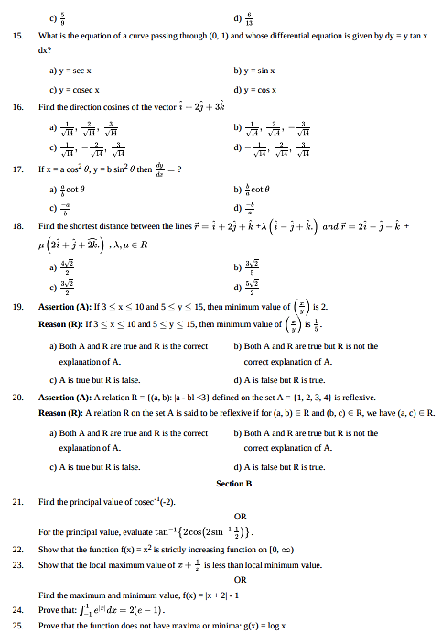5

9

* 1. 6 13

1. What is the equation of a curve passing through (0, 1) and whose differential equation is given by dy = y tan x dx?

**[1]**

* 1. y = sec x b) y = sin x

c) y = cosec x d) y = cos x

1. Find the direction cosines of the vector *i* + 2*j* + 3*k*

## [1]

* 1. 1 ,

2 , 3

* 1. 1 ,

2 , − 3

√14

√14

√14

√14

√14

√14

* 1. 1 , − 2 , 3

# − 1 ,

2 , 3

√14

√14

√14

√14

√14

√14

1. If x = a cos2 *θ*, y = b sin2 *θ* then *dy*

*dx*

= ? **[1]**

* 1. *a* cot *θ*

*b*

1. −*a b*
   1. *b* cot *θ*
2. −*b*

*a*

*a*

1. Find the shortest distance between the lines *r*⃗ = *i* + 2*j* + *k*^ +*λ* (*i* − *j* + *k*^.) *and r*⃗ = 2*i* − *j* − *k*^ +

*μ* (2*i* + *j* + 2*k*.) , *λ*, *μ* ∈ *R*

**[1]**

* 1. 4√2

2

c) 3√2

2

* 1. 3√2

5

d) 5√2

2

1. **Assertion (A):** If 3 ≤ x ≤ 10 and 5 ≤ y ≤ 15, then minimum value of ( *x* ) is 2.

*y*

**Reason (R):** If 3 ≤ x ≤ 10 and 5 ≤ y ≤ 15, then minimum value of ( *x* ) is 1 .

*y*

5

**[1]**

* 1. Both A and R are true and R is the correct explanation of A.
  2. Both A and R are true but R is not the correct explanation of A.
  3. A is true but R is false. d) A is false but R is true.

1. **Assertion (A):** A relation R = {(a, b): |a - bl <3} defined on the set A = {1, 2, 3, 4} is reflexive.

**Reason (R):** A relation R on the set A is said to be reflexive if for (a, b) ∈ R and (b, c) ∈ R, we have (a, c) ∈ R.

## [1]

* 1. Both A and R are true and R is the correct explanation of A.
  2. Both A and R are true but R is not the correct explanation of A.
  3. A is true but R is false. d) A is false but R is true.

## Section B

1. Find the principal value of cosec-1(-2). **[2]**

OR

For the principal value, evaluate tan−1{2 cos(2 sin−1 1 )} .

2

1. Show that the function f(x) = x2 is strictly increasing function on [0, ∞) **[2]**
2. Show that the local maximum value of *x* +  1

*x*

is less than local minimum value. **[2]**

OR

Find the maximum and minimum value, f(x) = |x + 2| - 1

1. Prove that: ∫ 1

−1

*e*|*x*|*dx* = 2(*e* − 1) . **[2]**

1. Prove that the function does not have maxima or minima: g(x) = log x **[2]**

## Section C

1. Find: ∫

(3 sin *ϕ*−2) cos *ϕ* 5−cos2 *ϕ*−4 sin *ϕ dϕ*

**[3]**

1. A problem is given to three students whose chances of solving it are 1/3, 2/7 and 3/8. What is the probability that the problem will be solved?
2. Evaluate ∫ 2 *x*2*dx*

1

**[3]**

## [3]

OR

Evaluate: ∫ cot5 x dx

1. Find the general solution of the differential equation: x *dy*

*dx*

+ 2y = x2 log x **[3]**

OR

Assume that a spherical rain drop evaporates at a rate proportional to its surface area. If its radius originally is 3 mm and 1 hour later has been reduced to 2 mm, find an expression for the radius of the rain drop at any time.

1. Maximize Z = x + 2y subject to the constraints **[3]**

*x* − *y* ≥ 0, 2*y* ≤ *x* + 2, *x*, *y* ≥ 0

OR

The feasible region for an LPP is shown in fig. Evaluate Z = 4x + y at each of the corner points of this region. Find the minimum value of Z, if it exists.

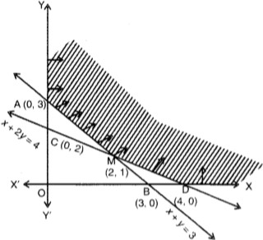

1. If x = tan( 1 log

), then show that (1 +

2 ) *d*2 *y* + (2 −

*dy* = 0 . **[3]**

*a y* *x*

*dx*2

*x a dx*

## Section D

)

1. Find the area between the curves y = x and y = x2 **[5]**
2. Let A be the set of all human beings in a town at a particular time. Determine whether each of the following relations are reflexive, symmetric and transitive:
3. R = {(x, y): x and y work at the same place}
4. R = {(x, y): x and y live in the same locality}

**[5]**

OR

Show that the function f : R → R defined by *f*(*x*) = *x* , ∀*x* ∈ *R*, is neither one-one nor onto.

2

*x* +1

1. Solve the system of the linear equations by Cramer's rule: x + y = 5

y + z = 3 x + z = 4

1. By computing the shortest distance determine whether the pairs of lines intersect or not:

*r*⃗ = ( *i* − *j*) + *λ*(2*i* + *k*^) and *r*⃗ = (2*i* − *j*) + *μ*( *i* + *j* − *k*^)

OR

## [5]

**[5]**

Find the distance of a point (2, 4, –1) from the line *x*+5

=

1

*y*+3

4 =

*z*−6 .

−9

## Section E

1. **Read the following text carefully and answer the questions that follow:**

To teach the application of probability a maths teacher arranged a surprise game for 5 of his students namely Govind, Girish, Vinod, Abhishek and Ankit. He took a bowl containing tickets numbered 1 to 50 and told the students go one by one and draw two tickets simultaneously from the bowl and replace it after noting the numbers.

1. Teacher ask Govind, what is the probability that tickets are drawn by Abhishek, shows a prime number on one ticket and a multiple of 4 on other ticket? (1)
2. Teacher ask Girish, what is the probability that tickets drawn by Ankit, shows an even number on first ticket and an odd number on second ticket? (1)
3. Teacher asks Abhishek, what is the probability that tickets drawn by Vinod, shows a multiple of 4 on one ticket and a multiple 5 on other ticket? (2)

## OR

Teacher asks Vinod, what is the probability that both tickets drawn by Girish shows odd number? (2)

## Read the following text carefully and answer the questions that follow:

Three slogans on chart papers are to be placed on a school bulletin board at the points A, B and C displaying A (Hub of Learning), B (Creating a better world for tomorrow) and C (Education comes first). The coordinates of these points are (1, 4, 2), (3, -3, -2) and (-2, 2, 6) respectively.

1. 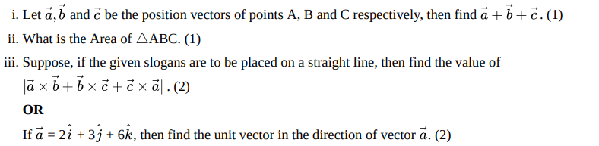Let *a*⃗, *b*⃗ and *c*⃗ be the position vectors of points A, B and C respectively, then find *a* +⃗ *b* +⃗ *c*⃗ . (1)
2. What is the Area of △ABC. (1)
3. Suppose, if the given slogans are to be placed on a straight line, then find the value of

|*a* ×⃗ *b* +⃗ *b* ×⃗ *c* +⃗ *c* ×⃗ *a*⃗| . (2)

## OR

If *a*⃗ = 2 *i* + 3*j* + 6*k*, then find the unit vector in the direction of vector *a*⃗. (2)

## Read the following text carefully and answer the questions that follow:

On the request of villagers, a construction agency designs a tank with the help of an architect. Tank consists of a

**[4]**

**[4]**

**[4]**

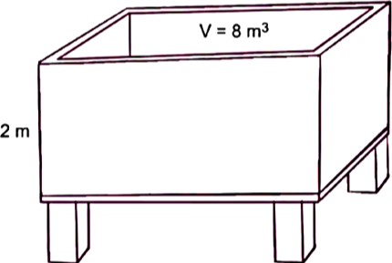rectangular base with rectangular sides, open at the top so that its depth is 2 m and volume is 8 m3 as shown below. The construction of the tank costs ₹70 per sq. metre for the base and ₹45 per square metre for sides.

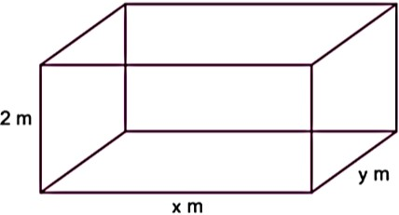

1. Express making cost C in terms of length of rectangle base. (1)
2. If x and y represent the length and breadth of its rectangular base, then find the relation between the variables. (1)
3. Find the value of **x** so that the cost of construction is minimum. (2)

## OR

Verify by second derivative test that cost is minimum at a critical point. (2)