(By Subrata Sir & group of ICSE and CBSE school teachers)

GUIDELINES

## Question 1

1. Correct option: (a)

## Class X Mathematics

**Mock Paper – 1 (2023) Section A**

MRP = Rs. 12,000, Discount % = 30%, GST = 18%

Discount = 30% of 12,000 =

30

100

 12000  Rs. 3600

Selling price (discounted value) = 12000 – 3600 = Rs. 8400 CGST = 9% of 8400 = Rs. 756

1. Correct option: (c)

Given: (x + 5)(x – 5) = 24

⇒ x2  52  24

⇒ x2  25  24

⇒ x2  49

⇒ x  7

1. Correct option: (a)

Let f(x) = 2x3 + 3x2 – kx + 5

Using Remainder Theorem, we have f(2) = 7

 2(2)3 + 3(2)2 – k(2) + 5 = 7

 16 + 12 – 2k + 5 = 7

 33 – 2k = 7

 2k = 26

 k = 13

1. 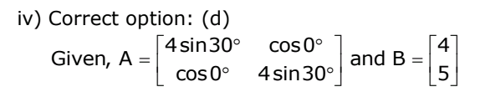Correct option: (d)

Given, A  4 sin30

cos 0

 and B  4

 cos 0 4 sin30 5

   

Let the order of matrix X = m × n Order of matrix A = 2 × 2

Order of matrix B = 2 × 1 Now, AX = B

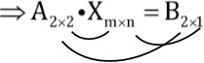

Thus, order of matrix X = m × n = 2 × 1

1. Correct option: (d)

Arithmetic mean of

− 5 and 41  5  41  36  18

2 2

1. Correct option: (d)

The reflection of point (1, 2) about y-axis is (–1, 2)

1. Correct option: (b)

Scale factor k =

1

300

Length of the model of the ship = k  Length of the ship

⇒ 2 =

1

300

* Length of the ship

⇒ Length of the ship = 600 m

1. Correct option: (a) For a circular cylinder, Height  h  20 cm

Radius of the base  r  7 cm Volume of a cylinder  r2h

 22  7  7  20 cm3

7

 3080 cm3

1. Correct option: (a) x + 7  11

x  11 – 7

x  4

1. Correct option: (c)

Given that the die has 6 faces marked by the given numbers as below:

3 2 1 1 2 3

When a die is rolled, total number of possible outcomes  6

For getting a positive integer, the favourable outcomes are: 1, 2, 3

⇒ Number of favourable outcomes  3

⇒ Required probability  3  1

6 2

1. Correct option: (b)

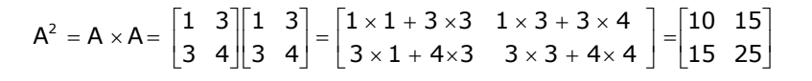

# A2  A  A 

1 3 1 3  1  1  3 3 1  3  3  4   10 15

# 3 4 3 4  3  1  43 3  3  4 4  15 25

       

1. Correct option: (c)

Let A’ = (x, y) be the image of the point A(5, –3), under reflection in the point P(–1, 3).

⇒ P(–1, 3) is the mid – point of the line segment AA’.

⇒ 5  x

  1 and

3  y  3

2 2

⇒ 5  x

  2 and

− 3  y  6

⇒ x   7 and y  9

Therefore the image of the point A(5, –3), under reflection in the point P(–1, 3) is A’(–7, 9).

1. Correct option: (b)

AD is parallel to BC, i.e., OD is parallel to BC and BD is transversal.

⇒ ODB  CBD = 32° Alternate angles

In ΔOBD,

OD = OB (Radii of the same circle)

⇒ ODB  OBD  32°

1. Correct option: (b)

Common difference, d = 6 – 4 = 2

1. Correct option: (b)

Sum of observations = 30

Mean = Sum of observations ÷ Number of observations

= 30 ÷ 5

= 6

## Question 2

* 1. Interest, I = Rs. 1,200

Time, n = 2 years = 2 × 12 = 24 months Rate, r = 6%

* + 1. To find: Monthly instalment, P Now,

I  P  n(n  1)  r

2  12 100

⇒ 1,200  P  24  25  6

24 100

⇒ 1,200  P  3

2

⇒ P  1,200  2

3

⇒ P  Rs. 800

So, the monthly instalment is Rs. 800.

* + 1. Total sum deposited = P × n = Rs. 800 × 24 = Rs. 19,200

 Amount of maturity = Total sum deposited + Interest on it

= Rs. (19,200 + 1,200)

= Rs. 20,400

Given,

First term, a  27

8th

term  ar7  1

81

n  10 Now,

ar7 a

 181

27

⇒ r7

 1

2187

 1 7

⇒ r7

  

 

3

⇒ r  1 (r  1) 3

 Sn

 a(1  rn) 1  r

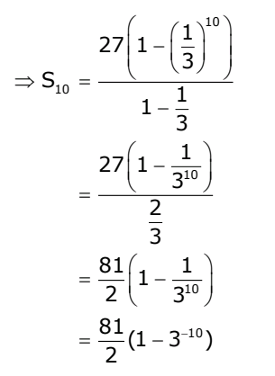  1 10 

27 1   3  

⇒ S10 

   

1  1

3

27 1  1 

 310 

  

2

3

 81 1  1 

2  310 

 

 81 (1  310) 2

* 1. To prove that:

cot A  1  cot A

2  sec2 A 1  tan A

L.H.S 

cot A  1

2  sec2 A

1  1

 tan A

2  1  tan2 A

 1  tan A

tan A 1 tan2 A

 1  tan A

tan A 1 tan A 1 

 1

tan A(1  tan A)

tan A

 1  1

tan A (1  tan A)

 cot A 1  tan A

 R.H.S

Hence proved.

## Question 3

1. According to the condition in the question,

77  16

 1 r2h

3

⇒ 77  16

 1  22

3 7

 7  7  h

⇒ h 

⇒ h 

77  16  3  7

22  7  7

11  16  3

22

⇒ h  24 m

We know that, l2 = r2 + h2

⇒ l2 = (7)2 + (24)2

⇒ l2 = 49 + 576

⇒ l2 = 625

⇒ l = 25 m

 Curved Surface Area = rl = 22  7 25 = 550m2

7

Therefore the height of the tent is 24m and its curved surface area is 550m2.

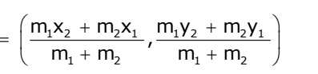ii) Take (x1, y1) = (–3, 3a + 1) ; (x2, y2) = B(5, 8a) and (x, y) = (–b, 9a – 2) Here m1 = 3 and m2 =1

 Coordinate of P(x, y) 

 m1x2  m2x1 , m1y2  m2y1 

 m  m m  m 

 1 2 1 2 

⇒ x 

m1x2

* m2x1

and y 

m1y2

* m2y1

m1  m2 m1  m2

⇒  b 

3  5  1  (3)

and 9a

− 2 

3  8a  1 3a  1

3  1 3  1

⇒  b 

15  3

and 9a

− 2 

24a  3a  1

4 4

⇒  4b 

12 and 36a  8

 27a  1

⇒

 a 

b   3 and 9a  9

1 and b   3

iii)

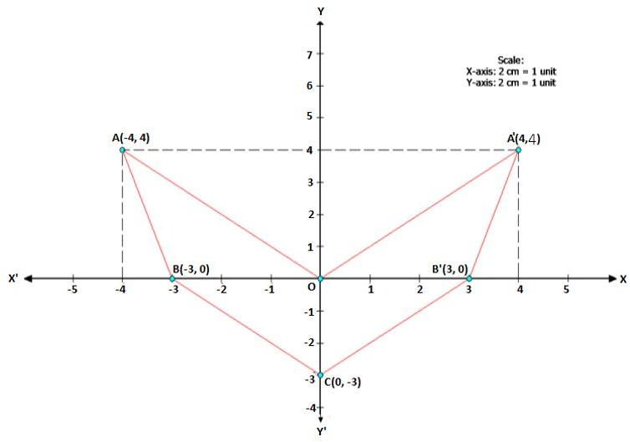

Hence, A’ = (4, 4) and B’ = (3, 0)

## Section B

**Question 4**

i)

|  |  |  |  |  |  |
| --- | --- | --- | --- | --- | --- |
| Name of  the person | Repairin  g cost (in Rs.) | Discount  % | Discount | Selling price | GST (18%) |
| A | 5500 | 30 | 1650 | 3850 | 693 |
| B | 6250 | 40 | 2500 | 3750 | 675 |
| C | 4800 | 30 | 1440 | 3360 | 604.8 |
| D | 7200 | 20 | 1440 | 5760 | 1036.8 |
| E | 3500 | 40 | 1400 | 2100 | 378 |
| Total |  |  |  | 18,820 | 3387.6 |

The total money (including GST) received by the mechanic is 18,820 + 3387.6 = Rs. 22,207.6

1. Given quadratic equation is 8x2  mx  15  0 …. (i)

One of the roots of (i) is 3 , so it satisfies (i)

4

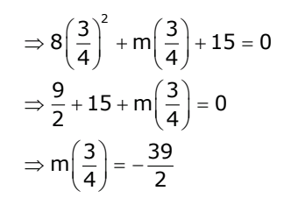 3 2

⇒ 8  4 

 m 3   15  0

4

 

   

⇒ 9  15  m 3   0

4

2

 

 

⇒ m 3    39

4

2

 

 

⇒ m  26

So, the equation (i) becomes

⇒ 8x2  20x  6x  15  0

⇒ 4x(2x  5)  3(2x  5)  0

⇒ (4x  3)(2x  5)  0

⇒ x  3 , 5

4 2

8x2  26x  15  0

5

Hence, the other root is 2 .

1. The cumulative frequency table of the given distribution table is as follows:

|  |  |  |
| --- | --- | --- |
| Weight in Kg | Number of workers (f) | Cumulative frequency |
| 50-60 | 4 | 4 |
| 60-70 | 7 | 11 |
| 70-80 | 11 | 22 |
| 80-90 | 14 | 36 |
| 90-100 | 6 | 42 |
| 100-110 | 5 | 47 |
| 110-120 | 3 | 50 |

Plot the points (60, 4), (70, 11), (80, 22), (90, 36), (100, 42), (110, 47) and

(120, 50) on a graph paper and join them to get an ogive.



**y**

70

65

60

55

(120, 50)

50

(110, 47)

45

(100, 42)

40

C

35

(90, 36)

B

30

25

(80, 22)

20

15

A

10

5

(70, 11)

(60, 4)

**x**

10 20 30 40 50 60 70 80 90 100 110 120 130

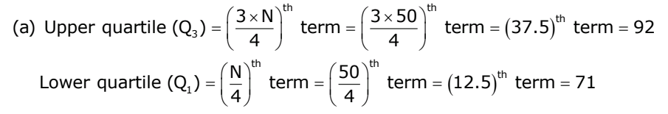Number of workers,N  50

* 1. Upper quartile (Q )   3  N

th 3  50 th

term 

 

term  37.5th

term  92

3  4   4 

   

th th

Lower quartile (Q )   N term   50  term  12.5th

term  71

1  4   4 

   

* 1. Through mark of 95 kg on the x  axis, draw a vertical line which meets the graph at point C.

Through point C, draw a horizontal line which meets the y-axis at the mark of 39.

 Number of workers who are overweight  50  39  11

## Question 5

i)

A2  A  A 

1 3 1 3  1  1  3 3 1  3  3  4   10 15

3 4 3 4  3  1  43 3  3  4 4  15 25

       

B2  B  B 

2 1 2 1  2   2

 1   3

2 1  1 2   1 0

3 2 3 2 3   2  2   3 3 1  2  2 0 1

       

Given: A2 – 5B2 = 5C

⇒ 10 15  5 1 0

 5C

15 25 0 1

   

⇒ 10 15  5 0

 5C

15 25 0 5

   

⇒  5 15  5C

15 20

 

⇒ 5 1 3  5C

3 4

 

⇒ C 

1 3

 

3 4

 

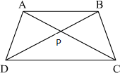ii)

In APB and CPD,

APB  CPD (vertically opposite angles)

ABP  CDP (alternate angles since AB||DC)

 APB ~ CPD (AA criterion for similarity)

⇒ PA  PB .....(Since corresponding sides of similar triangles are equal.)

PC PD

⇒ PA  PD  PB  PC

1. Here, f(x) = 16x3 – 8x2 + 4x + 7

Let the number subtracted be k from the given polynomial f(x). Given that 2x + 1 is a factor of f(x).

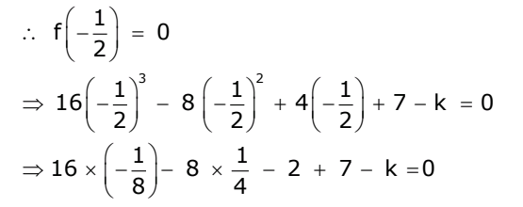 f   1   0

 2 

 

 1 3

 1 2

 1 

⇒ 16   2   8   2   4   2   7  k  0

     

⇒ 16    1   8  1

− 2 

7  k  0

 8  4

 

⇒  2

− 2 

2  7  k  0

⇒  6  7 k  0

⇒ k  1

Therefore 1 must be subtracted from 16x3 – 8x2 + 4x + 7 so that the resulting expression has 2x + 1 as a factor.

## Question 6

i)

* 1. Slope of AB 

3  4

 1

3  (5) 8

 Equation of AB is given by

y  4   1 (x  (5)) 8

8y  32  (x  5)

8y  32  x  5 x  8y  27

* 1. AB and CD are perpendicular to each other. Thus, product of their slopes  1

Slope of AB  Slope of CD  1

⇒ 1  Slope of CD  1 8

⇒ Slope of CD  8

Now, from graph we have coordinates of D  (3, 0)

 Equation of line CD is given by y  0  8(x  3)

y  8x  24

ii) sin2 280 + sin2 620 + tan2 380 – cot2 520 + 1 sec2 300

4

= sin2 280 + [sin (90 – 28)0]2 + tan2 380 – [cot(90 – 38)0]2 + 1 sec2 300

4

= sin2 280 + cos2 280 + tan2 380 – tan2 380 + 1 sec2 300

4

1  2 2

 1  0 

4   3 

 



 1  1

3

 3  1

3

 4

3

iii) We know that,

Sum of n terms of an A.P =

n a 

2



l

Let the first term be 2x and the last term be 3x.

 Sum of 5 terms of an A.P =

5 2x

2



 3x

⇒ 25 

5 2x

 3x

2 2

⇒ 25  25x

⇒ x  1

First term = 2x = 2 × 1 = 2 and the last term = 3x = 3 × 1 = 3 nth term of an A.P. is given by

tn = a + (n – 1)d

⇒ a5 = 2 + (5 – 1)d

⇒ 3 = 2 + 4d

⇒ 1 = 4d

1

⇒ d = 4 = 0.25

Therefore, the five numbers in an A.P. are 2, 2.25, 2.50, 2.75 and 3.

## Question 7

1. Here, Total number of all possible outcomes = 16
   1. a, e, i and o are the vowels. Number of favourable outcomes = 4

 Required Probability = Number of favourable outcomes

 4  1

Total number of all possible outcomes

* 1. Number of consonants = 16 – 4 (vowels) = 12

 Number of favourable outcomes = 12

16 4

 Required Probability = Number of favourable outcomes  12  3

Total number of all possible outcomes 16 4

* 1. Median contains 6 letters.

 Number of favourable outcomes = 16 – 6 = 10

 Required Probability = Number of favourable outcomes  10  5

Total number of all possible outcomes 16 8

Inner radius of the pipe  r  5 cm  2.5 cm

2

External radius of the pipe  R  Inner radius of the pipe  Thickness of the pipe

 2.5 cm  0.5 cm

 3 cm Length of the pipe  h  2 m  200 cm

Volume of the pipe  External Volume  Internal Volume

 R2h  r2h

  R2  r2 h

  R  r R  rh

 22 3  2.5 3  2.5  200

7

 22  0.5  5.5  200

7

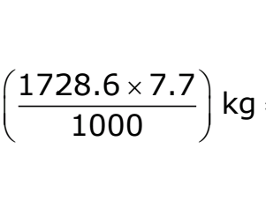 1728.6 cm3

Since 1cm3 of the metal weights 7.7 g,

 Weight of the pipe  (1728.6  7.7) g   1728.6  7.7  kg  13.31 kg

 1000 

 

1. DAE and DAB are linear pair So,

DAE + DAB = 180°

DAB = 110°

Also,

BCD + DAB = 180° … (Opp. Angles of cyclic quadrilateral BADC)

 BCD = 70°

BCD = 1BOD … (angles subtended by an arc on the center and on the

2

circle)

 BOD = 140° In BOD,

OB = OD … (Radii of same circle) So,

OBD =ODB … (Isosceles triangle theorem)

OBD + ODB + BOD = 180° … (Sum of angles of triangle) 2OBD = 40°

OBD = 20°

## Question 8

i)

8 1   1  4x 7 1 , x  I



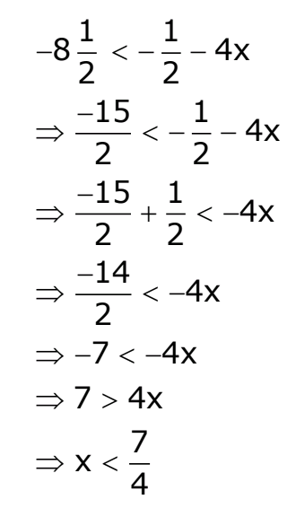2 2 2

8 1 1 4x

2   2 

⇒ 15 1

2   2  4x

⇒ 15  1  4x 2 2

⇒ 14  4x

2

⇒ 7  4x

⇒ 7  4x

⇒ x  7

4

1 1

− 2  4x  7 2

1 15

⇒  2  4x  2

⇒ 4x  15  1

2 2

⇒ 4x  8

⇒ x  2 So,

7  x  2

4

As, x  I

x  2, 1, 0,1

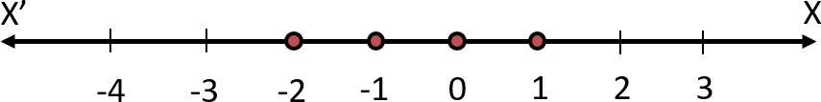

ii)

* 1. The frequency distribution table is as follows:

|  |  |
| --- | --- |
| Class interval | Frequency |
| 0-10 | 2 |
| 10- 20 | 5 |
| 20-30 | 8 |
| 30-40 | 4 |
| 40-50 | 6 |

* 1. (b)

|  |  |  |  |
| --- | --- | --- | --- |
| Class interval | Frequency (f) | Mean value (x) | fx |
| 0-10 | 2 | 5 | 10 |
| 10-20 | 5 | 15 | 75 |
| 20-30 | 8 | 25 | 200 |
| 30-40 | 4 | 35 | 140 |
| 40-50 | 6 | 45 | 270 |
|  | f = 25 |  | f = 695 |

 Mean 

 fx  695  27.8

 f 25

* 1. Here the maximum frequency is 8 which is corresponding to class 20 – 30. Hence, the modal class is 20 – 30.

iii)

(a)

In ∆PQR and ∆SPR,

PSR = QPR … given

PRQ = PRS … common angle

⇒ ∆PQR ∼ ∆SPR (AA Test)

(b) Since ∆PQR ∼ ∆SPR … from (i)

⇒ PQ

 QR

 PR (a)

SP PR SR

QR  PR ... from (a)

PR SR

⇒ QR  6

6 3

⇒ QR  6  6

3

 12 cm

PQ  PR ... from (a)

SP SR

⇒ 8  6

SP 3

(c)

⇒ SP 

8  3

6

 4 cm

area of

PQR

 PQ2  82  64  4

area of

SPR

SP2 42 16

## Question 9

i) Given quadratic equation is 1  1  3

⇒ x  2  x  3x(x  2)

⇒ 2  3x2  6x

⇒ 3x2  6x  2  0

x x  2

⇒ x  6 

⇒ x  6 

62  4(3)(2)

2  3

12

⇒ x 

2  3

3  1



3

Since, m and n are roots of the equation, we have



3  1

3



3  1

3

⇒ m  and n 



3

⇒ m  n  



3



3

 1  

− 1   2

Hence,



3

3

   

   

m  n  2 .

3

ii)

|  |  |  |
| --- | --- | --- |
| Scores | f | c.f. |
| 0 – 10 | 9 | 9 |
| 10 – 20 | 13 | 22 |
| 20 – 30 | 20 | 42 |
| 30 – 40 | 26 | 68 |
| 40 – 50 | 30 | 98 |
| 50 – 60 | 22 | 120 |
| 60 – 70 | 15 | 135 |
| 70 – 80 | 10 | 145 |
| 80 – 90 | 8 | 153 |
| 90 – 100 | 7 | 160 |
|  | n = 160 |  |

The o give is shown below:

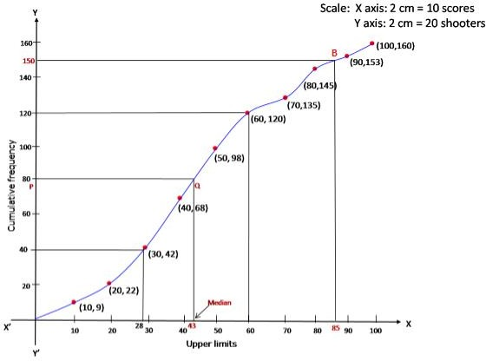

 n th

1. Median   

 160 th

term   

term  80th

term

 2   2 

Through mark 80 on y-axis, draw a horizontal line which meets theogive drawn at point Q.

Through Q, draw a vertical line which meets the x-axis at the mark of 43.

⇒ Median  43

1. Since the number of terms  160

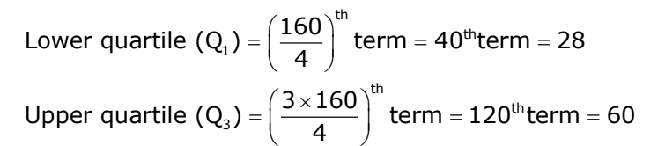 160 th

th

Lower quartile (Q1)   4  term  40 term  28

Upper quartile (Q ) 

 

 3  160 th

term  120thterm  60

3  4 

 

 Inter-quartile range  Q3  Q1  60  28  32

1. Since 85% scores  85% of 100  85

Through mark for 85 on x-axis, draw a vertical line which meets the ogive drawn at point B.

Through the point B, draw a horizontal line which meets the y-axis at the mark of 150.

⇒ Number of shooters who obtained more than 85% score  160  150  10

## Question 10

1. Let the number of boys be 3x. Then, number of girls = 2x

∴ 3x - 2x = 630 5x = 630 x =126

Number of boys = 3x = 3 ×126 = 378

And, Number of girls = 2x = 2 × 126 = 252

After admission of 90 new students, we have Total number of students = 630- 90 = 720 Now, let the number of boys be 7x.

Then, number of girls = 5x 7x - 5x = 720

12x = 720

x = 60

Number of boys = 7x = 7×60 = 420

And, Number of girls = 5x = 5 × 60 = 300

∴ Number of newly admitted boys = 420-378 = 42

1. Steps of construction:
   1. Draw BC= 6.5 cm
   2. With B as centre, draw an arc of radius 5.5 cm.
   3. With C as centre, draw an arc of radius 5 cm. Let this arc meets the previous are at A.
   4. Join AB and AC to get ΔABC
   5. Draw the bisectors of ∠ABC and ∠ACB. Let these bisectors meet each other at 0.
   6. Draw ON ⊥ BC.
   7. With 0 as centre and radius ON, draw a in circle that touches all the sides of ΔABC
   8. By measurement, radius ON = 1.5 cm

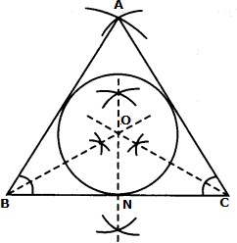

1. iii)

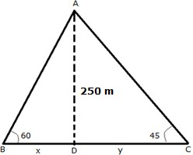

Let A be the position of the airplane and let BC be the river. Let D be the point on BC just below the airplane.

B and C be two boats on the opposite banks of the river with angles of depression 60° and 45° from A.

In ADC,

tan 45  AD

DC

⇒ 1  250

y

⇒ y  250 m  DC In ADB,

tan 60  AD

BD

⇒  250 x



3

⇒ x  250  250 3



 250  1.732 =144.3 m  BD

3

 BC  BD  DC

3 3

 144.3  250  394.3  394 m

Thus, the width of the river is 394 m.