**MOCK MANTRA**

**(CBSE Class 10 MOCK EXAMINATION)**

**MOCK PAPER 1**

**Mathematics**

**Time Allowed: 3 hours Maximum Marks: 80**

**General Instructions:**

Read the following instructions carefully and follow them:

1. This question paper contains 38 questions.
2. This Question Paper is divided into 5 Sections A, B, C, D and E.
3. In Section A, Questions no. 1-18 are multiple choice questions (MCQs) and questions no. 19 and 20 are Assertion- Reason based questions of 1 mark each.
4. In Section B, Questions no. 21-25 are very short answer (VSA) type questions, carrying 02 marks each.
5. In Section C, Questions no. 26-31 are short answer (SA) type questions, carrying 03 marks each.
6. In Section D, Questions no. 32-35 are long answer (LA) type questions, carrying 05 marks each.
7. In Section E, Questions no. 36-38 are case study-based questions carrying 4 marks each with sub-parts of the values of 1,1 and 2 marks each respectively.
8. All Questions are compulsory. However, an internal choice in 2 Questions of Section B, 2 Questions of Section C and 2 Questions of Section D has been provided. An internal choice has been provided in all the 2 marks questions of Section E.
9. Draw neat and clean figures wherever required.
10. Take $π = 22/7$ wherever required if not stated.
11. Use of calculators is not allowed.

**Section A**

1. Prime factorization of 882 is: **[1]**

# 22 × 33 × 7

c) 23 × 3 × 72

# 2 × 32 × 72

d) 22 × 32 × 7

1. Find the number of zeroes of p(x) in the figure given below. **[1]**

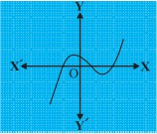

* 1. 3 b) 0

c) 2 d) 1

1. The number of solutions for two linear equations representing parallel lines is/are **[1]**

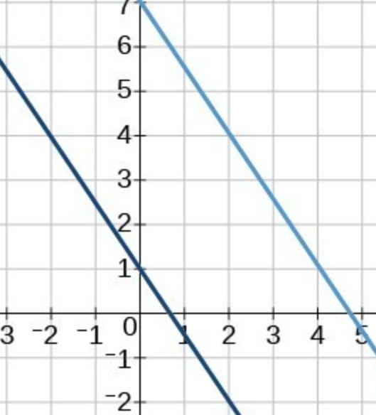

* 1. 2 b) ∞

c) 1 d) 0

1. If x = 1 is a common root of ax2 + ax + 2 = 0 and x2 + x + b = 0 then, ab **[1]**
   1. 2 b) 1

c) 3 d) 4

1. Which of the following is not an A.P.? **[1]**
   1. 2, 5 , 3, 7 , ... b) a, 2a, 3a, 4a, ...

2 2

c) -1.2, -3.2, -5.2, -7.2, ... d) 2, 4, 8, 16, ...

1. The points (-4, 0), (4, 0) and (0, 3) are the vertices of a: **[1]**
   1. isosceles triangle b) scalene triangle

c) equilateral triangle d) right triangle

1. If A (-1, 0), B(5, -2) and C(8, 2) are the vertices of a △ABC then its centroid is **[1]**
   1. (6, 0) b) (0, 6)

c) (4, 0) d) (12, 0)

1. In the figures find the measures of ∠*P* and ∠*R*

**[1]**

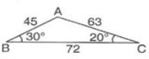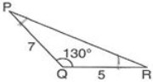

* 1. 20o, 30o. b) 50o, 40o.

c) 30o, 20o. d) 40o, 50o.

1. In the given figure, If TA and TC are two tangents to the circle with centre O, such that ∠*ATB* = 70*o*, then

∠*OBA* is equal to :

**[1]**

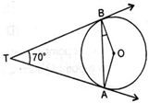

* 1. 30° b) 45°

c) 25° d) 35°

1. 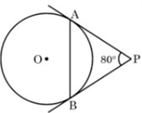In the given figure, tangents PA and PB drawn from P to circle are inclined to each other at an angle of 80o. The measure of ∠PAB is

|  |  |  |  |  |
| --- | --- | --- | --- | --- |
| a) 60o | | | b) 50o |  |
| c) 80o | | | d) 40o |
| 11. $\sqrt{(1 - cos2 θ) sec2 θ}$ = | | |  | **[1]** |
| a) tan*θ* | | | b) cot*θ* |  |
| c) sin*θ* | | | d) cos*θ* |  |
| 12. | cosec2 A−cot2 A 1−sin2 A | is equal to | **[1]** | |

* 1. sin2 A b) tan2 A

c) sec2 A d) cos2 A

1. The measure of the angle of elevation of the top of a tower 75√3 m high from a point at a distance of 75 m from the foot of the tower in a horizontal plane is

**[1]**

**[1]**

# 15∘

c) 45∘

* 1. 30∘

d) 60∘

1. The area of a sector of a circle with a sector angle *θ* is given by **[1]**

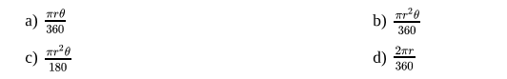

* 1. *πrθ* 360

c) *πr*2 *θ*

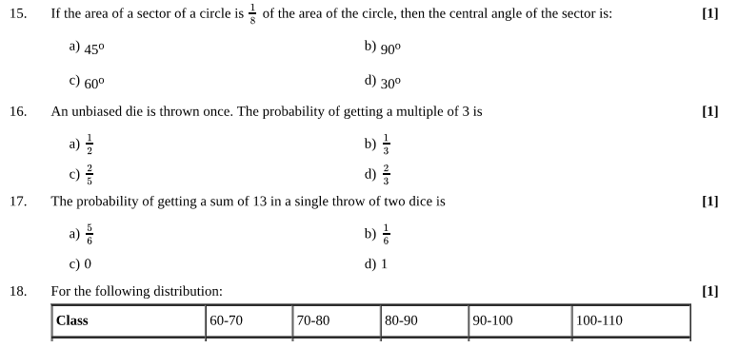180

* 1. *πr*2 *θ*

360

d) 2*πr* 360

1. If the area of a sector of a circle is 1

8

of the area of the circle, then the central angle of the sector is: **[1]**

* 1. 45o b) 90o

c) 60o d) 30o

1. An unbiased die is thrown once. The probability of getting a multiple of 3 is **[1]**
   1. 1 2

c) 2 5

* 1. 1 3

d) 2 3

1. The probability of getting a sum of 13 in a single throw of two dice is **[1]**
   1. 5 6
   2. 1 6
   3. 0 d) 1
2. For the following distribution:

**[1]**

|  |  |  |  |  |  |
| --- | --- | --- | --- | --- | --- |
| **Class** | 60-70 | 70-80 | 80-90 | 90-100 | 100-110 |

|  |  |  |  |  |  |
| --- | --- | --- | --- | --- | --- |
| **Frequency** | 13 | 10 | 15 | 8 | 11 |

the lower limit of the modal class is

* 1. 80 b) 100

c) 90 d) 70

1. 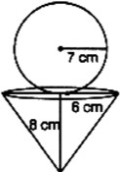**Assertion (A):** A sphere of radius 7 cm is m ounted on the solid cone of radius 6 cm and height 8 cm. the volume of the combined solid is 1737.47 cm3. [Take *π* = 3.14]

**Reason (R):** Volume of sphere and surface area of cone is given by 4 *πr*3 and 1 *πr*2*h* respectively.

**[1]**

3 3

* 1. Both A and R are true and R is the correct explanation of A.
  2. Both A and R are true but R is not the correct explanation of A.
  3. A is true but R is false. d) A is false but R is true.

1. **Assertion (A):** Common difference of the A.P. 5, 1, -3, -7 ... is 4.

**Reason (R):** Common difference of the A.P. a1, a2, a3 ... an is obtained by d = an - an-1.

**[1]**

* 1. Both A and R are true and R is the correct explanation of A.
  2. Both A and R are true but R is not the correct explanation of A.
  3. A is true but R is false. d) A is false but R is true.

**Section B**

1. In a teachers' workshop, the number of teachers teaching French, Hindi and English are 48, 80 and 144 respectively. Find the minimum number of rooms required if in each room the same number of teachers are seated and all of them are of the same subject.
2. In Fig. AD and CE are two altitudes of △ABC intersect each other at point F. Prove that Δ*FDC* ∼ Δ*BEC*

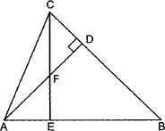

1. Prove that the tangent at any point of a circle is perpendicular to the radius through the point of contact. Using the above, do the following: In figure, O is the centre of the two concentric circles. AB is a chord of the larger

**[2]**

**[2]**

**[2]**

circle touching the smaller circle at C. Prove that AC = BC.

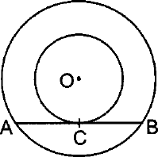

1. Prove that cot *A*−cos *A*

cot *A*+cos *A*

= cos2 *A* (1+sin *A*)2

OR

**[2]**

Prove that: tan *θ*−cot *θ*

sin *θ* cos *θ*

# = sec2 *θ* − cosec2 *θ*

1. A chord 10 cm long is drawn in a circle whose radius is 5√2 cm. Find the areas of both the segments. [Take *π* =

3.14.]

**[2]**

OR

Three horses are tied each with 7 m long rope at three corners of a triangular field having sides 20 m, 34 m and 42 m. Find the area of the plot which can be grazed by the horses.

**Section C**

1. A shopkeeper has 120 liters of petrol, 180 liters of diesel and 240 liters of kerosene. He wants to sell oil by filling the three kinds of oils in tins of equal capacity. What should be the greatest capacity of such a tin?
2. If the coefficient of x in a quadratic polynomial is zero, then prove that zeros will be equal in magnitude and opposite in sign.
3. Is the pair of linear equation consistent/inconsistent? If consistent, obtain the solution graphically: x + y = 5, 2x

+ 2y = 10

**[3]**

**[3]**

**[3]**

OR

The sum of two numbers is 16 and the sum of their reciprocals is 1 . Find the numbers.

3

1. 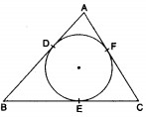In the given figure, a circle inscribed a in a triangle ABC, touches the sides AB, BC and AC at points D, E and F respectively. If AB = 12 cm, BC = 8 cm and AC = 10 cm, find the lengths of AD, BE and CF .

OR

In the adjoining figure PA and PB are tangents to the circle with centre O. If ∠*APB* = 60∘, then find ∠*OAB*.

**[3]**

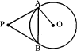

1. If sin *θ* = 12 , find the value of sin2 *θ*−cos2 *θ* × 1 . **[3]**

13 2 sin *θ* cos *θ* tan2 *θ*

1. The maximum bowling speeds (in km/hr) of 33 players at a cricket coaching centre are given below: **[3]**

|  |  |  |  |  |
| --- | --- | --- | --- | --- |
| **Speed in km/hr** | 85-100 | 100-115 | 115-130 | 130-145 |
|  |  |  |  |  |

|  |  |  |  |  |
| --- | --- | --- | --- | --- |
| **No. of players** | 10 | 4 | 7 | 9 |

Calculate the median bowling speed.

**Section D**

1. A train travels at a certain average speed for a distance of 54 km and then travels a distance of 63 km at an average speed of 6 km/h more than the first speed. If it takes 3 hours to complete the total journey, what was its first average speed?

**[5]**

OR

A rectangular field is 20 m long and 14 m wide. There is a path of equal width all around it, having an area of 111 sq

m. Find the width of the path.

1. ABCD is a trapezium in which AB || DC and P and Q are points on AD and BC, respectively such that PQ || DC. If PD = 18 cm, BQ = 35 cm and QC = 15 cm, find AD.
2. A tent is in the shape of a right circular cylinder up to a height of 3 m and then a right circular cone, with a maximum height of 13.5 m above the ground. Calculate the cost of painting the inner side of the tent at the rate of ₹ 2 per square metre, if the radius of the base is 14 m.

OR

A solid iron pole consists of a solid cylinder of height 200 cm and base diameter 28 cm, which is surmounted by another cylinder of height 50 cm and radius 7 cm. Find the mass of the pole, given that 1 cm3 of iron has approximately 8 g mass.

1. The distribution given below shows the number of wickets taken by bowlers in one-day cricket matches. Find

the mean and the median of the number of wickets taken.

|  |  |  |  |  |  |  |
| --- | --- | --- | --- | --- | --- | --- |
| Number of wickets: | 20 - 60 | 60 - 100 | 100 - 140 | 140 - 180 | 180 - 220 | 220 - 260 |
| Number of bowlers: | 7 | 5 | 16 | 12 | 2 | 3 |

**Section E**

1. **Read the following text carefully and answer the questions that follow:**

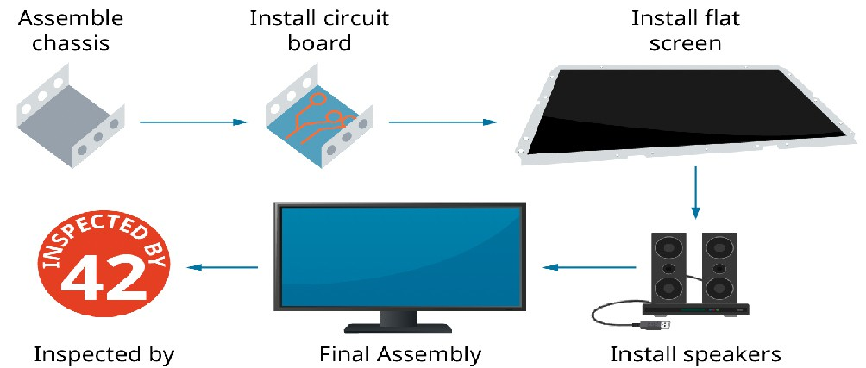Elpis Technology is a laptop manufacturer. The company works for many branded laptop companies and also provides them with spare parts. Elpis Technology produced 6000 units in 3rd year and 7000 units in the 7th year.

Assuming that production increases uniformly by a fixed number every year.

1. Find the production in the 1st year. (1)
2. Find the production in the 5th year. (1)
3. Find the total production in 7 years. (2)

**OR**

Find in which year 10000 units are produced? (2)

1. **Read the following text carefully and answer the questions that follow:**

Use of mobile screen for long hours makes your eye sight weak and give you headaches. Children who are addicted to play “PUBG’’ can get easily stressed out. To raise social awareness about ill effects of playing PUBG, a school decided to start ‘BAN PUBG’ campaign, in which students are asked to prepare campaign

**[5]**

**[5]**

**[5]**

**[4]**

**[4]**

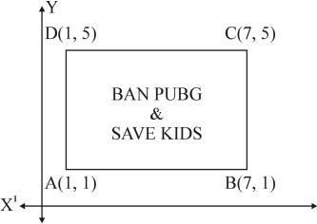board in the shape of a rectangle. One such campaign board made by class X student of the school is shown in the figure.

1. Find the coordinates of the point of intersection of diagonals AC and BD. (1)
2. Find the length of the diagonal AC. (1)
3. Find the area of the campaign Board ABCD. (2)

**OR**

Find the ratio of the length of side AB to the length of the diagonal AC. (2)

1. **Read the following text carefully and answer the questions that follow:**

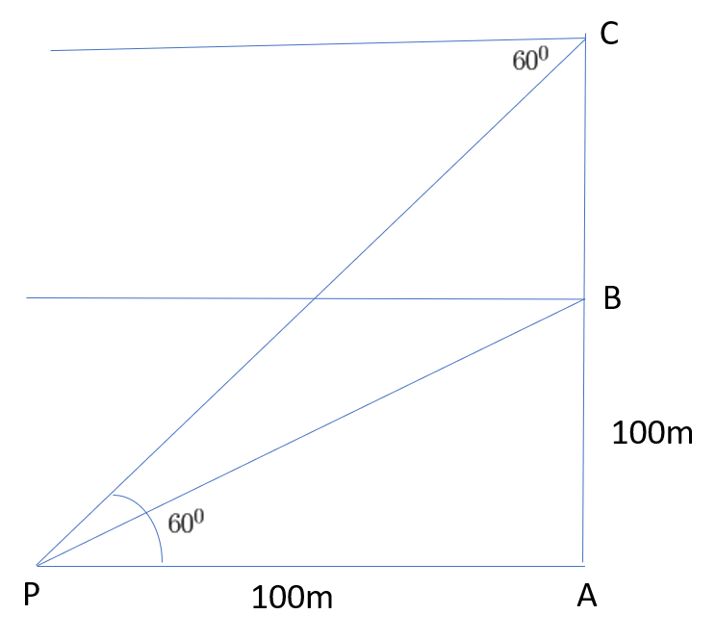A hot air balloon is rising vertically from a point A on the ground which is at distance of 100m from a car parked at a point P on the ground. Amar, who is riding the balloon, observes that it took him 15 seconds to reach a point B which he estimated to be equal to the horizontal distance of his starting point from the car parked at P.

1. Find the angle of depression from the balloon at a point B to the car at point P. (1)
2. Find the speed of the balloon? (1)
3. After certain time Amar observes that the angle of depression is 60o. Find the vertical distance travelled by the balloon during this time. (2)

**OR**

Find the total time taken by the balloon to reach the point C from ground? (2)

**[4]**