MOCK MANTRA

**(CBSE Class 11 MOCK EXAMINATION) MOCK PAPER 1**

**Mathematics**

**Time Allowed: 3 hours Maximum Marks: 80**

**General Instructions:**

1. This Question paper contains 38 questions. All questions are compulsory.
2. This Question paper is divided into five Sections - A, B, C, D and E.
3. In Section A, Questions no. 1 to 18 are multiple choice questions (MCQs) and Questions no. 19 and 20 are Assertion-Reason based questions of 1 mark each.
4. In Section B, Questions no. 21 to 25 are Very Short Answer (VSA)-type questions, carrying 2 marks each.
5. In Section C, Questions no. 26 to 31 are Short Answer (SA)-type questions, carrying 3 marks each.
6. In Section D, Questions no. 32 to 35 are Long Answer (LA)-type questions, carrying 5 marks each.
7. In Section E, Questions no. 36 to 38 are Case study-based questions, carrying 4 marks each.
8. There is no overall choice. However, an internal choice has been provided in 2 questions in Section B, 3 questions in Section C, 2 questions in Section D and one subpart each in 2 questions of Section E.
9. Use of calculators is not allowed.

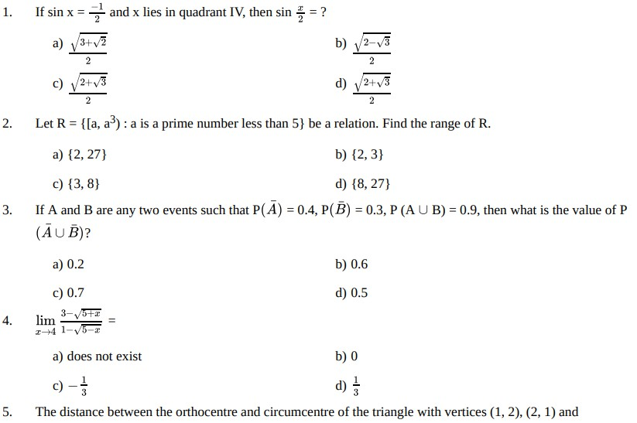**Section A**

1. If sin x = −1 and x lies in quadrant IV, then sin *x* = ?

2 2

a) √3+√2 b) √2−√3

2 2

c) √2+√3 d) √2+√3

2 2

2. Let R = {[a, a3) : a is a prime number less than 5} be a relation. Find the range of R.

a) {2, 27} b) {2, 3}

c) {3, 8} d) {8, 27}

3. If A and B are any two events such that P(*A*) = 0.4, P(*B*) = 0.3, P (A ∪ B) = 0.9, then what is the value of P

(*A* ∪ *B*)?

a) 0.2 b) 0.6

c) 0.7 d) 0.5

4. lim 3−√5+*x* =

*x*→4 1−√5−*x*

a) does not exist b) 0

c) − 1 d) 1

3 3

5. The distance between the orthocentre and circumcentre of the triangle with vertices (1, 2), (2, 1) and

**[1]**

**[1]**

**[1]**

**[1]**

**[1]**

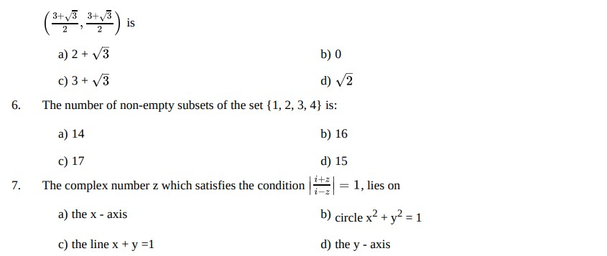**[1]**

( , ) is

~~2~~

3+√3

~~2~~

3+√3

a) 2 + √3

c) 3 + √3

b) 0

d) √2

6. The number of non-empty subsets of the set {1, 2, 3, 4} is:

a) 14

c) 17 d) 15

7. The complex number z which satisfies the condition

∣ ∣

*i*+*z*

*i*−*z*

= 1, lies on

a) the x - axis

c) the line x + y =1

b) circle x2 + y2 = 1

d) the y - axis

b) 16

**[1]**

1. Let n (A) = m, and n (B) = n. Then the total number of non-empty relations that can be defined from A to B is **[1]**
   1. mn b) mn - 1

c) nm - 1 d) 2mn - 1

1. If x belongs to set of integers, A is the solution set of 2(x - 1) < 3x - 1 and B is the solution set of 4x - 3 ≤ 8 + x, find A ∩ B

**[1]**

* 1. {0, 2, 4} b) {1, 2, 3}

c) {0, 1, 2} d) {0, 1, 2, 3}

1. If tan *α* = 1 , tan *β* = 1 , then cos 2*α* is equal to **[1]**

7 3

* 1. sin 4*β*

c) cos 2*β*

* 1. sin 3*β*

d) sin 2*β*

1. For any set A, (A')' is equal to **[1]**
   1. *ϕ* b) A''

c) A d) A'

1. Sum of n terms of the series √2 + √8 + √18 + √32+ ...... is **[1]**
   1. 2n (n + 1) b)

c) 1 d)

*n*(*n*+1)

√2 *n*(*n*+1) 2

1. {C0 + 2C1 + 3C2 + ...+ (n + 1)Cn} = ? **[1]**
   1. (n +1) . 2n b) (n + 2) . 2n+1

c) (n + 2) . 2n-1 d) n . 2n-1

1. Find all pairs of consecutive even positive integers, both of which are larger than 5, such that their sum is less than 23.

**[1]**

* 1. (3, 5), (5, 7), (7, 9) b) (6, 8),(8, 10), (10, 12)

c) (8, 6), (6, 4), (10, 6) d) (4, 6), (6, 8), (8, 10)

1. If A = {x : x is a multiple of 3, x natural no., x < 30} and B = {x : x is a multiple of 5, x is natural no., x < 30} then A - B is

**[1]**

* 1. {3, 6, 9, 12, 15, 18, 21, 24, 27, 30} b) {3, 6, 9, 12, 18, 21, 24, 27}

c) {3, 5, 6, 9, 10, 12, 15, 18, 20, 21, 25, 27,

30}

16. d) 2 cos 5*π* cos *π* = ?

12 12

a) √3

2

b)

1

√2

c) 1

2

d) √2

{3, 6, 9, 12, 18, 21, 24, 27, 30}

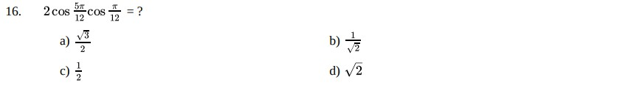**[1]**

1. Which of the following is correct ? **[1]**
   1. 3 − 4i < 2 − 3i b) 1 + i < 1 − i

c) none of these d) 2 + 3i < 3 + 4i

1. How many 3-digit even numbers can be formed with no digit repeated by using the digits 0, 1, 2, 3, 4 and 5? **[1]**
   1. 56 b) 52

c) 50 d) 54

1. **Assertion (A):** The expansion of (1 + x)n = *nc* 0 + *nc*1*x* + *nc*2 *x*2 … + *ncn xn* .

**Reason (R):** If x = -1, then the above expansion is zero.

**[1]**

* 1. Both A and R are true and R is the correct explanation of A.
  2. Both A and R are true but R is not the correct explanation of A.
  3. A is true but R is false. d) A is false but R is true.

1. **Assertion (A):** The mean deviation about the mean for the data 4, 7, 8, 9, 10, 12, 13, 17 is 3.

**Reason (R):** The mean deviation about the mean for the data 38, 70, 48, 40, 42, 55, 63, 46, 54, 44 is 8.5.

**[1]**

* 1. Both A and R are true and R is the correct explanation of A.
  2. Both A and R are true but R is not the correct explanation of A.
  3. A is true but R is false. d) A is false but R is true.

**Section B**

1. Draw the graph of the exponential function: f(x) = ($1/3$)*x*

**[2]**

OR

Let R be the relation on the set Z of all integers defined by (x, y) ∈ R ⇒ x - y is divisible by n Prove that: (x, y) ∈ R and (y, z) ∈ R ⇒ (x, z) ∈ R for all x, y, z ∈ R.

1. Differentiate the function with respect to x: x2 sin x log x. **[2]**
2. Find the equations of the lines joining the vertex of the parabola y2 = 6x to the point on it which have abscissa 24.

**[2]**

OR

If the latus rectum of an ellipse is equal to half of minor axis, then find its eccentricity.

1. State whether A = {x : x is a letter in the word LOYAL} and B = {x: x is a letter of the word ALLOY} are equal? Justify your answer.
2. Show that the path of a moving point such that its distances from two lines 3x – 2y = 5 and 3x + 2y = 5 are equal is a straight line.

**[2]**

**[2]**

**Section C**

26. If *f* (

*x* + ) = (*x* + ) for all x ∈ R - {0} then write an expression for f(x).

1

*x*

2

*~~x~~*2

1

**[3]**

1. Solve the given system of equations in R: |x - 1| + |x - 2| + |x - 3| ≥ 6 **[3]**
2. A cube of side 5 has one vertex at the point (1, 0, 1), and the three edges from this vertex are, respectively, parallel to the negative x and y axes and positive z-axis. Find the coordinates of the other vertices of the cube.

OR

**[3]**

Find the coordinates of the point which is equidistant from the points A(a, 0, 0), B(0, b, 0), C(0, 0, c) and O(0, 0, 0).

1. 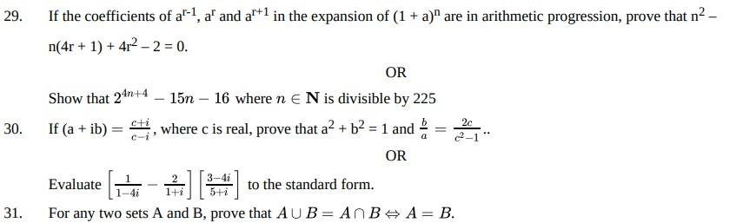If the coefficients of ar-1, ar and ar+1 in the expansion of (1 + a)n are in arithmetic progression, prove that n2 – n(4r + 1) + 4r2 – 2 = 0.

**[3]**

OR

Show that 24*n*+4 − 15*n* − 16 where *n* ∈ N is divisible by 225

1. If (a + ib) =  *c*+*i* , where c is real, prove that a2 + b2 = 1 and  *b* = 2*c* .. **[3]**

*c*−*i a c*2−1

OR

Evaluate [ 1 − 2 ][3−4*i* ] to the standard form.

1−4*i*  ~~1~~+*i* 5+*i*

1. For any two sets A and B, prove that *A* ∪ *B* = *A* ∩ *B* ⇔ *A* = *B*.

**Section D**

1. A fair coin is tossed four times, and a person win Rs. 1 for each head and lose Rs. 1.50 for each tail that turns up. Form the sample space calculate how many different amounts of money you can have after four tosses and the probability of having each of these amounts.

**[3]**

**[5]**

1. Differentiate x2 sin x from first principle. **[5]**

OR

Differentiate sin *x* from first principle.

*x*

1. Find the three numbers in GP, whose sum is 52 and sum of whose product in pairs is 624. **[5]**
2. Prove that: sin 20o sin 40o sin 80o = √3

8

OR

**[5]**

Prove that: sin 5x = 5 cos4x sin x - 10 cos2x sin3 x + sin5 x.

**Section E**

1. **Read the following text carefully and answer the questions that follow:**

A farmer wishes to install 2 handpumps in his field for watering.

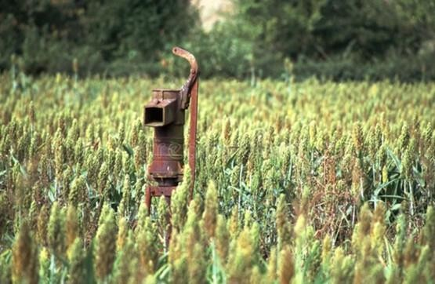

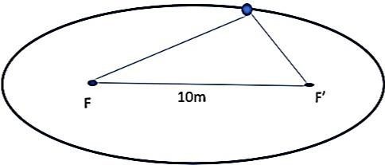The farmer moves in the field while watering in such a way that the sum of distances between the farmer and each handpump is always 26m. Also, the distance between the hand pumps is 10 m.

* 1. Name the curve traced by farmer and hence find the foci of curve. (1)

**[4]**

* 1. Find the equation of curve traced by farmer. (1)
  2. Find the length of major axis, minor axis and eccentricity of curve along which farmer moves. (2)

**OR**

* 1. Find the length of latus rectum. (2)

1. **Read the following text carefully and answer the questions that follow:**

For a group of 200 candidates, the mean and the standard deviation of scores were found to be 40 and 15 , respectively. Later on it was discovered that the scores of 43 and 35 were misread as 34 and 53, respectively.

|  |  |  |  |  |  |
| --- | --- | --- | --- | --- | --- |
| **Student** | **Eng** | **Hindi** | **S.St** | **Science** | **Maths** |
| Ramu | 39 | 59 | 84 | 80 | 41 |
| Rajitha | 79 | 92 | 68 | 38 | 75 |
| Komala | 41 | 60 | 38 | 71 | 82 |
| Patil | 77 | 77 | 87 | 75 | 42 |
| Pursi | 72 | 65 | 69 | 83 | 67 |
| Gayathri | 46 | 96 | 53 | 71 | 39 |

* 1. Find the correct variance. (1)
  2. What is the formula of variance. (1)
  3. Find the correct mean. (2)

**OR**

Find the sum of correct scores. (2)

1. **Read the following text carefully and answer the questions that follow:**

Ashish is writing examination. He is reading question paper during reading time. He reads instructions carefully. While reading instructions, he observed that the question paper consists of 15 questions divided in to two parts - part I containing 8 questions and part II containing 7 questions.

* 1. If Ashish is required to attempt 8 questions in all selecting at least 3 from each part, then in how many ways can he select these questions (1)
  2. If Ashish is required to attempt 8 questions in all selecting 3 from I part, then in how many ways can he select these questions (1)
  3. If Ashish is required to attempt 8 questions in all selecting 4 from part I and 4 from part II, then in how many ways can he select these questions (2)

**OR**

If Ashish is required to attempt 8 questions in all selecting 6 from one section and remaining from another section, then in how many ways can he select these questions (2)

**[4]**

**[4]**