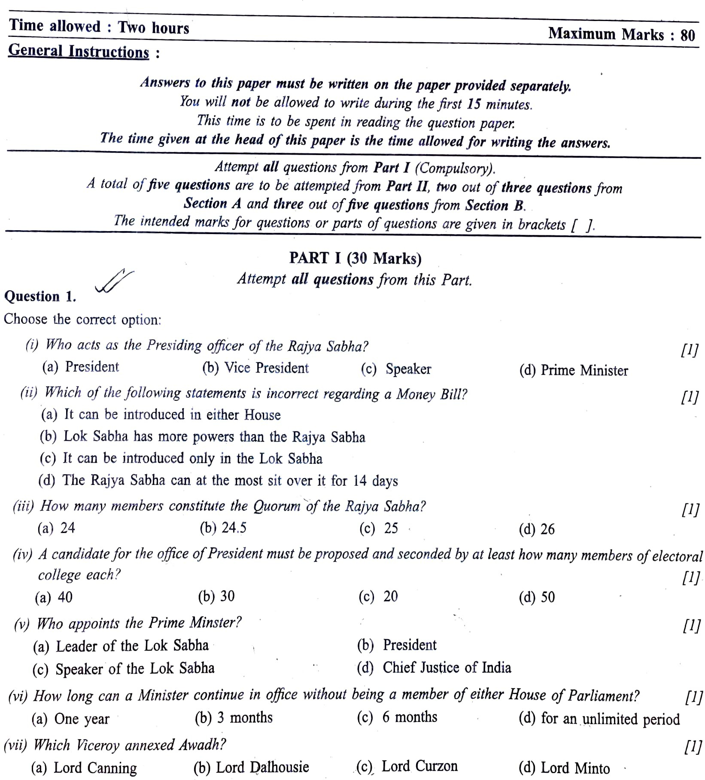

GUIDELINES

**[ 1 ]**

(By Subrata Sir & group of ICSE and CBSE school teachers)

# Question – 4. (2+2+3+3)

1. Mention the qualification of President.
2. Give 2 reason for Indirect election of President.
3. Explain 3 Executive Power of President.
4. Explain Legislative power of President.

# Question – 5. (2+2+3+3)

1. Why Supreme Court is known as Final interpreter and Guardian of the Constitution.
2. Mention the qualification of Supreme Court Judges.
3. Explain Original Functions of Supreme Court.
4. Mention 3 advantages of Lok Adalat.

# Section – B ( History )

**Attempt any three questions from this Section.**

# Question 6 :

**(2+2+3+3)**

1. Explain the contribution of Raja Rammohan Ray.
2. Mention the aims & objectives of INC.
3. Explain 3 political causes of 1857 Revolt.
4. Explain Immediate Cause of 1857 Revolt.

# Question 7 : (2+2+3+3)

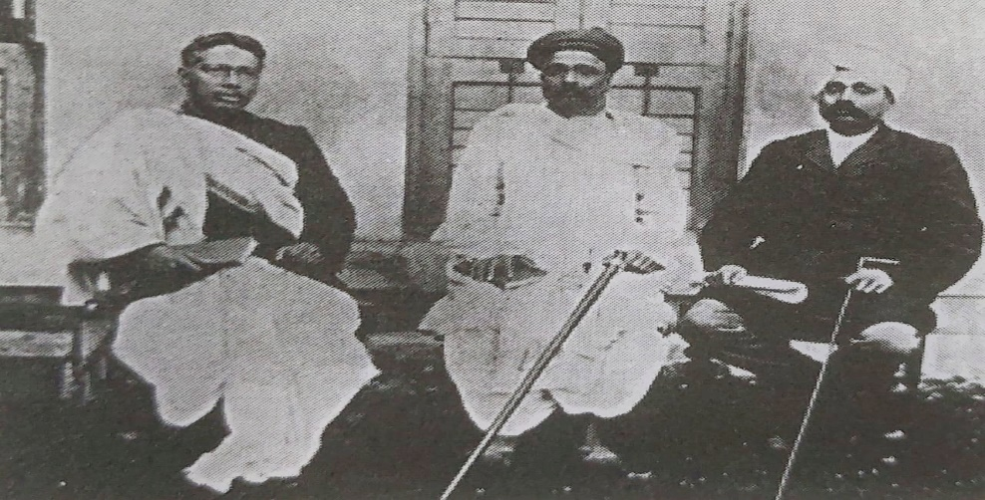

**[ 3 ]**

1. Name the personalities of above pictures.
2. Mention 2 real motive of Bengal Partition (1905).
3. Differentiate between Early & Assertive Nationalist in reference of Beliefs & Method.
4. Give 2 contribution of Bal Gangadhar Tilak & Bipin Chandra Pal.

# Question 8 : (2+2+3+3)

1. Explain - a) Chauri Chaura Incident

b) Dandi – March

1. What was Rowlatt Act ? Explain
2. In reference of Civil Disobedient Movement answer
   1. Gandhi - Irwin Pact
   2. Second Round Table Conference.
3. Mention 3 Contribution of INA & Subhas Chandra Bose.

# Question 9 : (2+2+3+3)

1. Name 2 groups of World War I & II
2. Mention 2 Causes of World War I ( except immediate cause )
3. Explain immediate cause of World War I & II
4. Explain 6 terms of Treaty of Versailles.

# Question – 10 : (2+2+3+3)

1. What is NAM, Mention 2 millitary alliances.
2. Name ‘Big Five’, What is Veto Power ?
3. Mention 2 function of each a) UNICEF

b) UNESCO

1. Explain the composition of General Assembly, Security Council & International Court of Justice.

**[ 4 ]**

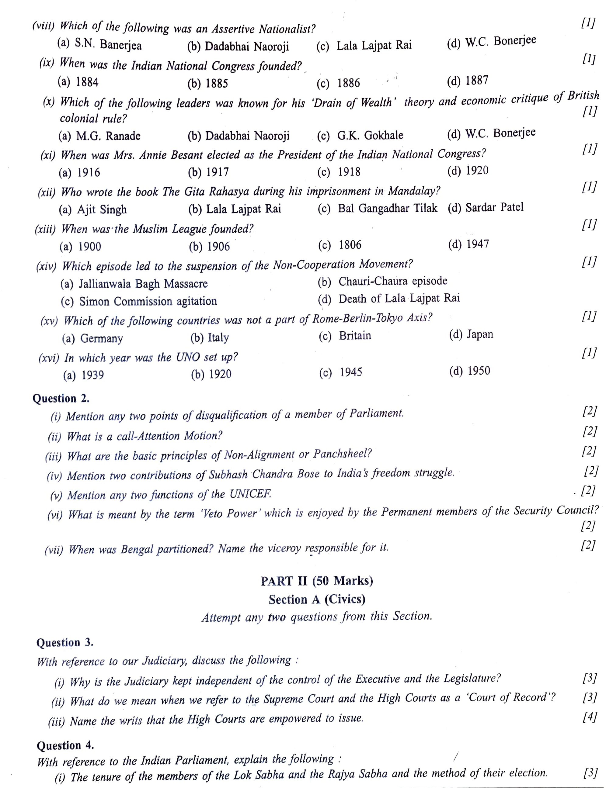

**[ 2 ]**