# Class X Mathematics

(By Subrata Sir & group of ICSE and CBSE school teachers)

GUIDELINES

**Mock Paper – 1 (2023)**

# Time: 2 ½ hours Total Marks: 80

**General Instructions:**

1. *Answers to this Paper must be written on the paper provided separately.*
2. *You will not be allowed to write during the first 15 minutes. This time is to be spent in reading the question paper.*
3. *The time given at the head of this Paper is the time allowed for writing the answers.*
4. *Attempt* ***all*** *questions from* ***Section A*** *and* ***any four*** *questions from* ***Section B****.*
5. *The intended marks for questions or parts of questions are given in brackets [ ]*

# Question 1

**Section A**

## (Attempt all questions from this section.)

Choose the correct answers to the questions from the given options. [15]

1. For a transaction within Delhi, MRP = Rs. 12,000, Discount % = 30%, GST = 18%, then CGST =?

(a) 756

(b) 765

(c) 786

(d) 768

1. The value of ‘x’ which satisfies the equation (x + 5)(x – 5) = 24 will be
   1. 5
   2. 6
   3. 7
   4. 8
2. If on dividing 2x3 + 3x2 – kx + 5 by x – 2, leaves a remainder 7, then the value of k is
   1. 13
   2. 7
   3. 3
   4. 17



1. i

matrix X is

(a) 1 × 1

(b) 2 × 2

(c) 1 × 2

(d) 2 × 1

1. The arithmetic mean of –5 and 41 is
   1. 13
   2. 6
   3. 12
   4. 18
2. The reflection of point (1, 2) about y-axis is (a) (–1, –2)

(b) (1, 2)

(c) (1, –2)

(d) (–1, 2)

1. A model of a ship is made to a scale 1 : 300. Now if the length of the model of the ship is 2 m, then the length of the ship will be
   1. 300 m
   2. 600 m

(c) 1200 m

(d) 800 m

1. The height of a circular cylinder is 20 cm and the radius of its base is 7 cm, then the volume will be

(a) 3080 cm3

(b) 3800 cm3

(c) 3880 cm3

(d) 3380 cm3

1. If x + 7  11, then value of x will be
   1. x  4
   2. x < 4
   3. x > 4
   4. x  4
2. A die has 6 faces marked by the given numbers as shown below:



The die is thrown once. So the probability of getting a positive integer is

(a) 1/3

(b) 2/3

(c) 1/2

(d) 1

1. xi)

If A

 1 3, then A2 =

 

3 4

(a)

(b)

(c)

(d)

15 15

15 25

 

10 15

15 25

 

 5 15

15 25

 

 0 15

15 25

 

1. The image of the point A(5, –3), under reflection in the point P(–1, 3) is (a) (–7, –9)

(b) (7, –9)

(c) (–7, 9)

(d) (7, 9)

1. In the given figure, AD is a diameter. O is the centre of the circle. AD is parallel to BC and ∠CBD = 32°. Then measure of ∠OBD is

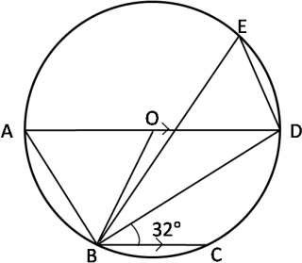

(a) 64°

(b) 32°

(c) 58°

(d) 30°

1. The common difference of the A.P. 4, 6, 8, …… is
   1. 4
   2. 2
   3. 10
   4. 6
2. The mean of the following observations is 3, 5, 7, 6, 9
   1. 5
   2. 6
   3. 10
   4. 7

# Question 2

1. Mohan has a recurring deposit account in a bank for 2 years at 6% p.a. simple interest. If he gets Rs. 1,200 as interest at the time of maturity, find: [4]
   1. The monthly instalment
   2. The amount of maturity.
2. The first term of a G.P. is 27. If the 8th term be 1

81

, what will be the sum of 10

terms? [4]

1. Prove that: [4]

cot A  1  cot A

2  sec2 A 1  tan A

# Question 3

1. A conical tent is to accommodate 77 persons. Each person must have 16m3 of air to breath. Given the radius of the tent as 7m, find the height of the tent and also its curved surface area. [4]
2. If P(–b, 9a – 2) divides the line segment joining the points [4] A(–3, 3a + 1) and B(5, 8a) in the ratio 3: 1, find the values of a and b.
3. Use graph paper for this question. [5]

(Take 2 cm = 1 unit along both x-axis and y-axis.)

Plot the points O(0, 0), A(–4, 4), B(–3, 0) and C(0, –3).

Reflect points A and B on the y-axis and name them A’ and B’ respectively. Write down their co-ordinates.

# Question 4

**Section B**

## (Attempt any four questions from this Section.)

1. A computer mechanic in Delhi charges repairing cost from five different persons A, B, C, D and E with certain discounts. The repairing costs and the corresponding discounts are as given below: [3]

|  |  |  |  |  |  |
| --- | --- | --- | --- | --- | --- |
| Name of the person | A | B | C | D | E |
| Repairing cost (in Rs. ) | 5500 | 6250 | 4800 | 7200 | 3500 |
| Discount % | 30 | 40 | 30 | 20 | 40 |

If the rate of GST is 18%, find the total money (including GST) received by the mechanic.

1. One root of the quadratic equation

8x2  mx  15  0

is 3 . Find the value of m.

4

Also, find the other root of the equation. [3]

1. The weight of 50 workers is given below : [4]

|  |  |  |  |  |  |  |  |
| --- | --- | --- | --- | --- | --- | --- | --- |
| Weight in Kg | 50-  60 | 60-  70 | 70-  80 | 80-  90 | 90-  100 | 100-  110 | 110-  120 |
| No. of workers | 4 | 7 | 11 | 14 | 6 | 5 | 3 |

Draw an ogive of the given distribution using a graph sheet. Take 2 cm = 10 kg on one axis and 2 cm = 5 workers along the other axis. Use the ogive drawn to estimate the following:

* 1. The upper and lower quartiles.
  2. If weighing 95 Kg and above is considered overweight, find the number of workers who are overweight.

# Question 5

, B=

1. If A 

1 3 

2 1

and A2

* 5B2  5C.Find the matrix C where C is a 2

3 4 3 2

   

by 2 matrix. [3]

1. In a trapezium ABCD, side AB is parallel to side DC; and the diagonals AC and BD intersect each other at point P. Prove that: PA x PD = PB x PC. [3]
2. What must be subtracted from 16x3 – 8x2 + 4x + 7 so that the resulting expression has 2x + 1 as a factor? [4]

# Question 6

1. Find [3]
   1. equation of AB
   2. equation of CD

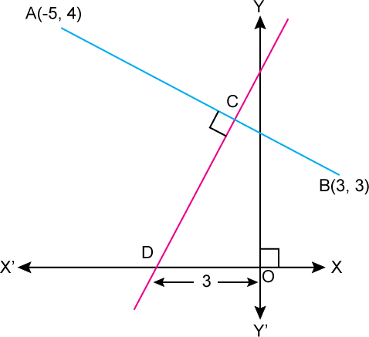

1. Evaluate without using trigonometric tables, [3]

sin2 280 + sin2 620 + tan2 380 - cot2 520 + 1 sec2 300

4

1. Find five numbers in A.P. whose sum is 12.5 and the ratio of the first to the last terms is 2:3. [4]

# Question 7

1. Sixteen cards are labelled as a, b, c, … , m, n, o, p. They are put in a box and shuffled. A boy is asked to draw a card from the box. What is the probability that the card drawn is:
   1. a vowel
   2. a consonant
   3. None of the letters of the word median?
2. A metal pipe has a bore (inner diameter) of 5 cm. The pipe is 5 mm thick all round. Find the weight, in kilogram, of 2 metres of the pipe if 1 cm3 of the metal weights 7.7 g.
3. In the figure given, O is the centre of the circle. DAE = 700. Find giving suitable reasons, the measure of
4. BCD
5. BOD
6. OBD

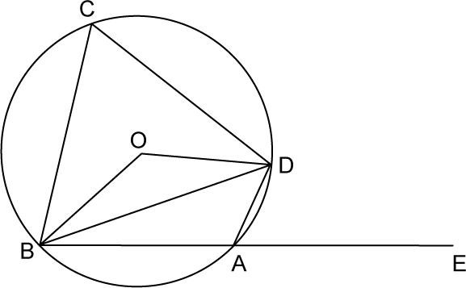

# Question 8

1. Solve the following in equation and represent the solution set on a number line.

8 1   1  4x 7 1 , x  I



[3]

2 2 2

1. The histogram below represents the scores obtained by 25 students in a Mathematics mental test. Use the data to:
   1. Frame a frequency distribution table.
   2. To calculate mean.
   3. To determine the Modal class.

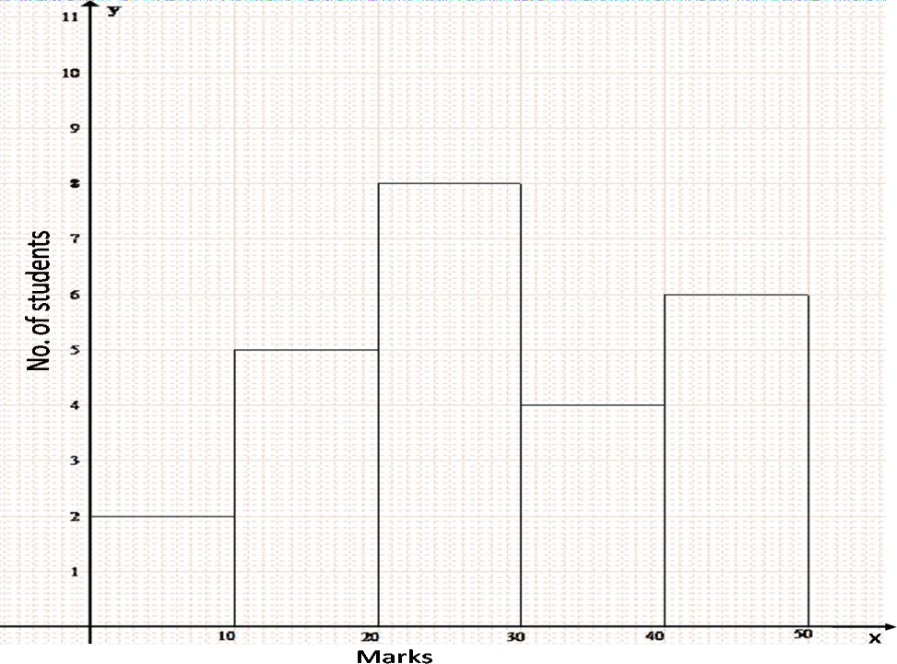

1. PQR is a triangle. S is a point on the side QR of ∆PQR such that PSR = QPR. Given QP = 8 cm, PR = 6 cm and SR = 3 cm. [4]
   1. Prove ∆PQR ∼ ∆SPR.
   2. Find the lengths of QR and PS.

area of PQR

* 1. (c)

area of SPR

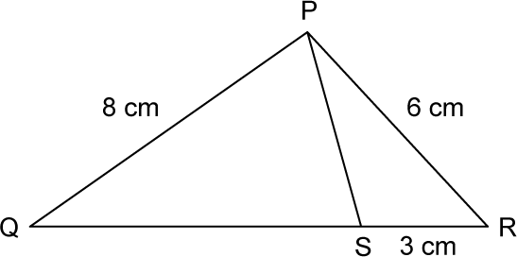

# Question 9

1. If m and n are roots of the equation 1  1  3; where x ≠ 0 and x ≠ 2; find

x x  2

m×n. [4]

1. The table shows the distribution of the scores obtained by 160 shooters in a shooting competition. Use a graph sheet and draw an ogive for the distribution. (Take 2 cm = 10 scores on the X-axis and 2 cm = 20 shooters on the Y-axis.)

|  |  |  |  |  |  |  |  |  |  |  |
| --- | --- | --- | --- | --- | --- | --- | --- | --- | --- | --- |
| Scores | 0-  10 | 10  - 20 | 20-  30 | 30-  40 | 40-  50 | 50-  60 | 60-  70 | 70-  80 | 80-  90 | 90-  100 |
| No. of shooters | 9 | 13 | 20 | 26 | 30 | 22 | 15 | 10 | 8 | 7 |

Use your graph to estimate the following: [6]

* 1. The median
  2. The interquartile range.
  3. The number of shooters who obtained a score of more than 85%.

# Question 10

1. A school has 630 students. The ratio of the number of boys to the number of girls is 3:2. This ratio changes to 7:5 after the admission of 90 new students. Find the number of newly admitted boys. [3]
2. Construct a ∆ABC with BC = 6.5 cm, AB = 5.5 cm, AC = 5 cm. Construct the incircle of the triangle. Measure and record the radius of the in circle. [3]
3. An aeroplane, at an altitude of 250 m, observes the angles of depression of two boats on the opposite banks of a river to be 45° and 60° respectively. Find the width of the river. Write the answer correct to the nearest whole number. [4]