**MATHEMATICS**

**Class-XI**

Time Allowed: 3 Hours Maximum Marks: 80

(Candidates are allowed additional 15 minutes for only reading the paper.

They must NOT start writing during this time).

*This Question Paper consists of three sections A, B and C.*

*Candidates are required to attempt all questions from Section A and all questions EITHER from Section B OR Section C. Section A: Internal choice has been provided in two questions of two marks each, two questions of four marks each and*

*two questions of six marks each.*

*Section B: Internal choice has been provided in one question of two marks and*

*one question of four marks.*

*Section C: Internal choice has been provided in one question of two marks and*

*one question of four marks.*

*All working, including rough work, should be done on the same sheet as, and adjacent to the rest of the answer. The intended marks for questions or parts of questions are given in brackets [].*

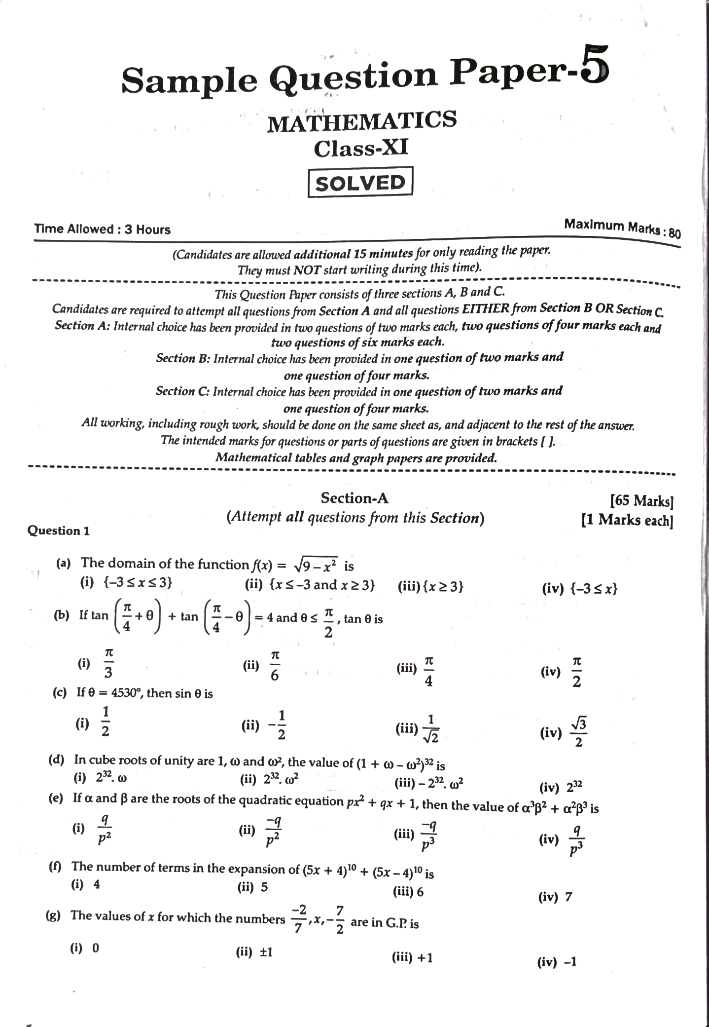*Mathematical tables and graph papers are provided.*

**Section-A**

*(Attempt all questions from this Section)*

Question 1

(a) The domain of the function f(x)= √9-x² is (ii) (xs-3 and x23)

(i) (-3≤x≤3)

(iii) (x23)

(iv) (-3≤x)

(b) If tan + tan 0=4 and 0 s tan 0 is

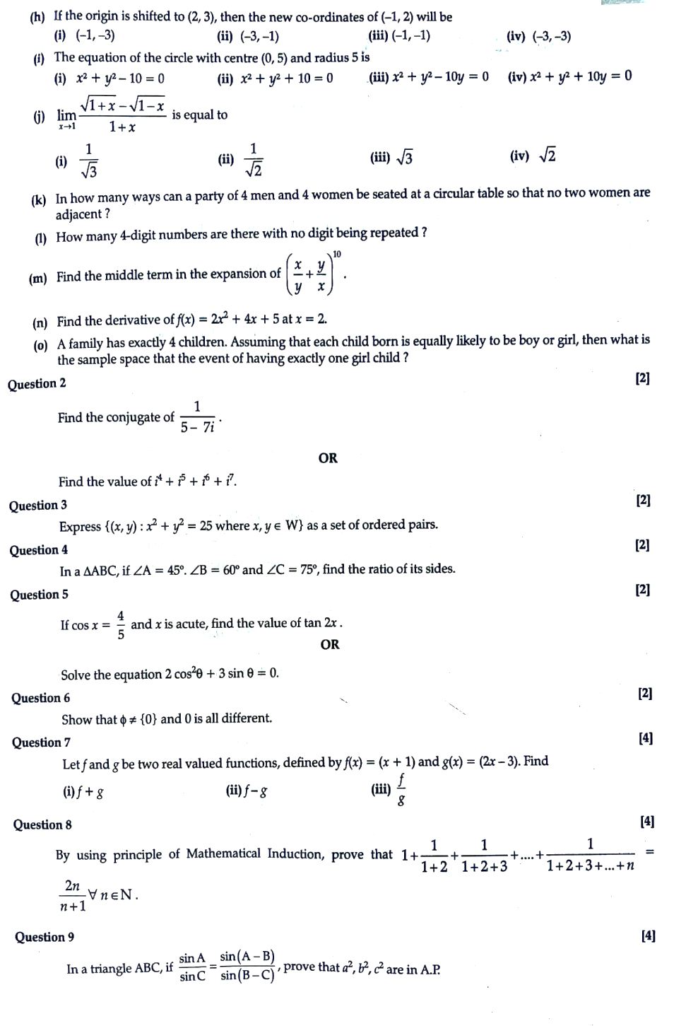2

(1) 3

(ii)

(iv)

(c) If 0=4530", then sin 0 is

(1) 2

(ii)

5 (iv) 2

(iii)

(d) In cube roots of unity are 1, 00 and to, the value of (1 + co-co) is

(i) 22.0 (e) If a and B are the roots of the quadratic equation pr²+qx + 1, then the value of a³ß2+ a²ß³ is

(ii) 232 002

(iii)-2, 002

Find the square root of:

(iv) 232

(i)

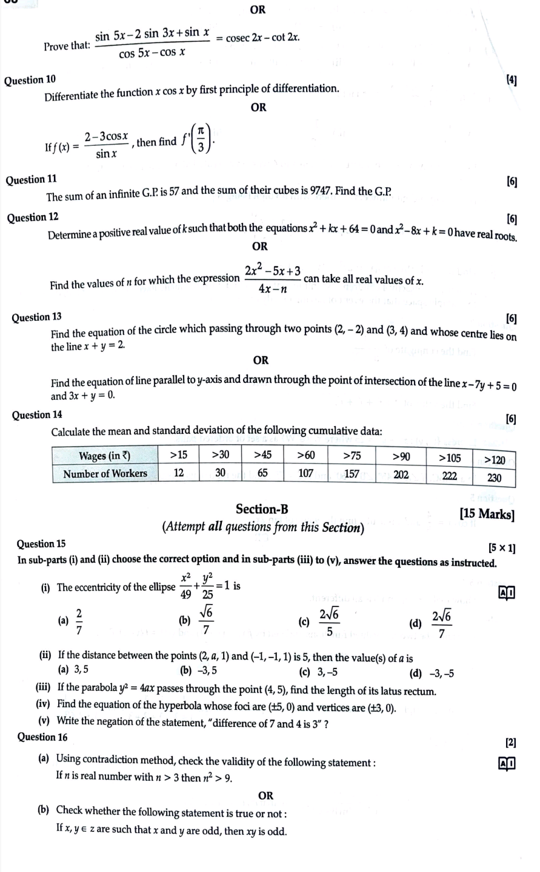p2 (ii)

(iii)

(iv) 15

(f) The number of terms in the expansion of (5x+4)10+ (5x-4) is

(i) 4

(ii) 5

(iii) 6

(iv) 7

(g) The values of x for which the numbers

are in G.P. is

(5) 0

(ii) 1

(iii) +1

(iv) -1

(h) if the origin is shifted to (2, 3), then the new co-ordinates of (-1, 2) will be

(ii) (-3,-1)

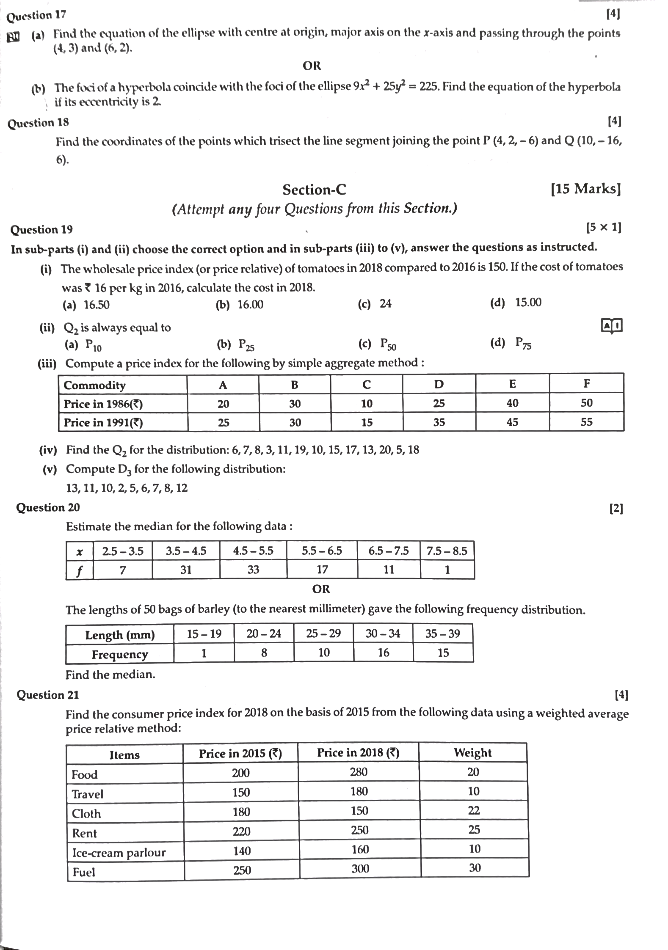

(1) (-1,-3) The equation of the circle with centre (0,5) and radius 5 is

(iii) (-1,-1)

(1)+y-10=0

(ii) x+y+10=0

(iv) (-3,-3)

(iii) x²+ y²-10y=0

(iv) x² + y²+ 10y=0

6) lim- is equal to

1 √2

(iii) √3

(iv) √2

(k) in how many ways can a party of 4 men and 4 women be seated at a circular table so that no two women are adjacent ?

(1) How many 4-digit numbers are there with no digit being repeated? 10

(m) Find the middle term in the expansion of

(n) Find the derivative of f(x)=2x+4x+5 at x=2

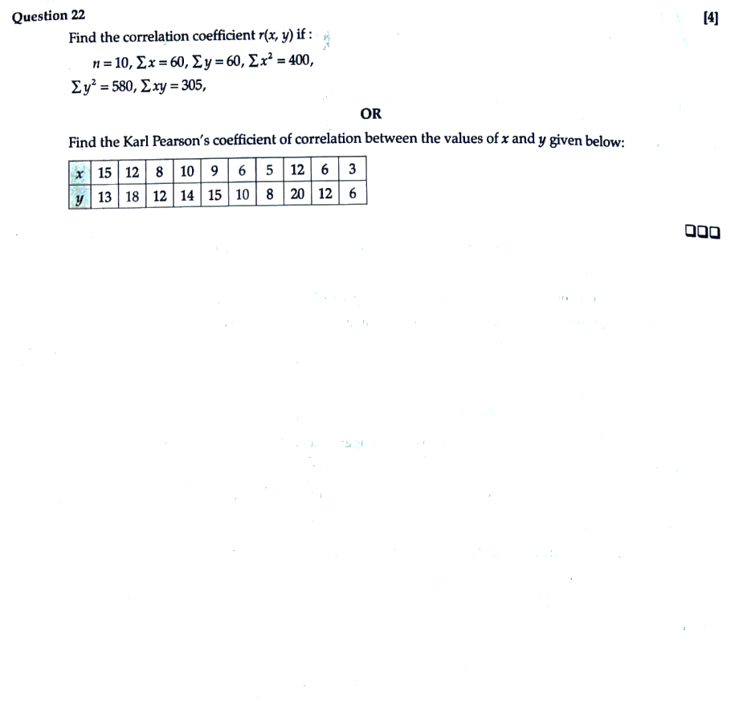

(0) A family has exactly 4 children. Assuming that each child born is equally likely to be boy or girl, then what is

the sample space that the event of having exactly one girl child?

Question 2

Find the conjugate of 1 5-71

OR

Find the value of +P-

Question 3

Express ((x, y): x² + y² = 25 where x, ye W) as a set of ordered pairs.