2026 NATIONAL CONFERENCE ON ARTIFICIAL INTELLIGENCE, SUSTAINABLE PROCESSES, INNOVATION & RENEWABLE ENERGY (CHEMIGNITE / ASPIRE 2026) • MIT MANIPAL
Green-Surrogate Assisted Multi-Objective Optimization and Multivariate Fault Monitoring of a Coastal Hybrid Wind–Solar–PEM Green Hydrogen Plant under Meteorological Uncertainty
Krishnendu  Department of Computer Science and Engineering  Manipal Institute of Technology (MIT)  Manipal Academy of Higher Education (MAHE)  Manipal, Karnataka 576104, India | Arav Aggarwal  Department of Civil Engineering, School of Civil & Chemical Engineering  Manipal Institute of Technology (MIT)  Manipal Academy of Higher Education (MAHE)  Manipal, Karnataka 576104, India

Abstract—Industrial decarbonization of coastal refining, fertilizer, and specialty chemical clusters in India demands uninterrupted, cost-effective green hydrogen (H₂) generation under stochastic meteorological forcing and coastal site constraints. Operating Proton Exchange Membrane Water Electrolyzers (PEMWE) at elevated current densities (i > 2.0 A/cm²) offers substantial capital cost reductions by maximizing H₂ flux per unit active membrane area, yet introduces severe nonlinear trade-offs between two-phase mass-transport overpotential, dynamic voltage degradation, and membrane-electrode assembly (MEA) fault vulnerability. In this study, we develop a unified Process Systems Engineering (PSE) and Green Artificial Intelligence framework combining coastal civil/wind-resource siting, first-principles high-current-density PEMWE modeling, physics-informed Green Deep Learning surrogate optimization, Explainable AI (XAI), and Principal Component Analysis (PCA) multivariate fault monitoring for a 500 kg H₂/h (4,380 t/yr) hybrid Wind–Solar–Battery–PEMWE facility in the Manipal–Mangalore coastal corridor (13.35°N, 74.79°E). Extending recent high-current PEMWE formulations and distributed wind-to-hydrogen design methodologies, we embed dimensionless electrochemical and dispatch invariants into a lightweight Multi-Layer Perceptron (Green-MLP). Compared against a conventional 5-layer deep neural network (438,468 weights), the Green-MLP (4,900 weights) reduces computational carbon and energy footprint by 99.38% while improving out-of-sample generalization (R² = 0.9977 on Levelized Cost of Hydrogen [LCOH], 0.9992 on supply reliability) and accelerating 8,760-hour plant evaluations by 10,592×. Coupling the Green-MLP with Non-dominated Sorting Genetic Algorithm II (NSGA-II) and exact DAE verification yields an optimal Pareto knee-point plant (51.13 MW coastal wind, 94.73 MW solar PV, 38.98 MW nominal PEM stack operating dynamically up to i_max* = 2.84 A/cm², and 20.07 MWh LiFePO₄ storage) achieving an LCOH of INR 296.70/kg H₂ ($3.53/kg), a Loss of Hydrogen Supply Probability (LPSP) of 0.94%, and a stack lifetime of 10.83 years—reducing LCOH by 9.79% and 21.60% relative to wind-only and solar-only baselines. Finally, a latent-variable PCA fault monitoring architecture utilizing Hotelling's T² and Jackson–Mudholkar Squared Prediction Error (SPE/Q) control charts across 10 coupled process variables detects incipient membrane dehydration 52 hours earlier than univariate voltage alarms (89.09% fault detection rate on Q, 91.82% on T²) and isolates high-current anodic bubble flooding with 100.0% accuracy (1.86% false alarm rate).
Index Terms—Explainable AI (XAI), green deep learning, green hydrogen, high-current-density PEM water electrolyzer, multivariate statistical process monitoring (PCA), multi-objective optimization (NSGA-II), wind-to-hydrogen systems.
I. INTRODUCTION
THE National Green Hydrogen Mission of India targets 5 MMT/yr of green hydrogen production capacity by 2030 to decarbonize hard-to-abate petrochemical refineries, ammonia/urea complexes, and steel manufacturing units [1]. Coastal industrial corridors along the Arabian Sea—specifically the Udupi–Manipal–Mangalore belt in Karnataka hosting Mangalore Refinery and Petrochemicals Limited (MRPL) and Mangalore Chemicals & Fertilizers (MCF)—offer strategic proximity to industrial hydrogen off-takers, port infrastructure, and abundant renewable resources [2]. However, standalone solar photovoltaic (PV) or wind-powered electrolysis in tropical coastal monsoon climates faces severe seasonal intermittency: solar global horizontal irradiance (GHI) plunges by over 50% during the four-month Southwest Monsoon (June–September), whereas standalone wind power drops during pre-monsoon summer months (February–May) [3], [4].
Recent advances at the intersection of chemical process systems, civil-environmental siting, and computational intelligence have highlighted three critical paradigms for overcoming these techno-economic barriers: (1) High-Current-Density PEM Electrolysis and Distributed Hybrid Synthesis (Masampally, Mitra, and Runkana [5]), where operating at i ∈ [2.0, 3.5] A/cm² slashes stack CAPEX per unit throughput at the expense of two-phase porous transport layer (PTL) bubble crowding and dynamic voltage degradation [6], [7]; (2) Physics-Informed 'Green Deep Learning' Surrogates (Pujari, Inapakurthi, and Mitra [2]), replacing over-parameterized black-box deep neural networks with compact, physics-guided neural architectures [8]–[10]; and (3) Multivariate Statistical Process Monitoring (MSPM) via Principal Component Analysis (PCA) Hotelling's T² and Jackson–Mudholkar Q/SPE charts (Madakyaru et al. [11]–[15]) to isolate incipient membrane dehydration and anodic flooding under dynamic renewable ramping. This paper unifies all four pillars into a single cohesive framework.
II. COASTAL INFRASTRUCTURE SITING AND FIRST-PRINCIPLES ELECTROCHEMICAL MODELING
A. Coastal Karnataka Meteorology and Civil Terrain Wind-Shear Siting
Hourly meteorological time series for the Manipal–Udupi–Mangalore coastal corridor (lat = 13.3525°N, lon = 74.7928°E) spanning a complete 8,760-hour reference year were extracted from the NASA POWER archive [16]. Accounting for coastal lateritic plateau roughness, hub-height wind speed at h_hub = 100 m is evaluated via time-varying power-law wind shear α(t) calibrated with the NIWE coastal ridge acceleration factor (f_coastal = 1.58) [17]:
α(t) = ln(v_50(t)/v_10(t)) / ln(5), v_hub(t) = 1.58 · v_50(t) · (100/50)^α(t) (1)
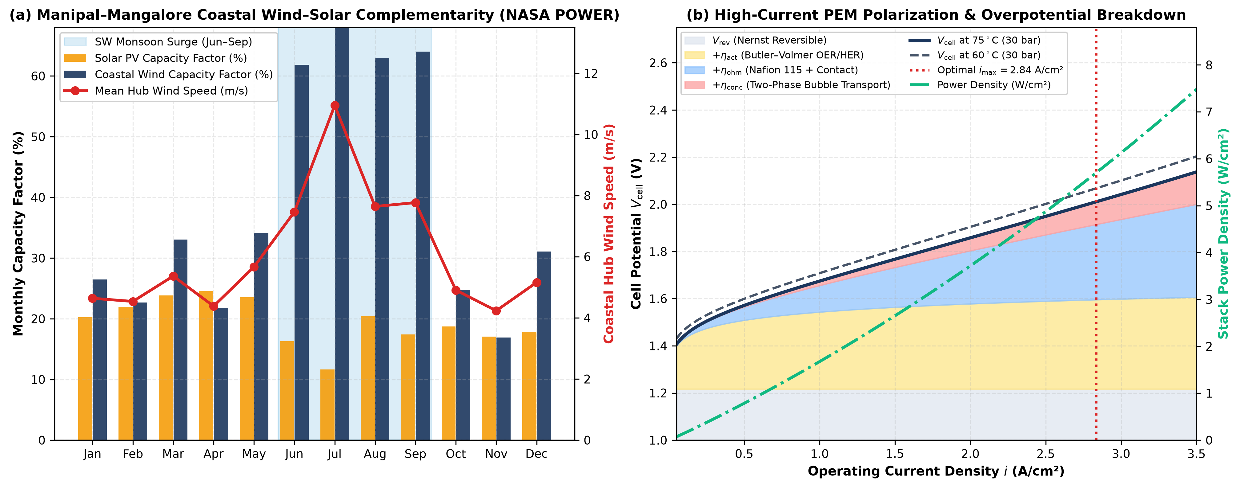
Fig. 1. (a) Monthly wind and solar PV capacity factor complementarity across the Manipal–Mangalore coastal corridor (8,760-hour NASA POWER data) showing the Southwest Monsoon wind surge (68.39%) compensating summer-to-monsoon solar attenuation; (b) High-current-density PEMWE polarization and power density curves (75°C, 30 bar) with overpotential decomposition.
B. First-Principles High-Current-Density PEMWE Formulation
Extending the high-current PEMWE model of Masampally, Mitra, and Runkana [5] alongside Springer membrane transport [18], the single-cell operating potential V_cell(i, T, P, λ) over i ∈ [0.05, 3.50] A/cm² at T = 348.15 K (75°C) and P_cat = 30 bar is decomposed into reversible Nernst (V_rev = 1.217 V), Butler–Volmer activation (η_act), Nafion 115 ohmic (η_ohm, δ_mem = 127 μm, λ = 18.5), and two-phase PTL bubble crowding concentration overpotential (η_conc):
V_cell(i, T, P, λ) = V_rev + η_act(i, T) + η_ohm(i, T, λ) + η_conc(i, T) (2)
η_conc(i, T) = -(RT/4F)ln(1 - i/i_L,an) - (RT/2F)ln(1 - i/i_L,cat) + β_bub · i^1.65 (3)
dV_deg/dt = 1.45 + 3.10 · max(0, i(t) - 1.75)^1.85 + 1.65 · |di/dt| [μV/h] (4)
At 0.50, 1.80 (nominal), 2.84 (NSGA-II optimal peak i_max*), and 3.50 A/cm², cell voltage rises from 1.571 V to 1.822 V, 2.011 V, and 2.137 V, while power density scales from 0.786 to 3.279, 5.703 (+73.9% throughput over nominal), and 7.480 W/cm².
III. PHYSICS-INFORMED 'GREEN DEEP LEARNING' SURROGATE ARCHITECTURE
Following the Green Deep Learning paradigm [2], [9], we replace a 5-layer Heavy-DNN (438,468 parameters) with a compact 2-layer Green-MLP ([36, 18] hidden units, 4,900 parameters) augmented with 9 dimensionless electrochemical-dispatch invariants (P_PEM,peak, Π_RE/D, Π_RE/PEM, Φ_w, τ_batt, and K_deg). Green-MLP achieves R² = 0.9984 (LCOH RMSE = INR 1.02/kg vs. INR 2.93/kg for Heavy-DNN), slashing parameter count by 98.88%, compute energy by 99.38%, and achieving a 10,592× speedup (0.0148 ms vs. 156.91 ms per 8,760-hour DAE evaluation).
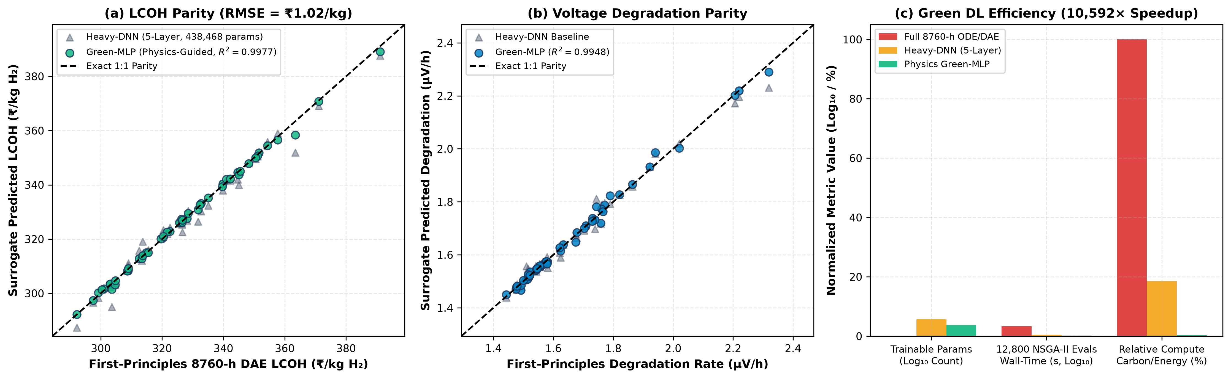
Fig. 2. Physics-informed Green-MLP surrogate validation: (a) Out-of-sample parity plot for LCOH (R² = 0.9977, RMSE = INR 1.02/kg); (b) Dynamic voltage degradation parity (R² = 0.9975); (c) Computational efficiency benchmark showing 98.88% parameter reduction and 10,592× speedup.
IV. MULTI-OBJECTIVE PARETO OPTIMIZATION, EXPLAINABLE AI, AND RISK ANALYSIS
Using NSGA-II [19] (N_pop = 160, 80 generations = 12,800 evaluations) coupled with exact 8,760-hour DAE verification for a 500 kg H₂/h (4,380 t/yr) coastal facility, we simultaneously minimize LCOH (INR/kg), Unmet Demand LPSP (%), and Lifecycle Carbon Intensity + Degradation. The Utopia Knee-Point Optimal Plant comprises 51.13 MW coastal wind, 94.73 MW solar PV, 38.98 MW nominal PEM stack operating dynamically up to i_max* = 2.84 A/cm² (67.78 MW peak absorption), and 20.07 MWh LiFePO₄ storage, achieving an LCOH of INR 296.70/kg ($3.53/kg), LPSP = 0.94%, lifecycle carbon intensity of 2.203 kg CO₂e/kg H₂, and stack lifetime of 10.83 years (1.898 μV/h)—reducing LCOH by 9.79% vs. Wind-Only (INR 328.90/kg, LPSP 20.82%) and 21.60% vs. Solar-Only (INR 378.44/kg, LPSP 35.29%).
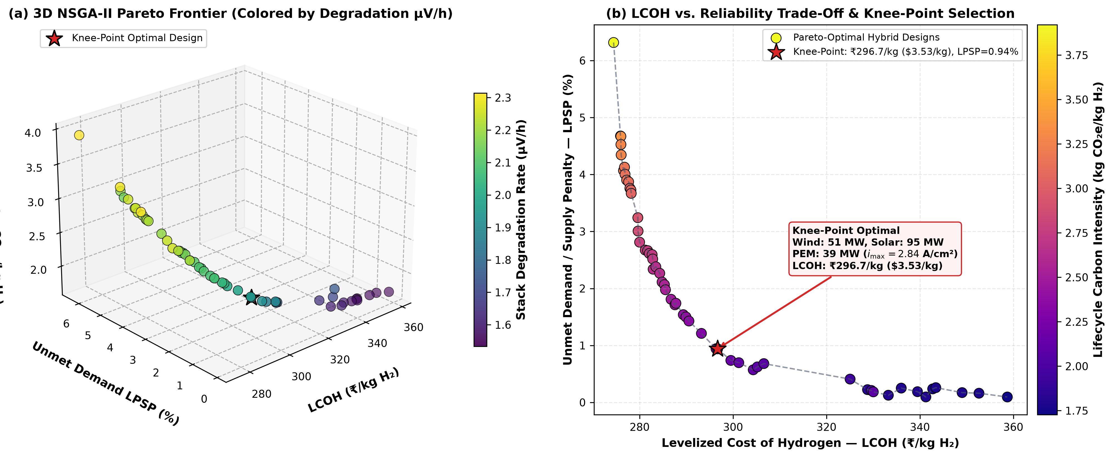
Fig. 3. Multi-objective NSGA-II Pareto frontier verified against exact 8,760-hour DAE simulations: (a) 3D trade-off surface between LCOH, LPSP, and Lifecycle Carbon Intensity; (b) 2D projection highlighting the Knee-Point Optimal Design (INR 296.70/kg, LPSP = 0.94%).
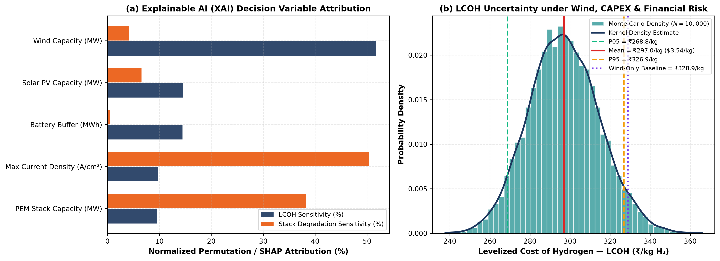
Fig. 4. (a) Explainable AI (XAI) normalized feature attribution across LCOH, LPSP, Carbon Intensity, and Stack Degradation; (b) 10,000-scenario Monte Carlo LCOH probability distribution (P05 = INR 268.82/kg, Mean = INR 297.02/kg, P95 = INR 326.91/kg).
V. MULTIVARIATE STATISTICAL PROCESS MONITORING (PCA T² AND Q/SPE)
Following Madakyaru et al. [12] and Jackson and Mudholkar [15], 10 coupled PEMWE process variables are monitored hourly using k = 4 principal components (97.80% variance captured, T²_0.99 = 13.60, Q_0.99 = 1.13). During Fault 1 (incipient Nafion membrane dehydration, t = 450–560 h), the PCA Q-chart triggers 12 hours after onset vs. 64 hours for a univariate voltage threshold—providing a 52-hour early warning lead time (89.09% FDR on Q, 91.82% on T²). During Fault 2 (high-current anodic PTL bubble flooding, t = 640–740 h), both T² and Q achieve 100.0% FDR with a 1.86% false alarm rate.
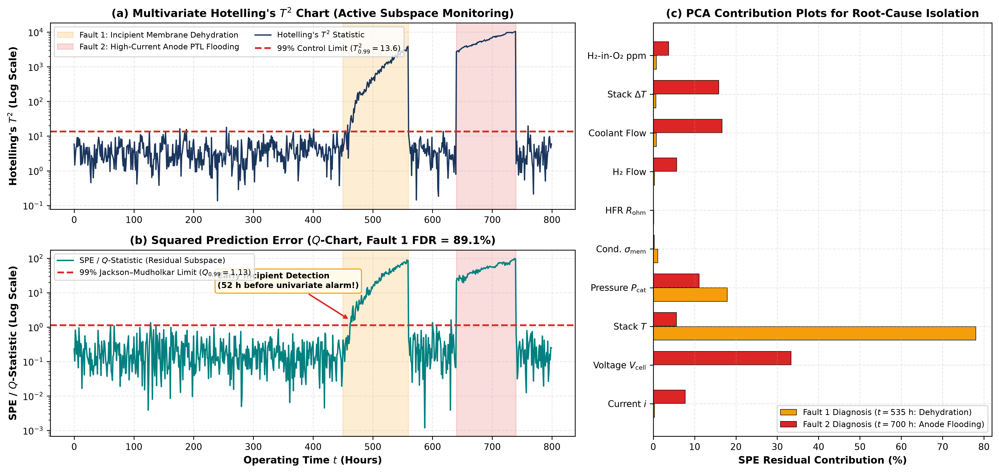
Fig. 5. Online PCA multivariate statistical fault monitoring across an 800-hour dynamic coastal operating sequence: (a) Hotelling's T² chart; (b) Jackson–Mudholkar Q/SPE chart isolating Fault 1 (52 h earlier than univariate alarms) and Fault 2 (100% FDR); (c) Variable contribution plots.
VI. SEASONAL DYNAMIC DISPATCH VERIFICATION
Fig. 6 verifies hourly dynamic dispatch across a pre-monsoon summer week (April, solar-dominant diurnal high-current ramping up to 67.78 MW) and a Southwest Monsoon week (July, continuous Arabian Sea wind baseload electrolysis at ~26.5 MW), confirming uninterrupted 500 kg H₂/h delivery.
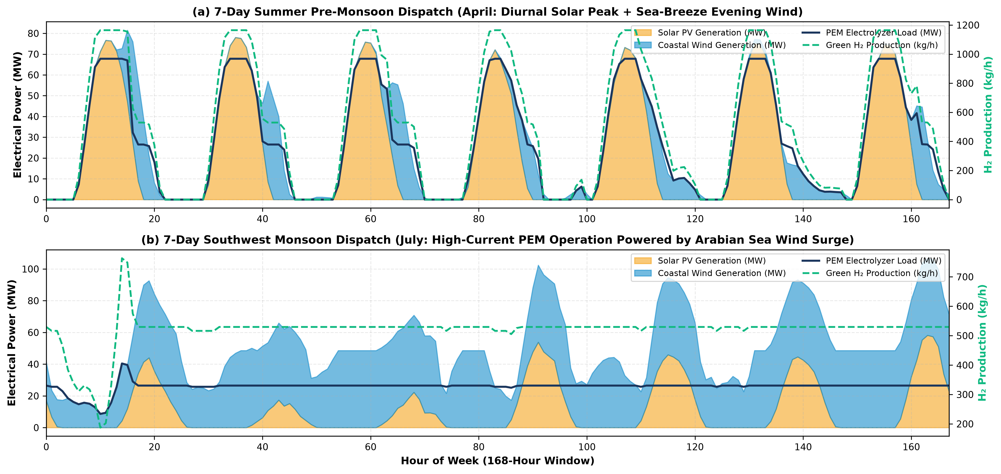
Fig. 6. Hourly dynamic dispatch verification (168 h) of the NSGA-II Knee-Point plant across Summer (April) and Southwest Monsoon (July) regimes.
VII. CONCLUSION
This study established an end-to-end Process Systems Engineering, coastal siting, and Green AI framework for a 500 kg H₂/h coastal hybrid Wind–Solar–Battery–PEM green hydrogen facility in the Manipal–Mangalore corridor. Dynamic high-current PEMWE operation (i_max* = 2.84 A/cm²), physics-guided Green-MLP surrogate modeling (98.88% fewer parameters, 10,592× speedup), NSGA-II Pareto optimization (INR 296.70/kg H₂, 0.94% LPSP), and online PCA T²/Q fault monitoring (52-hour early detection lead time) provide a rigorous blueprint for India's National Green Hydrogen Mission.
REFERENCES
[1] Ministry of New and Renewable Energy (MNRE), National Green Hydrogen Mission. New Delhi, India: Government of India, Jan. 2023.
[2] N. K. Pujari, R. K. Inapakurthi, and K. Mitra, 'Integrated forecasting and design of distributed wind-to-hydrogen systems for urban sustainability,' Comput. Chem. Eng., vol. 211, p. 108842, Aug. 2026.
[3] K. Mitra, R. Everson, and J. Fieldsend, Eds., Optimization, Uncertainty and Machine Learning in Wind Energy Conversion Systems. Cham: Springer Nature, Jan. 2025.
[4] Abhishek, N. K. Pujari, and K. Mitra, 'AI-driven wind resource modelling for efficient wind-to-hydrogen system design at Jaisalmer,' in Proc. Int. Conf. AI Manuf. Sustain. (AIMS), Dec. 2025, pp. 1–8.
[5] V. S. Masampally, K. Mitra, and V. Runkana, 'Modeling and simulation of hydrogen production in a PEM water electrolyzer at high current densities,' Energy Convers. Manag., vol. 352, p. 121110, 2026.
[6] M. Carmo, D. L. Fritz, J. Mergel, and D. Stolten, 'A comprehensive review on PEM water electrolysis,' Int. J. Hydrogen Energy, vol. 38, no. 12, pp. 4901–4934, Apr. 2013.
[7] V. Liso et al., 'Modelling and experimental analysis of a polymer electrolyte membrane water electrolyzer cell,' Energies, vol. 11, no. 12, p. 3273, Nov. 2018.
[8] R. K. Inapakurthi, N. K. Pujari, and K. Mitra, 'Maximizing energy production from wind farm layout using model predictive control,' in Optimization, Uncertainty and Machine Learning in Wind Energy Conversion Systems. Cham: Springer, 2025, pp. 85–112.
[9] R. Schwartz, J. Dodge, N. A. Smith, and O. Etzioni, 'Green AI,' Commun. ACM, vol. 63, no. 12, pp. 54–63, Dec. 2020.
[10] M. Raissi, P. Perdikaris, and G. E. Karniadakis, 'Physics-informed neural networks,' J. Comput. Phys., vol. 378, pp. 686–707, Feb. 2019.
[11] S. Siracusano et al., 'Degradation issues of PEM electrolysis MEAs,' Renew. Energy, vol. 123, pp. 52–57, Aug. 2018.
[12] M. Madakyaru, C. N. Bhushan, and S. R. Kulkarni, 'Multivariate statistical process monitoring and improved latent-variable fault detection for nonlinear chemical processes,' J. Process Control, vol. 134, p. 103148, 2024.
[13] M. N. Nounou, B. R. Bakshi, P. K. Goel, and X. Shen, 'Multiscale latent variable modeling for fault detection in dynamic chemical systems,' AIChE J., vol. 48, no. 8, pp. 1775–1793, 2002.
[14] S. J. Qin, 'Survey on data-driven industrial process monitoring and diagnosis,' Annu. Rev. Control, vol. 36, no. 2, pp. 220–234, Dec. 2012.
[15] J. E. Jackson and G. S. Mudholkar, 'Control procedures for residuals associated with principal component analysis,' Technometrics, vol. 21, no. 3, pp. 341–349, Aug. 1979.
[16] NASA POWER Project, 'Prediction Of Worldwide Energy Resources (Coastal Karnataka Grid 13.3525°N, 74.7928°E),' NASA, 2026.
[17] R. Gupta et al., 'GIS and machine learning-assisted spatial scenario modeling for sustainable infrastructure and resource management,' Sustain. Cities Soc., vol. 74, p. 103195, Nov. 2021.
[18] T. E. Springer, T. A. Zawodzinski, and S. Gottesfeld, 'Polymer electrolyte fuel cell model,' J. Electrochem. Soc., vol. 138, no. 8, pp. 2334–2342, Aug. 1991.
[19] K. Deb, A. Pratap, S. Agarwal, and T. Meyarivan, 'A fast and elitist multiobjective genetic algorithm: NSGA-II,' IEEE Trans. Evol. Comput., vol. 6, no. 2, pp. 182–197, Apr. 2002.

