Timetable AI System
Intelligent Timetable Generator with ML Clash Prediction

Module 4: System Analysis & Design

Updated UML & DFD Diagrams

All diagrams updated to reflect the latest implemented system:
Room & Resource Management • Intelligent Clash Resolution with Auto-Resolve
Global Search • CSV/ZIP Export with Semester-aware filenames
Lab 2-hour Start Slot Restrictions (08:30 / 10:30 / 13:00)
Faculty Working-Hours Enforcement • Occupied Room Filtering
Subject Load Balancing • Visiting Faculty Day-wise Scheduling

Patel Krish Kalpeshbhai | 230670142018
SAL Institute of Technology & Engineering Research | GTU | 2026-27

Figure 4.1: System Architecture Diagram

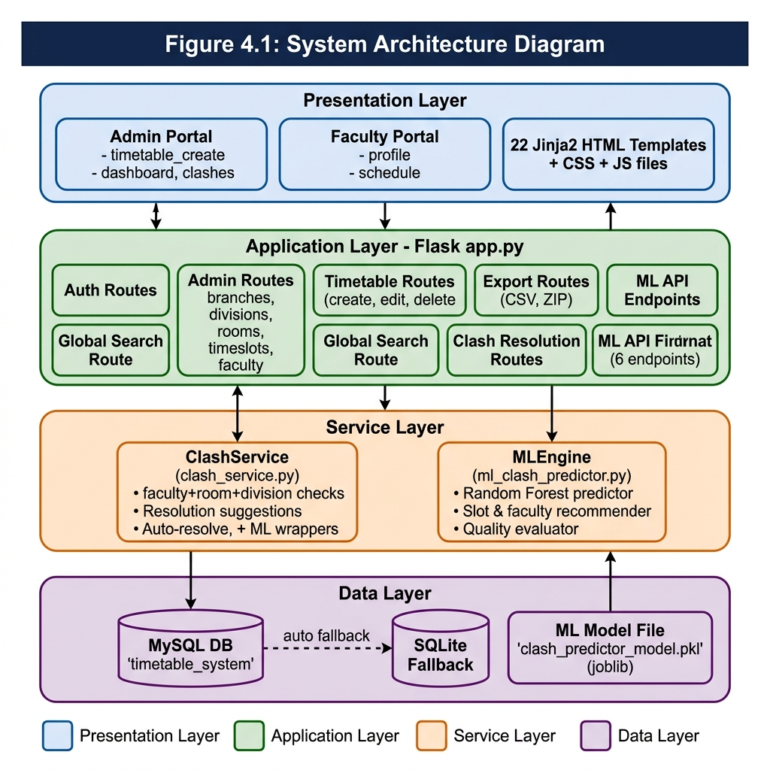

Figure 4.1: System Architecture Diagram

Figure 4.2: Overall Workflow Diagram

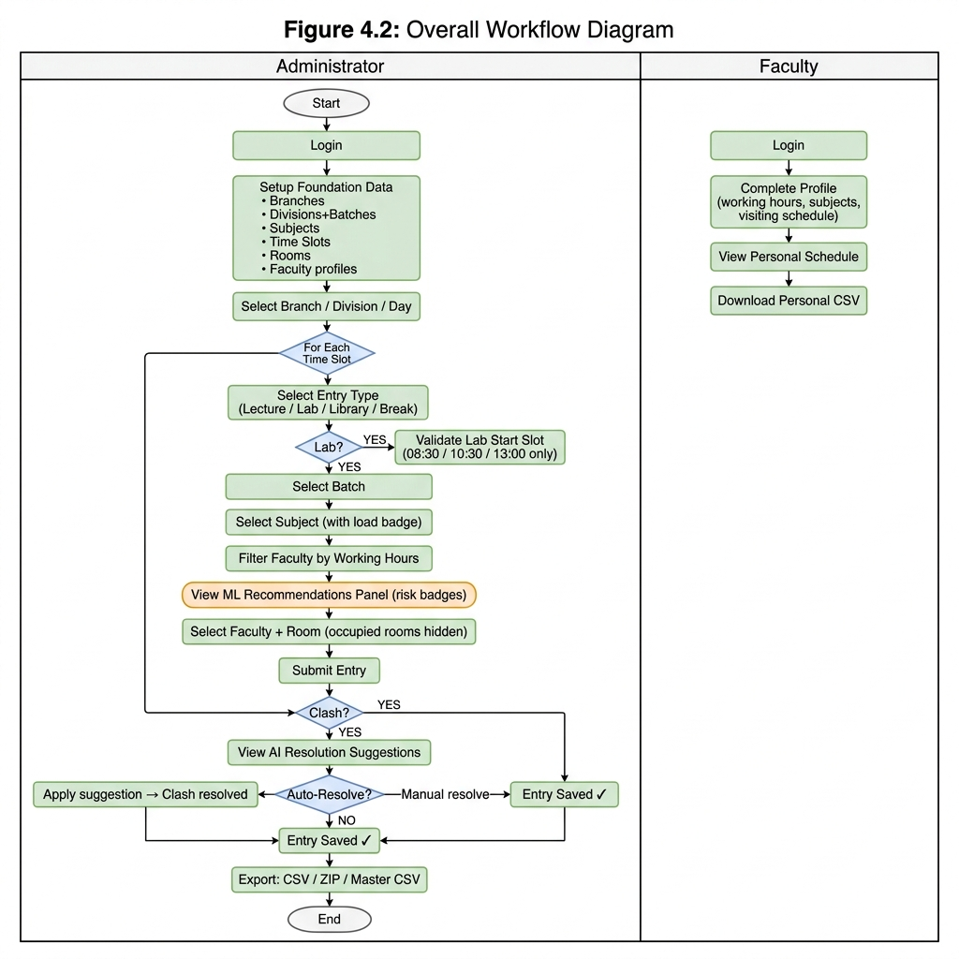

Figure 4.2: Overall Workflow Diagram

Figure 4.11: Use Case Diagram

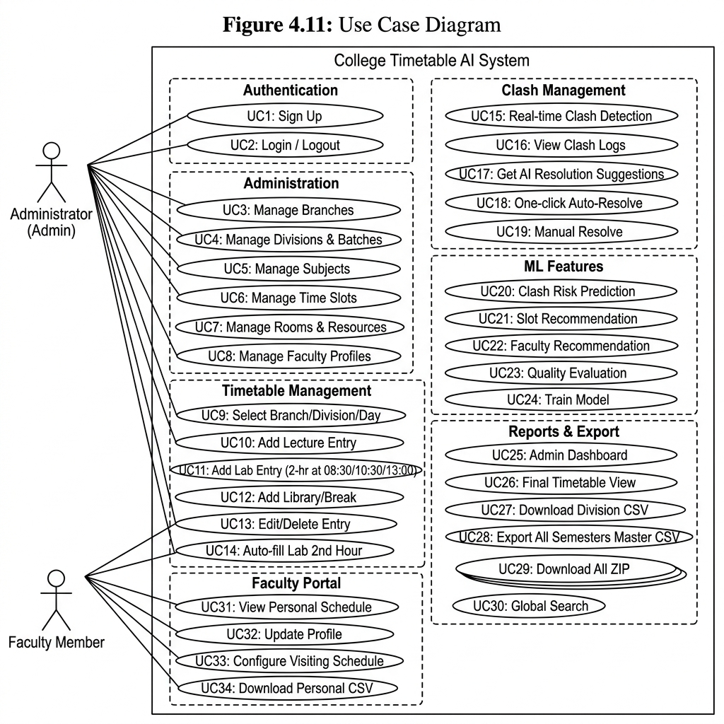

Figure 4.11: Use Case Diagram

Figure 4.12: Activity Diagram – Timetable Creation

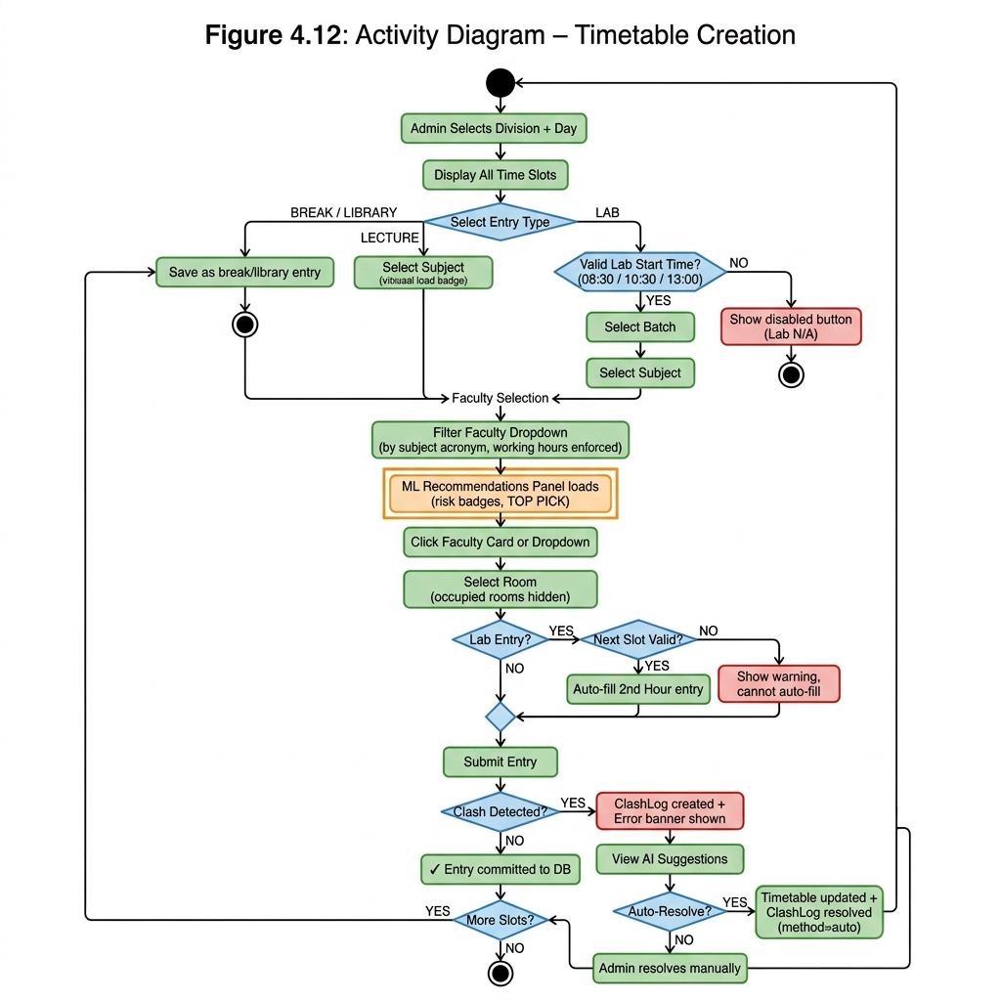

Figure 4.12: Activity Diagram – Timetable Creation

Figure 4.13: Sequence Diagram – Clash Detection and Resolution

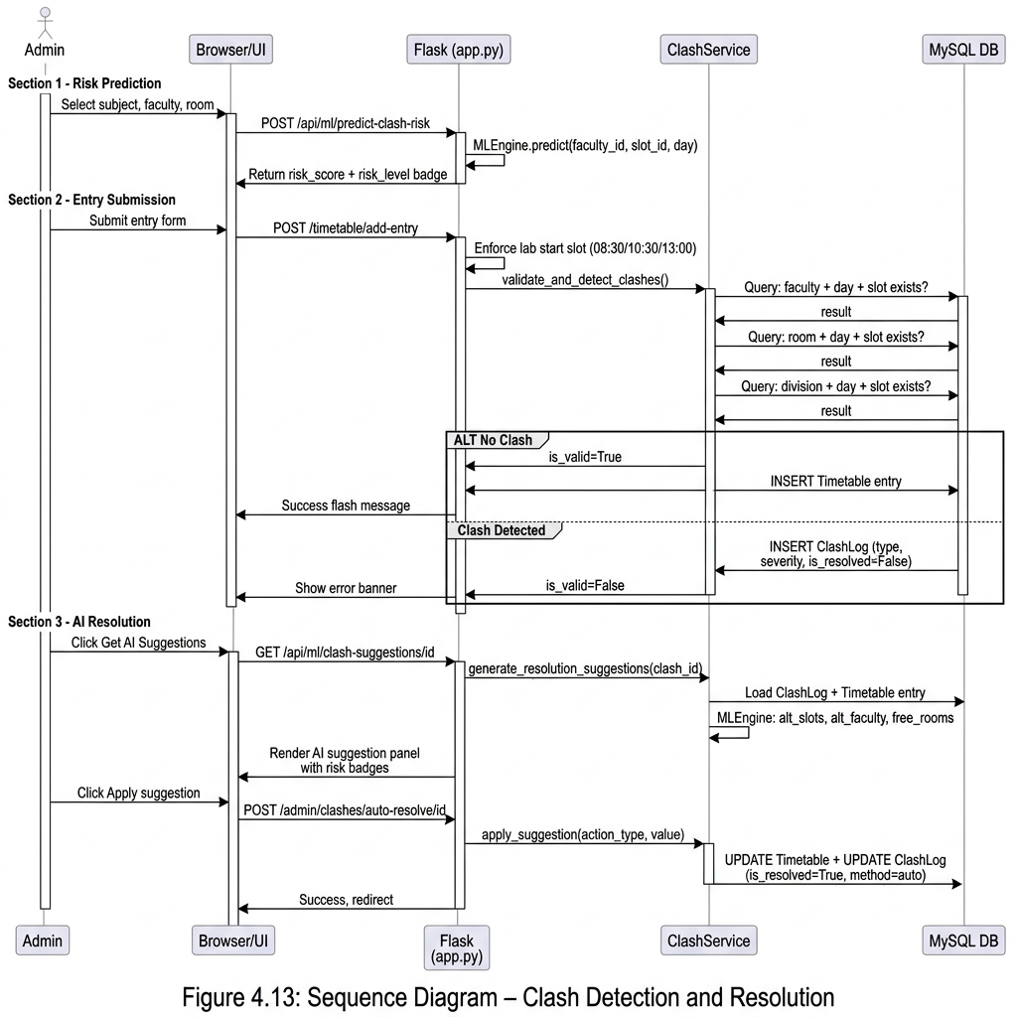

Figure 4.13: Sequence Diagram – Clash Detection and Resolution

Figure 4.14: Class Diagram

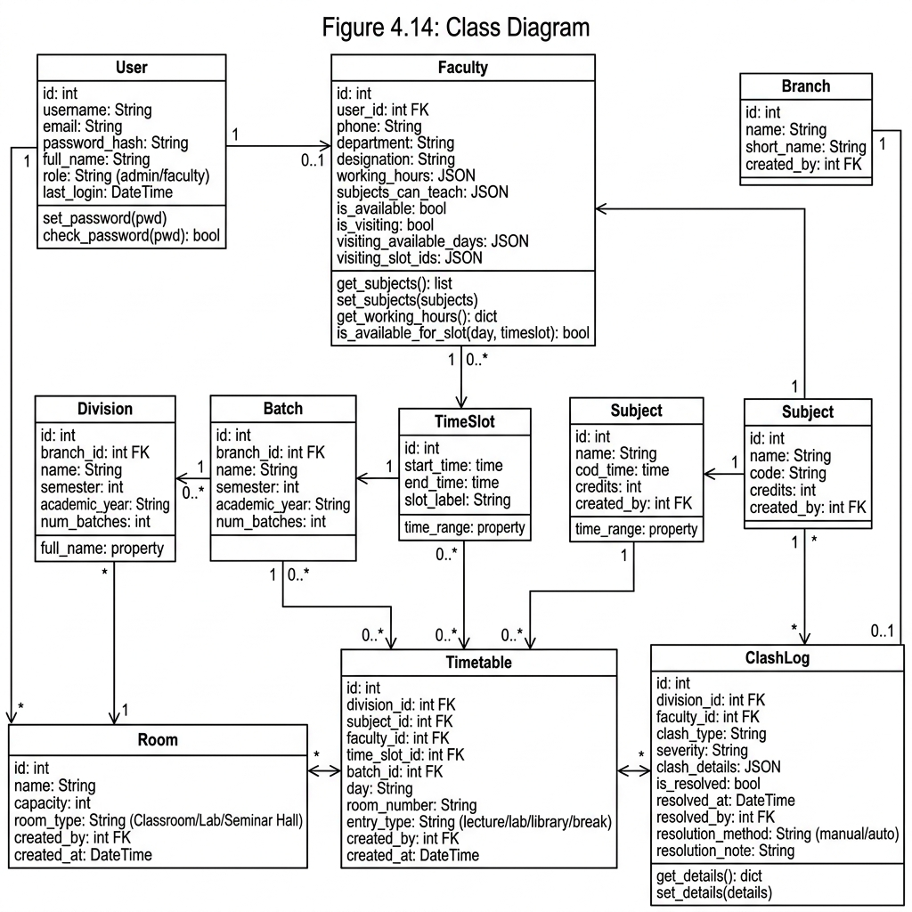

Figure 4.14: Class Diagram

Figure 4.15: Entity Relationship (ER) Diagram

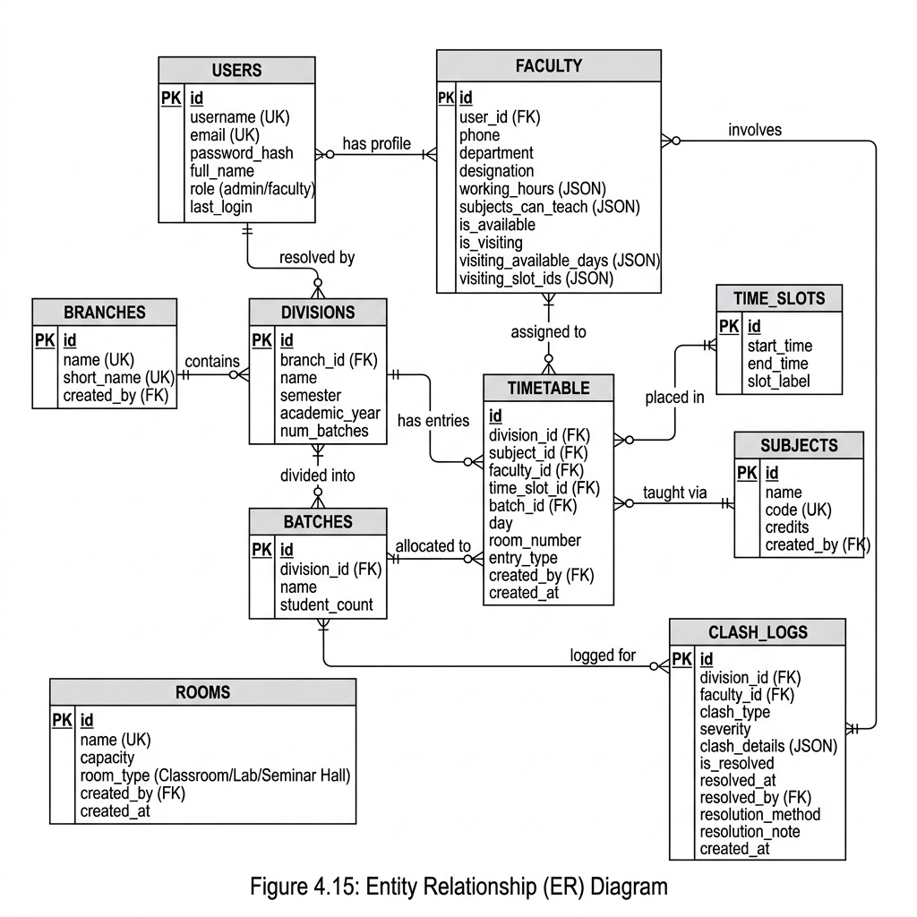

Figure 4.15: Entity Relationship (ER) Diagram

Figure 4.16: Component Diagram

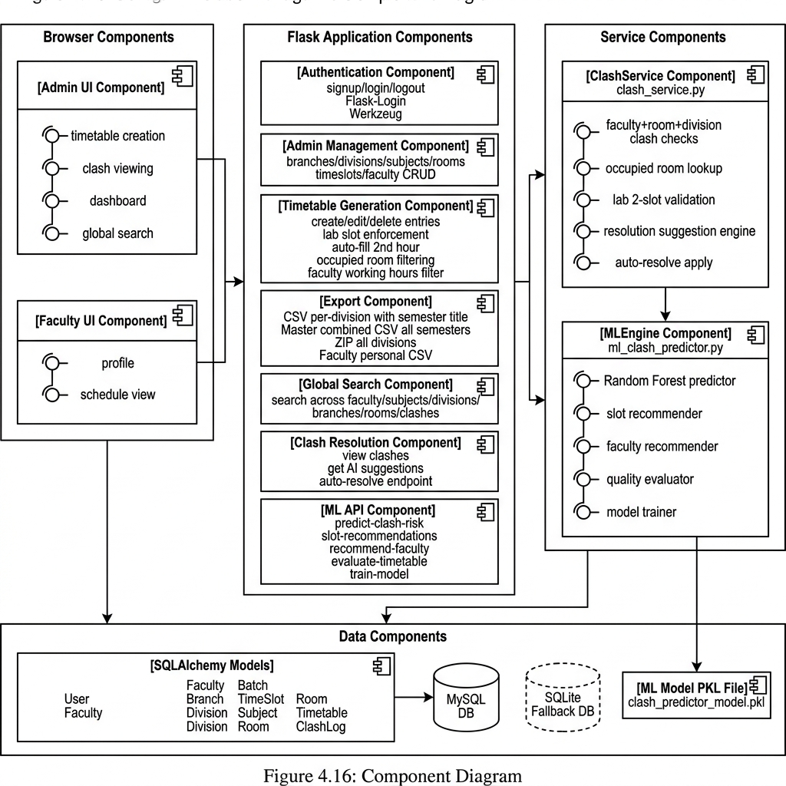

Figure 4.16: Component Diagram

Figure 4.17: Deployment Diagram

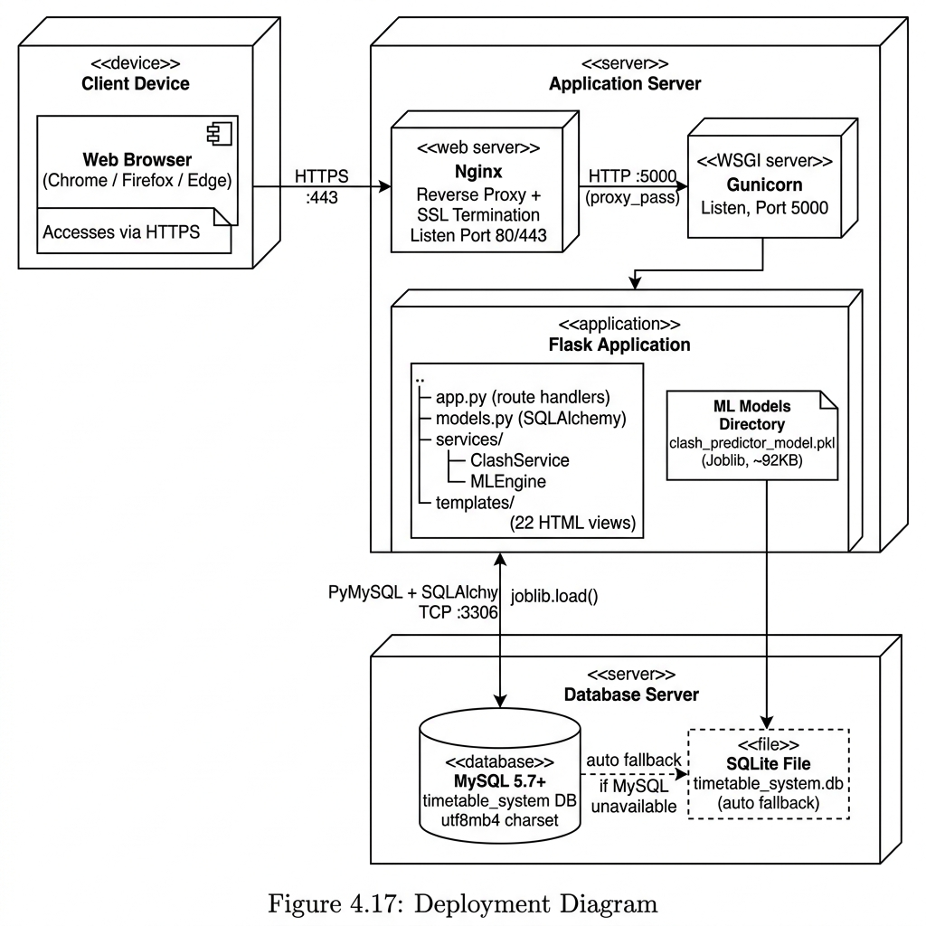

Figure 4.17: Deployment Diagram

Figure 4.18: Data Flow Diagram – Level 0

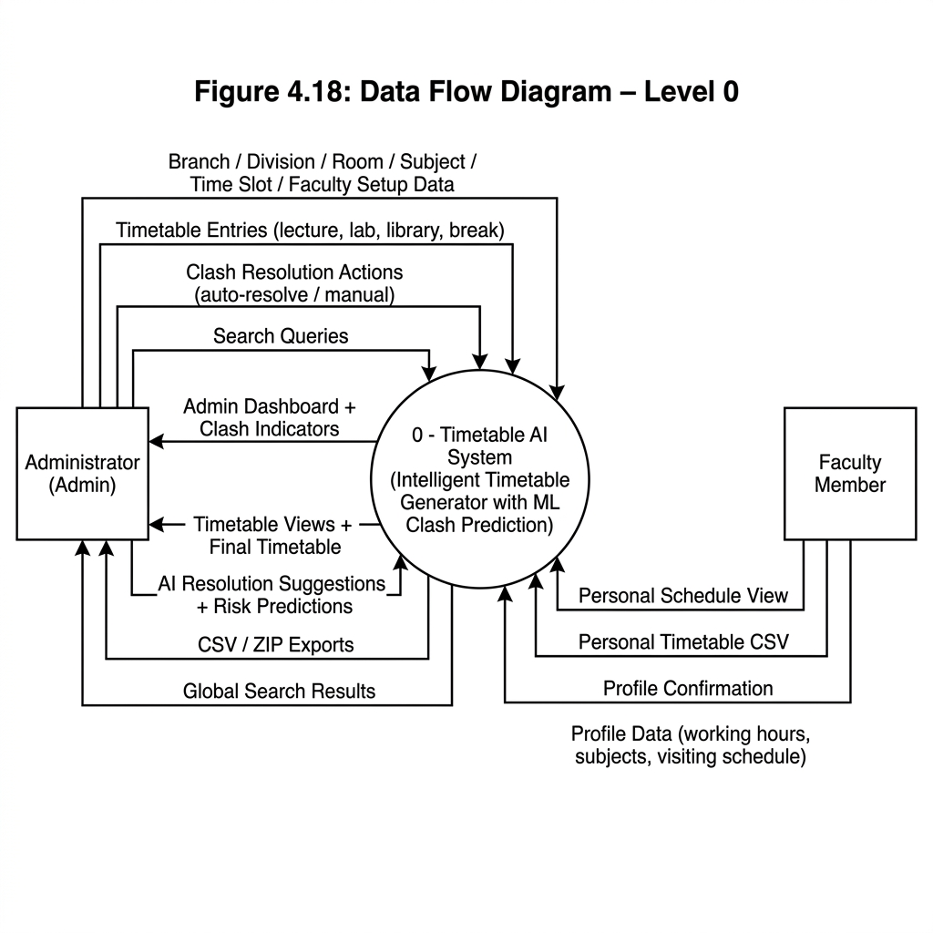

Figure 4.18: Data Flow Diagram – Level 0

Figure 4.19: Data Flow Diagram – Level 1

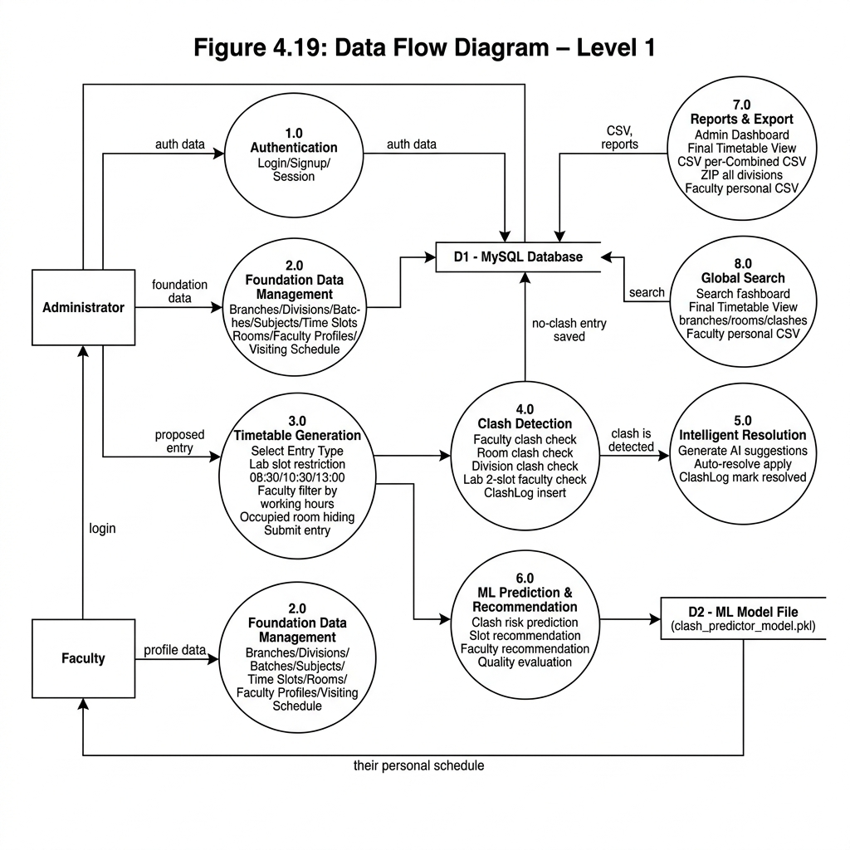

Figure 4.19: Data Flow Diagram – Level 1

Figure 4.20: Data Flow Diagram – Level 2

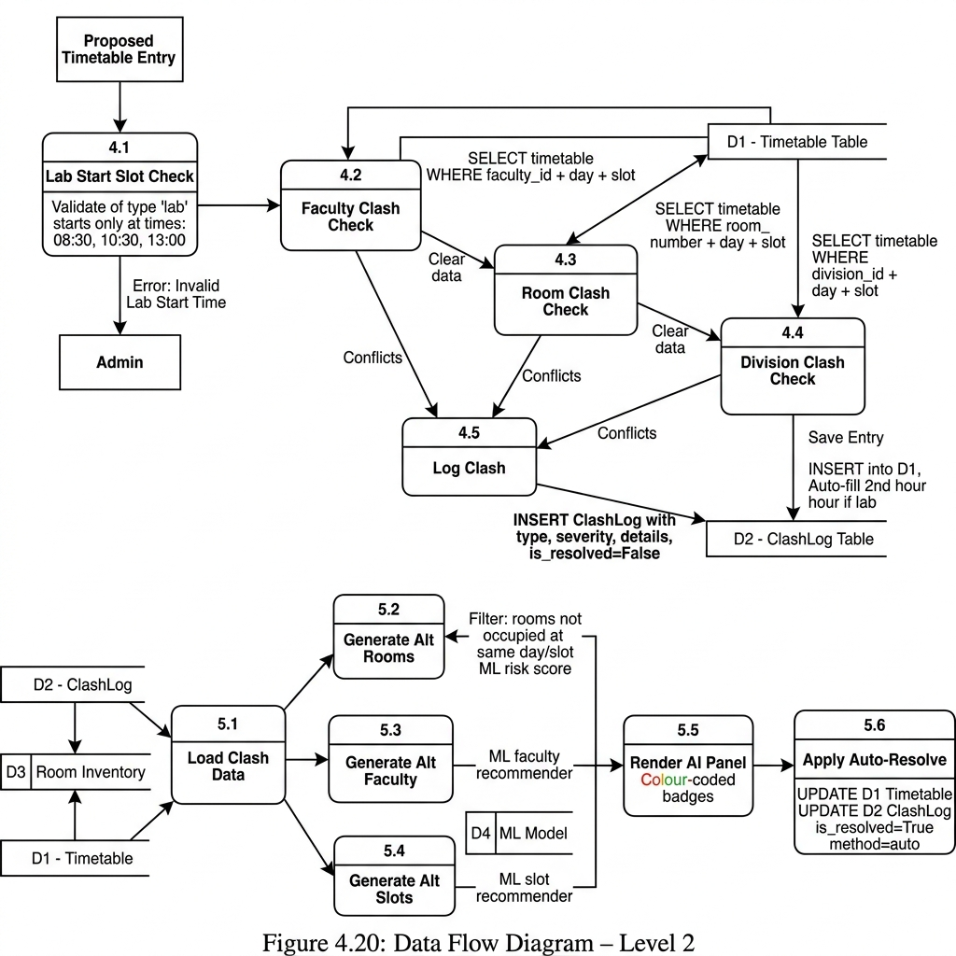

Figure 4.20: Data Flow Diagram – Level 2

