**Practical -1**

**Aim:** **Installation of WAMP/XAMP.**

**Solution:**

XAMPP:-

X-Cross Platform

A-Apache (Web Server)

M-Mysql/MariaDB (Database)

P-PHP (Server Side Scripting Language)

P-Perl (Server Side Scripting Language)

WAMPP:-

W-Windows

A-Apache (Web Server)

M-Mysql/MariaDB (Database)

P-PHP (Server Side Scripting Language)

P-Perl (Server Side Scripting Language)

**Step:1** Install the XAMPP file and run as administrator.

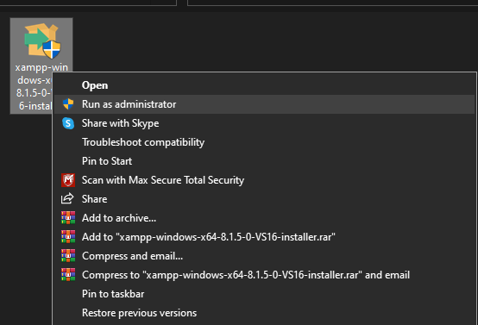

**Step:2** Click on “OK” button.

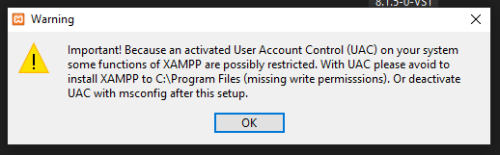

**Step:3**Click on “Next” button.

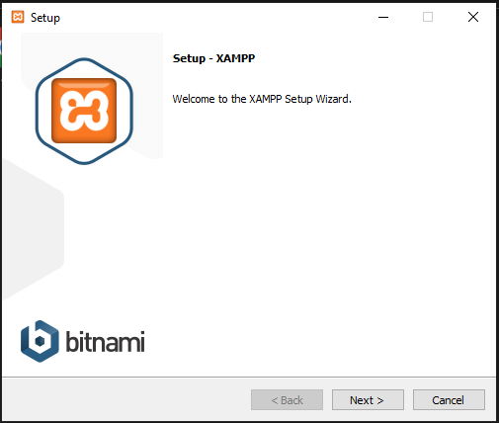

**Step:4** Select the component you want to install and click on “Next” button.

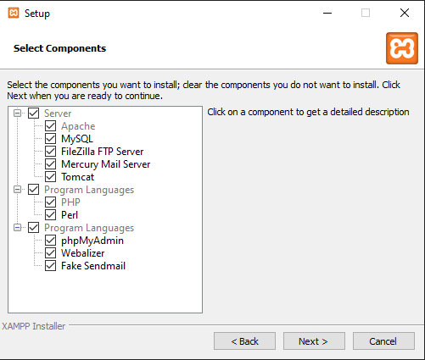

**Step:5** Browse the location and click on “Next” button.

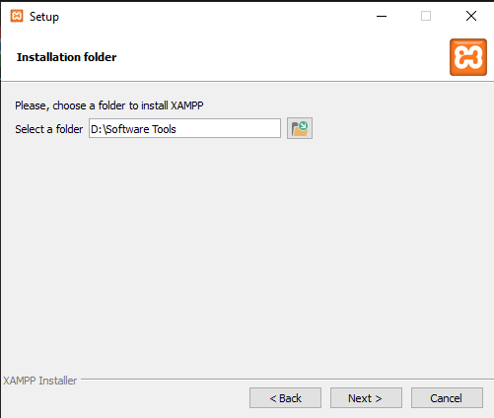

**Step:6** Select the language and click on “Next” button.

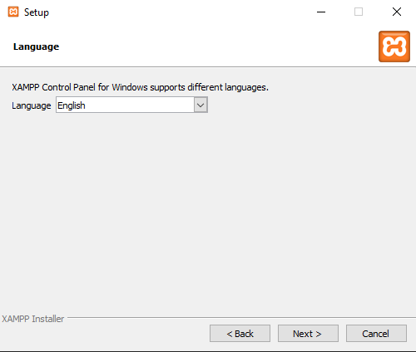

**Step:7** Click on “Next” button.

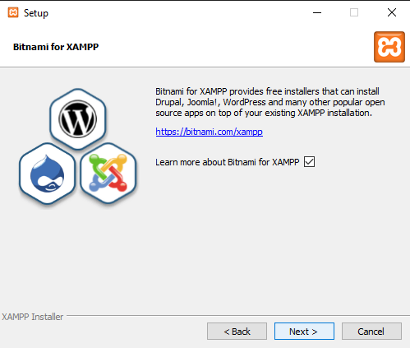

**Step:8** Click on “Next” button.

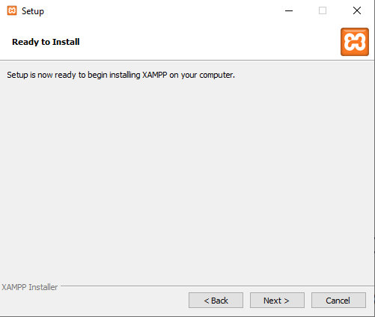

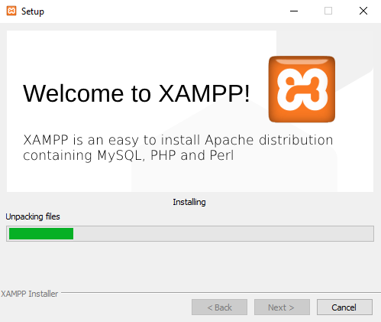

**Step:9** Click on “Finish” button.

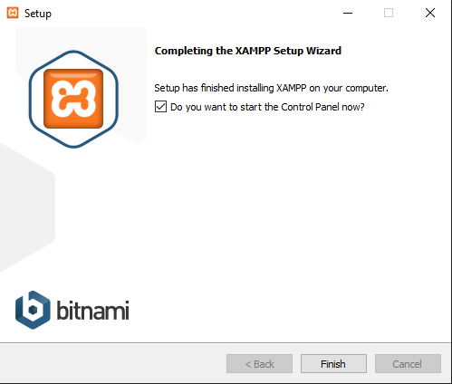

**Step:10** Click on “Start” button beside Apache.

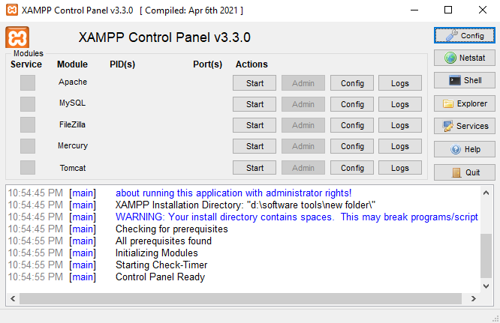

**Step:11** Click on “Allow access” button.

