**Practical -5**

**Aim: Write a program to do Array Operation in PHP.**

**Solution:**

<?php

$a=array(13,25,93,67,44);

echo print_r($a);

echo "<br>";

echo "Total no. of elements:";

echo count($a);

echo "<br>";

echo "Sum:";

echo array_sum($a);

echo "<br>";

echo "Reverse Array:";

echo print_r(array_reverse($a));

echo "<br>";

?>

**OUTPUT:**

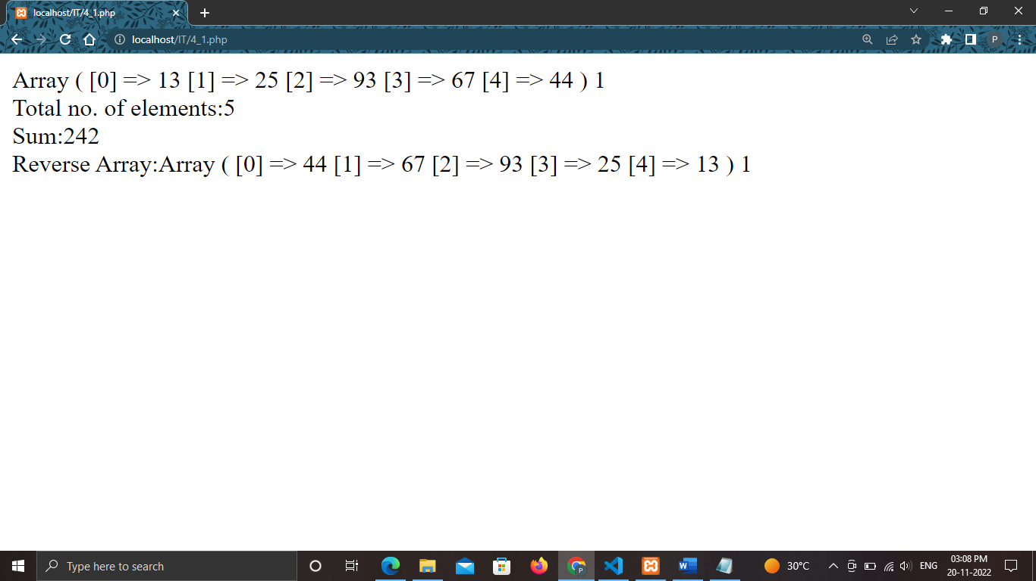

<?php

$a=array("Krish","Diya","Shreya");

print_r($a);

echo "<br>";

echo "Shuffled array: ";

shuffle($a);

print_r($a);

echo "<br>";

echo "Each :";

print_r(each($a));

echo "<br>";

echo "Next : ";

echo next($a);

echo "<br>";

echo "Previous : ";

echo prev($a);

echo "<br>";

echo "Reset : ";

echo reset($a);

echo "<br>";

echo "End : ";

echo end($a);

echo "<br>";

echo "Current : ";

echo current($a);

echo "<br>";

sort($a);

echo "Sorting : ";

print_r($a);

echo "<br>";

rsort($a);

echo "Reverse Sorting : ";

print_r($a);

?>

**OUTPUT:**

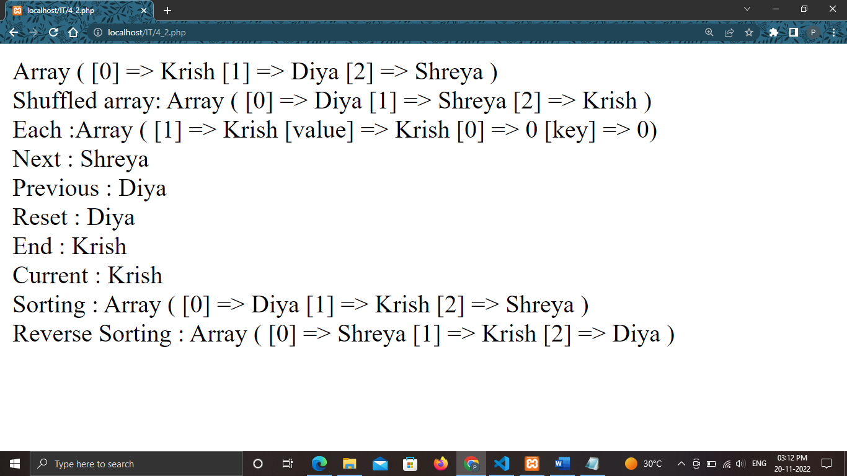

<?php

$a=array("Krish","Diya","Shreya");

$b=array("CSE","IT","BBA","CSE");

print_r($a);

echo "<br>";

print_r($b);

echo "<br>";

array_push($a,"Herin");

echo "After Pushing an element: ";

print_r($a);

echo "<br>";

array_pop($a);

echo "After Poping an element: ";

print_r($a);

echo "<br>";

echo "Unique element of Array: ";

print_r(array_unique($b));

echo "<br>";

echo "Merging of two Array: ";

print_r(array_merge($a,$b));

?>

**OUTPUT:**

