**Practical - 6**

**Aim: File handling using PHP.**

**Solution:**

<?php

$myfile=fopen("5.txt","w") or die("Unable to open the file!");

$a="PHP originally stood for Personal Home Page.<br>";

fwrite($myfile,$a);

echo readfile("5.txt");

fclose($myfile);

?>

**OUTPUT:**

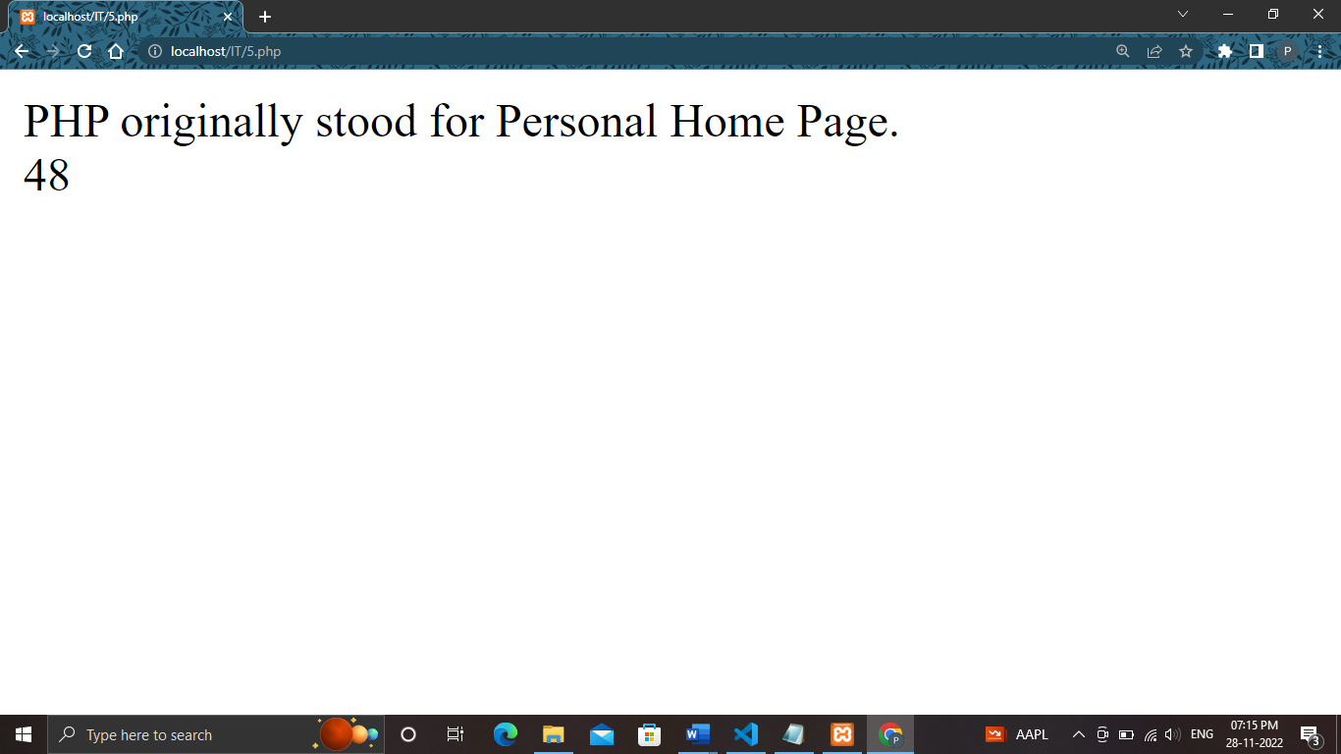

**WORD FILE:**

