**Practical - 7**

**Aim: Write simple PHP program to :-**

**a) Set cookies and read it.**

**b) Demonstrate session management.**

**Solution:**

**a)**

<?php

$cookie_name = "user";

$cookie_value = "Krish";

setcookie($cookie_name, $cookie_value, time() + 1, "/");

?>

<html>

<body>

<?php

if(!isset($_COOKIE[$cookie_name]))

{

echo "Cookie named '" . $cookie_name . "' is not set!";

}

else

{

echo "Cookie '" . $cookie_name . "' is set!<br>";

echo "Value is: " . $_COOKIE[$cookie_name];

}

?>

<p><strong>Note:</strong> You might have to reload the page to see the value of the cookie.</p>

</body>

</html>

**OUTPUT:**

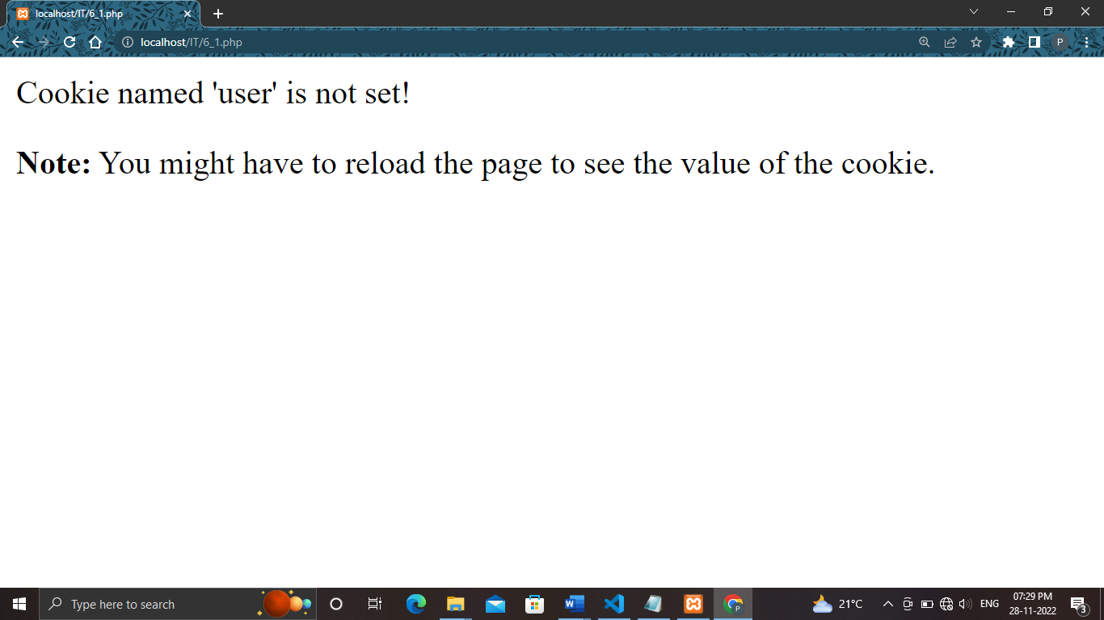

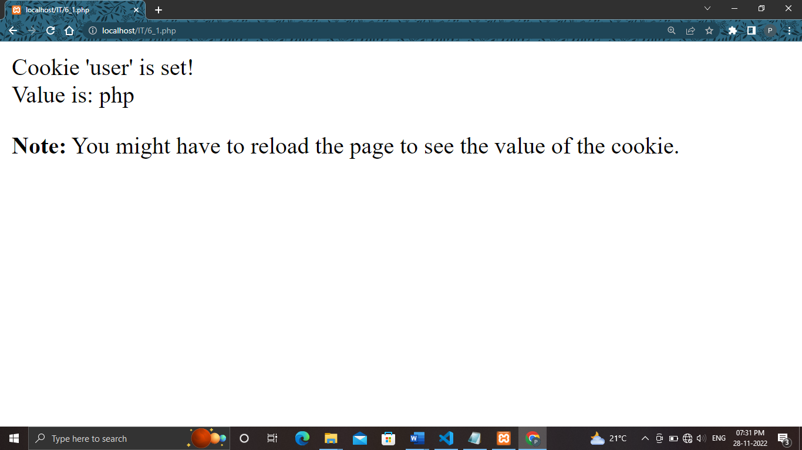

**b)**

<?php

session_start();

?>

<html>

<body>

<?php

$_SESSION["favcolor"] = "blue";

$_SESSION["favnum"] = "1322";

print_r($_SESSION);

echo "<br>Session variables are set.";

?>

</body>

</html>

**OUTPUT:**

