**VISVESVARAYA TECHNOLOGICAL UNIVERSITY, BELGAVI 590018**



Project Phase 1Report on

**“BMSCE Discussion Forum”**

By

Krishna T (1BM17CS042)

Kedar Shenoy(1BM17CSCS041)

Kratharth Hegde(1BM17CS035)

Under the Guidance of

**Nandhini Vineeth**

Assistant Professor, Department of CSE

BMS College of Engineering

Work carried out at



Department of Computer Science and Engineering

BMS College of Engineering

(Autonomous college under VTU)

P.O. Box No.: 1908, Bull Temple Road, Bangalore-560 019,2018-2019.

2018-2019

**BMS College of EngineerinG**

**DEPARTMENT OF COMPUTER SCIENCE AND ENGINEERING**



***CERTIFICATE***

This is to certify that the website development titled “BMSCE Discussion Forum” has been carried out by Krishna T (1BM17CS042), Kedar Shenoy(1BM17CS041), Kratharth Hegde(1BM17CS035) during the academic year 2018-2019.

Signature of the guide

**Nandhini Vineeth**

Assistant Professor

Department of Computer Science and Engineering

BMS College of Engineering, Bangalore

**BMS College of EngineerinG**

**DEPARTMENT OF COMPUTER SCIENCE AND ENGINEERING**



***DECLARATION***

We, Krishna T (1BM17CS042), Kedar Shenoy(1BM17CS041), Kratharth Hegde(1BM16CS035),students of 3rd Semester, B.E, Department of Computer Science and Engineering, BMS College of Engineering, Bangalore, hereby declare that, this website development work entitled "BMSCE Discussion Forum" has been carried out by us under the guidance of Nandhini Vineeth, Assistant Professor, Department of CSE, BMS College of Engineering, Bangalore during the academic semester Aug-Dec 2018.

We also declare that to the best of our knowledge and belief, the development reported here is not from part of any other report by any other students.

Signature

Krishna T (1BM17CS042)

Kedar Shenoy(1BM17CS041)

Kratharth Hegde (1BM17CS035)

1. Introduction

Website development for “BMSCE Discussion Forum”.

This online system supports following users

a. Students of BMSCE.

**Functionalities under Student login:**

1. Login of Students into their account with their USN and password.

**Functionalities under Student Signup:**

1. Can Register for the website through an online application form which contain the following fields:
2. Name
3. USN
4. Email-Id
5. Password
6. Re-enter Password
7. Department
8. Year.

**Functionalities under Home Page:**

1. Display
2. User’s basic information.
3. User’s interests.
4. Display the questions
5. Asked on the website pertaining to his interests (By Default).
6. Display the questions on the topic as chosen by the browser user.
7. Provision to post a question on the topic of his choice.
8. Provision to answer any question.
9. The user is enabled to see all the answers of a question.
10. Provision to comment on any of the answers.
11. Provision to report a question or an answer if the content is found to be inappropriate.

**Functionalities under Profile Page:**

1. Display of the user’s basic information.
2. A List of all his interests.
3. Display all the Questions asked by him along with the answers to that question and comments to those answers.
4. List of all the Questions answered by him.

**Functionalities under Settings Page:**

1. Provision for the user to change/update:
2. Year of study.
3. Department.
4. Location.
5. Topics of Interest.
6. Profile Picture.
7. Password.
8. Provision to Delete the account.

**All the pages mentioned above have a common navigation bar which comprises of:**

1. Home Tab.
2. A Profile Tab with:
3. A link to Profile page.
4. A link to settings page.
5. A button to Logout.

**2. Webpage Screen shots**

2.1 Login page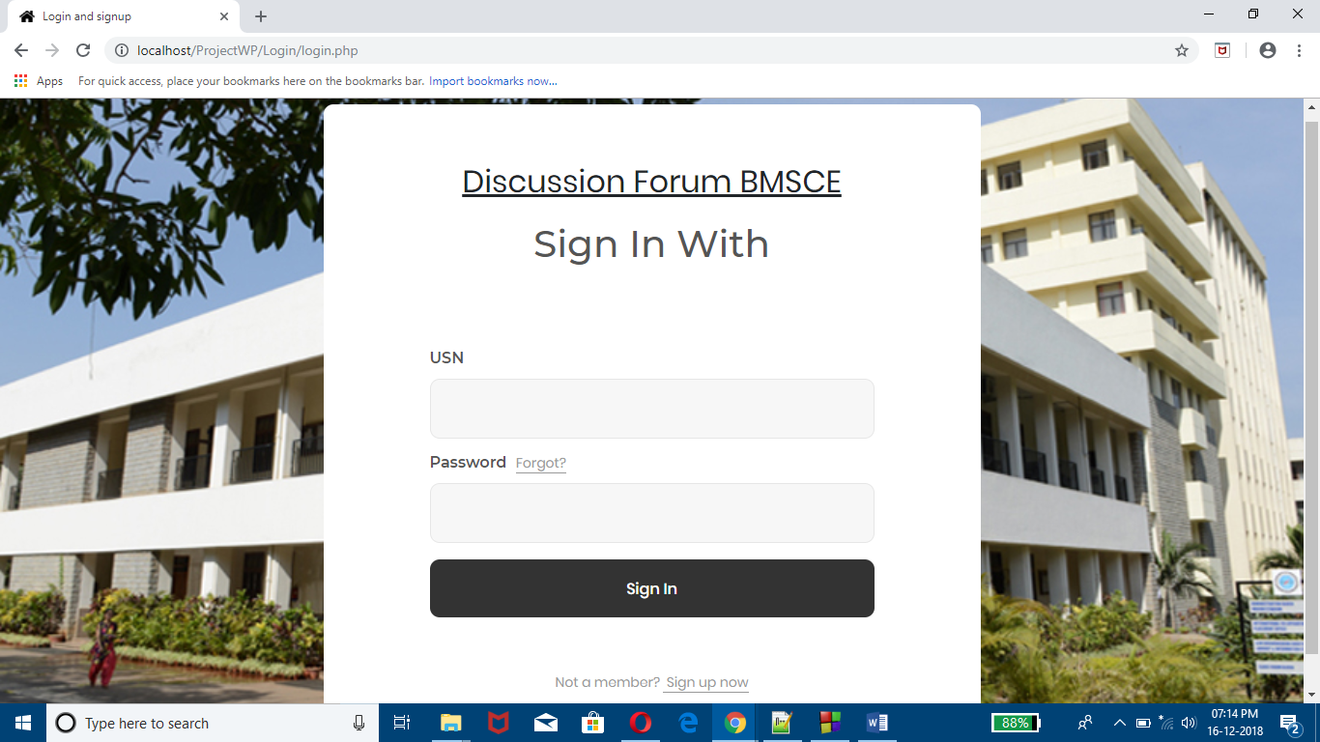

* 1. Sign-up Page

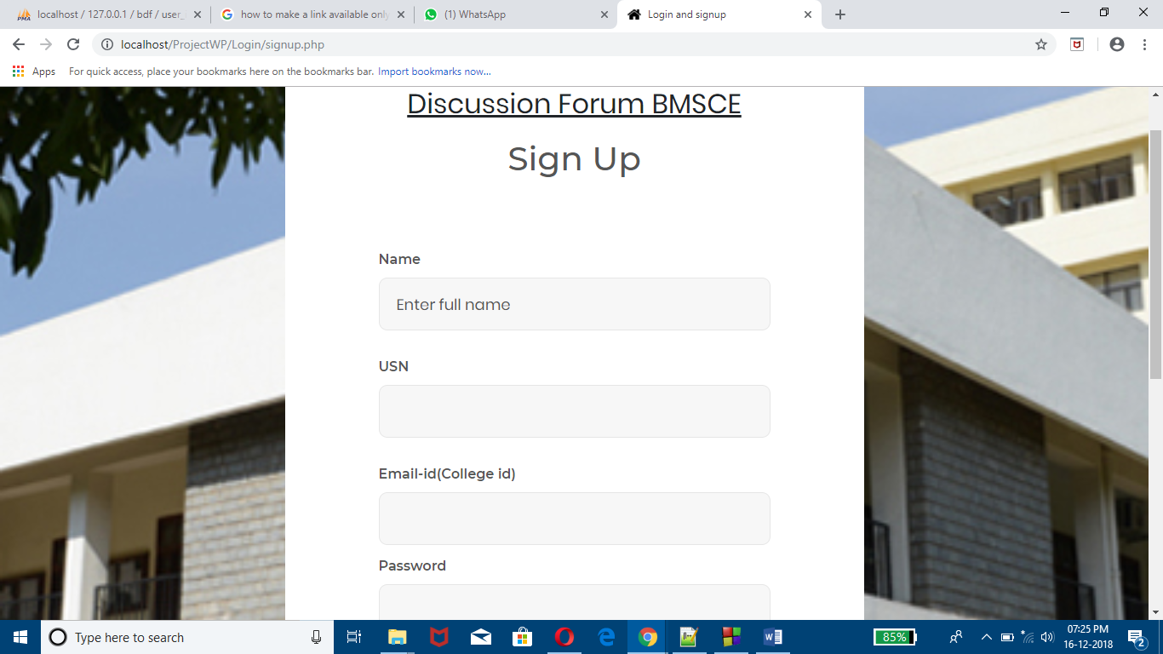

2.3. Home Page

2.4. Profile Page

2.5. Settings Page

3. Database Table Screen shots

Login Database Table: Description

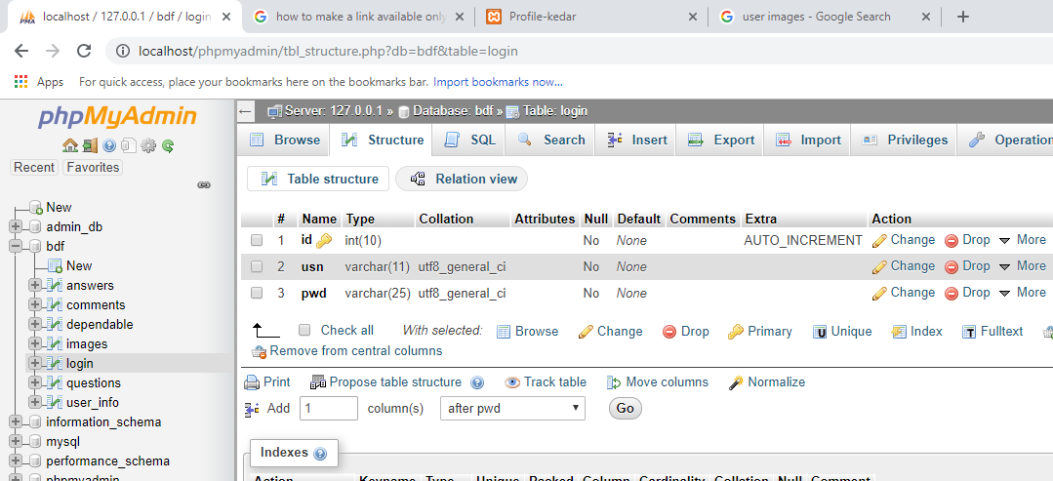

Login Database Table: Data

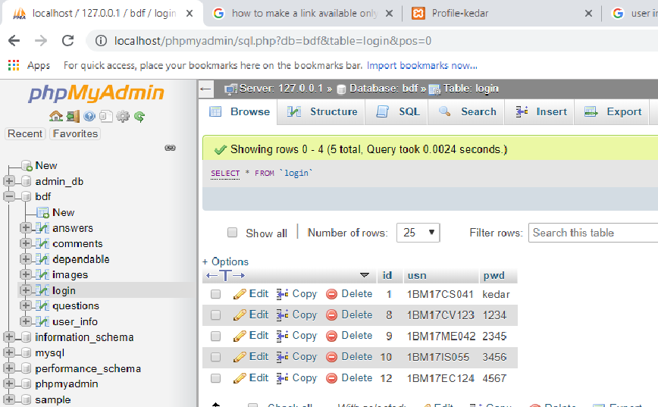

User Info Database Table: Description

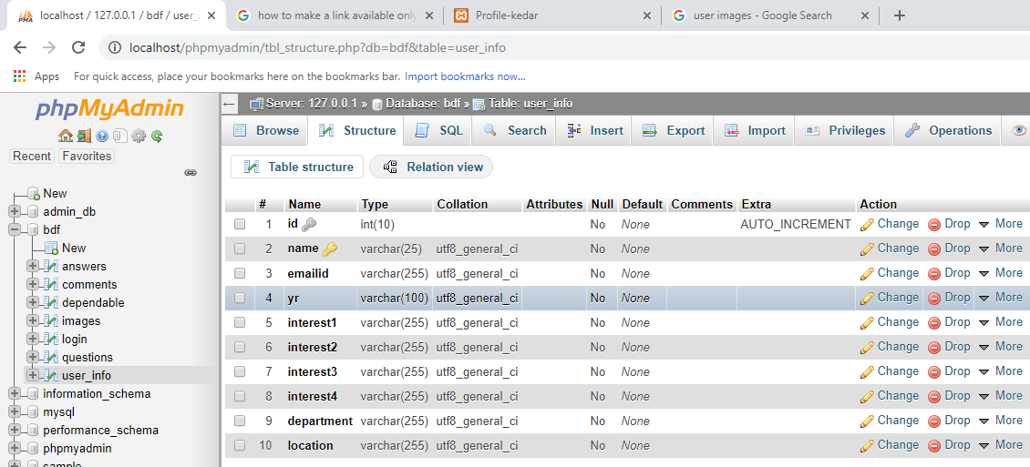

User Info Users Database Table: Data

