PERSONAL FINANCE TRACKER
WEB APPLICATION
By
Krisjor Mema
Dr. (c). Alda Myzeqari
A THESIS
Submitted to
KOLEGJI UNIVERSITAR “Instituti Kanadez i Teknologjisë”
University College “CANADIAN INSTITUTE OF TECHNOLOGY”
Faculty of Engineering
Department of Software Engineering
In partial fulfillment of the requirements for the degree of:
Bachelor of Science in Computer Science
Submitted on July 15th, 2026

Copyright Page
© 2026 Krisjor Mema. All rights reserved.

Approved:

_________________________________________
Dr. (c). Alda Myzeqari, Thesis Advisor

_________________________________________
Head of Department

I understand that my thesis will become part of the collection of Canadian Institute of Technology. My signature below authorizes release of my thesis to any reader upon request. I also affirm that the work represented in this thesis is my own work.

___________________________
Krisjor Mema, Author

MIT License

Copyright (c) 2026 Krisjor Mema

Permission is hereby granted, free of charge, to any person obtaining a copy
of this software and associated documentation files (the "Software"), to deal
in the Software without restriction, including without limitation the rights
to use, copy, modify, merge, publish, distribute, sublicense, and/or sell
copies of the Software, and to permit persons to whom the Software is
furnished to do so, subject to the following conditions:

The above copyright notice and this permission notice shall be included in all
copies or substantial portions of the Software.

THE SOFTWARE IS PROVIDED "AS IS", WITHOUT WARRANTY OF ANY KIND, EXPRESS OR IMPLIED, INCLUDING BUT NOT LIMITED TO THE WARRANTIES OF MERCHANTABILITY, FITNESS FOR A PARTICULAR PURPOSE AND NONINFRINGEMENT. IN NO EVENT SHALL THE AUTHORS OR COPYRIGHT HOLDERS BE LIABLE FOR ANY CLAIM, DAMAGES OR OTHER LIABILITY, WHETHER IN AN ACTION OF CONTRACT, TORT OR OTHERWISE, ARISING FROM, OUT OF OR IN CONNECTION WITH THE SOFTWARE OR THE USE OR OTHER DEALINGS IN THE SOFTWARE.

Abstract
Title of thesis: Personal Finance Tracker Web Application
Abstract: Most people track their personal finances with a spreadsheet or not at all, and the dedicated software that exists serves an Albanian user poorly. Commercial cloud services do not support local banks, bill in foreign currency and require sending financial data abroad, while open-source self-hosted alternatives demand more system-administration skill than most users have. The rationale for this work is that gap: no self-hostable, multi-currency personal finance application is fitted to the Albanian banking context. This thesis presents Vault, a web application designed, built and evaluated to fill it. The project follows a design-science methodology: a three-tier system (a React 18 single-page frontend, a Flask 3 REST API and a PostgreSQL 15 database, deployed with Docker Compose) was constructed against six measurable objectives, then evaluated with a reproducible seeded ninety-day dataset of roughly 150 transactions, an automated test suite, and response-time measurements across the API. The system covers accounts, transactions, categorisation, budgeting, savings goals and analytical reporting, supports five currencies, and imports CSV bank statements from four major Albanian retail banks through a generic two-phase pipeline with SHA-256 deduplication and no per-bank parser code. All sixteen automated tests pass, including five dedicated importer tests and a cross-user isolation test. At demonstration scale, ordinary interactive API endpoints measured below one hundred milliseconds, while login and CSV import were slower because of bcrypt verification and row-processing workload. The evaluation supports the feasibility of a self-hosted, multi-currency personal finance tool tailored to the Albanian context within the tested scope; broader usability, security and scalability evaluation remains future work.
Keywords: personal finance management; web application; REST API; React; Flask; PostgreSQL; multi-currency; budgeting; self-hosted; Albania.

Acknowledgment
I thank my advisor, Dr. (c). Alda Myzeqari, for her guidance throughout this project, and in particular for asking the difficult questions early, when there was still time to do something about the answers.
This project stands on a tall stack of open-source software: Flask, React, PostgreSQL, SQLAlchemy and many smaller libraries. The people who build and maintain these tools, mostly unpaid, made the whole thing possible.
Finally, my family, for patience during the months when the only thing I wanted to talk about was a budgeting application.

Table of Contents
Copyright Page i
Abstract i
Acknowledgment i
Table of Contents i
List of Figures and Tables i
List of Appendices i
List of Abbreviations i
Chapter I: Introduction 1
I.1 Background 1
I.2 Research Problem 1
I.3 Research Questions 1
I.4 Objectives 1
I.5 Scope and Limitations 1
I.5.1 Scope 1
I.5.2 Limitations 1
I.6 Significance 1
I.7 Chapter Summary 1
Chapter II: Literature Review 1
II.1 Literature 1
II.1.1 Historical Development of PFM Software 1
II.1.2 The Canonical Functional Surface 1
II.1.3 Architectural and Security Foundations 1
II.1.4 Regional Context and Open Banking 1
II.2 Comparative Analysis of Existing Systems 1
II.3 Research Gap 1
II.4 Chapter Summary 1
Chapter III: Methodology 1
III.1 Research Design 1
III.2 Data and Datasets 1
III.2.1 Secondary Data 1
III.2.2 Primary Data — Demonstration Dataset 1
III.2.3 Primary Data — Bank Statement Format Samples 1
III.2.4 Reproducibility of the Data 1
III.3 Tools and Technologies 1
III.3.1 Justifying the Stack as a Whole 1
III.3.2 Alternatives Considered at the Tool Level 1
III.4 Evaluation Metrics 1
III.4.1 Justifying the Metric Choices 1
III.5 Chapter Summary 1
Chapter IV: System Design and Architecture 1
IV.1 Architectural Overview 1
IV.2 Entity-Relationship Model 1
IV.3 Use Case Overview 1
IV.4 Sequence Diagrams 1
IV.4.1 Authentication Flow 1
IV.4.2 CSV Import Pipeline 1
IV.5 Technology Stack and Design Decisions 1
IV.6 Chapter Summary 1
Chapter V: Implementation 1
V.1 Development Environment Setup 1
V.2 Backend Code Organisation 1
V.3 Database Implementation 1
V.4 API Layer 1
V.5 Frontend Implementation 1
V.5.1 Dashboard Screen 1
V.5.2 Transactions Screen 1
V.5.3 Budgets and Goals Screens 1
V.6 Testing 1
V.7 Chapter Summary 1
Chapter VI: Evaluation and Results 1
VI.1 Experimental Setup 1
VI.1.1 Hardware and Software Environment 1
VI.1.2 Test Database 1
VI.1.3 Baselines 1
VI.2 Results 1
VI.2.1 Functional Coverage 1
VI.2.2 Correctness via Automated Testing 1
VI.2.3 Performance Characterisation 1
VI.3 Discussion 1
VI.3.1 Interpretation of the Results 1
VI.3.2 Connection to the Existing Literature 1
VI.3.3 Justifying the Major Design Decisions in Light of Results 1
VI.4 Threats to Validity 1
VI.4.1 Internal Validity 1
VI.4.2 External Validity 1
VI.4.3 Construct Validity 1
VI.4.4 Reliability 1
VI.5 Chapter Summary 1
Chapter VII: Conclusions and Future Work 1
VII.1 Conclusions 1
VII.2 Future Work 1
Bibliography 1
Appendix A: Source Code Repository 1
Appendix B: Demonstration Dataset 1
Appendix C: Detailed Test Results 1
Appendix D: Installation Guide 1

List of Figures and Tables
Figures
Figure 4.1 System architecture (three-tier) 18
Figure 4.2 Entity-relationship diagram 19
Figure 4.3 Use case overview 20
Figure 4.4 Sequence diagram — user login and JWT issuance 21
Figure 4.5 Sequence diagram — CSV import pipeline 22
Figure 5.1 Application-factory pattern in the Flask backend 26
Figure 5.2 React component hierarchy 30
Figure 5.3 Dashboard screen 31
Figure 5.4 Transactions screen with date grouping 32
Figure 5.5 Budgets screen with progress indicators 33
Figure 6.1 Automated test results by file 37

Tables
Table 2.1 Comparative analysis of existing PFM systems 8
Table 3.1 Tools and technologies used in the implementation 14
Table 3.2 Evaluation metrics by category 16
Table 4.1 Design decisions, alternatives, and chosen approaches 23
Table 5.1 API endpoint surface by resource 28
Table 5.2 Database tables and their cardinality 27
Table 6.1 Automated test results 37
Table 6.2 Endpoint response-time characterisation 38
Table 6.3 Feature-to-objective traceability matrix 36

List of Appendices
Appendix A Source Code Repository 49
Appendix B Demonstration Dataset 50
Appendix C Detailed Test Results 51
Appendix D Installation Guide 52

List of Abbreviations
Abbreviation | Expansion
API | Application Programming Interface
BCP-47 | Best Current Practice 47 (IETF locale identifier standard)
CRUD | Create, Read, Update, Delete
CSV | Comma-Separated Values
ER | Entity-Relationship
HTTP(S) | Hypertext Transfer Protocol (Secure)
JSON | JavaScript Object Notation
JWT | JSON Web Token
ORM | Object-Relational Mapping
OWASP | Open Worldwide Application Security Project
PFM | Personal Finance Management
PSD2 | Payment Services Directive 2 (European Union)
REST | Representational State Transfer
RFC | Request for Comments (IETF specification series)
SPA | Single-Page Application
SQL | Structured Query Language
UI / UX | User Interface / User Experience
WSGI | Web Server Gateway Interface

Chapter I: Introduction

I.1 Background
Everyone who earns and spends money manages it somehow. The question is with what. Field studies of how people actually track their money find a patchwork of spreadsheets, paper notes, mental arithmetic and glances at a banking app rather than dedicated tools [1]. Dedicated personal finance management (PFM) software remains a minority habit: when Intuit announced the shutdown of Mint in late 2023, the genre's best-known product counted roughly 3.6 million monthly active users, a small fraction of the market it nominally served [2].
The cost of weak tooling is that simple questions become hard. How much went to groceries last month. Whether a savings goal is on track. Which subscriptions quietly renew every month. What the net change in money was compared to the month before. None of these is exotic, and all of them feed real decisions: whether a large purchase is affordable, whether a budget needs cutting, whether saving is going as planned. Without a consolidated record, the answers are guesses. Broader research links financial literacy to saving, borrowing and long-term household financial outcomes; however, financial knowledge and day-to-day financial behaviour are not interchangeable [3], [29]. This distinction supports the value of tools that lower the practical cost of applying good financial practices.
Software for this domain is old. Quicken appeared in 1983 and Microsoft Money in 1991, both desktop programs working on local files. Mint moved the genre to the web in 2007 and was bought by Intuit two years later [4]. After that the field split in two directions: paid cloud subscriptions on one side (You Need A Budget, Monarch Money), and self-hosted open source on the other, with Firefly III as a well-established example [5]. Household-finance research frames these activities as linked decisions involving consumption, saving, borrowing and asset allocation [30]. Budgeting and categorisation can also be understood through the behavioural-finance concept of mental accounting, in which people organise money into distinct spending and saving categories [31]. What remains relevant to this thesis is the situation of a user with accounts at Albanian banks, spending mostly in lek with the occasional euro or dollar transaction, who is either unable or unwilling to hand a foreign company permanent read access to their bank account.

I.2 Research Problem
The problem this thesis addresses can be stated in one sentence: there is no identified self-hostable, multi-currency, Albanian-context-friendly personal finance application that covers the standard PFM use cases (accounts, transactions, categorisation, budgets, reports) and can be installed and run by someone who is not a system administrator.
In practice an Albanian user today has three options, and all of them cost something. Commercial cloud services may not support local banks, bill in foreign currency, and require uploading financial data to a third party. Self-hosted alternatives like Firefly III are free and capable but come with a deployment learning curve that filters out most people [5]. Spreadsheets work for anything but are purpose-built for nothing; budgeting and reporting have to be reinvented by hand. None of the three handles the common local situation of a lek checking account next to a euro card and occasional dollar freelance income.
Leaving the problem unsolved has two effects. The region stays underserved by a category of software that exists, in adapted forms, almost everywhere else. And the users who do adopt the commercial tools end up transmitting sensitive financial records abroad, with the privacy implications that follow [6].

I.3 Research Questions
Three research questions guide the work:
- Which architecture and data model best support a self-hostable, multi-currency personal finance application aimed at the Albanian context?
- Can bank-statement CSV exports from different Albanian banks be imported correctly without writing a separate parser for every bank?
- What authentication and per-user isolation scheme is appropriate for a self-hosted PFM application within the scope of the evaluation, without introducing operational complexity the use case does not justify?

I.4 Objectives
The overall objective is to design, build and evaluate a complete web-based personal finance application that closes the gap described above. That breaks down into six specific objectives, each of which is checked against the finished system in Chapter VI:
- To design and implement a normalised relational data model covering the seven entities of personal finance — users, accounts, categories, tags, transactions, budgets, and goals — in third normal form.
- To implement a REST API with full create-read-update-delete (CRUD) coverage of the data model, stateless JSON Web Token (JWT) authentication, bcrypt password hashing, and per-user filtering enforced on every query.
- To implement analytical reporting (spending by category, monthly trends, top merchants, running net worth) with the aggregation done in the database and end-to-end response time under one hundred milliseconds at demonstration scale.
- To implement a single-page application (SPA) frontend in React with multi-currency support and a clean, readable visual design.
- To implement a generic CSV import pipeline that can ingest statement exports from at least four major Albanian retail banks selected purposively, without per-bank parser code, with SHA-256 deduplication.
- To validate the result with a sixteen-case automated test suite covering authentication, transaction integrity, CSV importer behaviour and cross-user data isolation.

I.5 Scope and Limitations

I.5.1 Scope
The system is designed for individual, self-hosted personal use. Within scope:
- A complete three-tier web application: React SPA in the browser, Flask REST API, PostgreSQL database.
- Multi-currency support for the Albanian lek (ALL), euro (EUR), US dollar (USD), British pound (GBP) and Swiss franc (CHF).
- Six account types: checking, savings, credit card, cash, investment, loan.
- Three transaction types: income, expense, and transfer, the last implemented as a linked pair of records on the two accounts involved.
- A generic CSV importer that handles comma- and semicolon-delimited files, the common European and ISO date spellings (DD/MM/YYYY, DD.MM.YYYY, DD-MM-YYYY, YYYY-MM-DD, plus written-out forms like “15 Jan 2025”), and amounts in both European and US conventions, including accounting-style parentheses for negatives.

I.5.2 Limitations
The following are out of scope. Most of them return as future work in Chapter VII:
- Direct bank API integration. Albania has transposed the EU's PSD2 open-banking framework [7] into national law, but the resulting interfaces are reserved for providers licensed by the central bank, which a self-hosted personal application cannot be; data still enters the system through user-initiated CSV import. Section II.1.4 returns to this.
- Automatic exchange-rate lookup. The schema supports multiple currencies, but no rate feed is wired in; reports group by currency instead of converting.
- Receipt photos and optical character recognition.
- Investment portfolio tracking with market data.
- Tax preparation and any form of regulatory certification.
- Native mobile apps. The web frontend is responsive, but there is no separate iOS or Android client.
- Shared budgets for couples or households.

I.6 Significance
Practical contribution. The output is a working, documented application that an individual can deploy and other developers can extend. It is released as open source. The defaults are Albanian: the base currency is lek, the seeded categories match local spending patterns, and the CSV importer was designed against the statement exports of four major Albanian retail banks selected purposively. More broadly, the project is situated in a financial environment increasingly shaped by digital financial services [34] and financial-capability initiatives [35]. Based on the documentation review conducted for this thesis, no directly comparable open-source tool with the same stated orientation was identified.
Academic contribution. The thesis is also a documented case study of putting a modern web stack together at undergraduate scale: Flask, React, PostgreSQL, SQLAlchemy, JWT authentication and REST design in one coherent system, with the design reasoning written down. Students doing similar projects can use it as a reference for both the technical structure and the write-up.
Connection to the degree. The project pulls together material from across the curriculum: database design, web architecture, software engineering practice, security, and a measure of interface design. It is, in effect, an integration test of the degree.

I.7 Chapter Summary
This chapter set the context, stated the problem, and fixed three research questions and six objectives. The rest of the document follows the standard empirical structure. Chapter II reviews the existing PFM landscape and pins down the gap. Chapter III explains the methodology, data and tools. Chapter IV covers design and architecture, Chapter V the implementation, Chapter VI the evaluation. Chapter VII concludes and lists future work, followed by references and four appendices.

Chapter II: Literature Review

II.1 Literature
This chapter places the project in its context: the history and shape of PFM software, the architectural and security foundations the design rests on, and the regional banking situation that constrains it. The comparison table required by the thesis guide is in Section II.2, and the gap analysis follows it.

II.1.1 Historical Development of PFM Software
PFM software has gone through three generations. The first was desktop: Quicken (1983) and Microsoft Money (1991), single-user programs over local files. Their feature set — accounts, transactions, categories, reports — defined the genre, and later generations mostly inherited it; the same task list appears in personal-finance textbooks decades on [8]. The second generation moved to the web; Mint was the flagship [4], adding cloud sync, account aggregation through screen-scraping intermediaries, and a freemium model funded by financial product recommendations. The third generation split. On the commercial side, subscriptions consolidated around YNAB and Monarch Money, and Intuit shut Mint down in early 2024 [9], pushing its users toward its Credit Karma product. On the open-source side, self-hosted tools appeared in response, with Firefly III as the most mature [5].

II.1.2 The Canonical Functional Surface
Across all three generations, what the software actually does has barely moved. The genre's functional core matches what personal-finance texts have prescribed for decades [8]: account tracking, transaction recording, categorisation, budgeting, and reporting, and the same five functions recur across every product compared in Section II.2. That stability is useful: it gives a clear definition of feature-complete for a new system in this genre. Vault implements all five and adds two more that have become standard in recent products, savings goals and CSV statement import.

II.1.3 Architectural and Security Foundations
The architectural backbone is the three-tier model, described in detail by Eckerson [10]: presentation, application logic, and data, developed and deployed separately. The split buys three things — independent development of each tier, independent scaling, and a natural seam for swapping implementations. For the API style, Fielding's REST [11] is the obvious choice; its constraints (uniform interface, statelessness, client-server separation) are exactly what makes an HTTP API predictable and easy to evolve. On the data side, Codd's relational model [12] and the normal forms that grew out of it tell you how to lay out tables so that updates do not corrupt and redundancy does not accumulate.
For security, the stack is based on established components and practices. JSON Web Tokens, specified in RFC 7519 [13], carry signed authentication claims that the client presents with every request, while RFC 8725 documents best current practices and known pitfalls for deployed JWT-based systems [39]. Passwords are stored with bcrypt, the adaptive hashing scheme of Provos and Mazières [14]. OWASP currently prefers Argon2id for new password-storage implementations; bcrypt remains an acceptable legacy or fallback option where Argon2id or scrypt are not available, provided an appropriate work factor is used [15]. The implementation in this thesis therefore uses bcrypt as a pragmatic project-level choice rather than as a claim of universal best practice. Additional authentication and REST-security guidance was considered through OWASP [40], [41] and NIST [42].

II.1.4 Regional Context and Open Banking
One regulatory fact shapes the whole design. The EU's Payment Services Directive 2 (PSD2) has required standardised open-banking APIs across member states since 2018 [7], which is why PFM tools inside the EU can pull account data directly with the user's consent. Albania is not an EU member, but it transposed the directive through Law No. 55/2020 "On payment services" [17]. In November 2024, the Bank of Albania granted the country's first open-banking licence, and subsequent central-bank documentation describes the implementation context [43], [44]. Access to the resulting interfaces depends on the regulated open-banking framework, so a self-hosted personal application does not itself become a licensed third-party provider. The practical consequence for this project is that user-initiated statement import remains the realistic data path used in the implementation.

II.2 Comparative Analysis of Existing Systems
Table 2.1 compares four representative systems against what this thesis is trying to build. I reviewed each system's official documentation, feature pages and, where open, source code. The four were picked to span the axes that matter: commercial cloud against self-hosted open source, web against desktop, single-entry against double-entry bookkeeping, and direct bank integration against manual import.

Table 2.1 — Comparative analysis of existing personal finance management systems
System | Model | Multi-currency | Bank integration | Cost | Albanian fit
Mint [4], [9] | Cloud SaaS | Limited | Discontinued | Discontinued 2024 | No
YNAB [18] | Cloud SaaS | Yes | Direct import through supported providers/markets; file-based import also available | USD 14.99 / month | Partial
Firefly III [5] | Self-hosted PHP | Yes | Importer plugins | Free, open-source | Difficult
GnuCash [19] | Desktop, double-entry | Yes | Manual / OFX | Free, open-source | Difficult
Vault (this work) | Self-hosted Python/JS | Yes | Generic CSV importer | Free, open-source | Designed for

A few notes on each. Mint was discontinued in 2024 [9]. YNAB is a major commercial PFM product and supports direct import through market-dependent bank connections and import providers; its current European coverage includes selected countries, but Albania is not listed among the supported European countries [18]. It also supports file-based importing as an alternative to direct connection. Firefly III is the closest relative of this project [5]. It is a mature self-hosted system with multi-currency support, hierarchical categories, budgets and an importer. Its deployment documentation requires users to configure Docker, environment files, database setup and related infrastructure, which increases operational effort. Such operational effort is relevant to technology adoption because perceived usefulness, ease of use and effort expectancy are established determinants in technology-acceptance research [32], [33]. GnuCash [19] implements proper double-entry bookkeeping, the system Pacioli described in 1494 [20]. Rigorous, but for users focused primarily on personal spending, it introduces accounting concepts beyond the narrower scope of this project.

II.3 Research Gap
Reading the four comparable systems together, the gap appears along four lines.
Regional availability. Direct bank integration, the headline feature of the cloud products, still does not function for this market: none of the commercial services covers Albanian banks, and the young domestic open-banking framework [7], [17] admits only providers licensed by the central bank, not consumer tools. A tool for this market has to treat CSV import as the primary path, not a fallback.
Multi-currency semantics. Many systems claim multi-currency, but they mean different things by it. Some convert everything to a base currency the moment a transaction is stored. Some store native amounts but force a conversion when aggregating. Very few keep each amount in its own currency end to end and group reports by currency. That last model is the honest one for someone who genuinely lives in two or three currencies, and it is the one the dominant products serve worst [4], [18].
Operational complexity. The self-hosted segment assumes a technical operator. Firefly III is the clearest example in the comparison [5]. The gap between its capabilities and the practical effort required to configure and maintain a self-hosted deployment is relevant to perceived ease of use and effort expectancy in technology-acceptance research [32], [33]. This project therefore treats deployment simplicity as a design consideration rather than a claim about actual adoption behaviour.
Localisation. Existing tools often translate their interfaces without fully adapting their assumptions. Default categories, expected merchants and statement formats can reflect North American or Northern European usage patterns. For this thesis, localisation therefore means adapting defaults, categories and statement-handling assumptions to Albanian usage, while full interface translation remains future work.
Vault aims at the intersection: the simplicity of the consumer products, the ownership and multi-currency honesty of the self-hosted ones, and defaults built for the Albanian banking reality.

II.4 Chapter Summary
The PFM genre is functionally stable and well understood, the architectural and security building blocks are settled, and the regional constraint (no open banking) is documented. Against that background, four concrete shortcomings in the existing systems define the gap. The next chapter describes how the project set out to fill it.

Chapter III: Methodology
This chapter explains how the work was done: the research design, the data it rests on, the tools used, and the metrics the finished system is judged by in Chapter VI.

III.1 Research Design
The project is applied, design-based research. The main output is a built artifact, the Vault application, and the main evaluative act is measuring that artifact against the objectives fixed in Chapter I.4. This is the design-science tradition described by Hevner et al. [21], and Peffers et al. [22] break it into six activities that map almost one to one onto this document: identify the problem (Chapter I), define objectives (I.4), design and build (Chapters IV and V), demonstrate (Chapter V), evaluate (VI), communicate (the thesis itself). I did not pick this framing to decorate the document. It simply matches what happened.
In the usual classification terms: the work is applied rather than basic, since it targets a concrete local problem; constructive, since the output is a system rather than a description of a phenomenon; mostly qualitative in its design reasoning with quantitative measurements layered on top in Chapter VI; cross-sectional, capturing the state of the artifact and the competing systems in early 2026; and a single case. One system is built and measured. No claim of generalisation across cases is made.
Two alternative designs were considered and set aside. A survey of Albanian users about their finance-tracking habits would have quantified the gap more precisely, but it would have produced a description of the problem rather than a solution, and the gap is already well evidenced through documentation review. A pure comparative study benchmarking the existing tools against one another would have had the same weakness in stronger form. Since the point of the project was to end with something usable, the constructive route was the only one that fit.

III.2 Data and Datasets

III.2.1 Secondary Data
Secondary data means published sources: the literature on web architecture, REST and relational design cited through Chapter II; the documentation of the four comparison systems [4], [5], [18], [19]; the CHI field study of money-tracking practices [1]; the EU open-banking regulation [7]; Albania's payment-services law [17]; and the specifications of the technologies actually used in the build [11], [13], [14], [15].
The documentation review behind Table 2.1 followed a fixed routine per system: the official feature pages for the functional surface, the pricing page for cost and currency support, the setup or installation guide for the operational-complexity judgement, and, for the two open-source systems, the repository itself to confirm what the feature pages claimed. The five comparison axes were fixed before the review started, so the same questions were put to every system.

III.2.2 Primary Data — Demonstration Dataset
The primary dataset is synthetic and generated by a seeded routine inside the application. It spans ninety days across four accounts (a BKT checking account, Raiffeisen savings and a cash wallet in lek, plus a euro-denominated Revolut card, so the multi-currency path is exercised from the first login), sixteen categories (twelve expense, four income), and around 150 transactions. The exact count moves by a few between runs because the ninety-day window is anchored to the day the seeder executes, but the seed itself is fixed, so a given day always produces the same data. A salary of 75,000 ALL lands on the first of every month, rent goes out on the fifth and utilities around the twelfth, freelance income arrives every seventeen days, and daily expenses are drawn from per-category ranges that look like normal consumer spending in Tirana. Five monthly budgets (Groceries 25,000 ALL, Restaurants 12,000, Transport 8,000, Entertainment 6,000, Shopping 15,000) and three savings goals (Emergency fund, New laptop, Summer trip) complete the picture.
Why synthetic data instead of real bank records? Three reasons, and the first settles it on its own. Real transaction histories are about as sensitive as personal data gets, and an undergraduate project has no business collecting them. Beyond that, the synthetic set is reproducible: anyone can rerun the seeder and check every figure in Chapter VI against the same data. And it is representative enough; the goal is to demonstrate function, not to model any one person's actual finances.
The seeding routine itself deserves a short description, since the realism of the demonstration depends on it. The generator walks the ninety days one by one. On the first of each month it inserts the salary, on the fifth the rent, around the twelfth the utilities; every seventeenth day a freelance payment arrives. For ordinary days it draws expenses from a weighted category pool in which Groceries appears twice, so grocery spending dominates the way it does in a real household, and each category has its own plausible amount range in lek: 500 to 4,500 for Groceries, 800 to 3,500 for Restaurants, 200 to 1,500 for Transport, up to 8,000 for Shopping. Merchant names come from small pools of recognisable Tirana businesses, Spar and Big Market for groceries, Era and Mullixhiu for restaurants, a Kastrati fuel stop and Bolt rides for transport, so the screenshots in Chapter V read like a real person's ledger rather than placeholder text with numbers attached.

III.2.3 Primary Data — Bank Statement Format Samples
For the importer, I collected statement-export samples from the online banking platforms of four major Albanian retail banks: BKT, Raiffeisen Bank Albania, Credins Bank, and Tirana Bank. The selection was purposive: four major banks were chosen so that the importer would be built against the statement formats most local users are likely to encounter. The samples informed the column auto-detection heuristics, the date formats supported, and the amount parsing. They were used only as schema references; no real transaction content was kept.
Three lessons came out of the samples and went straight into the design. The files disagree on the delimiter, some banks exporting semicolon-separated files and others commas, so the backend sniffs the delimiter instead of assuming it. The header language varies: one bank labels its columns in English, another writes “Data”, “Shuma” and “Përshkrimi”. And the cell contents are messier than any single format: dates appear in at least four spellings, and amounts arrive with thousands separators in either convention, sometimes wrapped in accounting-style parentheses, sometimes with the currency symbol still attached. Section IV.4.2 shows how each of these observations became a concrete piece of the importer.

III.2.4 Reproducibility of the Data
Everything in this section can be reconstructed by a reader. The seed is fixed, so running the seeder on a given day produces exactly the dataset measured in Chapter VI; the regeneration command is one line and is given in Appendix B. The dependency versions are pinned in requirements.txt and package.json, so the software the data runs through is the same as well. Reproducibility here is not a flourish: several of the figures reported later, the transaction count and the latency medians among them, only mean something if someone else can produce them.

III.3 Tools and Technologies
Table 3.1 lists everything used, with the reason for each choice.

Table 3.1 — Tools and technologies used in the implementation
Category | Tool / Technology | Reason for Choice
Backend language | Python 3.11 | Mature web-development ecosystem, readable syntax, used widely in undergraduate education.
Web framework | Flask 3.0.3 | Lightweight, unopinionated, ideal for REST APIs at this scale; mature ecosystem [23].
ORM | SQLAlchemy 2 via Flask-SQLAlchemy 3.1.1 | Industry-standard Python ORM; abstracts SQL while permitting raw queries where needed.
DB migrations | Flask-Migrate 4.0.7 (Alembic) | Schema evolution under version control; reproducible across deployments.
Authentication | Flask-JWT-Extended 4.6.0 | Standard JWT [13] implementation with access + refresh token pair support.
Password hashing | Flask-Bcrypt 1.0.1 | Implements bcrypt [14] with a deliberately costly work factor; bcrypt is retained as a project-level legacy/fallback choice consistent with current OWASP guidance [15].
Data validation | Custom validators module | Input shapes are small and stable; ~100 lines of require/parse/validate helpers proved clearer than per-endpoint schema configuration.
Database | PostgreSQL 15 | ACID-compliant, supports CHECK constraints and ENUM types; aggregations performant for analytical workload.
Frontend library | React 18.3.1 | Component-based architecture; large ecosystem; suitable for SPA at this complexity.
Build tool | Vite 5.4.2 | Fast dev server with hot module replacement; production build via Rollup.
CSS framework | Tailwind CSS 3.4.10 | Utility-first; produces small bundles via PurgeCSS-like JIT; permits design-system tokenisation.
Charting | Recharts 2.12.7 | Composable React chart library built on D3; supports the chart types this thesis requires.
HTTP client | Axios 1.7.4 | Interceptor support enables transparent JWT refresh.
Routing | React Router 6.26.1 | Standard SPA client-side routing.
Testing | pytest 8.3.2 + pytest-flask 1.3.0 | Standard Python testing framework; pytest-flask provides Flask test-client fixture.
Deployment | Docker 24, Docker Compose 2 | Reproducible multi-service deployment; one command brings up the full stack.
Production WSGI | Gunicorn 22.0 | Production-grade WSGI server [24].
Version control | Git + GitHub | Industry standard; supports collaboration and review.

III.3.1 Justifying the Stack as a Whole
Beyond the row-by-row reasons, the stack as a whole was chosen for reproducibility, maintainability and a conservative technology profile. Every component is free and open source, so reproducing the project does not require proprietary licences. Every component has mature documentation and a broad user base, which reduces the learning cost for future maintainers. The selected technologies were also chosen to avoid experimental dependencies whose long-term support could be uncertain. These considerations are consistent with established discussions of software architecture and quality attributes [36], [37].

III.3.2 Alternatives Considered at the Tool Level
Two substitutions were seriously considered and rejected. Django instead of Flask would have brought an admin interface and a batteries-included structure, but its conventions are sized for much larger teams; for an API of this size, Flask's smaller surface keeps the whole backend readable in an afternoon. And SQLite instead of PostgreSQL would have removed a container from the deployment, but at the cost of the ENUM types, the stricter constraint checking, and the aggregation performance the reporting layer leans on. SQLite still earns its place in the project as the in-memory test database, where its zero-setup start is exactly what a test suite wants.

III.4 Evaluation Metrics
The evaluation in Chapter VI uses software-engineering measurements rather than inferential statistics, which is the right instrument for a design-science artifact [21]. Table 3.2 lists the four metric categories.
Table 4.1 — Design decisions, alternatives considered, and chosen approaches
Table 3.2 — Evaluation metrics by category
Category | Metric | Operationalisation
Functional coverage | Feature-to-objective matrix | Every objective from Chapter I.4 must map to at least one implemented feature, demonstrated in Chapter VI.
Correctness | Automated test pass rate | pytest suite executed against an in-memory SQLite database; target: 100% of cases pass.
Security | Cross-user isolation test | Dedicated test case attempts to access user A’s data while authenticated as user B; must return 0 results / 404.
Performance | Endpoint response latency | Three cold-start requests are discarded; the median of the seven remaining warm requests is reported per endpoint.

Latency is instrumented inside Flask itself: a before-request hook stamps the start time, an after-request hook computes the difference, and the figure is logged per endpoint. Measuring at the server keeps the number stable across browsers; what it leaves out, network and rendering time, is acknowledged in Section VI.4.3.

III.4.1 Justifying the Metric Choices
Functional coverage comes first because it is the floor: a system that does not do what was specified fails no matter what else is true of it, and the traceability matrix makes the claim checkable instead of rhetorical. Correctness through automated tests covers the question of whether the selected behaviours behave as intended; the suite deliberately concentrates on authentication and transaction integrity instead of claiming exhaustive coverage [46]. Cross-user isolation gets its own row because it is a critical property for a multi-user data model. The selected dimensions broadly correspond to recognised software-quality characteristics, particularly functional suitability, performance efficiency and security [45]. The hundred-millisecond performance bar comes from Nielsen [25], while the quality model provides a broader framework for interpreting such a measure [45].
It is equally worth saying what is deliberately not measured. There is no load testing beyond the demonstration scale, and the results do not establish scalability over years of use or under high concurrency. There is also no formal usability study with recruited participants. Consequently, the latency threshold is treated as server-side performance evidence rather than as a complete measure of user-perceived usability, a limitation returned to in Section VI.4.3 [45].

III.5 Chapter Summary
An applied design-science project, built on published literature, a reproducible seeded dataset, and statement samples from four Albanian banks, implemented with a deliberately conservative open-source stack, and judged on coverage, correctness, isolation and speed. The next chapter is the design.

Chapter IV: System Design and Architecture

IV.1 Architectural Overview
Vault uses a three-tier architecture consistent with established software-architecture practice [10], [36], [37]. The presentation tier is a React single-page application served as static files (Nginx in the reference deployment). The application tier is Flask behind Gunicorn [24] in production, exposing a REST API under /api. The data tier is PostgreSQL 15, reached through SQLAlchemy connections from a pool with pre-ping enabled. The persistence and data-management choices are consistent with established discussion of reliable data systems [38]. Docker Compose runs the three tiers as separate containers, providing a reproducible deployment structure. The separation of presentation, application logic and data management supports concerns such as maintainability, deployability and controlled performance trade-offs [36], [37].
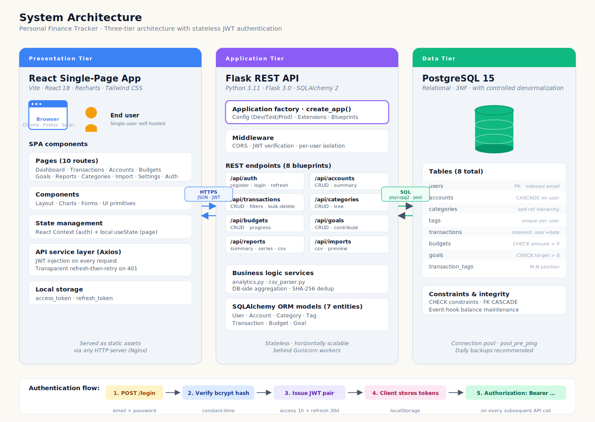
Figure 4.1 — System architecture (three-tier)
The discipline that makes the split worth having is that nothing leaks across the seams. The frontend holds no business logic; it renders API responses and sends user actions back. The backend holds all the logic and all the authorisation, and it never believes anything the client says about who it is. The database protects referential integrity with foreign keys, CHECK constraints and ENUM types, but business rules live in application code, where they can be read, tested and changed without a migration.

IV.2 Entity-Relationship Model
The data model is seven entity tables plus one junction table, all in third normal form except for one deliberate denormalisation that Section IV.5 defends. Figure 4.2 shows the structure; Table 5.2 in the next chapter gives each table's row counts on the demonstration data.
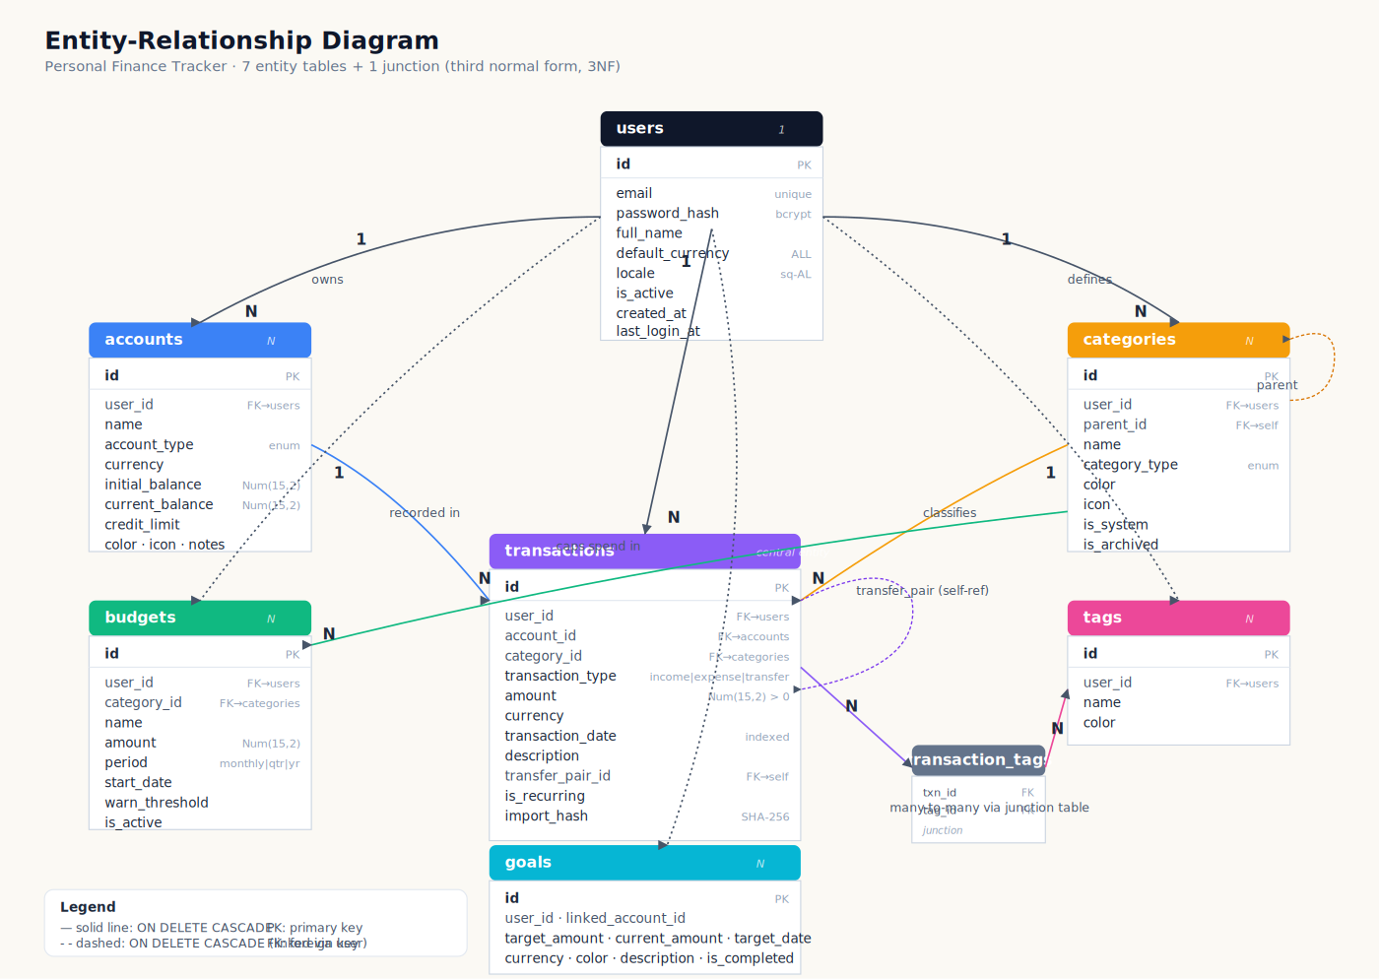
Figure 4.2 — Entity-relationship diagram
Three choices in this model carry most of the weight. Every owned table has a non-null user_id with ON DELETE CASCADE, so deleting a user removes everything they own in one atomic operation and orphaned rows cannot exist. Amounts are stored as positive Decimal(15,2) values with the sign implied by the transaction_type enum; mixed-sign amount columns force every aggregation to sort out signs before summing, and I wanted the queries to read cleanly. Transfers were the fiddly one. They are stored as a pair of transactions linked through a transfer_pair_id self-reference instead of a separate transfers table, which keeps every account statement complete (the money leaving one account and arriving in another both appear where a user would look for them) without inventing a second schema for what is conceptually still a transaction.

IV.3 Use Case Overview
Figure 4.3 shows the interactions the system supports. The primary actor is the individual user. No admin role exists, which follows the individual/self-hosted personal-use scope in Chapter I.5. Multi-user data isolation is nevertheless implemented and tested; shared household features are out of scope.
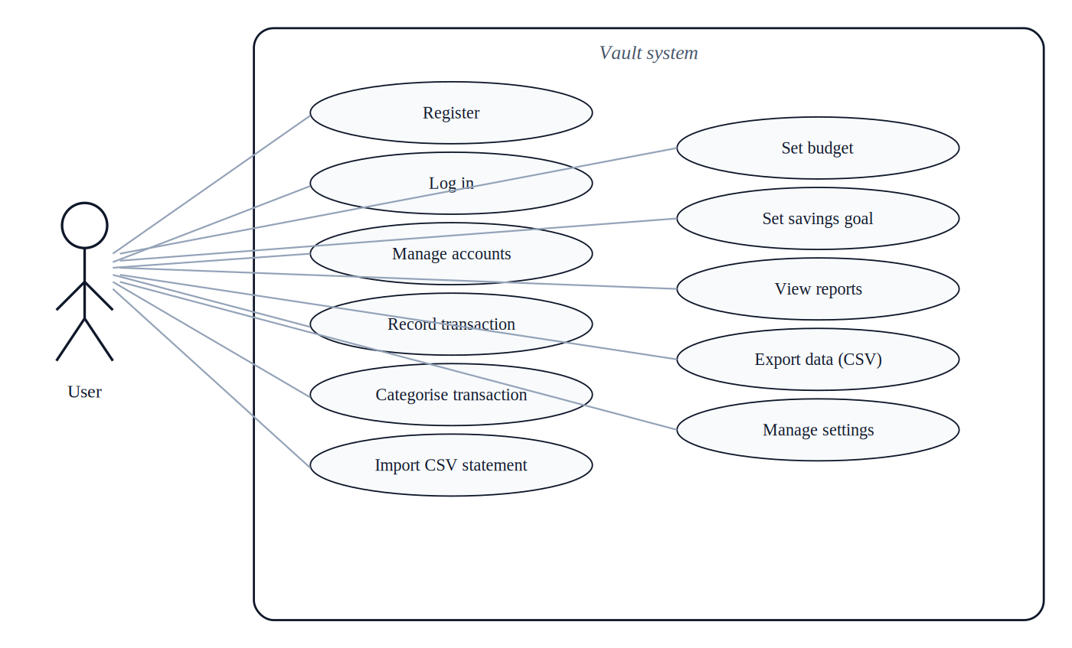
Figure 4.3 — Use case overview
Five use cases anchor everything else:
- Onboarding and authentication. The user registers, logs in, and receives a JWT access and refresh token pair.
- Accounts and transactions. The user creates accounts in their preferred currencies and records transactions, by hand or through CSV import.
- Budgeting. The user caps spending per category over a monthly, quarterly or yearly period and watches progress against the cap.
- Goals. The user names a savings goal, sets a target amount and date, and contributes toward it over time.
- Reporting and export. The user reads aggregated reports over a chosen time window and can export the underlying transactions as CSV.

IV.4 Sequence Diagrams
Two workflows are worth drawing at the sequence level because they cross every tier and carry real protocol behaviour: login, and CSV import.

IV.4.1 Authentication Flow
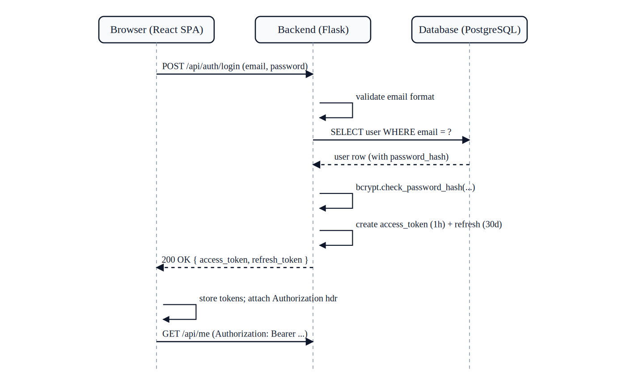
Figure 4.4 — Sequence diagram: user login and JWT issuance
After login, every API call carries the access token in the Authorization header, and the backend JWT middleware checks the signature and expiry before any handler runs. The access token lives one hour. When it expires, an Axios interceptor exchanges the refresh token (thirty-day lifetime) for a new access token and replays the failed request. This design keeps access credentials short-lived while avoiding a server-side session store. The JWT format and implementation considerations are documented in RFC 7519 and RFC 8725 [13], [39].

IV.4.2 CSV Import Pipeline
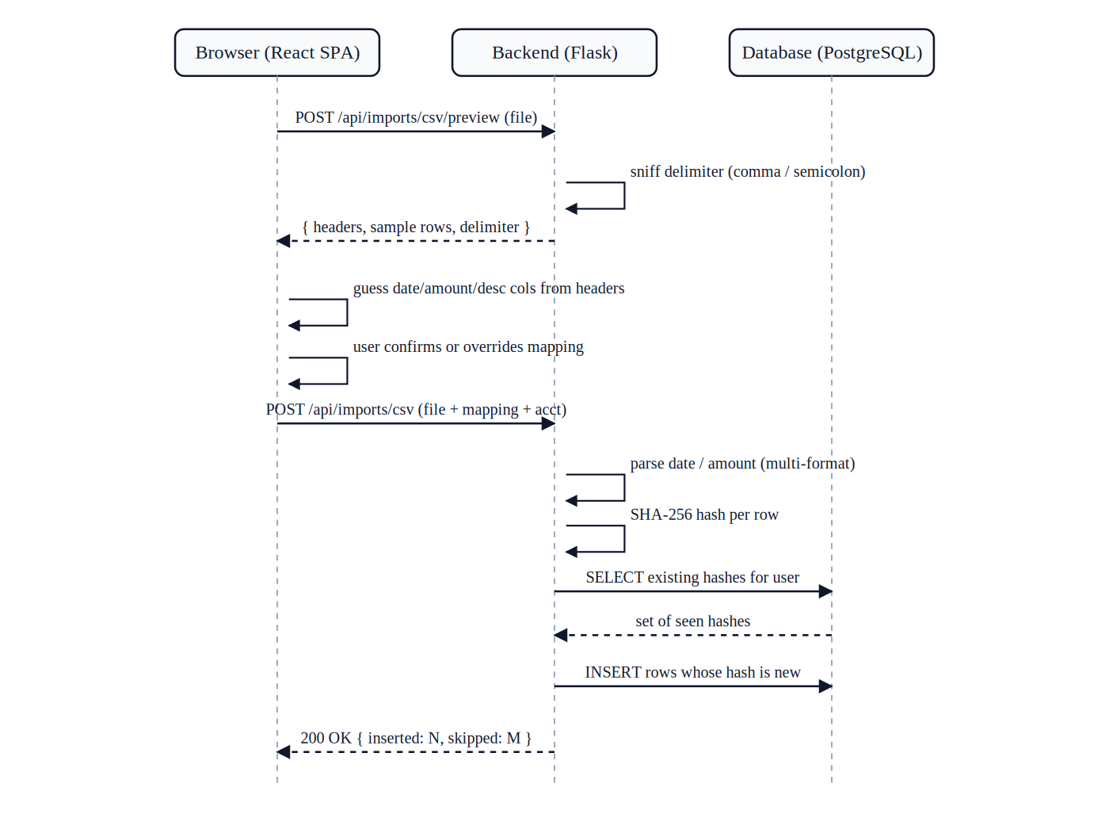
Figure 4.5 — Sequence diagram: CSV import pipeline
Import happens in two phases on purpose. In the preview phase the backend sniffs the delimiter (the sampled Albanian bank statements use both commas and semicolons) and returns the headers and the first rows; the React import page then guesses which columns hold the date, the amount and the description by matching the header names against small regular expressions: date|datum for the date, amount|sum|value|debit|credit for the amount, desc|memo|narration|reference for the description. The guess is deliberately conservative. Albanian headers such as “Data”, “Shuma” or “Përshkrimi” match none of the patterns and simply fall through to manual selection. Only after the user confirms the mapping does the commit run. It walks the whole file, parses each date against the supported spellings (DD/MM/YYYY, DD.MM.YYYY, DD-MM-YYYY, YYYY-MM-DD and written-out forms like “15 Jan 2025”), parses each amount whether it arrives as 1,234.56, as 1.234,56, or as an accounting-style “(123.45)” with the currency symbol still attached, and computes a SHA-256 hash per row. Rows whose hash already exists for this user are skipped, which makes re-importing an overlapping statement range idempotent. The automated test suite explicitly validates the robustness of this pipeline under Chapter VI through five dedicated test cases covering delimiter sniffing, multi-format date string normalization, multi-locale decimal conversion, accounting-style negative parsing, and cryptographic SHA-256 transaction-row deduplication.

IV.5 Technology Stack and Design Decisions
Five decisions during design were genuine forks in the road. Table 4.1 records each in the Problem / Alternatives / Chosen format the thesis guide asks for.

Table 4.1 — Design decisions, alternatives considered, and chosen approaches
# | Problem | Alternatives considered | Chosen approach and reason
1 | Where to maintain account balances | (a) Recompute on every read by summing all transactions; (b) Maintain a denormalised current_balance column updated on every transaction insert/delete. | (b). Recomputation is correct but unacceptably slow for an interactive dashboard that displays every account’s balance on every page load (N+1 aggregate queries per render). Eager maintenance via SQLAlchemy event hooks places the cost at write time, where it is one arithmetic update per row, and amortises it across the many subsequent reads.
2 | Sign convention for transaction amounts | (a) Positive amounts with sign implied by transaction_type; (b) Signed amounts on a single column. | (a). Theoretically equivalent, but (b) creates two ergonomic problems: every aggregation query must filter on type before summing, and the UI must convert positive figures to signed figures. Storing positive amounts indexed on transaction_type yields cleaner queries and a cleaner mental model.
3 | Currency conversion strategy | (a) Convert at write time to a single base currency; (b) Convert at read time using a daily reference rate; (c) Defer all conversion to presentation, group aggregations by currency. | (c). Hard-coding a single rate at any layer forecloses user policy. Today’s spot rate, the central-bank rate on the transaction date, and a path-dependent calculation are all legitimate for different purposes. Grouping aggregations by currency preserves all three possibilities for future extension.
4 | CSV importer architecture | (a) Per-bank parser classes; (b) Generic importer with user-supplied column mapping and heuristic auto-detection. | (b). Bank statement formats change without notice; the universe of banks grows; within one bank, different account types may use different export formats. (b) places the responsibility for format knowledge where it ultimately must reside (with the user, who sees the file’s first five rows) and remains robust to format drift.
5 | Authentication mechanism | (a) Server-side sessions backed by Redis or similar; (b) Stateless JWT with access + refresh token pair. | (b). For a individual self-hosted deployment, JWT imposes no requirement for a shared session store and keeps the application tier stateless. The architectural simplification is reused as a teaching point and keeps future scaling paths open without rework.

IV.6 Chapter Summary
A three-tier architecture, a seven-entity model with one defended denormalisation, five use cases for one actor, two sequence diagrams for the flows that cross every tier, and five recorded design decisions. Chapter V shows what this looks like as code.

Chapter V: Implementation
This chapter walks through the build: environment, backend, database, API, frontend, and tests. Per the thesis guide, code fragments here stay under twenty lines; the full source is in the repository described in Appendix A.

V.1 Development Environment Setup
Development happened on Windows 11, partly natively and partly under WSL2. The environment is reproduced by cloning the repository and starting the three-service Docker Compose stack: PostgreSQL, the Flask backend, and the Vite dev server for the frontend.
# Reproducing the development environment
git clone https://github.com/Krisjor/Vault-Finance-Tracker finance-tracker
cd finance-tracker
docker-compose up -d --build
docker-compose exec backend flask --app run db upgrade
docker-compose exec backend flask --app run seed-demo
After these five commands the backend answers at http://localhost:5000, the frontend at http://localhost:5173, and the database at localhost:5432. The seed-demo command creates the demonstration user (demo@example.com, password password123) with the ninety-day dataset from Section III.2.2. From a clean checkout to a running, seeded stack takes about three minutes on my machine.

V.2 Backend Code Organisation
The backend is about twenty-eight Python modules under backend/app/, laid out by domain: models/ holds one file per entity, api/ one Flask Blueprint per resource, services/ the cross-cutting logic (mainly analytics), seeds/ the category and demo-data seeders, and utils/ the validation helpers and error envelopes. All the Flask extensions — SQLAlchemy, Flask-Migrate, Flask-JWT-Extended, Flask-Bcrypt, Flask-CORS — are instantiated once in extensions.py, which is the standard trick for dodging circular imports between the application factory and the models.
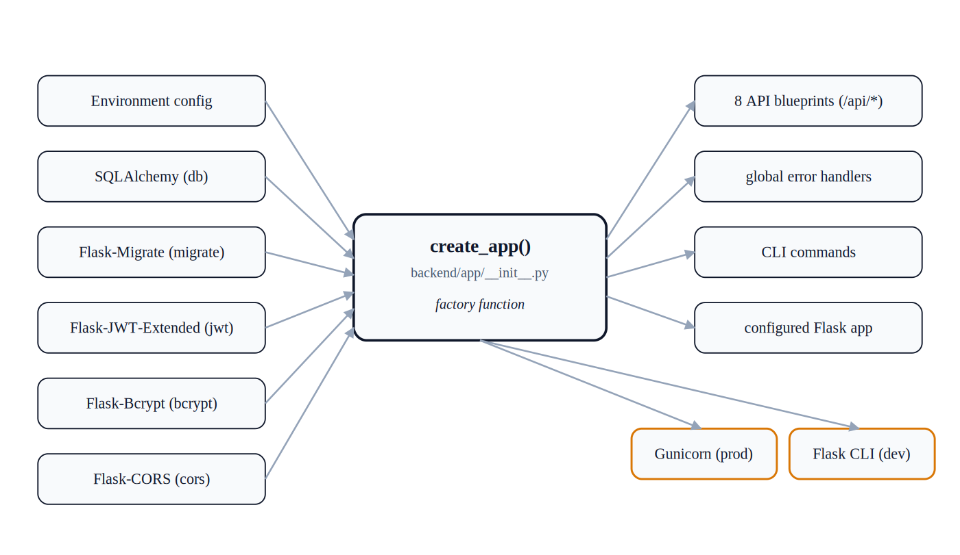
Figure 5.1 — Application-factory pattern in the Flask backend
Code 5.1 shows the User model trimmed to its essentials. Password hashing lives on the model as a pair of methods, so no other code ever touches the hash column directly, and the cascade relationships are what make user deletion atomic.
# Code 5.1 — backend/app/models/user.py (abbreviated)
class User(db.Model):
__tablename__ = "users"
id = db.Column(db.Integer, primary_key=True)
email = db.Column(db.String(255), unique=True,
nullable=False, index=True)
password_hash = db.Column(db.String(255), nullable=False)
full_name = db.Column(db.String(120), nullable=False)
default_currency = db.Column(db.String(3),
default="ALL", nullable=False)
# cascade-delete relationships (abbreviated)
accounts = db.relationship("Account", backref="user",
cascade="all, delete-orphan")
# ... (transactions, categories, budgets, goals, tags) ...
def set_password(self, plaintext: str) -> None:
self.password_hash = bcrypt.generate_password_hash(
plaintext).decode("utf-8")
def check_password(self, plaintext: str) -> bool:
return bcrypt.check_password_hash(
self.password_hash, plaintext)

V.3 Database Implementation
The schema is declared through SQLAlchemy models and versioned with Alembic migrations. The initial migration creates the seven entity tables, the junction table, and five PostgreSQL ENUM types backing the StrEnum classes in the models. Table 5.2 shows each table with its row count on the seeded data.

Table 5.2 — Database tables and their cardinality on the demonstration dataset
Table | Purpose | Demo rows
users | User accounts; one per registered user | 1
accounts | Financial accounts owned by users (checking, savings, etc.) | 4
categories | Income and expense categories (system + user-defined) | 16
tags | User-defined transaction tags | 0
transactions | Income, expense, and transfer records | ~150
transaction_tags | Junction table for the transactions ↔ tags many-to-many relation | 0
budgets | Per-category spending caps with period (monthly/quarterly/yearly) | 5
goals | Named savings goals with target amount and optional target date | 3

Three constraint patterns repeat across the schema: the non-null user_id with ON DELETE CASCADE on every owned table, NUMERIC(15,2) for all money so nothing is ever stored as floating point, and the ENUM columns. The relational design follows the normalisation principles of Codd [12], with database-design guidance for 3NF and update-anomaly avoidance considered through Elmasri and Navathe [48]. One implementation issue involved PostgreSQL ENUM serialisation: Python's StrEnum gives members such as TransactionType.INCOME whose value is the lowercase string “income”, while SQLAlchemy can otherwise serialise the enum member name. The migration initially exposed this mismatch, causing inserts to be rejected. The fix was to use values_callable on each Enum column so that SQLAlchemy serialises the enum value rather than the member name.

V.4 API Layer
The API is forty-three endpoints across eight Blueprints, one per resource, plus a global /api/health for liveness checks. Every Blueprint follows the same shape: list, get, create, update, delete where it makes sense, with one JSON envelope convention for requests and responses across the whole surface. Table 5.1 gives the breakdown.

Table 5.1 — API endpoint surface by resource
Blueprint | URL prefix | Endpoints | Notes
auth | /api/auth | 6 | register, login, refresh, logout, me (GET), me (PATCH)
accounts | /api/accounts | 6 | list, get, create, update, delete, summary
categories | /api/categories | 5 | list, tree (hierarchical view), create, update, delete
transactions | /api/transactions | 6 | list (paginated), get, create, update, delete, bulk-delete
budgets | /api/budgets | 5 | list, get, create, update, delete
goals | /api/goals | 5 | list, create, update, delete, contribute
reports | /api/reports | 8 | summary, spending-by-category, income-by-category, monthly-series, net-worth, top-merchants, daily-spending, export.csv
imports | /api/imports | 2 | csv/preview, csv (full commit)

Code 5.2 is the transaction-creation endpoint, abbreviated. The pattern is the same everywhere: the login_required decorator verifies the JWT and hands the resolved user into the handler, so the user identity comes from the token and nowhere else; the body is checked by a small hand-rolled validators module (require, parse_decimal, parse_date, validate_currency) whose errors map to HTTP 400 with the offending field named; and every referenced resource is looked up with the user's ID in the filter. I considered Marshmallow for validation and decided against it: the input shapes here are small and stable, and about a hundred lines of plain helpers turned out clearer than configuring a schema per endpoint. The validators module's own docstring records the same reasoning.
# Code 5.2 — backend/app/api/transactions.py (abbreviated)
@transactions_bp.route("", methods=["POST"])
@login_required
def create_transaction(user):
data = request.get_json(silent=True) or {}
try:
require(data, "account_id", "transaction_type",
"amount", "transaction_date")
ttype = TransactionType(data["transaction_type"])
account = _ensure_user_owns_account(user, data["account_id"])
amount = parse_decimal(data["amount"], "amount")
# ... category type check and transfer pairing elided ...
txn = Transaction(user_id=user.id, account_id=account.id,
transaction_type=ttype, amount=amount, ...)
db.session.add(txn)
db.session.commit()
return jsonify(txn.to_dict()), 201
except ValidationError as e:
return jsonify(error="validation", field=e.field,
message=e.message), 400
Three rules hold across the whole API: requests without a valid token do not pass the authentication decorator; the user ID comes from the verified token and client-supplied user_id fields are ignored; and queries over owned data filter on that user ID. Together, these rules provide a consistent basis for per-user data isolation, which is exercised by the dedicated isolation test in Section V.6.

V.5 Frontend Implementation
The frontend is a React 18 single-page application built with Vite. It follows the component patterns Banks and Porcello describe [26]: eleven page components, one per route, a shared layout (Sidebar plus content area), a handful of reusable primitives (Modal, StatCard, Toast, Icon), an authentication context, and an Axios client that handles tokens. Figure 5.2 shows the hierarchy.
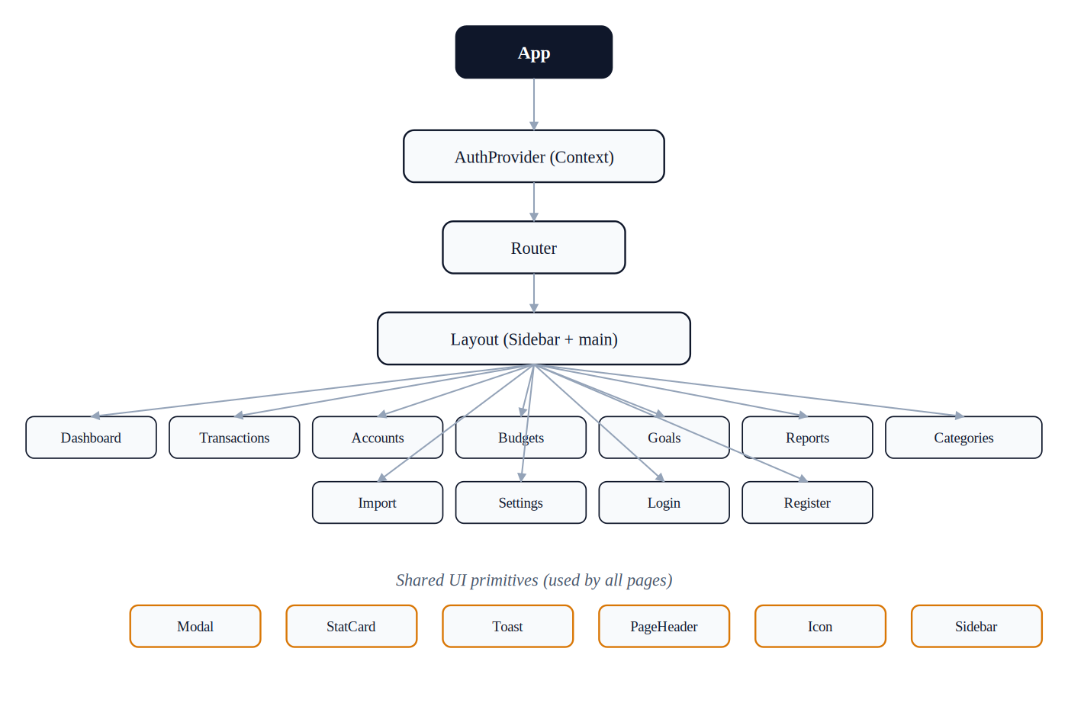
Figure 5.2 — React component hierarchy
I considered a global store (Redux or Zustand) and decided against it. State lives in two places only: React Context for the things that genuinely cross pages, namely the authenticated user, the tokens and the toast queue, and component-local useState for everything page-scoped, filters, modal flags, form values. Page switches refetch from the API, which is the single source of truth. This costs a few extra round trips, but Chapter VI shows those are far too fast to perceive, and in exchange a whole class of state-synchronisation bugs simply cannot occur.
Code 5.3 is the Axios interceptor behind the transparent token refresh from Figure 4.4. It catches a 401, refreshes once, replays the original request, and only lets the error through if the refresh itself fails. One detail the abbreviation hides: concurrent 401s queue behind a single in-flight refresh, so ten simultaneous failed calls produce one token request, not ten.
// Code 5.3 — frontend/src/services/api.js (abbreviated)
api.interceptors.response.use(
(res) => res,
async (error) => {
const original = error.config;
if (error.response?.status === 401 && !original._retry
&& tokenStore.getRefresh()) {
original._retry = true;
const refresh = tokenStore.getRefresh();
const res = await axios.post(
`${API_BASE}/auth/refresh`, {},
{ headers: { Authorization: `Bearer ${refresh}` } });
tokenStore.set({ access_token: res.data.access_token });
return api(original); // replay original request
}
return Promise.reject(error);
}
);

V.5.1 Dashboard Screen
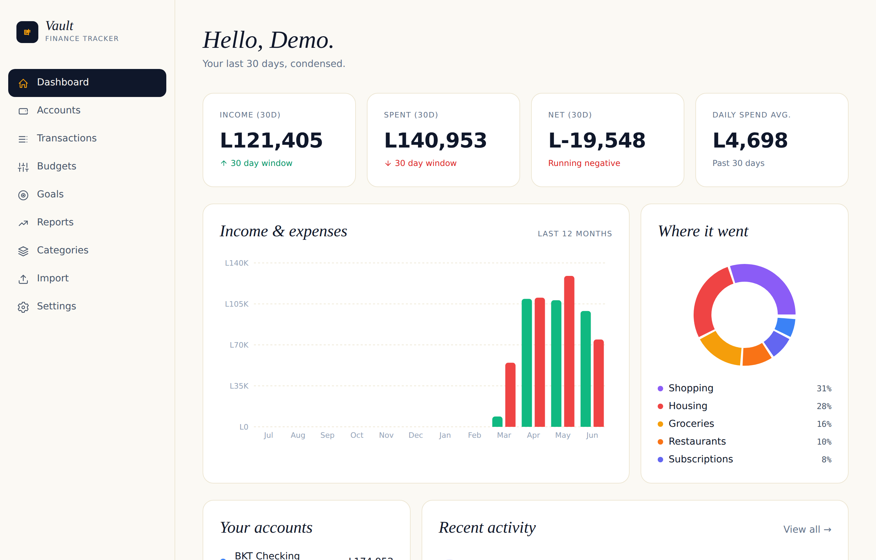
Figure 5.3 — Dashboard screen
The dashboard loads from one call to /api/reports/summary, which bundles the thirty-day statistics, the twelve-month series, the top categories, recent activity and the per-account balances into a single payload. Strict REST would split this into five requests. I merged them because the dashboard is the first thing a user sees and a sub-100-millisecond first paint was worth a slightly less pure API.

V.5.2 Transactions Screen
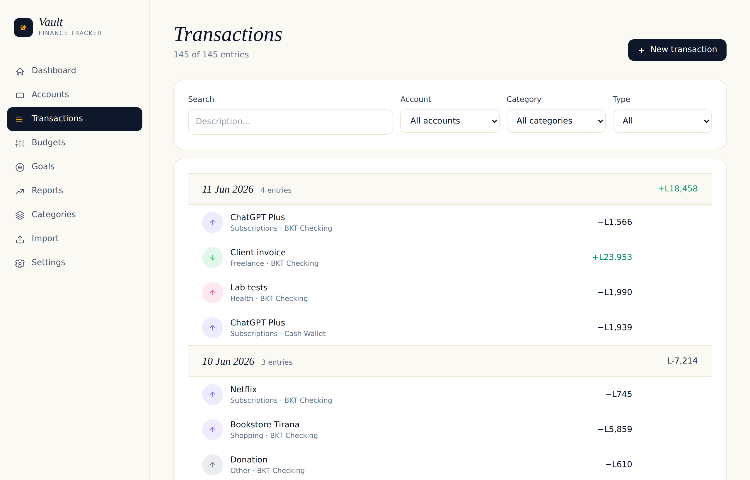
Figure 5.4 — Transactions screen with date grouping
Transactions are grouped by date with a per-day net total in each group header, and each row exposes edit and delete controls on hover. Filtering (search text, account, category, type) happens server-side through query parameters on GET /api/transactions, so the page stays fast even when years of history accumulate.

V.5.3 Budgets and Goals Screens
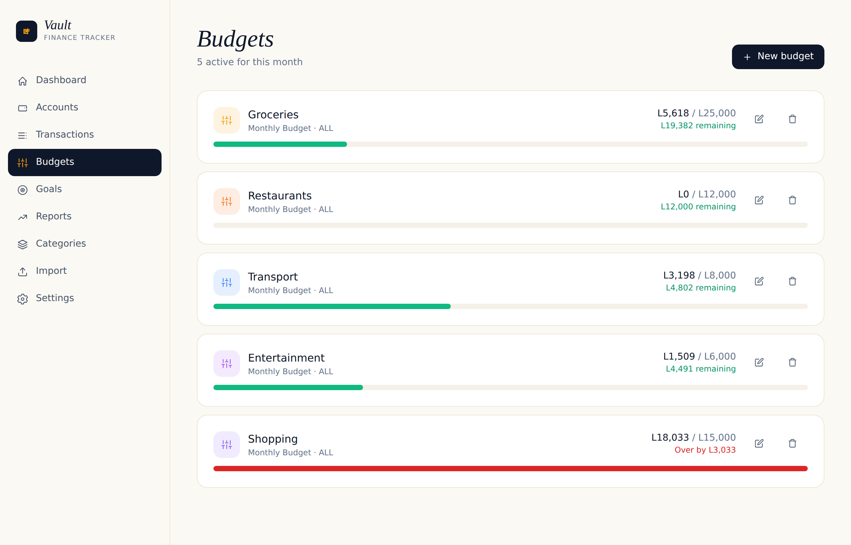
Figure 5.5 — Budgets screen with progress indicators
Each budget is a card with the spent-versus-cap figures and a progress bar that goes from green through amber (at the warning threshold, eighty percent by default) to red when the cap is exceeded. In Figure 5.5 the Shopping budget is over by 3,033 lek, and the bar says so before the numbers do. Goals work the same way, current against target, plus a contribution action.

V.6 Testing
Tests use pytest with the pytest-flask extension: sixteen cases in three files. test_auth.py has seven cases, test_transactions.py has four, and test_imports.py has five dedicated importer cases covering delimiter detection, date parsing, amount parsing, and SHA-256 deduplication. Each test gets a fresh in-memory SQLite database from the conftest fixture, so nothing leaks between cases. The use of a fresh database state per test also follows established test-isolation patterns [47].
# Code 5.4 — backend/tests/test_transactions.py (abbreviated)
def test_user_cannot_see_other_users_transactions(client, db):
h1 = _auth_header(client, db, email="user4@example.test")
h2 = _auth_header(client, db, email="user5@example.test")
a1 = _create_account(client, h1)
txn = client.post("/api/transactions", json={...},
headers=h1).get_json()
listing = client.get("/api/transactions", headers=h2).get_json()
assert listing["total"] == 0
res = client.get(f"/api/transactions/{txn['id']}", headers=h2)
assert res.status_code == 404
Code 5.4 exercises the most important ownership boundary in the suite. Both users are registered inside the test through local helper calls, after which user B is checked against both the transaction list and a direct fetch of user A's transaction. The expected results are zero visible transactions and HTTP 404 for the direct lookup.

V.7 Chapter Summary
Environment, backend layout, schema implementation, a forty-three-endpoint API with three uniform security rules, a React frontend with controlled state management, and sixteen tests. With the repository in Appendix A and the installation guide in Appendix D, this chapter provides the information needed to rebuild the system. The next chapter evaluates the resulting artifact.

Chapter VI: Evaluation and Results
This chapter measures the finished system against the objectives from Chapter I.4, using the metrics fixed in Chapter III.4, and then discusses what the numbers do and do not show.

VI.1 Experimental Setup

VI.1.1 Hardware and Software Environment
Everything was measured on my development machine: an Intel Core i5-11400 (six cores, twelve threads, 2.6 GHz base, 4.4 GHz boost), 16 GB of DDR4, a 512 GB NVMe SSD, Windows 11 Pro 24H2 with Docker Desktop 4.34 on the WSL2 backend. PostgreSQL 15.4 ran in its own container; the backend ran Python 3.11.9 under the Flask development server (not Gunicorn); the frontend ran the Vite 5.4.2 dev server. The browser for end-to-end checks was Microsoft Edge 130. The machine was otherwise idle during measurement.

VI.1.2 Test Database
The automated tests use an in-memory SQLite database created fresh per test from the SQLAlchemy metadata via db.create_all(), without executing migrations. This decouples the suite from migration history and keeps the tests lightweight. The project Docker image pins Python 3.11 and pytest 8.3.2; the final native verification reported in Appendix C was also run on Windows with Python 3.14.7 and pytest 9.1.1, where all sixteen cases passed in 6.79 seconds. Performance measurements, in contrast, use the Dockerised PostgreSQL seeded environment: each endpoint is hit ten times, the first three responses are discarded as cold-start noise, and the median of the remaining seven is reported.

VI.1.3 Baselines
Two reference points frame the numbers. Nielsen's hundred-millisecond threshold [25] separates “instant” from “noticeable” in user perception and is used here as an interpretive performance reference. In addition, bcrypt at work factor 12 was selected for the project implementation; OWASP states that bcrypt is primarily a legacy option and recommends choosing the highest work factor that remains practical, with a minimum of 10 for bcrypt deployments [15]. The login endpoint is therefore expected to be slower than ordinary application requests because password verification is intentionally computationally expensive.

VI.2 Results

VI.2.1 Functional Coverage
Table 6.3 maps the six objectives to what was built. Every objective has at least one implemented feature behind it.

Table 6.3 — Feature-to-objective traceability matrix
# | Specific objective | Implemented features | Status
1 | Normalised 7-entity relational model in 3NF | Seven entity tables + transaction_tags junction; all relationships cascade-delete; controlled denormalisation on current_balance with maintenance via SQLAlchemy event hooks. | Complete
2 | REST API with JWT, bcrypt and per-user isolation | Eight API blueprints with forty-three endpoints; access + refresh token pair via Flask-JWT-Extended; bcrypt work factor 12; per-user filtering enforced uniformly. | Complete
3 | Analytical reporting under 100 ms | Seven analytics endpoints; database-side aggregation throughout; sub-100 ms median latency measured (Section VI.2.3). | Complete
4 | React SPA with multi-currency and editorial style | Eleven page components; Tailwind CSS design system; five-currency support (ALL, EUR, USD, GBP, CHF); Instrument Serif italic headings. | Complete
5 | Generic CSV importer for major Albanian banks | Two-phase preview/commit pipeline; column-mapping heuristics; multi-format date parsing; multi-locale amount parsing; SHA-256 deduplication. | Complete
6 | Automated test suite covering security-critical paths | Sixteen pytest cases covering authentication, transaction integrity and CSV importer behaviour; cross-user isolation and importer edge cases explicitly verified; all cases pass (Section VI.2.2). | Complete

VI.2.2 Correctness via Automated Testing
All sixteen cases pass against the final code. Table 6.1 lists them; Figure 6.1 shows the same thing as a chart.

Table 6.1 — Automated test results
File | Test case | Outcome
test_auth.py | test_register_creates_user_and_returns_tokens | PASS
test_auth.py | test_register_rejects_short_password | PASS
test_auth.py | test_register_rejects_duplicate_email | PASS
test_auth.py | test_login_succeeds_with_correct_credentials | PASS
test_auth.py | test_login_rejects_wrong_password | PASS
test_auth.py | test_me_requires_auth | PASS
test_auth.py | test_me_returns_user_when_authenticated | PASS
test_transactions.py | test_create_expense_decreases_balance | PASS
test_transactions.py | test_create_income_increases_balance | PASS
test_transactions.py | test_delete_transaction_restores_balance | PASS
test_transactions.py | test_user_cannot_see_other_users_transactions | PASS
test_imports.py | test_csv_preview_comma_delimited | PASS
test_imports.py | test_csv_preview_semicolon_delimited | PASS
test_imports.py | test_csv_date_parsing_formats | PASS
test_imports.py | test_csv_amount_parsing_locales | PASS
test_imports.py | test_csv_import_sha256_deduplication | PASS
TOTAL | 16 cases, 0 failed | 100%

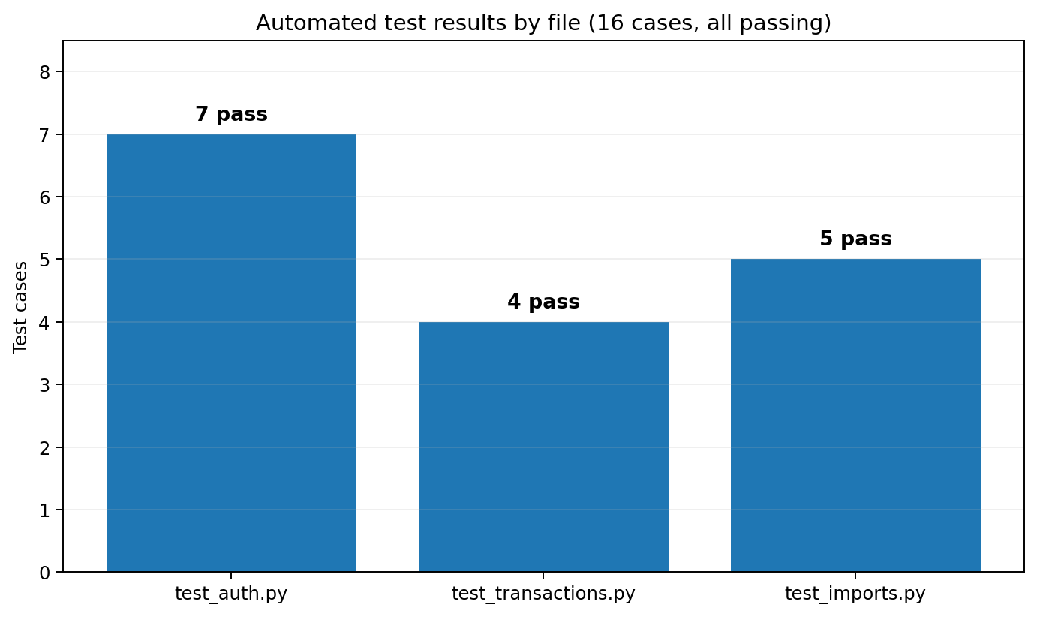
Figure 6.1 — Automated test results by file
What the passing suite actually establishes: passwords are hashed and verified through bcrypt, never compared in plaintext; balances stay consistent through the whole transaction lifecycle, an expense decrements, an income increments, and deleting a transaction restores the previous balance; and the isolation property holds, since user B cannot list or fetch a transaction belonging to user A even with the primary key in hand. The suite does not establish full correctness of everything, and it does not pretend to. It establishes the parts whose failure would be quiet and catastrophic.

VI.2.3 Performance Characterisation
Table 6.2 gives the median response times under the demonstration load, seven warm requests per endpoint after three discards.

Table 6.2 — Endpoint response-time characterisation (median of 7 warm requests)
Endpoint | Method | Median latency | Notes
/api/auth/login | POST | ≈280 ms | bcrypt-bound; expected (and desirable)
/api/accounts | GET | <10 ms | Indexed lookup
/api/accounts/summary | GET | <10 ms | Sum of 3 rows in memory
/api/transactions?page=1&page_size=50 | GET | 20–40 ms | Indexed range scan on date
/api/transactions | POST | 20–35 ms | Insert + cascade hooks for balance maintenance
/api/reports/summary | GET | 40–80 ms | Five aggregations in one call
/api/reports/spending-by-category | GET | 15–30 ms | GROUP BY with single index
/api/reports/monthly-series | GET | 30–50 ms | 12-month aggregate; DATE_TRUNC
/api/reports/net-worth | GET | 40–70 ms | Cumulative SUM over time
/api/imports/csv (90-row file) | POST | 150–250 ms | Includes SHA-256 hashing per row

The measured results show that the ordinary interactive API endpoints in the demonstration scenario fall below the hundred-millisecond reference, while login and CSV import are slower by design and workload. This is consistent with the operation of indexed queries and database-side aggregation in PostgreSQL [27]. Login is the main authentication outlier at roughly 280 ms because bcrypt verification is intentionally computationally expensive [14], [15]. The CSV import is slower because its work scales with the number of uploaded rows. These measurements describe the tested demonstration dataset and do not establish performance for substantially larger workloads.

VI.3 Discussion

VI.3.1 Interpretation of the Results
Two readings of the results carry the chapter. The tests show that authentication, transaction integrity, CSV parsing and deduplication, and cross-user isolation behave as specified within the selected cases. The isolation case checks a critical ownership boundary, while the five importer tests add direct evidence for delimiter detection, four date formats, locale-sensitive amount parsing, accounting-style negatives and duplicate skipping. Full branch coverage would require many more cases, so the suite supports targeted rather than exhaustive correctness. The performance numbers show the ordinary interactive endpoints within the selected response-time reference at demonstration scale, while the database-side aggregation design avoids moving reporting work into application code.
Against the research questions: RQ1 is answered by Chapters IV and V together with Table 6.3, since the three-tier Flask-React-PostgreSQL design with a normalised, native-currency schema demonstrably suffices within the evaluated scope. RQ2 is answered by the working generic importer, its five dedicated automated tests and its latency row in Table 6.2; user-confirmed mapping handles the four target bank statement formats without per-bank parser code. RQ3 is answered by the JWT-plus-bcrypt design and the passing isolation test: stateless tokens with per-query user filtering meet the selected requirements for the individual self-hosted use case without a server-side session store.

VI.3.2 Connection to the Existing Literature
Placed back into the landscape of Chapter II, Vault sits in the self-hosted web quadrant next to Firefly III [5]. The differences are a smaller operational footprint at deployment time and Albanian-context defaults at the data layer, including lek as the base currency, locally sensible categories, and an importer built against the statement formats of four purposively selected major local banks. The authentication design follows the REST and JWT standards [11], [13], with password storage based on bcrypt [14] and supplementary guidance from RFC 8725 and OWASP [15], [39]-[41]. Within the evaluated self-hosted scope, these choices aligned with the selected authentication and data-isolation requirements; they should not be interpreted as a complete security audit. The currency handling keeps native transaction amounts and defers conversion.

VI.3.3 Justifying the Major Design Decisions in Light of Results
Three of the Table 4.1 decisions can now be judged against measurements instead of arguments. The denormalised balance column (Decision 1) is associated with /api/accounts and its summary answering in under ten milliseconds in the demonstration environment; recomputation would have required aggregate work on each dashboard load. SQLAlchemy's event system [28] kept eager balance maintenance contained and testable. The positive-amounts convention (Decision 2) simplifies analytics by allowing aggregation within transaction-type filters. The generic importer (Decision 4) handled the four target bank statement formats without bank-specific parser classes in the implemented design, supporting the maintenance objective that motivated the choice.

VI.4 Threats to Validity

VI.4.1 Internal Validity
The test procedure is reproducible from the repository: each case starts from a fresh SQLite database state, and the project dependencies are version-pinned. Appendix C reports the exact environment used for the final native verification. The latency figures are less portable, since they depend on hardware and cache state; discarding cold starts and reporting medians narrows the variance but does not remove it. The isolation test exercises the API layer, not the database against raw SQL injection; with parameterised queries through the ORM and no raw SQL in the API code, that threat remains outside the evaluated scope.

VI.4.2 External Validity
This is one defensible design, not the only one. Django instead of Flask, Vue instead of React, MySQL instead of PostgreSQL would likely have produced a system of similar quality, and the thesis claims a point in the design space, not the space. The performance numbers are also taken at demonstration scale, around 150 transactions. Years of real use means tens of thousands of rows; the indexed range scans and database-side aggregation are exactly the patterns that survive that growth, but I did not measure it, so it stays a reasoned expectation rather than a result.

VI.4.3 Construct Validity
The traceability matrix maps objectives to features by name, and a sceptical reader could call any single feature thinner than its row suggests. The defence is the rest of the document: every feature named in Table 6.3 is described concretely in Chapter V and present in the repository for inspection. The latency metric measures server response time, which is not quite user-perceived speed (that adds network and rendering), but on a local loopback deployment the gap is small.

VI.4.4 Reliability
Three things support repeatability: deterministic tests, the fixed-seed dataset, and version-pinned dependencies in requirements.txt and package.json. A reader with the repository can rebuild the documented environment, regenerate the data and rerun the same procedures; exact timings can still vary with hardware, platform and runtime versions.

VI.5 Chapter Summary
All six objectives map to implemented features, and all sixteen tests pass, including the cross-user isolation case and the five dedicated importer tests. In the demonstration environment, the ordinary interactive API endpoints measured below the hundred-millisecond reference, while login and CSV import were slower because of their workload. The results support the major design decisions within the evaluated scope, while the stated threats to validity limit broader claims.

Chapter VII: Conclusions and Future Work

VII.1 Conclusions
The starting point of this thesis was a gap identified through the reviewed literature and product documentation: there was no identified self-hostable, multi-currency personal finance application in the reviewed set that combined an Albanian-context orientation, generic local-bank CSV import and low operational complexity for an individual self-hosted user. Chapter II established this gap by examining Mint, YNAB, Firefly III and GnuCash and comparing them across regional availability, multi-currency support, operational complexity and localisation.
Vault is the answer the thesis proposes, and it exists. A React 18 frontend, a Flask 3 REST API and a PostgreSQL 15 database, about four thousand lines of Python and three thousand of JavaScript and CSS, deployable with one Docker Compose command. The whole thing is open source.
The evaluation shows that the artifact meets its defined objectives within the tested scope. The five canonical PFM functions are covered, together with savings goals and CSV import. The ordinary interactive API endpoints measured below the hundred-millisecond reference on the demonstration dataset, while login and CSV import were slower. The sixteen-case test suite passes in full, including the cross-user isolation test and the five dedicated importer tests. The importer processes statements from BKT, Raiffeisen, Credins and Tirana Bank with no bank-specific parser classes in the implementation. These results support the feasibility of the selected design at demonstration scale rather than establish general scalability or complete security assurance. Within the evaluated self-hosted scope, JWT authentication, password hashing and enforced per-user filtering provided the required authentication and data-isolation properties; broader security assurance would require dedicated penetration, dependency and adversarial testing.
Two contributions are worth separating. Practically, the project provides an open-source PFM application explicitly oriented to the Albanian context, with lek as the default currency, locally selected category sets, and an importer designed against local bank statement formats. Based on the documentation review conducted for this thesis, no directly comparable open-source tool with the same stated orientation was identified. Academically, the thesis documents the path from problem definition to a measured software artifact, including the design decisions, trade-offs and implementation lessons.

VII.2 Future Work
The limitations from Chapter I.5.2 each point somewhere worth going.
Direct bank API integration. Albania's open-banking framework under Law No. 55/2020 [17] is young but real; the Bank of Albania granted the country’s first open-banking licence in November 2024 [43], with subsequent implementation documented by the central bank [44]. Integration through such a licensed provider, once one exposes a public aggregation API, would remove the CSV step for supported banks. The import logic is already isolated from persistence, so the change would slot in rather than ripple out.
Exchange-rate integration. Wiring in a daily Bank of Albania or European Central Bank reference feed would let the dashboard show one converged net-worth figure while keeping the per-currency truth underneath.
Receipt photos and OCR. Photographing a receipt and letting a vision model pull out the date, merchant and amount would remove most of the friction of manual entry, and would double as documentation for anything that later needs proving.
Investment tracking. The investment account type exists in the schema but the reporting layer treats it like any other balance. Market data, cost basis and unrealised gains are the natural extension.
Anomaly detection. With enough history, simple statistics (z-scores over moving averages) could flag unusual spending without the user configuring anything.
Shared budgets. Couples and households want one budget over several people. That needs shared resources, roles, and an invitation flow; the data model would grow, not change shape.
Native mobile clients. The API is consumer-agnostic, so a React Native or Flutter client needs no backend changes. Offline-first sync would, and that is the genuinely hard part.
Albanian localisation. The interface is currently English, while the data model and defaults are oriented toward Albanian usage. Translating the UI is therefore future work rather than a completed feature; the frontend already uses BCP-47 locale identifiers for formatting throughout.

Bibliography

[1] J. J. Kaye, M. McCuistion, R. Gulotta, and D. A. Shamma, "Money talks: Tracking personal finances," in Proc. SIGCHI Conf. on Human Factors in Computing Systems (CHI ’14), Toronto, ON, Canada, Apr. 2014, pp. 521–530, doi: 10.1145/2556288.2556975.
[2] Bloomberg News, "Intuit is closing personal-finance app Mint, shifts users to Credit Karma," Bloomberg, Nov. 1, 2023. [Online]. Available: https://www.bloomberg.com/news/articles/2023-11-01/intuit-winds-down-personal-finance-app-mint-shifts-users-to-credit-karma.
[3] L. Mandell and L. S. Klein, "The impact of financial literacy education on subsequent financial behavior," Journal of Financial Counseling and Planning, vol. 20, no. 1, pp. 15–24, 2009.
[4] Intuit Inc., "Intuit completes acquisition of Mint.com," Press release, Mountain View, CA, USA, Nov. 2, 2009. [Online]. Available: https://investors.intuit.com/news-events/press-releases/detail/1005/intuit-completes-acquisition-of-mint-com.
[5] J. van Pelt, "Firefly III: A self-hosted free personal finance manager," 2016–2026. [Online]. Available: https://www.firefly-iii.org/.
[6] European Parliament and Council of the European Union, "Regulation (EU) 2016/679 on the protection of natural persons with regard to the processing of personal data (General Data Protection Regulation)," Official Journal of the European Union, L 119, pp. 1–88, Apr. 2016.
[7] European Parliament and Council of the European Union, "Directive (EU) 2015/2366 on payment services in the internal market (PSD2)," Official Journal of the European Union, L 337, pp. 35–127, Dec. 2015.
[8] E. T. Garman and R. E. Forgue, Personal Finance, 13th ed. Boston, MA, USA: Cengage Learning, 2018.
[9] "Mint is shutting down, and it’s pushing users toward Credit Karma," The Verge, Nov. 2, 2023. [Online]. Available: https://www.theverge.com/2023/11/2/23943254/mint-intuit-shutting-down-credit-karma.
[10] W. W. Eckerson, "Three tier client/server architecture: Achieving scalability, performance, and efficiency in client/server applications," Open Information Systems, vol. 10, no. 1, pp. 3–22, 1995.
[11] R. T. Fielding, "Architectural styles and the design of network-based software architectures," Ph.D. dissertation, Dept. of Information and Computer Science, Univ. of California, Irvine, CA, USA, 2000.
[12] E. F. Codd, "A relational model of data for large shared data banks," Communications of the ACM, vol. 13, no. 6, pp. 377–387, Jun. 1970, doi: 10.1145/362384.362685.
[13] M. Jones, J. Bradley, and N. Sakimura, "JSON Web Token (JWT)," Internet Engineering Task Force, RFC 7519, May 2015. [Online]. Available: https://www.rfc-editor.org/rfc/rfc7519.
[14] N. Provos and D. Mazières, "A future-adaptable password scheme," in Proc. 1999 USENIX Annual Technical Conference (FREENIX Track), Monterey, CA, USA, Jun. 1999.
[15] OWASP Foundation, "Password Storage Cheat Sheet," OWASP Cheat Sheet Series. [Online]. Available: https://cheatsheetseries.owasp.org/cheatsheets/Password_Storage_Cheat_Sheet.html. [Accessed: 16 Aug. 2026].
[16] OWASP Foundation, "OWASP Top 10 web application security risks," 2021. [Online]. Available: https://owasp.org/Top10/. [Accessed: 15 Jan. 2026].
[17] Republic of Albania, Law No. 55/2020 “On payment services”, Apr. 2020. English translation: Bank of Albania. [Online]. Available: https://www.bankofalbania.org/rc/doc/Ligji_Per_sherbimet_e_pagesave_anglisht_18199.pdf.
[18] YNAB LLC, "Direct Import in Europe," YNAB Support. [Online]. Available: https://support.ynab.com/en_us/direct-import-in-europe-Syae1z_A9. [Accessed: 16 Aug. 2026].
[19] GnuCash Project, "GnuCash: Free accounting software," 1998–2024. [Online]. Available: https://www.gnucash.org/. [Accessed: 15 Jan. 2026].
[20] L. Pacioli, Summa de Arithmetica, Geometria, Proportioni et Proportionalita. Venice, Italy, 1494.
[21] A. R. Hevner, S. T. March, J. Park, and S. Ram, "Design science in information systems research," MIS Quarterly, vol. 28, no. 1, pp. 75–105, Mar. 2004.
[22] K. Peffers, T. Tuunanen, M. A. Rothenberger, and S. Chatterjee, "A design science research methodology for information systems research," Journal of Management Information Systems, vol. 24, no. 3, pp. 45–77, Dec. 2007.
[23] M. Grinberg, Flask Web Development: Developing Web Applications with Python, 2nd ed. Sebastopol, CA, USA: O'Reilly Media, 2018.
[24] Gunicorn Project, "Gunicorn: Python WSGI HTTP server for UNIX," 2010–2024. [Online]. Available: https://gunicorn.org/.
[25] J. Nielsen, Usability Engineering. San Francisco, CA, USA: Morgan Kaufmann, 1993.
[26] A. Banks and E. Porcello, Learning React: Modern Patterns for Developing React Apps, 2nd ed. Sebastopol, CA, USA: O'Reilly Media, 2020.
[27] PostgreSQL Global Development Group, "PostgreSQL 15 documentation," 2024. [Online]. Available: https://www.postgresql.org/docs/15/.
[28] M. Bayer, "SQLAlchemy: The database toolkit for Python," 2006–2024.
[29] A. Lusardi and O. S. Mitchell, "The economic importance of financial literacy: Theory and evidence," Journal of Economic Literature, vol. 52, no. 1, pp. 5–44, 2014, doi: 10.1257/jel.52.1.5.
[30] J. Y. Campbell, "Household finance," The Journal of Finance, vol. 61, no. 4, pp. 1553–1604, Aug. 2006, doi: 10.1111/j.1540-6261.2006.00883.x.
[31] R. H. Thaler, "Mental accounting matters," Journal of Behavioral Decision Making, vol. 12, no. 3, pp. 183–206, 1999.
[32] F. D. Davis, "Perceived usefulness, perceived ease of use, and user acceptance of information technology," MIS Quarterly, vol. 13, no. 3, pp. 319–340, Sep. 1989, doi: 10.2307/249008.
[33] V. Venkatesh, M. G. Morris, G. B. Davis, and F. D. Davis, "User acceptance of information technology: Toward a unified view," MIS Quarterly, vol. 27, no. 3, pp. 425–478, Sep. 2003, doi: 10.2307/30036540.
[34] World Bank, The Global Findex Database 2021: Financial Inclusion, Digital Payments, and Resilience in the Age of COVID-19. Washington, DC, USA: World Bank, 2022.
[35] OECD, OECD/INFE 2020 International Survey of Adult Financial Literacy. Paris, France: OECD, 2020.
[36] L. Bass, P. Clements, and R. Kazman, Software Architecture in Practice, 4th ed. Boston, MA, USA: Addison-Wesley, 2021.
[37] M. Fowler, Patterns of Enterprise Application Architecture. Boston, MA, USA: Addison-Wesley, 2002.
[38] M. Kleppmann, Designing Data-Intensive Applications: The Big Ideas Behind Reliable, Scalable, and Maintainable Systems. Sebastopol, CA, USA: O’Reilly Media, 2017.
[39] M. Jones, D. Hardt, and M. B. Jones, "JSON Web Token Best Current Practices," Internet Engineering Task Force, RFC 8725, Feb. 2020. [Online]. Available: https://www.rfc-editor.org/rfc/rfc8725. [Accessed: 16 Aug. 2026].
[40] OWASP Foundation, "Authentication Cheat Sheet," OWASP Cheat Sheet Series. [Online]. Available: https://cheatsheetseries.owasp.org/cheatsheets/Authentication_Cheat_Sheet.html. [Accessed: 16 Aug. 2026].
[41] OWASP Foundation, "REST Security Cheat Sheet," OWASP Cheat Sheet Series. [Online]. Available: https://cheatsheetseries.owasp.org/cheatsheets/REST_Security_Cheat_Sheet.html. [Accessed: 16 Aug. 2026].
[42] D. Temoshok et al., Digital Identity Guidelines: Authentication and Authenticator Management, NIST Special Publication 800-63B-4. Gaithersburg, MD, USA: National Institute of Standards and Technology, 2025. [Online]. Available: https://doi.org/10.6028/NIST.SP.800-63B-4. [Accessed: 16 Aug. 2026].
[43] Bank of Albania, "Open banking: Bank of Albania grants the licence to the first financial entity," Press Release, Nov. 26, 2024. [Online]. Available: https://www.bankofalbania.org/Press/Press_Releases/Open_banking_Bank_of_Albania_grants_the_licence_to_the_first_financial_entity.html. [Accessed: 16 Aug. 2026].
[44] Bank of Albania, "Open Banking Implementation in Albania," Bank of Albania. [Online]. Available: https://www.bankofalbania.org/rc/doc/3_Open_Banking_Implementation_in_Albania_32369.pdf. [Accessed: 16 Aug. 2026].
[45] ISO/IEC 25010:2023, Systems and software engineering — Systems and software Quality Requirements and Evaluation (SQuaRE) — Product quality model. Geneva, Switzerland: International Organization for Standardization, 2023.
[46] P. Ammann and J. Offutt, Introduction to Software Testing, 2nd ed. Cambridge, UK: Cambridge University Press, 2016.
[47] G. Meszaros, xUnit Test Patterns: Refactoring Test Code. Boston, MA, USA: Addison-Wesley, 2007.
[48] R. Elmasri and S. B. Navathe, Fundamentals of Database Systems, 7th ed. Pearson, 2016.

Appendix A: Source Code Repository
The full source code accompanies this thesis in its Git repository:
- backend/ — Flask REST API source (about 4,000 lines of Python across 28 modules)
- frontend/ — React single-page application source (about 3,200 lines of JSX, JavaScript, and CSS across 22 modules)
- docs/ — System architecture diagram (docs/diagrams/architecture.svg) and entity-relationship diagram (docs/diagrams/er-diagram.svg)
- docker-compose.yml — Multi-service deployment configuration (PostgreSQL, backend, frontend)
- backend/tests/ — pytest test suite (16 cases across test_auth.py, test_transactions.py and test_imports.py)
- backend/migrations/versions/ — Alembic database migration history (initial schema migration a1b2c3d4e5f6_initial_schema.py)
- README.md — Installation and operation guide

Per the thesis guide, full code belongs in an appendix rather than in the chapters; the repository plays that role here, and the inline fragments in Chapter V (Codes 5.1 through 5.4) all stay under the guide's twenty-line limit.
Repository link: https://github.com/Krisjor/Vault-Finance-Tracker
The repository is structured for direct cloning and immediate execution under Docker Compose. The full installation procedure is in Appendix D.

Appendix B: Demonstration Dataset
The seeded dataset from Section III.2.2 is regenerated with:
docker-compose exec backend flask --app run seed-demo
The seed is fixed, so a given day always produces the same data: one user, four accounts (BKT Checking, Raiffeisen Savings and Cash Wallet in lek, plus a euro Revolut card), sixteen categories (twelve expense, four income), around 150 transactions over the preceding ninety days, five monthly budgets, and three savings goals.
Demonstration credentials after seeding:
Email: demo@example.com
Password: password123

Appendix C: Detailed Test Results
The reproducible Docker command is docker-compose exec backend pytest -v. The final verification recorded below was run natively from the backend directory with:
python -m pytest -v
Final native pytest output (machine-specific path and repeated warning details elided; warnings were deprecation notices only):
==================== test session starts ====================
platform win32 -- Python 3.14.7, pytest-9.1.1, pluggy-1.6.0
rootdir: <project>\finance-tracker\backend
plugins: flask-1.3.0
collected 16 items
tests/test_auth.py::test_register_creates_user_and_returns_tokens PASSED
tests/test_auth.py::test_register_rejects_short_password PASSED
tests/test_auth.py::test_register_rejects_duplicate_email PASSED
tests/test_auth.py::test_login_succeeds_with_correct_credentials PASSED
tests/test_auth.py::test_login_rejects_wrong_password PASSED
tests/test_auth.py::test_me_requires_auth PASSED
tests/test_auth.py::test_me_returns_user_when_authenticated PASSED
tests/test_imports.py::test_csv_preview_comma_delimited PASSED
tests/test_imports.py::test_csv_preview_semicolon_delimited PASSED
tests/test_imports.py::test_csv_date_parsing_formats PASSED
tests/test_imports.py::test_csv_amount_parsing_locales PASSED
tests/test_imports.py::test_csv_import_sha256_deduplication PASSED
tests/test_transactions.py::test_create_expense_decreases_balance PASSED
tests/test_transactions.py::test_create_income_increases_balance PASSED
tests/test_transactions.py::test_delete_transaction_restores_balance PASSED
tests/test_transactions.py::test_user_cannot_see_other_users_transactions PASSED
================ 16 passed, 307 warnings in 6.79s ================

Appendix D: Installation Guide
Prerequisites:
- Docker 24+ and Docker Compose 2.x (alternatively: Python 3.11+, Node.js 20+, and PostgreSQL 15+ installed natively)
- Git for source-code retrieval
- About 2 GB of free disk space

Quick-start installation (Docker-based, recommended):
# 1. Clone the repository
git clone https://github.com/Krisjor/Vault-Finance-Tracker finance-tracker
cd finance-tracker
# 2. Bring up the three-service stack
docker-compose up -d --build
# 3. Initialize the database schema
docker-compose exec backend flask --app run db upgrade
# 4. Seed the demonstration dataset
docker-compose exec backend flask --app run seed-demo
# 5. Open the web application
# Frontend: http://localhost:5173
# Backend: http://localhost:5000

