Game Design Document

Fill up the following document

1. Write the title of your project.

Among us ball fire

1. What is the goal of the game?

The main goal of the project is to doge the fire balls and the obstacles that are coming ahead ,at the last level we will know who the imposter was and we have to deafeat him.

1. Write a brief story of your game.

Once a airship in the outerspace was moving to its destination to

other planet but when the airship was going to reach the destination somebody attacked it....and the crewmates jumped and landed

on a planet but when they took a deep breath they saw fireballs coming towards them and they started dogging them and throwing fireballs even

they knew that the imposter attacked them on their way ,now he is throwing fireball towards them.!!......but if the crew mates manages to survive the

obstacles thrown by the imposter ,they will be able to fight and defeat him

and if the imposter wins in the last round he will kidnapp the crewmates ,then the crewmates will try to escape from the traps of the imposter....

1. Which are the playing characters of this game?

* Playing characters are the ones who respond to the user based on the input from the user.
* Cars, monkeys, dinos, wizards, etc., are the playing characters in the game.

|  |  |  |
| --- | --- | --- |
| Number | Character Name | What can this character do? |
| 1 | **Jinny D santa** | ***Throw snow balls*** |
| 2 | **Red Samurai Pinch** | ***Throw swords and have splash attack skill*** |
| 3 | **Spacer Guardian** | ***Throws fireballs and have a secret splash weapon*** |
| 4 | **Metrix Goop** | ***Throws balls of slime and can pass through the obstacle*** |
| 5 | **Cyan crew** | ***Throws water that does splash damage*** |
| 6 | **Corpse mate** | ***Throws dark daggers***  ***Does a splash smoke damage*** |
| 7 | **Kimheli rockard** | ***Throws unicorn horns*** |
| 8 | **Xynox girl** | ***Throws spikes and have a splash spike skill*** |

1. Which are the Non-Playing Characters of this game?

* Non-Playing characters are the ones that don't have an action or behavior when the user interacts with the game.
* Hurdles, stones, bananas, coins, etc., are non-playing characters in the game.

|  |  |  |
| --- | --- | --- |
| Number | Character Name | What can this character do? |
| 1 | **Golem imposter(Boss)** | ***Throws fireballs,rocks,lava,dark Elixir and have a spell skill which does damage of***  ***100*** |
| 2 | **Goblin imposter** | ***Throws electrical charges,ice bregs,firecrackers***  ***And does a splash damage from acid rain*** |
| 3 | **Boomer imposter** | ***Throws bomb,grenades,tnt and does a splash damage of atomic explosion.*** |
| 4 |  |  |
| 5 |  |  |
| 6 |  |  |
| 7 |  |  |
| 8 |  |  |

Draw your imagination of this game. What does this game look like?

* Draw the game either on your computer or on paper.
* Add images of the game scenes to show each of the playing and non-playing characters at least once.

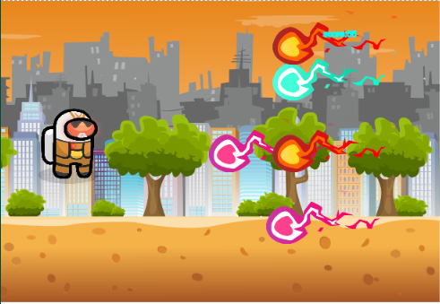

How do you plan to make your game engaging?

***I plan to make my game more engaging by adding more interestion levels and adding different skills ,attacks ,obstacles etc.players will be eager to play the last level after crossing 8 levels ....in which the crewmates will be attacking the imposters....***