# ID705 DB3 Exam

Time allowed: Test closes at 10am 21st June

This test will be semi open book. You may use any course material, yours or mine.

Answer in your own words, do not copy and paste your answers (except queries).

You must work alone. Do not communicate with other students in any way.

Choose 4 of the following questions. Each question is worth 25 marks. Please number your answers.

You may submit your answers in this document or digitally into the GitHub exam repository

**Please number which questions you are answering.**

Total marks: 100 Weighting 25%

Name: ________________________

1. Implement troubleshooting techniques to solve complex database performance issues.
2. Design and develop relational databases to meet specified requirements that are subject to high-availability, high-reliability, security, and performance constraints.
3. Critically analyse database administrator tasks in order to determine a management approach.

You may use the databases available to you on our Azure SQL Server - ictgateway.ict.op.ac.nz:46815 .

SSH Tunnels Source: 1433 Destination 10.3.0.6:1433 (then connect SSMS using 127.0.0.1,1433 – password sent on Teams at the beginning of the semester)

Questions 1, 2 & 5 use the WORLD database. You don’t have write permission so you will need to refer to the World database by its FQDN – script available in the GitHub repository

1. Develop a view named DiverseCountry that handles data in the world database. The

view lists all countries that use four or more languages. The view must return the country name and the number of languages used in the country.

1. Create a stored procedure named GetByInitial that takes a single character parameter named InitialLetter. The stored procedure returns all the country names that start with the InitialLetter. The country names are sorted in order of their length, with the longest name listed first and the shortest name listed last.

EXEC GetByInitial 'z';

1. A database developer wants to create the Question 4 data structure using the following script. Build the tables and Identify 10 errors in the script. This script is available digitally in the GitHub repository

create table Team ( TeamCode char(5) null,  
TeamName varchar(50) not null default ‘<no name>’,  
HomeField varchar(75) not null );  
  
create table Play (PlayerID int not null,  
Name varchar(80) not null default ‘<unknown>’,  
DateOfBirth int not null,  
Position varchar(50) default’<no position>’ null,  
TeamCode char(10) null,  
primary key (Player));  
  
alter table Player drop constraint FK_Player_Team   
foreign key TeamCode   
references Player (PlayerID) on delete cascade on update cascade;

1. Develop a stored procedure named GetEmptyTeams for the following data structure. The stored procedure will list the TeamCode, TeamName and HomeField of teams that have no players.

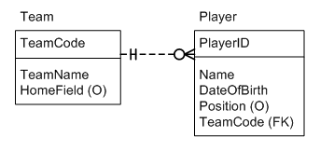

1. Develop a view named UncommonLanguages that handles data in the world database. The view lists all languages that are used in 3 or fewer countries. The view must return the language name and the number of countries the language is used in.

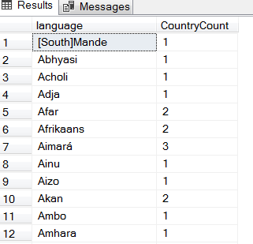

1. Transact-SQL provides five types of join: inner join, left outer join, right outer join, full outer join, cross join. Describe how each join operates and give an example of the results produced by each join. (You may submit this answer on paper if preferred)
2. Describe the process required to perform a scheduled full database backup. Include any scripts and service you may need to activate