Student’s name: Kristina Sviazhin ID:342407533
Project Goal: In this project, I analyzed network traffic protocols. In Part 1 I simulated TCP/IP encapsulation using Wireshark. In Part 2 I developed a multi-threaded Chat System based on TCP Sockets to demonstrate a real time client-server communication.

Part 1: Encapsulation & Traffic Analysis
- CSV Creation:
I created a CSV file named group05_chat_input.csv manually to simulate a chat conversation at the app layer.Each row represents one application message and contains the following fields: src_app(sending app - client), dst_app(receiving app), message(message content), timestamp(message timestamp).
This CSV file serves as the application-layer input for the encapsulation process.
- Encapsulation Process:
The Jupyter notebook reads the CSV file row by row.
For each row, the message payload is extracted and sent over a TCP socket (SOCK_STREAM) to a local server running on 127.0.0.1.Although a raw TCP/IP packet crafting approach was initially implemented, macOS restricts the use of raw sockets without elevated privileges. Therefore, the final implementation uses standard TCP sockets, which still generate real TCP/IP traffic and allow full inspection of the encapsulation process.
- Wireshark Capture:
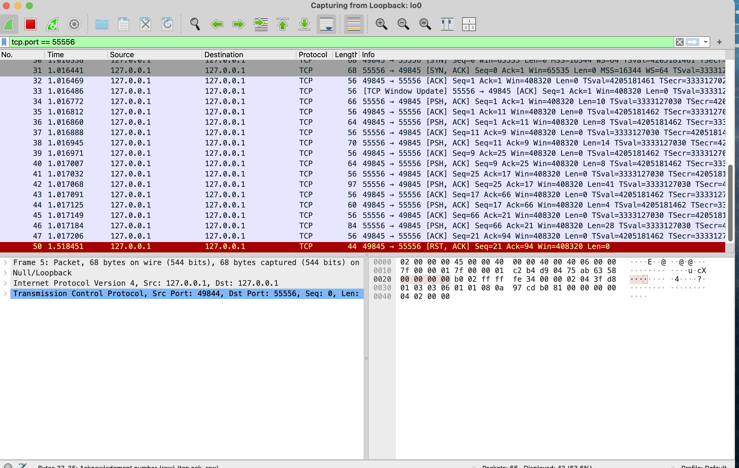
Traffic was captured using Wireshark on the macOS loopback interface (lo0) with the display filter: tcp.port = = 55556.
The capture shows:
- Source IP: 127.0.0.1
- Destination IP: 127.0.0.1
- TCP segments carrying application data
The TCP PSH, ACK packets contain the actual payload originating from the CSV file (e.g., chat messages), confirming the correct mapping from application-layer data to TCP segments and IP packets.

Part 2: Chat Application
- System Overview:
The chat application follows a Client-Server architecture implemented in Python using the socket and threading libraries.
All communication uses TCP to ensure reliable, ordered delivery of messages.
- Database Structure:
The server maintains an in-memory database implemented as a Python dictionary:
- Key: Client username (string)
- Value: Client socket object
This structure allows the server to quickly locate an active client by username and forward messages between connected users.

Code Description:
Server: Listens on port 55556. When a client connects, it starts a new thread. It handles Handshakes (getting names) and Bridging (sending messages from user A to user B).
Client: Uses two threads: one for typing messages and one for listening to incoming messages so the chat is real time.
- Wireshark Analysis:
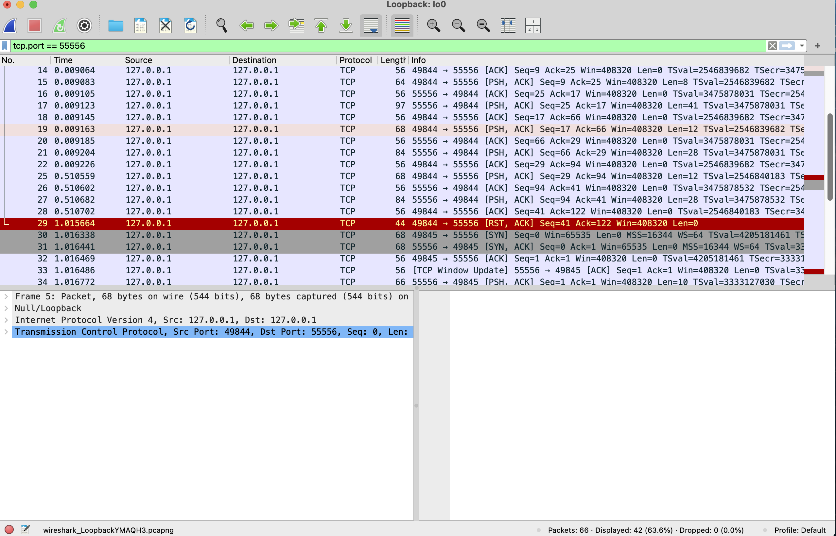
Traffic between two chat users (e.g., Alice and Bob) was captured in Wireshark.
The capture clearly shows:
- The TCP three-way handshake (SYN, SYN-ACK, ACK)
- PSH, ACK packets carrying chat messages
- Proper TCP connection termination
These observations confirm correct TCP behavior and successful application-layer communication.

How to Run
  - Open Terminal 1 and run: python server.py
  - Open Terminal 2 and run: python client.py
  - Enter a username .
  - Enter the name of the person to chat with.
  - Repeat steps 2-4 in Termonal 3 the second client.
- Conclusion:
This project successfully demonstrates TCP/IP communication from the application layer down to the transport and network layers.
Using Wireshark, I was able to observe real TCP traffic, verify the encapsulation process, and analyze the behavior of a multi-threaded TCP chat system in a controlled environment.

