|  |  |
| --- | --- |
|  | **2016** |
|  | BGSU MLS  Author: Melissa Kaiser  Mentors: K. Muili, P. Kin  Analysis Mentors:  S. Bediako, F. Han  Principal Investigator:  D. Goldstein |

|  |
| --- |
| **[Evaluating hematocrit and hemoglobin levels for transwomen receiving hormone replacement therapy]** |
|  |

More than half a century ago, research was carried out to obtain a more realistic picture regarding the red blood cell count of normal women (1). Before this, normal ranges were described to be much higher, as the range was founded on studies of men only, or from inappropriate representations of women in the population (1). Clinical treatment was given to women in an effort to raise their count and hemoglobin values to the accepted standard, with no success (1). With the completion of this study, quality of care was improved for women by acknowledging that their physiology is indeed different (1). The transgender community deserves this same initiative to improve their quality of care. The goal of this retrospective study is to assess the hematocrit and hemoglobin values of transwomen receiving hormone therapy.

**Introduction to Transgender and Hormone Replacement Therapy**

In this paper, I will be utilizing GLAAD definitions in relation to transwomen, or those who were designated male at birth (2,3). Sex is assigned to the population at birth, generally based on the appearance of external reproductive organs (2,3). However, GLAAD points out that sex is actually “a combination of bodily characteristics including: chromosomes, hormones, internal and external reproductive organs, and secondary sex characteristics” (2). Transgender is an umbrella term for those whose gender identity (internal sense of self) and/or gender expression (external manifest) differs from the sex they were assigned at birth (2,3). A Transwoman (s) (Transwomen (pl)), if she chooses, has the opportunity to actualize her gender identity through hormone replacement therapy and/or sex-reassignment-surgery (2,3). Hormone replacement therapy (also known as simply hormone therapy or cross-sex hormone therapy) includes testosterones, androgens, anti-androgens, and estrogens that are administered to contribute towards the secondary sex characteristics society recognizes as being male or female (2,5). For transwomen, hormone therapy is primarily estrogens with possible anti-androgen administration as well (2, 5). It is important to note that the term “transsexual” is outdated and obsolete, as most of the transgender community finds this term offensive, with the exception of those who choose to identify themselves with this term (2).

Transwomen who seek to be placed on hormone therapy must fit the current DSM criteria for Gender Identity Dysphoria (4,5) and have documented experience of a minimum of three months living as a woman or have been counseled via psychotherapy for at least 3 months (4). However, more relevant diagnostic criteria is required to identify those individuals who do not experience any social/occupational distress living as their identified gender (5). The “readiness criteria” for transwomen to begin hormone replacement therapy requires psychotherapeutic diagnosis of mental stability, or the ability to give informed consent (5), and otherwise reliability to consistently and responsibly take the prescribed hormones (4). However, primary care providers that are experienced in working with transgender individuals may begin hormone treatment for the patient without psychotherapy assessment using an informed consent model (5). It is then recommended practice for the physician to counsel the patient on fertility options before beginning the hormone treatment (4). For transwomen, this would include cryogenics, as testicular damage has been reported with prolonged estrogen treatment, and spermatogenesis after prolonged treatment has not yet been studied at length (4).

After beginning hormone therapy, transwomen will start the transition of inhibiting or suppressing male secondary characteristics and develop female secondary sex characteristics (4). Treatment will allow transwomen to experience effects within the first three months to include: decreased libido and decreased spontaneous erections, though by 6 months these side effects should subside (4). In the next three months (3-6 months after treatment) effects include: redistribution of body fat (which can take up to 3 years for maximum effect), decrease in muscle mass and strength (which can take up to 2 years for maximum effect), softening of the skin and decreased oiliness of the skin, breast growth (which can take up to 2 years for maximum effect), and decreased testicular volume (4). Over time, the testes and prostate gland will continue to atrophy (4). The preferred treatment is 17-beta estradiol (estradiol) and an anti-androgen to help suppress or inhibit testosterone levels as well as decrease the estradiol dosage to be below supraphysiological levels that are risk-associated (4).

**Transgender Healthcare Opportunities**

The healthcare industry poses several obstacles that need to be addressed to improve care for the transgender community. Electronic medical records (EMR) and laboratory information systems (LIS) are capable of misgendering the patient, thereby affecting the ability to properly diagnose and treat the patient (6, 7, 8). For example, procedures are ordered according to the sex listed in the e-systems (6). It is therefore not possible to order some needed procedure that disagrees with the sex listed, i.e. you cannot order a prostate exam for a transwoman, and some systems prevent ordering pregnancy tests or hCG quantification for transmen (6). There are steps being taken to introduce a two-step gender identification into 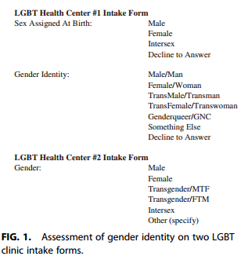EMS/LIS (8). A study of 30 members of the transgender community in Chicago, IL suggests that this two-step question method was an excellent approach to solve this specific obstacle (7). Reasons that were given include: increase access to funding and care, the option to identify other gender identities such as two-spirit, genderqueer, agender, and non-binary (7). Some of the respondents pointed out indescrepancies that the #2 intake form offered, such as “intersex” as a gender option, whereas that term does not accurately define as a gender, as well as offering “other”, which may be considered pejorative (7). Overall, the #1 intake form option was agreed to fit the needs of the respondents, especially because it included the “Decline to Answer” option, which the respondents felt emphasized privacy (7). For various reasons, it is important that we understand that some of the transgender community do not feel comfortable in “outing” themselves to healthcare professionals without promise of a private, safe environment so that they may avoid any discrimination or disrespect (7, 5).

Another opportunity that needs to be addressed is that there is a lack of coverage for transgender procedures and treatment, which promotes a lack of access to care for the transgender community (5, 6, 7). Insurance plans vary by state and employer, though employers and Medicaid have both, in recent years, expanded availability of transgender treatment coverage options (5). Some insurance claims are automatically rejected if they are one of the EMR/LIS orders that are specifically based on sex (5). To elaborate on how lack of access to care can affect the transgender community, a study was conducted in New York City, NY with 101 self-identified transwomen (9). Of these respondents, 71% were currently on hormones; of this percentage, 71% received information about hormone use from a physician (9). Of the percentage which obtained information from a physician, 5 transwomen reported obtaining hormones from another source to supplement their prescription regimen. For 23% of those transwomen currently on hormones, information about hormone use was derived from other sources (9). One transwoman reported sharing needles for hormone use, though not sharing needles for illicit drug use. Additionally, 45% of the transwomen currently on hormones were taking medications that might affect their hormone regimens. Furthermore, a study conducted in San Francisco, CA identified 314 transwomen using respondent driven sampling (RDS) also illustrated opportunities for lack of access to care for the transgender community (10). In this study, 68.7% of transwomen were taking hormone replacement therapy (HRT) (10). Of this percent, 41% were taking hormones consistently, and 49.1% reported non-prescribed use of hormones (10). Reasons given by the respondents with non-prescribed use of hormones were 1) the patient was unable to see their provider, with some respondents indicating that they were turned away from their provider because they were transgender; 2) the patient desired a quicker transition; 3) The non-prescribed use provided physical changes which were consistent with the patient’s personal goals, and 4) other (10). Transwomen patients taking non-prescribed hormones could present to the emergency department with complications such as possible needle sharing complications, pulmonary embolism, deep vein thrombosis (DVT), and hyperkalemia (10). Conditions that may be exacerbated in transwomen with hormone use include thromboembolic disease, macroprolactinoma, severe liver dysfunction with transaminases measuring greater than 3x normal levels, coronary artery disease, cerebrovascular disease, and severe migraine headaches (4). Increasing coverage and access to care for the transgender community will help lessen the possibility of transwomen experiencing complications while taking hormones.

Perhaps the biggest obstacle to overcome to increase the quality of care for the transgender community is the lack of formal training for medical professionals (5, 6, 11). In 2012, a comprehensive book describing the various clinical differences between men and women was written, though it was misleadingly titled “Sex and Gender Aspects in Clinical Medicine”. This work describes various disease states and what to expect for male or female, and serves as a great reference for male and female disease states, however, it does not address gender aspects for the transgender community at all. Further research needs to be conducted to include the effects of the members of the transgender community receiving hormone therapy, as their laboratory results do not fit the status quo. The transgender community should be included in publications such as this which serve as a resource for professional healthcare workers. From the pathologist’s perspective, biopsies may be misinterpreted due to lack of reference information, which can affect diagnoses and treatment (6). Further, laboratory values obtained from retrospective studies do not fit normal male or female measurands, so new empirical data is needed (5, 6, 16, 19).

**Laboratory Values for Transwomen on Hormone Replacement Therapy**

In Mercy Hospital of Tiffin, OH laboratory where I am participating in an externship for Medical Laboratory Science through Bowling Green State University (BGSU), Stat orders which come from the Emergency Department primarily request some form of metabolic panel and a complete blood count with differential so that the physicians may have a better understanding of the patient’s current state. Without two-step verification systems in place (as previously stated), transgender patients may experience misdiagnosis, cross-reactive treatment medications, and a general low quality of care, as their laboratory values differ from what is generally taught, referenced, and therefore “expected” (4, 5, 6, 12). For example, in transwomen, prostate specific antigen, which is a screen for prostate cancer, may be falsely decreased with longterm anti-androgenic therapy (6). Because research is limited on transwomen receiving hormone therapy, scientists are beginning their studies based on male, female, and post-menopausal female values (4). Studies have shown that transwomen present with low hematocrit and hemoglobin values, more resembling the female range (12, 14). Creatinine values, however, resemble male values rather than female values (12, 13). Sodium values did not vary in transwomen, but potassium levels were increased secondary to spironolactone (12). Alkaline Phosphatase (ALP) levels resembled male values, which was unexpected to the researcher because previous studies of post-menopausal women on hormone therapy show the ALP usually decreased (12). Low-density Lipoprotein (LDL) values in transwomen on hormone therapy were decreased, which did follow post-menopausal hormone therapy trends (12).

Additionally, hemostatic variables may be influenced by hormonal treatment such as oral ethinyl estradiol + cyproterone acetate (CPA) as an anti-androgen (15). This treatment is capable of inducing a clinically relevant thrombotic state with a 20-fold increase of DVT risk compared to transdermal estradiol + CPA (15). Hemostatic variables may change on a quantitative basis due to higher dosage of oral ethinyl estradiol, which include: 1) increased APC resistance (possibly influenced by CPA), 2) Increased protein C, 3) Increased prothrombin, 4) decreased protein S, 5) Increased nAPCsr (a marker for thrombotic risk) after 4 months of treatment, comparable to factor V Leiden mutation (influenced by oral ethinyl estradiol combination, as nAPCsr was found to be decreased in APC-only treated natal-females (15).

**Hematocrit, Hemoglobin, and the Erythropoietic Effect of Sex Hormones**

I began thinking of the concept for this study during my hematology class at BGSU, wondering if hormone use would influence erythropoiesis in transwomen so that they presented with female values 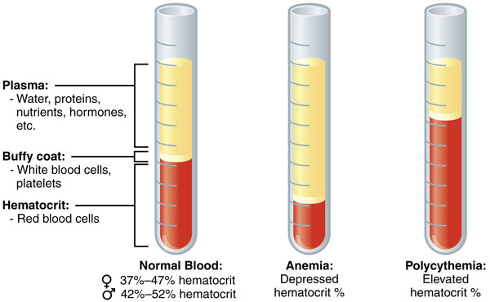of hematocrit and hemoglobin. Hematocrit is the percent volume occupied by red blood cells in relation to the total whole blood volume (which includes white blood cells, platelets, and plasma) (16). Hematocrit percentages are useful in the diagnoses of anemia, where there is a decreased percent because there are less red blood cells per whole blood volume; or in diagnosing polycythemia vera, where there is an increased percent because there are more red blood cells per whole blood volume (16).

Hemoglobin is the functional protein within red blood cells that provides oxygen exchange between blood vessels and tissue or cells (16). The primary structure consists of alpha, beta, delta, gamma, epsilon, or zeta subunit chains which through secondary, tertiary, and quaternary structure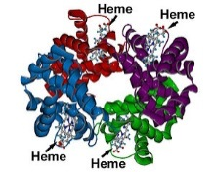 form a tetrahedron with a dyad axis of symmetry, housing four heme groups (18). Hemoglobin can be chronically or constitutively influenced dependent on physiological factors such as race (19, 21) BMI/fitness, altitude, puberty, or menopause (17). Hemoglobin may also be acutely influenced through posture and hydration (17). Hemoglobin variability may be influenced through normal biological processes within the body which are not well understood, or with treatment such as erythropoiesis stimulating agents in patients with chronic kidney disease (20). Because hemoglobin variation mechanisms are not well understood, “it is only conjecture to state why” there are differing levels for males vs. females (17). Hemoglobin measurements can be useful in the diagnosis of anemia as well (19). Precipitated hemoglobin can be visible microscopically in differentials in the form of Heinz bodies for some hemolytic anemia disorders (16, 18). Further studies of hemoglobin structure can be used to diagnose hemoglobinopathies (16). In a healthy patient, hematocrit will vary predictably with hemoglobin during short intervals, though these variances become less predictable over long periods of time (17).

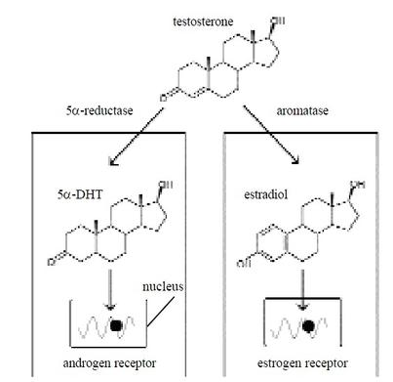Erythropoietin is a hormone produced by the kidney which stimulates red blood cell maturity in the bone marrow (16, 20). Erythropoietin production is stimulated by low density of circulating red blood cells, while an excess of circulating red blood cells causes a negative feedback reaction (20). Because values such as hemoglobin and hematocrit remain relatively the same between males and females until puberty, when male ranges begin to be higher than female ranges, there have been studies concerning the sex-hormone effect on hematologic ranges (17, 22-24). It is the general consensus that the female sex-hormone estrogen serves as an inhibitor for erythropoiesis while male sex-hormones such as testosterone and androgens serve as a stimulant (17, 22, 23). Testosterone is normally formed into estradiol through three hydroxylations of the 19-methyl group of androgens with elimination of the methyl group and resulting aromatization of the A-ring (24). However, a study of two aromatase -deficient men has disproven the theory that estrogen has a direct effect on erythropoiesis (24). This study, while small, is useful in further understanding sex hormone effects on erythropoiesis because both men lack the enzyme necessary to convert testosterone to estradiol, therefore eliminating variables such as hypothalamic interaction from incomplete suppression during treatment and analysis of each sex hormone’s erythopoietic effect (24). The study also confirms that androgens do act as a stimulant for erythropoiesis, though the mechanism for such stimulation still remains elusive (24). Unfortunately, this study also brings us further from understanding the physiological mechanisms in which estrogen plays a part in erythropoiesis (24).

In studying hematology at BGSU, we are required to obtain Denise Harmening’s Clinical Hematology and Fundamentals of Hemostasis as our reference. In her text, she gives “normal” hematologic values which she has derived from various sources; the hemoglobin and hematocrit normal values come from Case Records of the Massachusetts General Hospital published in The New England Journal of Medicine (16). I have provided an updated copy of the hematocrit and hemoglobin values from the last published study in 2004 (below; 25). As you can see, both values are organized by sex, with no two-step gender identification listed (25). Students in Medical Laboratory Science are expected to memorize these normal values as references before they enter a laboratory facility where these values may change based on population demographics.

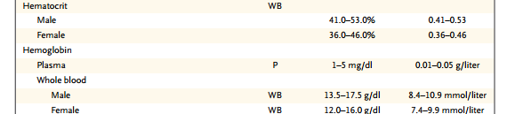

Previous studies of hematologic values in pregnant patients have been accepted to be mitigated by the increase in estrogen levels throughout pregnancy and are included in reference intervals (16, 17). It is my opinion that there should be a reference interval similar to this inclusion which will identify variations to be expected for the transgender population that is receiving hormone therapy.

**Methods and Limitations**

CLSI document EP28-A3c is the third and most recent edition explaining how to define, establish, and verify reference interval for the clinical laboratory (26). In this edition, it is recommended that for small populations in which healthy patients are not able to be the only data which is collected for the study, (such as pediatric, geriatric, or, in this case, transwomen) robust statistics is the analysis method to be utilized when creating reference intervals (27).

I contacted Whitman-Walker in Washington, D.C. to collect data for my study because this organization is renowned for their involvement in research that benefits the LGBT community. I requested to receive a numbered patient list which only provided hematocrit and hemoglobin levels at baseline for transwomen before receiving hormone therapy, and any other hematocrit and hemoglobin levels that were measured after beginning hormone therapy with the included time frame of how long they had been receiving hormone therapy when that level was recorded. I also requested the brand/type of hormone treatment along with dosage.

My goal was to collect enough data so that I could illustrate expected trends in hematocrit and hemoglobin levels for transwomen receiving hormone therapy over the course of treatment. The study I had initially read by Roberts, *et al.* was a retrospective study for transwomen receiving hormone therapy after 6 months of treatment and up to 10 years of treatment (12). Though the findings in this study did suggest that transwomen receiving hormone therapy did not fit into expected male nor female measurands (12), I wanted to see when this trend started, thus my request for patient levels at baseline. I requested the dosage and form of hormone therapy so that, with enough patient information, I may be able to separate similar treatment methods vs. differences in values to see if there were any differing trends among treatment preferences over the course of treatment.

After deciding on the method of robust statistics, making arrangements to discuss analyses with mathematics graduate students, and collecting all the supporting information for my research from the library, I began to reread Roberts study again, this time recognizing that they included the limitations of their study to be that their values could not be validated because they had used two different analyzers; one of which, the manufacturer’s controls could not be run on (12). It occurred to me that my initial proposal and request was flawed in that I did not request information about the analyzer and validation of those patient’s values through using the same analyzer each time. I wrote to the principal investigator and requested information concerning where the specimens were processed. The reply was that their specimens were sent out to LabCorp. Because Whitman-Walker has several satellite locations within D.C., I called multiple LabCorp locations in the area requesting to speak with their Hematology department in search of this information. I found, unfortunately, that most locations were phlebotomy offices, and my requests to speak with their supervisor to receive more information resulted in leaving messages on answering machines that remain, to this day, un-returned. After a week of waiting for a response, I decided to at least attempt eliminate the variable of altitude from hemoglobin measurements through calling major hospitals in the D.C. area to collect information about their normal levels for male and female patients on both hematocrit and hemoglobin. None of the hospitals I contacted used the same hematology analyzer; they were all different analyzers. Still, I used the values that I was given and took the average of their highs and lows to at least give an *idea* of what is expected to be a normal value for that area.

When I did receive the patient information for this study from the principal investigator, there were only three patient values, thus eliminating the possibility to use robust statistics to represent the population. I decided to present instead each patient value over the course of treatment as a line-connected scatterplot graph over the expected values from the Boston General Hospital publication identified ranges for male (blue) and female (pink) (overlapping values are purple – blue+pink) as well as the same patient scatterplot over the expected values for the D.C. area. Additionally, I was given the HIV status of each patient, and HIV influences on hematologic levels was not in my initial research. Nevertheless, I found that anemia was an important pathophysiological factor in HIV positive persons and may also correlate with the severity or stage of the disease, or may be influenced by treatment (28). I was also given the smoking status of each patient and that too, was not part of my initial research. I found that hemoglobin concentration decreases with smoking (29).

**Data on a Case Basis**

Case: Patient 1

Patient 1 is a 22 year old transwoman from the D.C. area who is HIV positive and smokes. Her baseline hemoglobin was 14.6 mg/dL before hormone treatment with estradiol 2mg PO twice daily. The hemoglobin value decreased to 12.5 mg/dL at 2-4 months of treatment, and then rose to 13.6 mg/dL by 6-12 months of treatment. As you can see, her baseline hemoglobin was in the lower range of male values/higher range of female values for Boston General Hospital (left), and the D.C. area (right). At 2-4 months, her hemoglobin value decreased to the lower range of female values, and by 6-12 months of treatment she raised again to the higher range of female values/lower range of male values, though this level is below that of her initial baseline value. As stated before, HIV positive status will decrease hemoglobin values with progression of the disease (28), and as I am unaware of her current HIV stage or treatment status, I am unable to comment on whether these were a factor in her initial levels, nor if it had an effect on her hormone treatment. Additionally, as she is a smoker, and smoking has been found to decrease hemoglobin concentration (29), this may be why her initial levels began in the lower range of male values/higher range of female values.

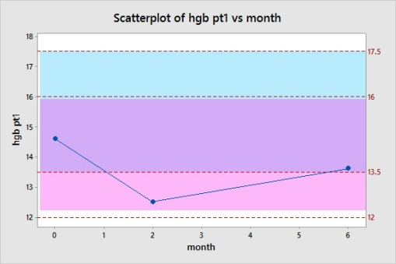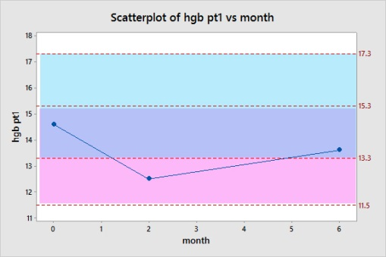

Patient 1 hematocrit levels at baseline are 44%, then drop to 36.8% after 2-4 months of treatment, then raise a bit and level out at 40.8% by 6-12 months of treatment. As you can see, her baseline hematocrit was in the lower range of male values/higher range for Boston General Hospital (left), and the D.C. area (right). She lowered to the lower range of female values by 2-4 months, and then rose back into the higher range for female values by 6-12 months.

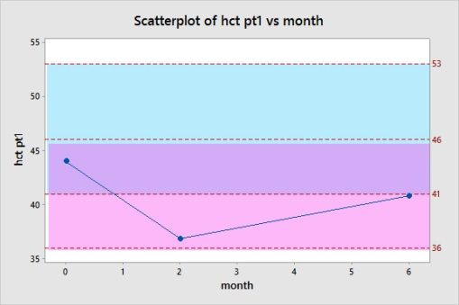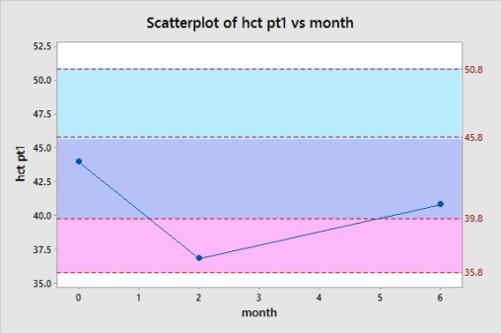

Case: Patient 2

Patient 2 is a 74 year old transwoman from the D.C. area who is HIV negative and does not smoke. Her baseline hemoglobin was 12.9 mg/dL before hormone treatment with estrace 1mg PO twice daily. The hemoglobin value decreased to 11.7 mg/dL at 2-4 months of treatment, and then decreased slightly more to 11.5 mg/dL by 6-12 months of treatment. As you can see, her baseline hemoglobin was in the lower range of female values for Boston General Hospital (left), and the D.C. area (right). At 2-4 months, her hemoglobin value decreased to slightly below lower range of female values, and by 6-12 months of treatment she lowered again. Age does have a decreasing effect on hemoglobin levels, so because the patient is 74 years old, this may be why her initial level was at the lower female range.

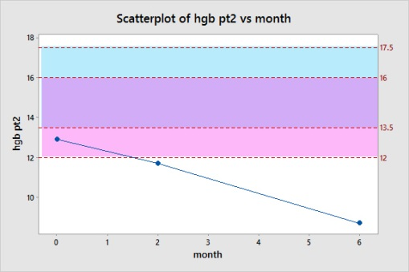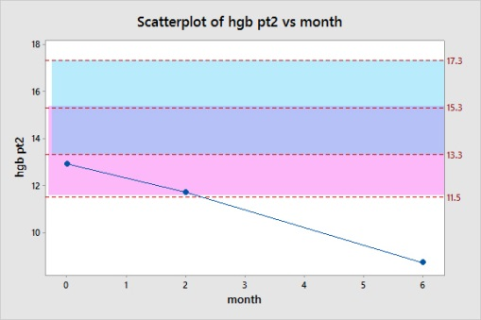

Patient 2 hematocrit levels at baseline are 44%, then drop to 36.8% after 2-4 months of treatment, then raise a bit and level out at 40.8% by 6-12 months of treatment. As you can see, her baseline hematocrit was in the lower range of female values Boston General Hospital (left), and the D.C. area (right). She lowered to just below the lower range of female values by 2-4 months, and then lowered a bit more to just below the lower range for female values by 6-12 months.

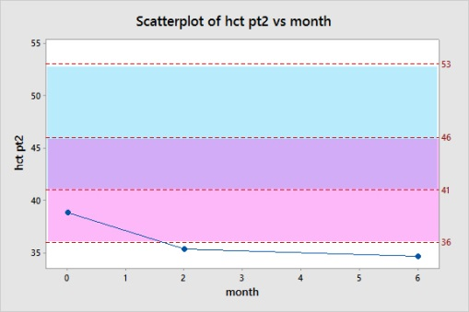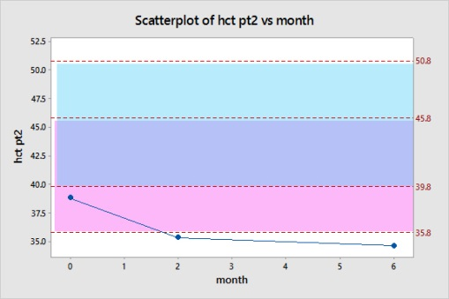

Case: Patient 3

Patient 3 is a 29 year old transwoman who is HIV positive and smokes. Her baseline hemoglobin was 12.2 mg/dL before hormone treatment with estradiol 2mg PO twice daily. The hemoglobin value decreased to 8.7 mg/dL at 2-4 months of treatment, and then decreased slightly moreto 8.5mg/dL by 6-12 months of treatment. As you can see, her baseline hemoglobin was in the lower range of female values for Boston General Hospital (left), and the D.C. area (right). At 2-4 months, her hemoglobin value decreased to the below the lower range of female values, and by 6-12 months of treatment she lowered a bit again to below the lower range of female values. As stated before, HIV positive status will decrease hemoglobin values with progression of the disease (28), and as I am unaware of her current HIV stage or treatment status, I am unable to comment on whether these were a factor in her initial levels, nor if it had an effect on her hormone treatment. Additionally, as she is a smoker, and smoking has been found to decrease hemoglobin concentration (29), this may be why her initial levels began in the lower range of male values/higher range of female values. Furthermore, I am unaware of any other information about this patient that may explain the almost critical hemoglobin level that she maintains in 2-12 months after treatment.

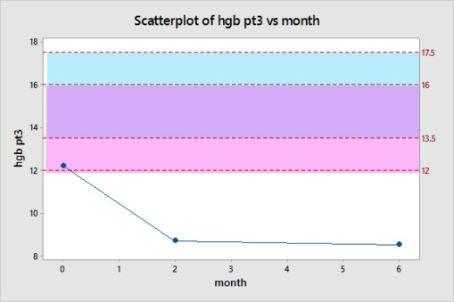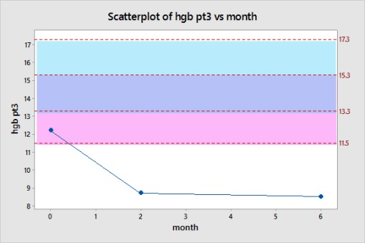

Patient 3 hematocrit levels at baseline are 35.9%, then drop to 27.7% after 2-4 months of treatment, then raise a bit and level out at 28.4% by 6-12 months of treatment. As you can see, her baseline hematocrit was in the lower range of female values Boston General Hospital (left), and the D.C. area (right). She lowered to significantly below female ranges by 2-4 months, and then lowered a bit more by 6-12 months.

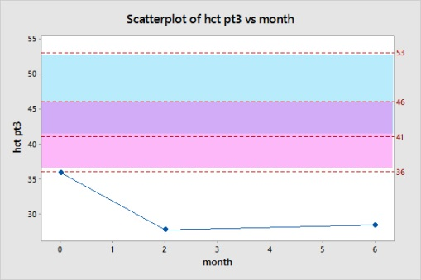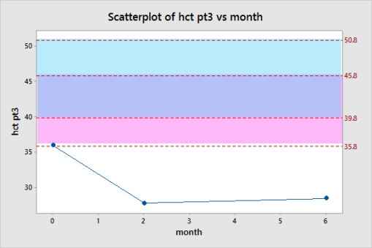

**Conclusion**

While I am not able to offer any conclusive data for such a small sample set, the graphs do suggest a need for further study as all patients initially drop in both hematocrit and hemoglobin values over the first 2-4 months of treatment, with a possible slight rise in value and then leveling off at 6-12 months of treatment.

If I were to redo this study, I would begin by requesting patients that were analyzed with the same hematology analyzer at the same location so that it could be proven that those results were validated using manufacturer’s controls. Further, I would continue to collect patient data until I had a suitable number to use the robust statistics method as designated in the CLSI guideline, and separate patient value averages based on age in groups of decades to eliminate hematologic variations with age. With these requirements, I believe that I would be more successful in suggesting any expected hemoglobin or hematocrit measurements over the course of treatment for transwomen.

**References:**

1. Judy HE, Price NB. Hemoglobin level and red blood cell count findings in normal women. Journal of the American Medical Association. 1958;167:563.
2. GLAAD. GLAAD Media Reference Guide – Transgender. GLAAD.org. <http://www.glaad.org/reference/transgender>
3. Teich N. Transgender 101: A Simple Guide to a Complex Issue. New York: Columbia University Press; 2012.
4. Hembree W, Cohen-Kettenis P, Delemarre-van de Waal H, et al. Endocrine Treatment of Transsexual Persons: An Endocrine Society Clinical Practice Guideline. *Journal of Clinical Endocrinology & Metabolism*. 2009;94:3132-3154.
5. Deutsch, Madeline (primary author). Overview of Feminising Hormone Therapy. Center of Excellence for Transgender Health, Department of Family and Community Medicine, University of California San Francisco. Guidelines for the Primary and Gender-Affirming Care of Transgender and Gender Nonbinary People; 2nd edition. Deutsch MB, ed. June 2016. Available at [www.transhealth.ucsf.edu/guidelines](http://www.transhealth.ucsf.edu/guidelines).
6. Gupta S, Imborek KL, Krasowski MD. Challenges in Transgender Healthcare: The Pathology Perspective. Laboratory medicine. 2016;47:180.
7. Thompson HM. Patient Perspectives on Gender Identity Data Collection in Electronic Health Records: An Analysis of Disclosure, Privacy, and Access to Care. Transgender Health. 2016;1:25-215.
8. Department of Health and Human Services Centers for Medicare and Medicaid Services. Medicare and Medicaid Programs; Electronic Health Record Incentive Program--Stage 3 and Modifications to Meaningful Use in 2015 through 2017; 2015. <<https://www.federalregister.gov/documents/2016/06/01/2016-12853/medicare-and-medicaid-programs-electronic-health-record-incentive-program-stage-3-and-modifications>>
9. Sanchez NF, Sanchez JP, Danoff A. Health Care Utilization, Barriers to Care, and Hormone Usage Among Male-to-Female Transgender Persons in New York City. American Journal of Public Health. 2009;99:713-719.
10. de Haan G, Santos G, Arayasirikul S, Raymond H. Non-Prescribed Hormone Use and Barriers to Care for Transgender Women in San Francisco. LGBT Health. 2015;2:313-323.
11. Oertelt-Prigione S, Regitz-Zagrosek V. Sex and Gender Aspects in Clinical Medicine. 1. Aufl.;2012; ed. New York;London;: Springer; 2012;2011;.
12. Roberts TK, Kraft CS, French D, et al. Interpreting laboratory results in transgender patients on hormone therapy. The American journal of medicine. 2014;127:159.
13. Fernandez J, Tannock L. Metabolic Effects of Hormone Therapy in Transgender Patients. Endocrine Practice. 2016;22:383-388.
14. T’Sjoen GG, Beguin Y, Feyen E, Rubens R, Kaufman J, Gooren L. Influence of exogenous oestrogen or (anti-) androgen administration on soluble transferrin receptor in human plasma. Journal of Endocrinology. 2005;186:61-67.
15. Toorians A, Thomassen M, Zweegman S, et al. Venous thrombosis and changes of hemostatic variables during cross-sex hormone treatment in transsexual people. *Journal of Clinical Endocrinology and Metabolism*. 2003;88:5723-5729.
16. Harmening, D. Clinical Hematology and Fundamentals of Hemostasis. 5th ed. Philadelphia: F.A. Davis, 2009.
17. Murphy W. The sex difference in haemoglobin levels in adults - Mechanisms, causes, and consequences. Blood Reviews. 2014;28:41-47.
18. Bunn HF1, Forget BG, 1939. Hemoglobin--Molecular, Genetic, and Clinical Aspects. Philadelphia: W.B. Saunders Co; 1986.
19. Beutler E, West C. Hematologic differences between African-Americans and whites: the roles of iron deficiency and alpha-thalassemia on hemoglobin levels and mean corpuscular volume. Blood. 2005;106:740-745.
20. Gupta A, David W. Does Erythropoietin Cause Hemoglobin Variability- Is It 'Normal'? PLOS ONE. 2014;9:e92890.
21. Beutler E, Waalen J. The definition of anemia: what is the lower limit of normal of the blood hemoglobin concentration? BLOOD. 2006;107:1747-1750.
22. Gardner FH, Besa EC. Physiologic mechanisms and the hematopoietic effects of the androstanes and their derivatives. *Current topics in hematology*. 1983;4:123.
23. Peschle C, Rappaport I, Sasso G, Condorelli M, Gordon A. Role of Estrogen in Regulation of Erythropoietin Production. Endocrinology. 1973;92:358-362.
24. Rochira V, Zirilli L, Madeo B, Maffei L, Carani C. Testosterone action on erythropoiesis does not require its aromatization to estrogen: Insights from the testosterone and estrogen treatment of two aromatase-deficient men. Journal of Steroid Biochemistry and Molecular Biology. 2009;113:189-194.
25. Kratz A, Ferraro M, Sluss PM, Lewandrowski KB. Case Records of the Massachusetts General Hospital. Weekly Clinicopathological Exercises. Laboratory reference values. The New England Journal of Medicine. 2004;351:1548.
26. CLSI. Defining, Establishing, and Verifying Reference Intervals in the Clinical Laboratory; Approved Guideline—Third Edition. CLSI document EP28-A3c. Wayne, PA: Clinical and Laboratory Standards Institute; 2008.
27. Determining Laboratory Reference Intervals: CLSI Guideline Makes the Task Manageable. LABMEDICINE. 2009;40:75-76.
28. Redig A, Berliner N. Pathogenesis and clinical implications of HIV-related anemia in 2013. Hematology-American Society of Hematology Education Program. 2013;2013:377-381.
29. Skjelbakken T, Dahl IMS, Løchen M. Changes in body mass index and smoking habits have a different impact on hemoglobin concentration in men and women: A longitudinal follow-up of the tromsø study, 1994–2002. Gender Medicine. 2010;7:230-239.