Made in Unreal 5.2.1

Controls:
WASD – Move
1,2,3 – Swap to ally (4v4)
1,2,3,4,5 – Swap to ally (6v6) – Can only swap to a defender ally that is not imprisoned
Esc – Pause Menu

AI Behaviour
- Attacking – Capture Flag
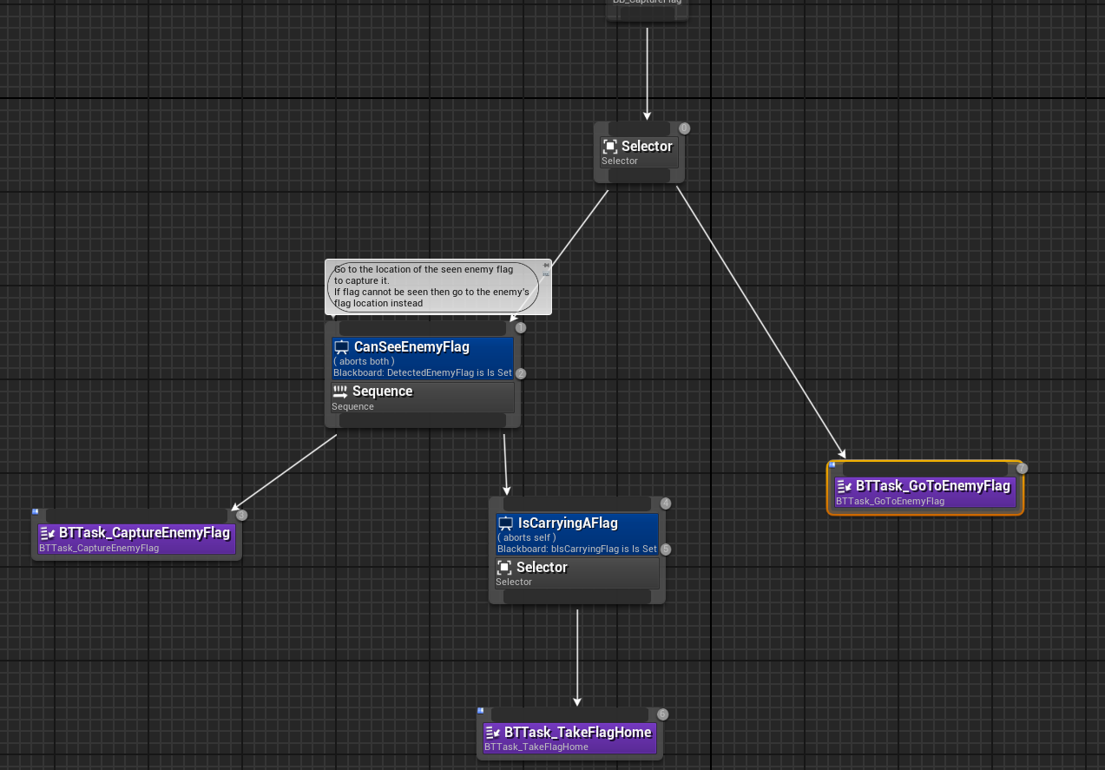
- The agent will move to the location of the opposing team’s flag area
- When the agent perceives an opponent’s flag, it moves towards its location to perform collision with it
- Once collided, the agent now carries the flag and must go to the location of its team’s flag area to capture the flag

- Attacking – Rescuing teammate
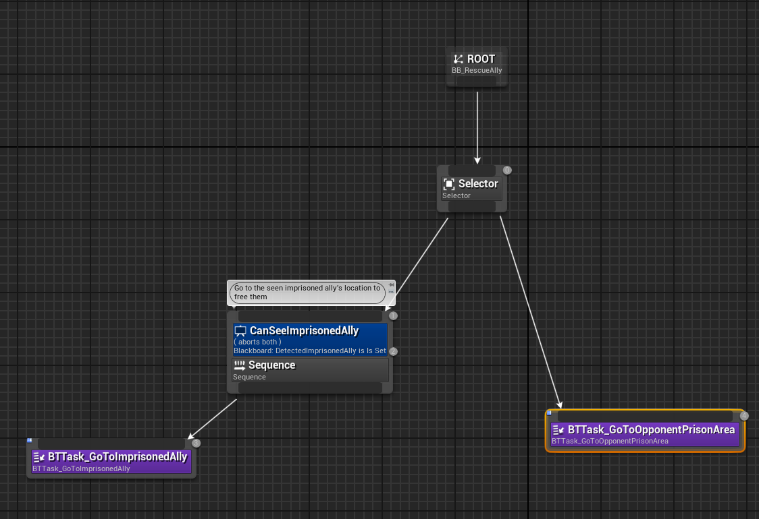
- Similar to capturing the flag, the agent will go to location of the opposing team’s prison area.
- The agent will attempt to collide with an imprisoned teammate to free them – causing both agents to return to their base

- Defending
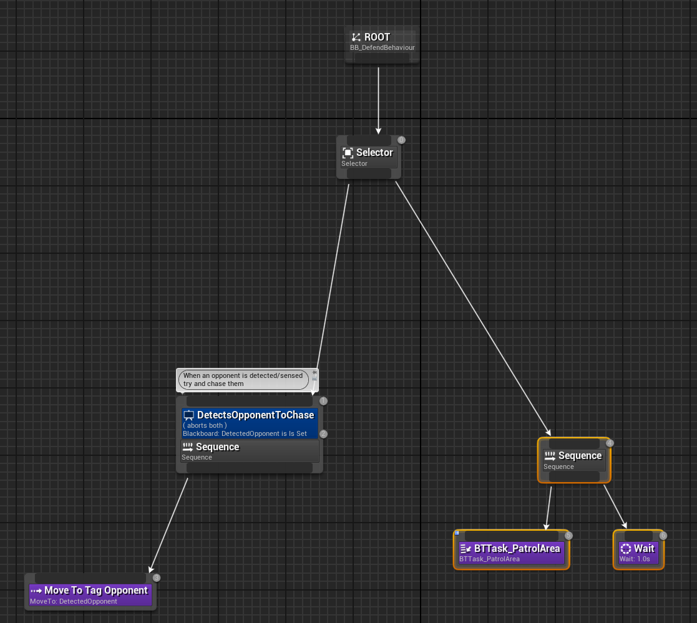
- If the agent has detected an enemy, it will try to chase them and tag them by moving to their location
- If the agent has not detected an enemy, then it would patrol to its given patrol area
- The given patrol area is set on its respective AI Controller – General Defender, Prison Defender and Flag Defender

Assigning roles/ Updating roles after rescue or teammate imprisonment
Choosing new attacking agent
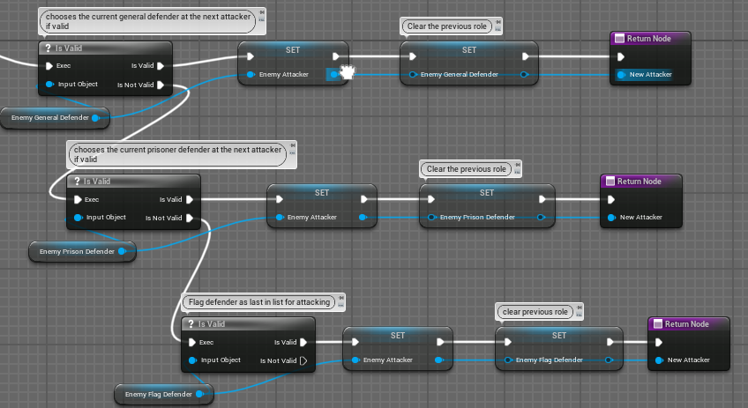
- When the attacker has been imprisoned, a new attacker will be chosen
- The new attacker is chosen based on its current defending role
- Replacing attacker is based on priority: General Defender first then Prison Defender then Flag Defender

Choosing what kind of attack to perform – Capture flag or Rescue Teammate
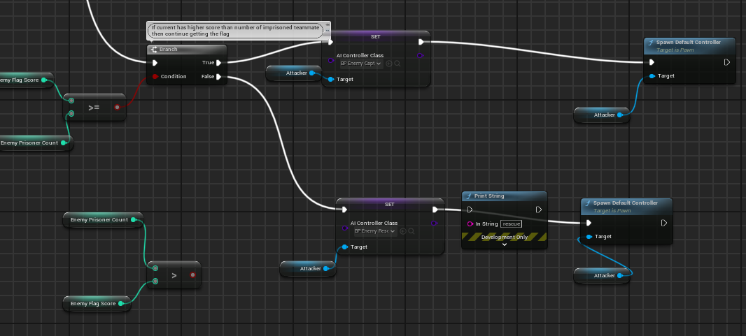
- Choosing the kind of attack to perform is based on the team’s current score and current number of imprisoned teammates.
- If the current number of imprisoned teammates is greater than their current score then attack by rescuing teammates.
- If the current score is greater than their number of imprisoned teammates then attack by capturing opponent’s flag
- If equal scores then 50/50 chance of rescuing or attacking flag
- The new attacker is given a new AI Controller with the chosen attack
- After successfully performing its current attacking goal, it will re-evaluate its attack goal by re-checking the current conditions

AI Steering Behaviour/Navigation for evade/avoidance while attacking
- When attacking, agent will try and avoid player/other defending npcs while still moving towards its goal (flag location/taking flag home)
- This was done by setting a nav mesh modifier around the defending agent/player with a nav area cost of 10

Resources Used:
Flag Icon: Flying flag icon, SVG and PNG | Game-icons.net
Prisoner Icon: Prisoner icon, SVG and PNG | Game-icons.net
Old-school arena FPS announcer voice lines by jkerman: https://freesound.org/s/718360/
KeySFX by Vinrax: Key pickup | OpenGameArt.org
JailSFX by Endritprenku: Freesound - Prison Cell Door sound effect.mp3 by endritprenku

