Technological University of the Philippines

Ayala Boulevard, Ermita, Manila

**INFORMATION MANAGEMENT**

**(Transforming ERD to Relations)**

Submitted by:

**LEADER:**

BALANGA, KRISTAN LLOYD B.

**ASST. LEADER:**

AVELLANA, DOROTHEA

**MEMBERS:**

CAYCO, SHEKINAH MARIE D.V

LEONARDO, NYL RAEMON S.

**2nd Semester**

**S.Y 2022-2023**

Submitted to:

**Prof. DELA CRUZ, FRANCIS L.**

Faculty in Charge

1. Enumerate all the data that need to be accommodated in your data model.

2. Draw the Conceptual Model (Entities, Relationship, Cardinality)

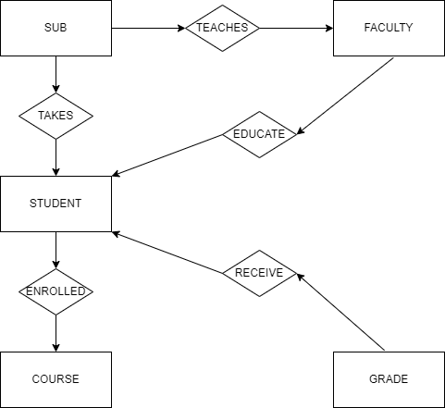

3. Draw the Logical Design ( Conceptual Model + Attributes e.g. identifiers, associative entities)

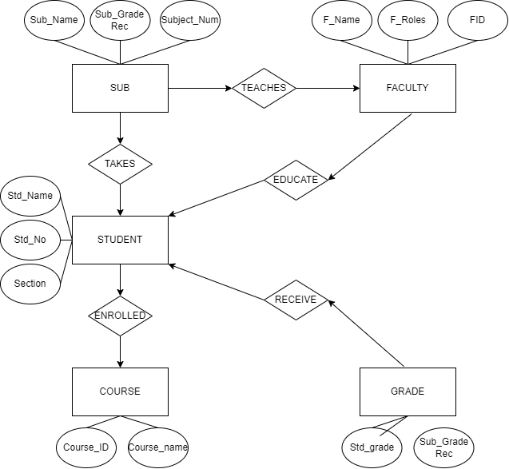

4. Transform the Logical Design into Relational Schema.

5. List and enumerate all the derived Relations.