

Introduction to Micro:bit

# Introduction

In this lesson, we will learn how use Micro:bit programming environment. We will create a simple led drawing and load it into the micro:bit controller.

# Necessarry:

* Micro:bit controller
* USB cable
* Micro:bit program or internet link in which to do programming

# Process!

1. Follow the link:

[Microsoft MakeCode for micro:bit (microbit.org)](https://makecode.microbit.org/)

1. Choose a new project: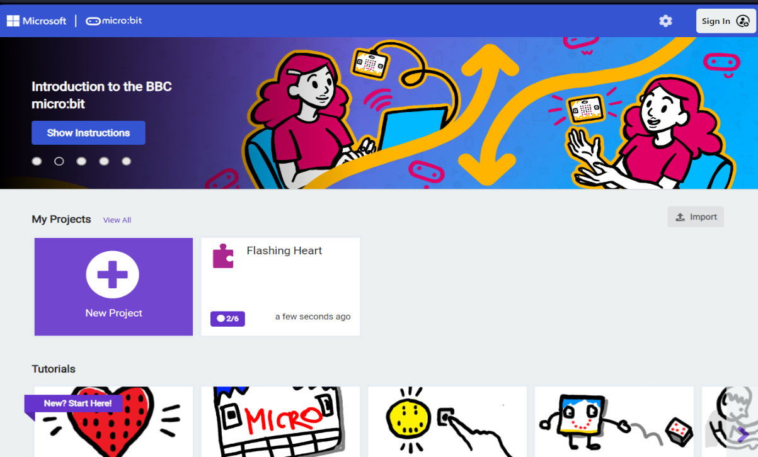
2. A window will pop out in which you need to type the name of the project, then press the Create button:

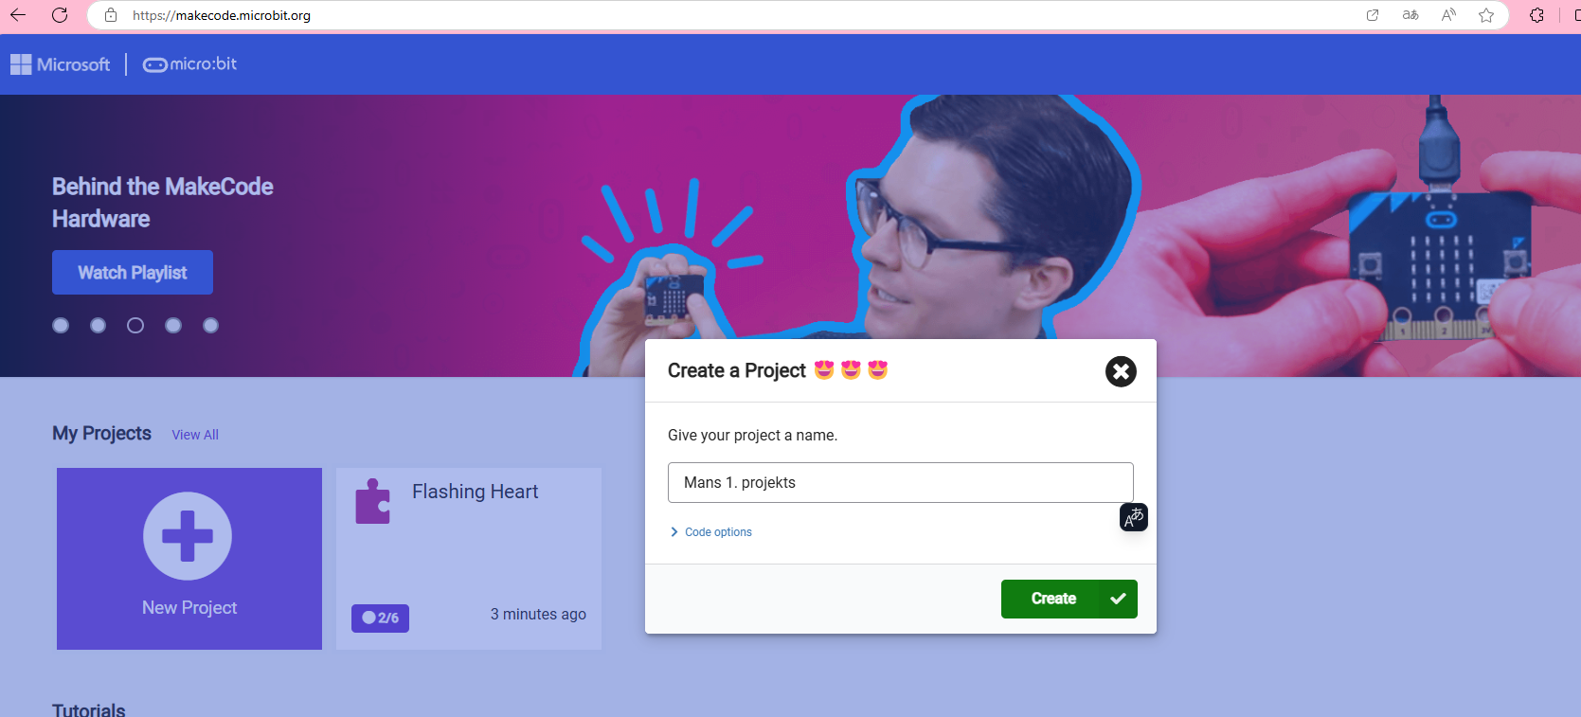

1. Next, a window opens in which you can already start programming. The program offers three types of programming: block programming, JavaScript and Python programming languages.

1. Create any image and save the project.
   1. From the **basic** choice, take the command **on start**
   2. from the same **basic** choice take the command **show leds.**
   3. LED lights can be lit by **pressing** on the corresponding **LED square** directly in the **Show Leds** command

1. In turn, in the **Python code language**, it looks like this:

To depict a drawing, it is necessary to create an array that represents the entire LED block. Burning LED lamps are denoted by a hashtag, but non-combustible ones by a dot. In the first line, the command basic.show_leds is recorded, which means that the controller will show the burning lights all the time. Behind the command, open the parentheses and form an array in parentheses.

1. When you press the "save" button, the project is automatically saved on the computer, but the program also offers the ability to connect the micro:bit controller with a USB wire to the computer and create a pair, thereby allowing you to immediately put the code in the controller.